OPERATING SYSTEMS | CONCURRENCY CONTROL
A Comparative Study of Synchronization Techniques
Semaphores, Monitors, Peterson's Algorithm and Dekker's Algorithm
Covered in this report
Algorithms, pseudocode and tested C / Java code
Flowcharts of every technique
Feature, correctness and performance comparison tables
Charts: radar, bar, totals, timeline, cost model
Strengths, weaknesses and expected limitations
Selection guide, review questions, references and glossary

Mutual exclusion - Progress - Bounded waiting
November 2026

Contents

1. Introduction and Problem Statement 3
2. Taxonomy and Historical Context 4
3. Dekker's Algorithm 5
4. Peterson's Algorithm 7
5. Semaphores 10
6. Monitors 12
7. Hardware and Memory-Model Considerations 14
8. Side-by-Side Comparison 16
9. Strengths and Weaknesses at a Glance 19
10. Expected Limitations and Common Pitfalls 19
11. Selection Guide 21
12. Review Questions 21
13. Conclusion 22
References and Glossary 22

About the code in this report
The C listings for Dekker, Peterson and the semaphore bounded buffer were compiled and run (2 threads, shared counter / producer-consumer) and produced the expected results. The Java monitor listing follows the standard synchronized / wait / notifyAll pattern.

1. Introduction and Problem Statement

1.1 Why synchronization matters
When two or more threads or processes share data, the final result may depend on the exact order in which their instructions interleave. This situation is called a race condition. The classic example is incrementing a shared counter: the statement counter++ is compiled into three machine steps (load, add, store), and if two threads execute these steps at the same time, one of the updates can be lost.
The part of a program that accesses shared data is the critical section. The *critical-section problem* asks for a protocol that lets cooperating processes enter their critical sections one at a time, without relying on assumptions about relative process speeds. Dekker's algorithm, Peterson's algorithm, semaphores and monitors are four historically important answers to this problem, and each represents a different level of abstraction.
Listing 1 - The race condition that motivates every algorithm in this report
/* UNSAFE: two threads run this loop on the same variable */
long counter = 0;

void *worker(void *arg) {
for (int k = 0; k < 1000000; k++)
counter++; /* load, add, store: NOT atomic */
return NULL;
}
/* Typical result with 2 threads: far less than 2,000,000 */

1.2 The three classical requirements
Any correct solution to the critical-section problem must satisfy three properties. We use them throughout the report as the formal yardstick for comparing the four techniques.
Requirement | Meaning | Violation looks like
Mutual exclusion | At most one process is inside its critical section at any time. | Lost updates, corrupted data structures.
Progress | If no process is in its critical section and some want to enter, only those competing decide who enters next, and the decision cannot be postponed forever. | Deadlock or livelock: everybody waits although the section is free.
Bounded waiting | After a process requests entry, there is a bound on how many times others may enter before it does. | Starvation: one process is overtaken indefinitely.

Two further criteria are often added in practice: no assumptions about speed or number of CPUs, and no waiting inside the remainder section (a process that is not interested in the critical section must never block others).

1.3 Scope and method of the comparison
The report compares the four techniques along the following dimensions: underlying idea, number of supported processes, correctness properties, hardware and operating-system requirements, waiting strategy (busy waiting versus blocking), expressive power, ease of programming, typical failure modes, performance behaviour, and recommended use cases. For each technique we give the algorithm, a flowchart, working code, strengths, weaknesses and expected limitations. Section 8 then puts everything side by side in tables and charts.
Reading guide
Sections 3-6 describe the individual techniques. Section 7 explains why software-only algorithms need care on modern CPUs. Sections 8-10 contain the comparison tables, charts and the strengths/weaknesses summary. Sections 11-13 cover limitations, selection guidance and review questions.

2. Taxonomy and Historical Context

2.1 Four techniques, three levels of abstraction
Although all four techniques provide mutual exclusion, they sit at different layers of the software stack. Dekker's and Peterson's algorithms are software-only protocols built directly on ordinary shared variables. Semaphores are an operating-system primitive that adds blocking and waking. Monitors are a language-level construct that packages the lock, the protected data and the condition queues into one structured unit, so that the compiler or runtime enforces correct use.
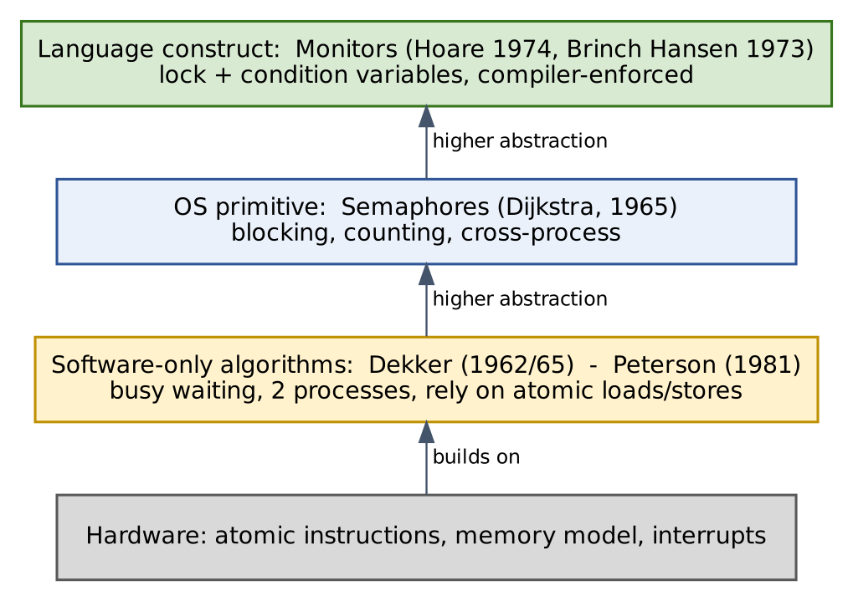
Figure 1 - Abstraction layers of the four synchronization techniques

2.2 Timeline
Dekker's solution is the first known correct software solution to the two-process mutual-exclusion problem and was described by Dijkstra in the mid-1960s, crediting the Dutch mathematician Th. J. Dekker. Dijkstra introduced semaphores in the same period. Hoare (1974), building on Brinch Hansen's earlier work, formalised monitors. Peterson published his compact two-process algorithm in 1981, showing that Dekker's idea could be expressed far more simply.
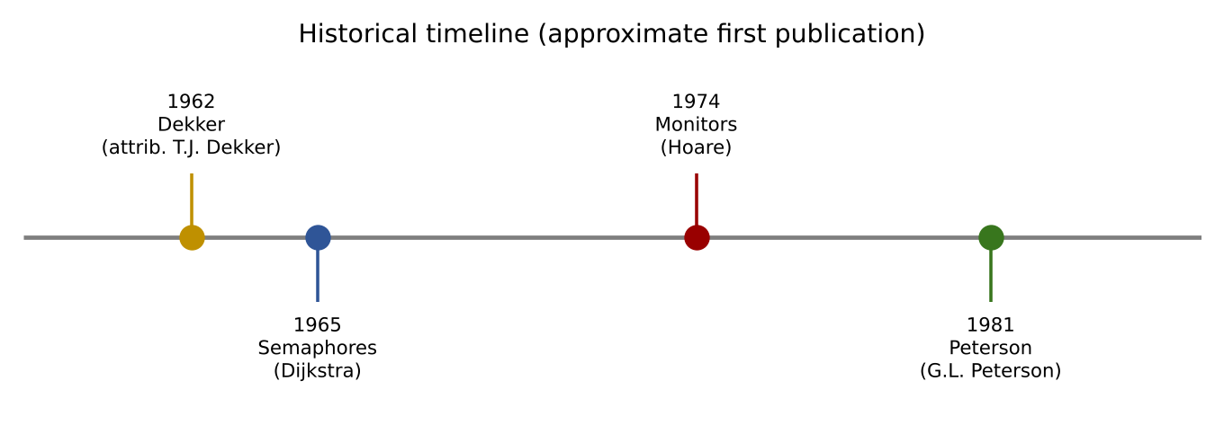
Figure 2 - Approximate chronology of the four techniques

2.3 One-page overview
 | Dekker | Peterson | Semaphore | Monitor
Inventor / source | Th. J. Dekker; described by E. W. Dijkstra (c. 1965) | G. L. Peterson (1981) | E. W. Dijkstra (1965) | C. A. R. Hoare (1974); P. Brinch Hansen (1973)
Kind | Software algorithm | Software algorithm | OS / library primitive | Language construct
Processes supported | 2 | 2 (N via filter lock) | N | N
Waiting style | Busy waiting | Busy waiting | Blocking (queue) | Blocking (queues)
Shared state | 2 flags + turn | 2 flags + turn | 1 integer + queue | Lock + data + condition queues
Main purpose | Mutual exclusion | Mutual exclusion | Exclusion and signalling | Exclusion and condition sync
Typical today | Teaching, proofs | Teaching, proofs, spinlock ideas | Everywhere (POSIX, Windows) | Java, C#, Python, Go-style locks

3. Dekker's Algorithm

3.1 Idea
Dekker's algorithm lets two processes, P0 and P1, share a resource using only three shared variables: a boolean array wants[2] that records interest, and an integer turn that records whose turn it is to insist on entering when both are interested. A process first announces its interest. If the other process is also interested, the algorithm uses turn to decide who backs off: the process whose turn it is persists, and the other lowers its flag, waits for its turn, and then tries again.

3.2 Algorithm in pseudocode
Listing 2 - Dekker's algorithm (pseudocode)
shared: boolean wants[2] = {false, false};
int turn = 0;

/* Process Pi, with j = 1 - i */
do {
wants[i] = true;
while (wants[j]) {
if (turn != i) {
wants[i] = false;
while (turn != i) ; /* wait for my turn */
wants[i] = true;
}
}
/* ---- critical section ---- */
turn = j;
wants[i] = false;
/* ---- remainder section ---- */
} while (true);

3.3 Flowchart
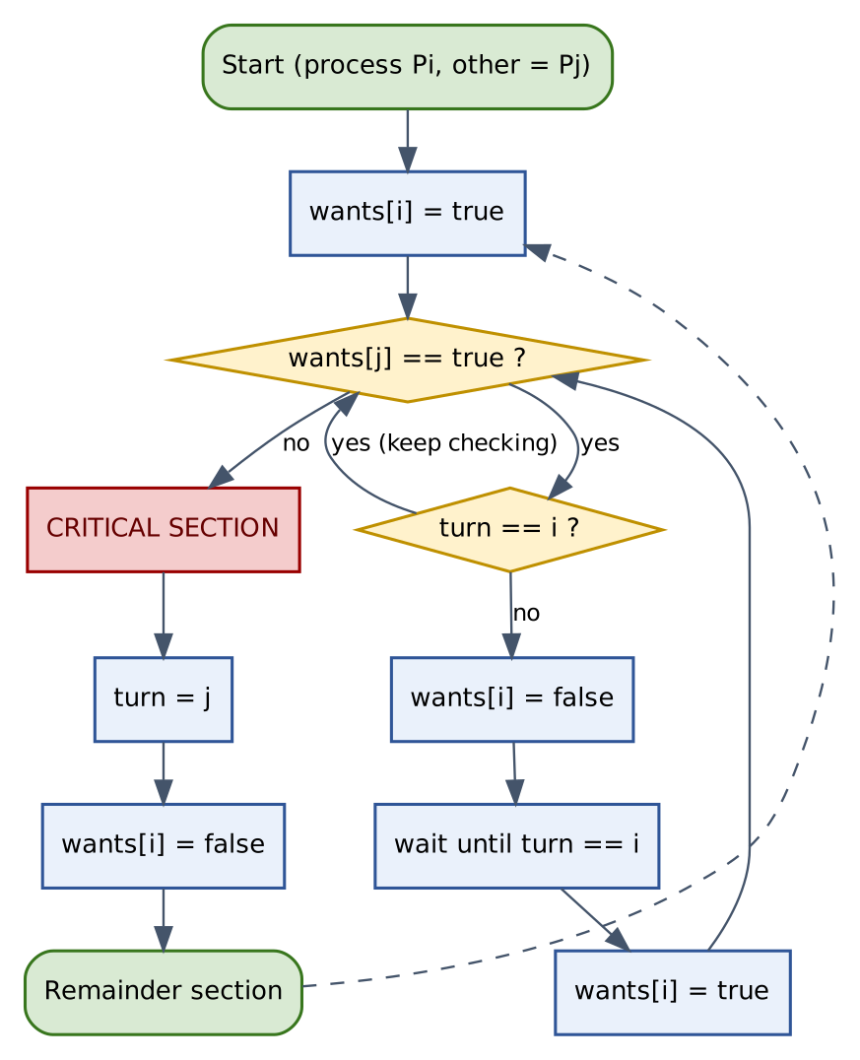
Figure 3 - Flowchart of Dekker's algorithm for process Pi

3.4 Working implementation (C11)
The listing below is a tested C11 version. Atomic types with the default sequentially consistent ordering are required; with plain int variables the compiler and the CPU are free to reorder the accesses and the algorithm breaks (see Section 7).
Listing 3 - Dekker lock/unlock with C11 atomics (tested: 2 threads x 20,000 increments)
#include <stdatomic.h>
atomic_bool wants[2];
atomic_int turn;

void lock(int i) {
int j = 1 - i;
atomic_store(&wants[i], 1);
while (atomic_load(&wants[j])) { /* contention? */
if (atomic_load(&turn) != i) { /* not my turn: back off */
atomic_store(&wants[i], 0);
while (atomic_load(&turn) != i) ; /* spin until my turn */
atomic_store(&wants[i], 1);
}
}
}

void unlock(int i) {
atomic_store(&turn, 1 - i); /* hand the turn over */
atomic_store(&wants[i], 0);
}

3.5 Correctness argument
- Mutual exclusion: a process enters only if it observed wants[j] == false after setting wants[i] = true. If both observed the other's flag as false, each flag write would have to precede the other's read, which is impossible in a sequentially consistent execution.
- Progress: when both are interested, turn breaks the tie in favour of exactly one process, and the other lowers its flag so the favoured one can proceed. No deadlock is possible.
- Bounded waiting: on leaving, a process gives the turn to the other, so a waiting process is overtaken at most once.

3.6 Properties, strengths and weaknesses
Strengths | Weaknesses
Needs no special hardware instruction such as test-and-set or compare-and-swap. | Works for exactly two processes; generalising it is complicated.
First historically correct software solution; a rich source for formal proofs. | Complex control flow (nested loops, flag withdrawal) is hard to read and to verify.
Satisfies mutual exclusion, progress and bounded waiting. | Busy waiting wastes CPU cycles, especially on a single core.
No operating-system support required. | Requires sequential consistency; breaks on reordering CPUs without fences.
Strictly alternating hand-over gives deterministic fairness under contention. | Strict hand-over can force the faster process to wait for a slower partner.

Expected limitations of Dekker's algorithm
Do not expect it to scale beyond two threads, to survive compiler/CPU reordering without atomics or fences, or to be efficient when critical sections are long: the waiting process burns an entire CPU. On a single-core machine, the spinning process can consume its whole time slice before the lock holder is even scheduled.

4. Peterson's Algorithm

4.1 Idea
Peterson's algorithm achieves the same goal as Dekker's with a much simpler structure. A process sets its flag, then politely gives the turn to the other process, and finally waits only while the other process both wants to enter *and* holds the turn. Because both processes write turn, whichever write happens last decides who waits - the later writer defers.

4.2 Algorithm in pseudocode
Listing 4 - Peterson's algorithm (pseudocode)
shared: boolean flag[2] = {false, false};
int turn;

/* Process Pi, with j = 1 - i */
do {
flag[i] = true; /* I want to enter */
turn = j; /* ...but you may go first */
while (flag[j] && turn == j) ; /* busy wait */
/* ---- critical section ---- */
flag[i] = false; /* I am done */
/* ---- remainder section ---- */
} while (true);

4.3 Flowchart
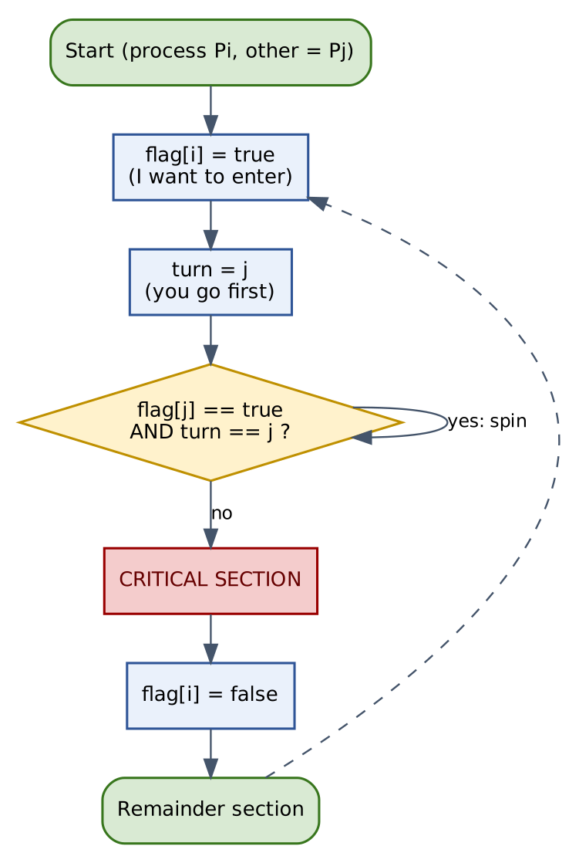
Figure 4 - Flowchart of Peterson's algorithm for process Pi

4.4 Working implementation (C11)
Listing 5 - Peterson lock/unlock with C11 atomics (tested: 2 threads x 20,000 increments)
#include <stdatomic.h>
atomic_bool flag[2];
atomic_int turn;

void lock(int i) {
int j = 1 - i;
atomic_store(&flag[i], 1); /* I want to enter */
atomic_store(&turn, j); /* you go first */
while (atomic_load(&flag[j]) && atomic_load(&turn) == j)
; /* spin */
}

void unlock(int i) {
atomic_store(&flag[i], 0);
}

4.5 Correctness argument
- Mutual exclusion: suppose both are in the critical section. Each must have seen either the other's flag false or turn pointing to itself. Since turn has a single value and both set their flags before writing it, at least one of them must have seen the other's flag true and turn pointing at the other - contradiction.
- Progress: if only Pi wants to enter, flag[j] is false and Pi passes immediately. If both want to enter, turn selects exactly one.
- Bounded waiting: after Pi leaves and tries again, it writes turn = j and therefore yields to a waiting Pj. A waiting process is overtaken at most once (bound = 1).

4.6 Generalisation to N processes: the filter lock
Peterson's idea extends to N threads by organising them in N-1 "waiting rooms" (levels). At each level one thread is filtered out and must wait, so that only one thread survives the last level. The generalisation keeps mutual exclusion and starvation freedom but requires O(N) shared variables, O(N) steps even without contention, and much more busy waiting - which is why practical systems use hardware atomics (or the bakery algorithm by Lamport) instead.
Listing 6 - Sketch of the N-thread filter lock
int level[N]; /* level[i] = highest level thread i tries to enter */
int victim[N]; /* victim[L] = last thread to arrive at level L */

void lock(int i) {
for (int L = 1; L < N; L++) {
level[i] = L;
victim[L] = i;
/* wait while some other thread is at level >= L and I am the victim */
while (victim[L] == i && exists_k_not_i_with(level[k] >= L)) ;
}
}
void unlock(int i) { level[i] = 0; }
/* Note: shared arrays must be atomic / fenced exactly as in Listing 5. */

4.7 Properties, strengths and weaknesses
Strengths | Weaknesses
Extremely short and easy to understand; easy to prove correct. | Only two processes in its basic form.
Satisfies mutual exclusion, progress and bounded waiting (bound of one). | Busy waiting: CPU is wasted while spinning.
No atomic read-modify-write instruction needed. | Incorrect on modern CPUs unless sequentially consistent atomics or fences are used.
Extensible to N processes (filter lock). | The N-process extension is slow and memory-hungry.
Excellent teaching tool for reasoning about shared-memory concurrency. | Not used in production kernels; hardware primitives are cheaper and more scalable.

Dekker versus Peterson in one sentence
Both give two-process mutual exclusion with busy waiting; Peterson achieves it with fewer steps and a clearer proof, whereas Dekker's explicit back-off logic is more elaborate. Peterson is therefore preferred for teaching, and Dekker for historical and proof-oriented study.

5. Semaphores

5.1 Idea
A semaphore, introduced by Dijkstra, is an integer variable that can be accessed only through two atomic operations. wait(S) (originally P, from Dutch *proberen*, "to test") decrements the value and blocks the caller if the result is negative. signal(S) (originally V, *verhogen*, "to increment") increments the value and wakes one blocked process if there is any. Unlike Dekker and Peterson, a waiting process is put to sleep in a queue, so it consumes no CPU time.

5.2 Kinds of semaphores
Kind | Value range | Typical use
Binary semaphore | 0 or 1 | Mutual exclusion (behaves like a lock, but any thread may signal it).
Counting semaphore | 0 ... N | Managing a pool of N identical resources (buffers, connections).
Strong semaphore | Any | Blocked processes are woken in FIFO order: bounded waiting is guaranteed.
Weak semaphore | Any | Wake-up order unspecified: starvation is possible.

5.3 Definition with blocking queue
Listing 7 - Semaphore operations (textbook definition)
typedef struct { int value; struct process *queue; } semaphore;

void wait(semaphore *S) { /* P : executed atomically */
S->value--;
if (S->value < 0) {
add_to_queue(S->queue, current_process);
block(); /* sleep until woken */
}
}

void signal(semaphore *S) { /* V : executed atomically */
S->value++;
if (S->value <= 0) {
P = remove_from_queue(S->queue);
wakeup(P);
}
}

The atomicity of wait and signal themselves must be provided by the kernel, typically by disabling interrupts on a single CPU or by using spinlocks/atomic instructions on a multiprocessor. In other words, semaphores are built on top of a lower-level mutual-exclusion mechanism, which can itself be Peterson-style or hardware-based.

5.4 Flowchart
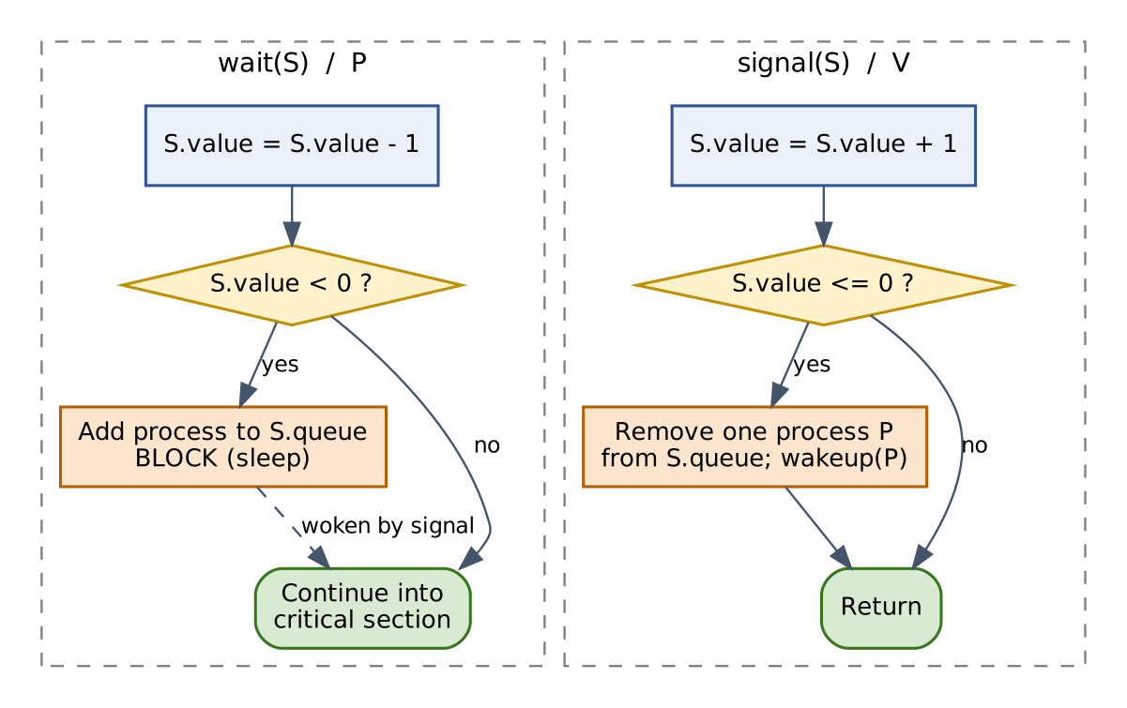
Figure 5 - Flowchart of wait(S) and signal(S)

5.5 Working example: bounded buffer (POSIX)
The producer-consumer problem needs both mutual exclusion (the buffer indices) and condition synchronization (do not produce into a full buffer; do not consume from an empty one). Three semaphores solve it: mutex (initial value 1), empty (initial value N) and full (initial value 0).
Listing 8 - Producer-consumer with three semaphores (tested: sum 1..20 = 210)
#include <semaphore.h>
#define N 8
int buf[N], in = 0, out = 0;
sem_t empty, full, mutex;

/* initialisation */
sem_init(&empty, 0, N); sem_init(&full, 0, 0); sem_init(&mutex, 0, 1);

void produce(int item) {
sem_wait(&empty); /* wait for a free slot */
sem_wait(&mutex); /* enter critical section */
buf[in] = item; in = (in + 1) % N;
sem_post(&mutex); /* leave critical section */
sem_post(&full); /* announce a new item */
}

int consume(void) {
sem_wait(&full);
sem_wait(&mutex);
int item = buf[out]; out = (out + 1) % N;
sem_post(&mutex);
sem_post(&empty);
return item;
}

Classic mistake
Swapping the two sem_wait calls in produce (taking mutex before empty) can deadlock: a producer holding the mutex sleeps on a full buffer while the consumer cannot enter to empty it. Order of acquisition matters.

5.6 Properties, strengths and weaknesses
Strengths | Weaknesses
Blocking wait: no CPU wasted while a process sleeps. | Low-level and error-prone: a forgotten signal or reversed order causes deadlock.
Works for any number of processes and threads. | No ownership: any thread can signal, so misuse is not detected.
Provides both mutual exclusion and signalling (counting resources). | Programmer must pair wait/signal manually; correctness is spread over the whole program.
Available everywhere: POSIX, Windows, Linux kernel; cross-process variants exist. | Priority inversion is possible (a low-priority holder blocks a high-priority waiter).
Strong semaphores guarantee bounded waiting. | Weak semaphores allow starvation; kernel entry costs time for very short critical sections.

Expected limitations of semaphores
Semaphores give no help in detecting deadlock, do not tie a lock to the data it protects, and make large programs hard to reason about. Expect bugs to appear only under specific interleavings, which makes them difficult to reproduce and test.

6. Monitors

6.1 Idea
A monitor is a module that encapsulates shared data together with the procedures that operate on it. The language guarantees that at most one thread is active inside the monitor at any time, so mutual exclusion is automatic and cannot be forgotten. For condition synchronization a monitor offers condition variables with two operations: wait (release the monitor and sleep) and signal/notify (wake a waiting thread).

6.2 Hoare versus Mesa semantics
Aspect | Hoare monitor (1974) | Mesa / Java style
After signal | Signaller yields; the woken thread runs at once | Signaller keeps running; woken thread is only made ready
Waiting pattern | if (!cond) wait(); is sufficient | while (!cond) wait(); is mandatory
Guarantee on wake-up | Condition is true when the waiter resumes | Condition may have changed again (spurious wake-ups possible)
Implementation cost | More context switches; harder to implement | Cheaper; used by Java, C#, POSIX threads, Python

6.3 Flowchart
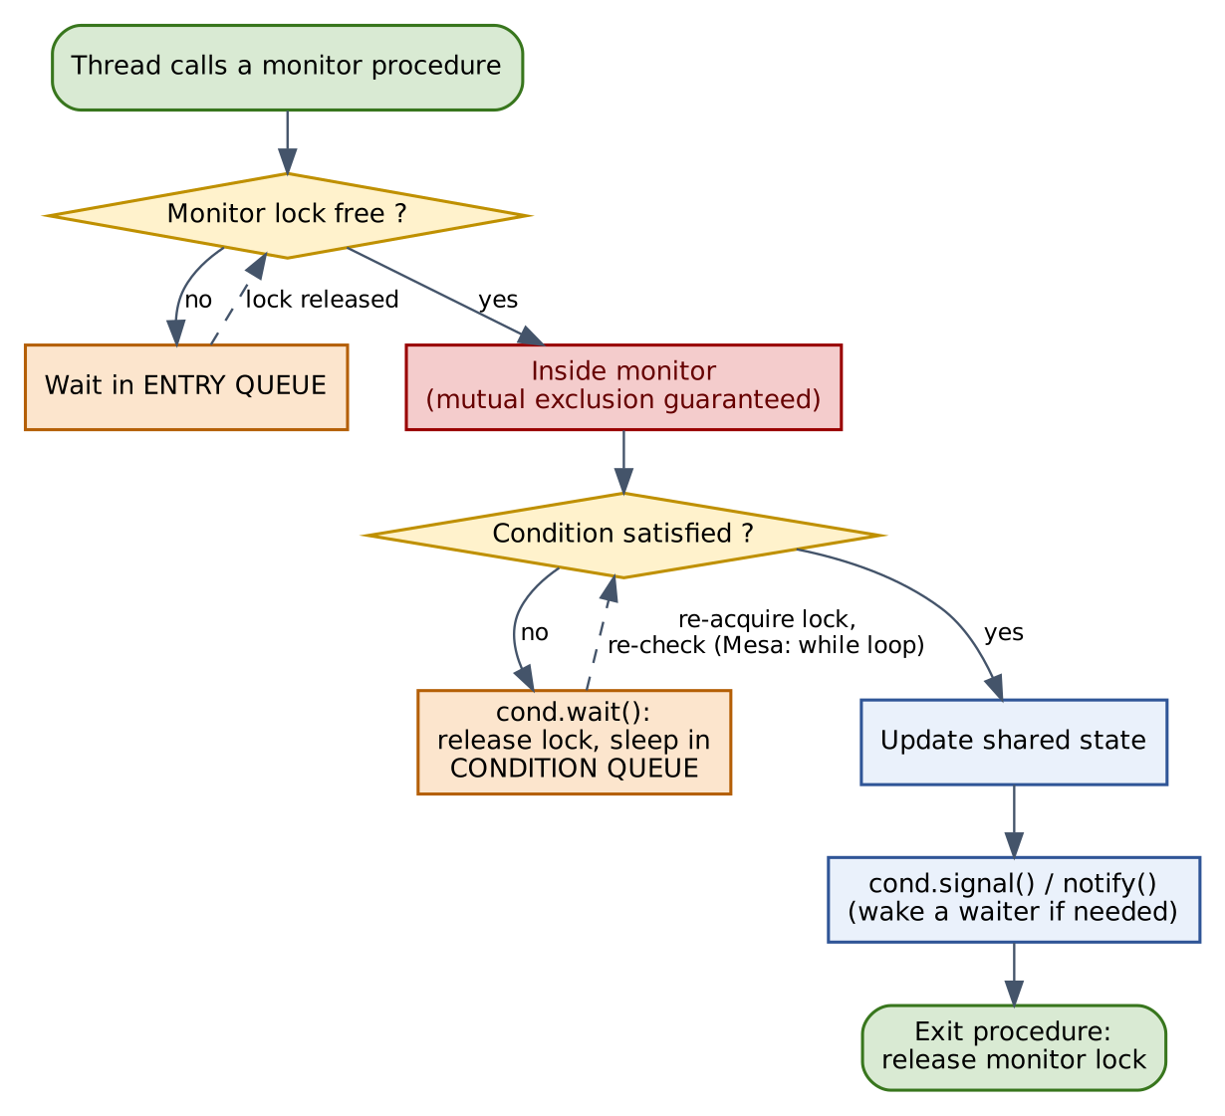
Figure 6 - Flow of a thread through a monitor (Mesa semantics)

6.4 Working example: bounded buffer (Java monitor)
Listing 9 - Bounded buffer as a Java monitor
public class BoundedBuffer {
private final int[] items;
private int in = 0, out = 0, count = 0;

public BoundedBuffer(int capacity) { items = new int[capacity]; }

public synchronized void put(int x) throws InterruptedException {
while (count == items.length) // Mesa semantics: always re-check
wait(); // releases the monitor lock
items[in] = x; in = (in + 1) % items.length; count++;
notifyAll(); // wake waiting threads
}

public synchronized int take() throws InterruptedException {
while (count == 0)
wait();
int x = items[out]; out = (out + 1) % items.length; count--;
notifyAll();
return x;
}
}

Compare Listing 9 with Listing 8: the monitor version has no explicit lock calls and no counters to pair up. The lock is acquired on entry to each synchronized method and released on exit, even if an exception is thrown. The condition logic is expressed as an ordinary boolean test on the protected data.

6.5 Properties, strengths and weaknesses
Strengths | Weaknesses
Mutual exclusion is automatic and structured; impossible to forget to unlock. | Needs language or library support (Java, C#, Python, C++ mutex + condvar).
Data and synchronization live together, which improves modularity and reasoning. | Nested monitor calls can deadlock ("nested monitor problem").
Condition variables express "wait until state X" naturally. | Spurious wake-ups and lost signals force the while loop pattern.
Blocking wait: no CPU waste; scales to many threads. | Coarse monitor locks serialise everything and can limit parallelism.
Compiler / runtime enforces correct usage; fewer human errors. | Fairness depends on the runtime: Java's intrinsic locks do not promise FIFO order.

Expected limitations of monitors
Monitors do not remove deadlock or starvation, restrict synchronization to one process address space unless built on OS primitives, and cannot express counting resources as directly as semaphores. A badly designed monitor with one big lock becomes a performance bottleneck.

7. Hardware and Memory-Model Considerations

7.1 Why textbook Peterson and Dekker can fail
Both software-only algorithms were designed under sequential consistency: every read and write happens in program order and all processors see the same global order. Modern CPUs and compilers do not provide this by default. Two effects matter:
- Compiler reordering and caching in registers: the compiler may keep turn or flag in a register, hoist reads out of the spin loop, or move a read above a write to a different address.
- Store-buffer reordering (e.g. x86-TSO): a CPU may let a later *load* complete before an earlier *store* becomes visible to other cores. Peterson's write flag[i] = true followed by the read of flag[j] is exactly the pattern that is affected.
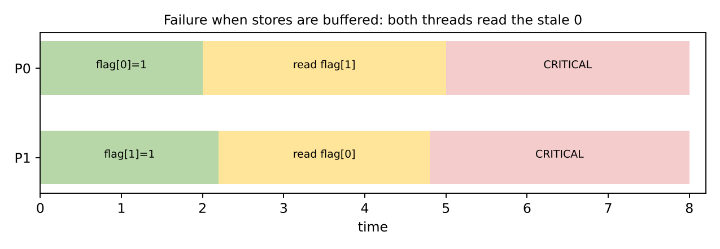
Figure 7 - Both threads read a stale value because each store sits in a store buffer
If this happens, both threads see the other's flag as false, both enter the critical section, and mutual exclusion is lost. The cure is to use sequentially consistent atomics (memory_order_seq_cst, the default in C11/C++11 and Java volatile) or to place a full memory fence between the store and the following load.

7.2 Broken versus fixed Peterson
Listing 10 - Why memory ordering matters
/* BROKEN on real hardware: plain variables, no ordering guarantees */
int flag[2]; int turn;
void lock(int i) {
flag[i] = 1; turn = 1 - i;
while (flag[1 - i] && turn == 1 - i) ; /* compiler may hoist the loads */
}

/* FIXED: sequentially consistent atomics (see Listing 5) */
atomic_bool flag[2]; atomic_int turn;
void lock(int i) {
atomic_store(&flag[i], 1);
atomic_store(&turn, 1 - i);
while (atomic_load(&flag[1 - i]) && atomic_load(&turn) == 1 - i) ;
}

7.3 Effect on semaphores and monitors
Semaphores and monitors are protected from this problem because their implementations include the required atomic instructions and memory barriers: acquiring and releasing a lock or semaphore act as acquire/release fences. This is one more reason why production code uses them instead of hand-written flag-and-turn protocols.

7.4 Busy waiting versus blocking
Dekker and Peterson spin: a waiting thread repeatedly reads shared memory. Spinning is cheap if the wait is shorter than a context switch, and wasteful otherwise. Blocking primitives (semaphores, monitors) pay a fixed cost for putting the thread to sleep and waking it later, but then use no CPU during the wait. The conceptual model below shows the break-even point.
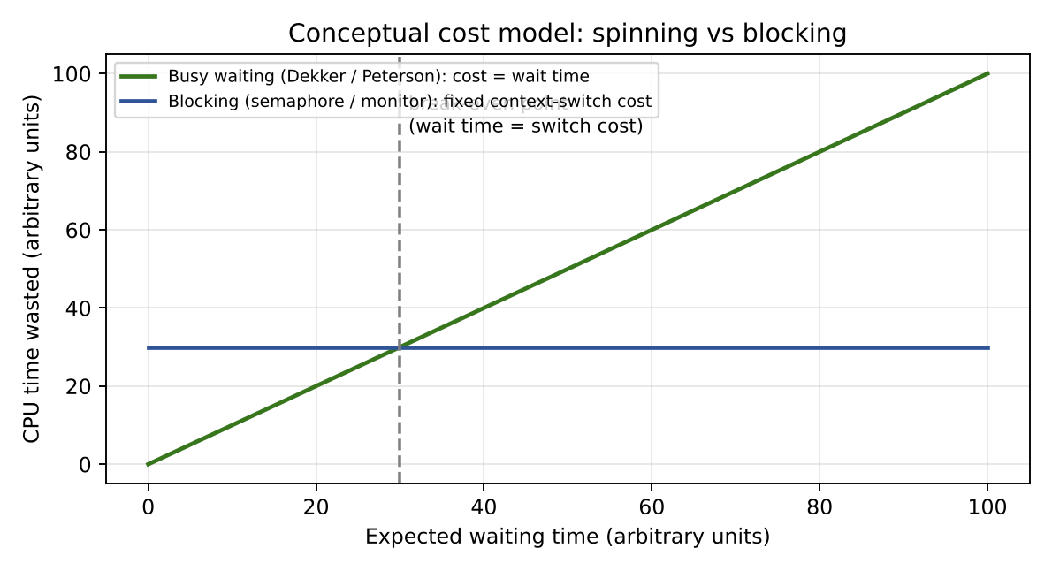
Figure 8 - Conceptual cost model: spinning grows with wait time, blocking has a fixed cost
On a single-core processor spinning is almost always harmful: the spinner occupies the only CPU while the lock holder cannot run. On multi-core hardware short spin phases are acceptable, which is why operating systems combine both (spin briefly, then sleep - "adaptive" or hybrid locks).

8. Side-by-Side Comparison

8.1 Core feature comparison
Feature | Dekker | Peterson | Semaphore | Monitor
Number of processes | 2 | 2 (N with filter lock) | Any N | Any N
Mechanism | flags + turn, back-off | flags + turn, yield | integer + wait queue | lock + condition queues
Waiting method | Busy waiting (spin) | Busy waiting (spin) | Blocking (sleep) | Blocking (sleep)
Level | Algorithm | Algorithm | OS / library primitive | Language construct
Atomic instruction needed | No (atomic loads/stores only) | No (atomic loads/stores only) | Yes, inside the kernel implementation | Yes, inside the runtime
OS support needed | None | None | Yes | Yes (or runtime)
Condition synchronization | No | No | Yes (counting, signalling) | Yes (condition variables)
Ownership of lock | Implicit per index | Implicit per index | None (any thread may signal) | Yes (holder only)
Cross-process use | Shared memory only | Shared memory only | Yes (named / shared semaphores) | Mostly within one process
Lines of code to use | About 15 | About 5 | 1 wait + 1 signal per use | 1 keyword (synchronized)

8.2 Correctness properties
Property | Dekker | Peterson | Semaphore | Monitor
Mutual exclusion | Yes | Yes | Yes | Yes
Progress | Yes | Yes | Yes | Yes
Bounded waiting | Yes (bound 1) | Yes (bound 1) | Depends: strong = yes, weak = no | Depends on runtime queue policy
Deadlock free by itself | Yes | Yes | No (wrong ordering deadlocks) | No (nested monitors deadlock)
Starvation free | Yes | Yes | Depends on semaphore kind | Depends on runtime
Needs sequential consistency | Yes | Yes | No (provides fences) | No (provides fences)
Safe against programmer misuse | Partial | Partial | Weak | Strong

8.3 Resource and performance behaviour
Aspect | Dekker | Peterson | Semaphore | Monitor
CPU use while waiting | High (spins) | High (spins) | None (sleeps) | None (sleeps)
Uncontended cost | Very low | Very low | Low (atomic op, maybe syscall) | Low (fast-path lock)
Cost under long contention | Very high | Very high | Moderate (context switches) | Moderate (context switches)
Memory footprint | 3 shared words | 3 shared words | 1 integer + queue | Lock + queues
Scalability to many threads | Poor | Poor (filter: worse) | Good | Good
Cache-line bouncing | Yes (shared flags and turn) | Yes (shared flags and turn) | Limited to the counter | Limited to the lock word
Behaviour on one core | Poor (spin wastes slice) | Poor (spin wastes slice) | Good | Good

8.4 Programmer effort and risk
Aspect | Dekker | Peterson | Semaphore | Monitor
Ease of learning | Hard | Medium | Medium | Easy
Ease of correct use | Hard | Medium | Hard at scale | Easy
Typical bug | Missing atomics or fences | Missing atomics or fences | Reversed order, lost signal | Wrong wait condition, if instead of while
Debuggability | Hard (timing) | Medium | Hard (distributed logic) | Medium (structured)
Tool support | Model checkers | Model checkers | Detectors, tracers | Language runtime, IDE

8.5 Charts
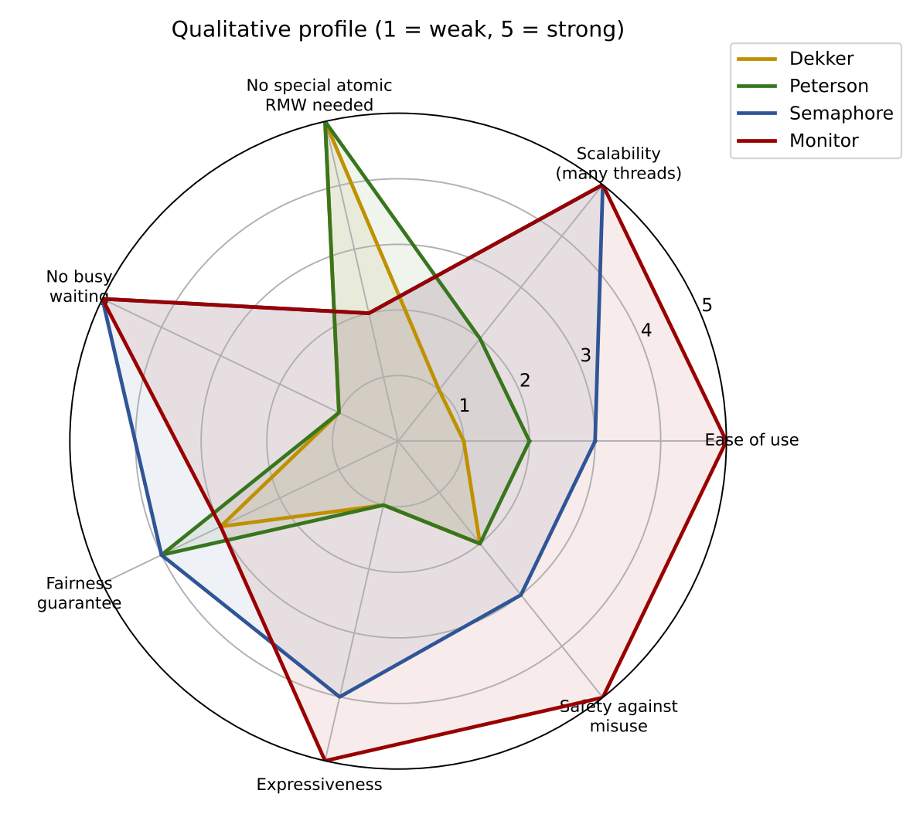
Figure 9 - Radar chart of qualitative scores across seven criteria
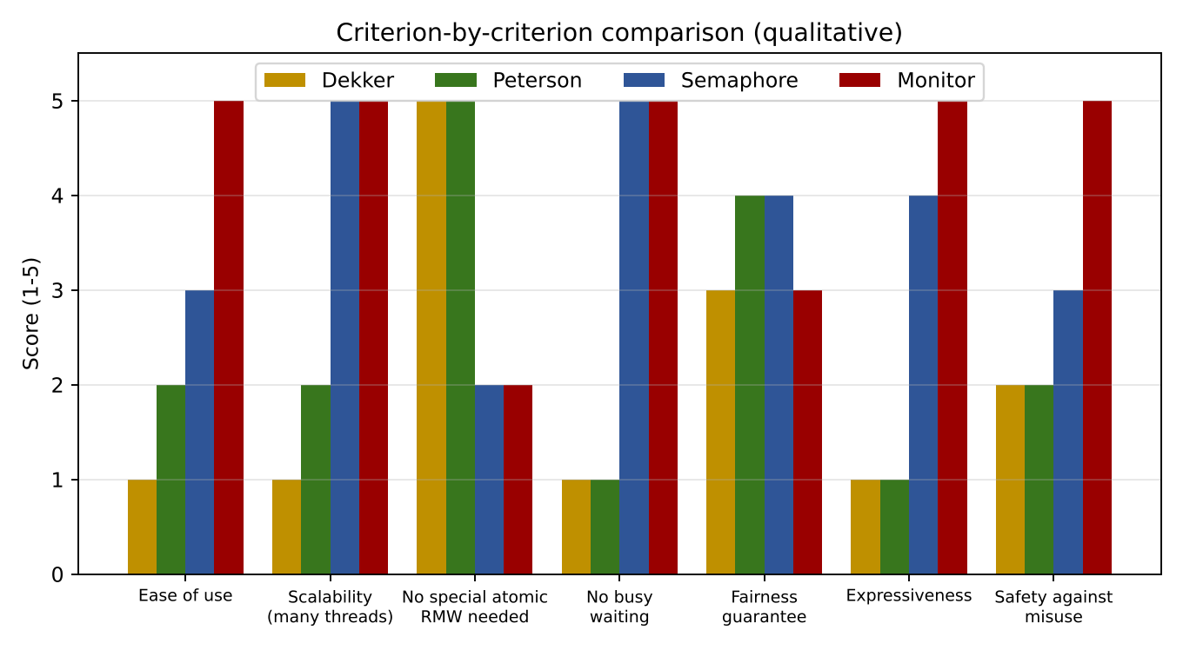
Figure 10 - Grouped bar chart of the same scores
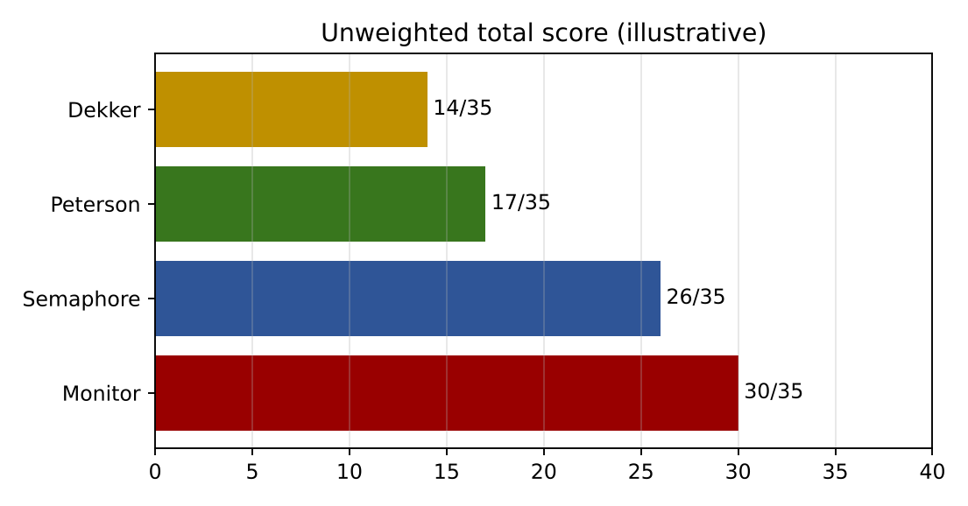
Figure 11 - Unweighted total scores
How to read the charts
The scores are a qualitative expert assessment on a 1-5 scale, not benchmark measurements. The totals weight all criteria equally; in a real project the weights depend on the requirements (for example, a kernel without atomics would weight "no special atomic instruction" much more heavily, and the ranking would change).

8.6 Mapping of the four techniques to classic problems
Problem | Dekker | Peterson | Semaphore | Monitor
Mutual exclusion of 2 threads | Yes | Yes | Yes | Yes
Mutual exclusion of N threads | No | Filter lock (slow) | Yes | Yes
Producer-consumer | No (no waiting condition) | No (no waiting condition) | Yes (3 semaphores) | Yes (wait / notify)
Readers-writers | No | No | Yes (with care) | Yes (natural)
Dining philosophers | No | No | Yes (needs deadlock avoidance) | Yes (state-based monitor)
Barrier / rendezvous | No | No | Yes | Yes
Resource pool with N units | No | No | Yes (counting semaphore) | Yes (counter + condition)

9. Strengths and Weaknesses at a Glance
Technique | Main strengths | Main weaknesses | Best described as
Dekker | No special hardware; first correct software solution; fair hand-over; mutual exclusion, progress and bounded waiting. | 2 processes only; complicated logic; busy waiting; needs sequential consistency. | A historical and theoretical milestone.
Peterson | Very simple; easy proof; bounded waiting of 1; generalisable (filter lock). | 2 processes in basic form; busy waiting; fails without atomics/fences; N-version is slow. | The cleanest teaching algorithm for mutual exclusion.
Semaphore | Blocking; any number of processes; counting; signalling; ubiquitous. | Low level; deadlock-prone; no ownership; priority inversion; scattered correctness. | A flexible, general-purpose OS primitive.
Monitor | Structured; automatic locking; condition variables; data encapsulation; fewer errors. | Needs language support; nested-monitor deadlock; coarse locking; runtime-dependent fairness. | The safest high-level abstraction.

9.1 What each technique does better than the others
- Dekker: shows that mutual exclusion is possible with only reads and writes, and its back-off scheme is a model for reasoning about turn-taking.
- Peterson: conveys the same fact in a few lines; it is the easiest algorithm to prove and to teach.
- Semaphore: the only one of the four that naturally counts resources and signals events between unrelated threads or processes.
- Monitor: the only one that binds locking to the protected data and lets the compiler enforce it, greatly reducing human error.

9.2 What each technique does worse
- Dekker and Peterson: cannot block, so they waste CPU; they do not scale; they are fragile on modern memory models.
- Semaphore: places the burden of correctness on the programmer, and a single misplaced call can freeze the whole system.
- Monitor: hides the mechanism, so performance problems (lock contention) are less visible, and it requires a language or library that supports it.

10. Expected Limitations and Common Pitfalls
The table below collects the limitations a reader should expect when applying each technique, the failure each one typically causes, and the standard mitigation.
Technique | Expected limitation | Typical failure | Mitigation
Dekker | Two threads only; sequential consistency assumed | Lost mutual exclusion on reordering hardware | Use atomics / fences; prefer hardware locks for production
Dekker | Spinning in nested loops | CPU saturation, slow progress on one core | Limit to short critical sections; yield inside the loop
Peterson | Two threads only; array indexed by id | Wrong thread ids break the algorithm | Assign fixed ids 0 and 1; use filter lock for N
Peterson | No fence between store and load | Both threads enter the critical section | memory_order_seq_cst or a full fence
Peterson | Unbounded spin when holder is preempted | Convoy / priority inversion | Disable preemption or use blocking locks
Semaphore | Order of wait calls | Deadlock | Fix a global acquisition order
Semaphore | Forgotten signal | Permanent blocking, resource leak | Pair wait/signal in one function; use RAII wrappers
Semaphore | No owner | Wrong thread releases the lock | Use a mutex when ownership is needed
Semaphore | Low-priority holder, high-priority waiter | Priority inversion | Priority inheritance protocol
Monitor | if instead of while before wait | Wrong state after spurious wake-up | Always re-check the condition in a loop
Monitor | Calling another monitor while holding one | Nested-monitor deadlock | Release before calling out; consistent lock order
Monitor | One lock for everything | Poor parallelism | Split the monitor; use finer-grained locks

10.1 Limitations shared by all four techniques
- They do not prevent deadlock in general. Each of them can be part of a deadlocked system when several locks or resources are involved.
- They do not guarantee freedom from priority inversion unless the operating system adds a protocol.
- They address mutual exclusion on one machine. Distributed mutual exclusion needs message-passing algorithms or a coordination service.
- Correctness is not compositional: two individually correct synchronized components may deadlock when combined.
- Testing is insufficient: interleaving bugs may appear once in millions of runs; formal reasoning and model checking are needed.

11. Selection Guide

11.1 Decision flowchart
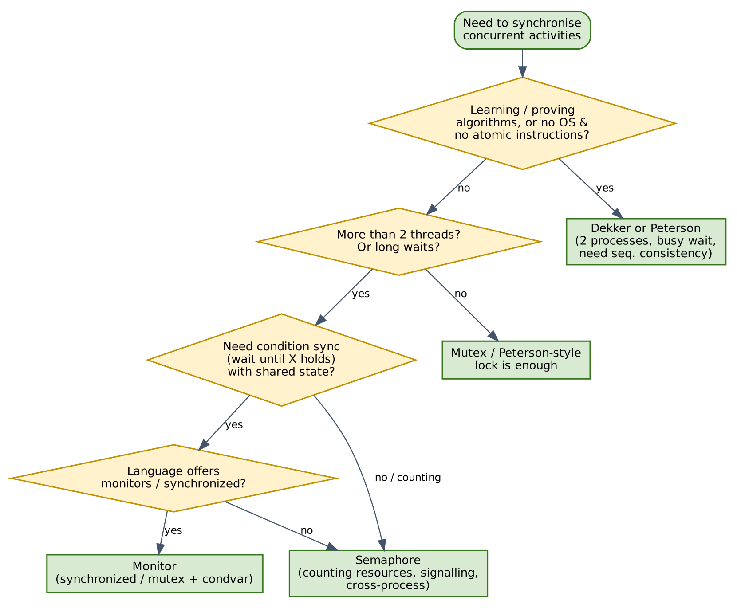
Figure 12 - Choosing a synchronization technique

11.2 Scenario table
Scenario | Recommended | Reason
University exercise on mutual exclusion | Peterson (then Dekker) | Short, provable, shows what hardware-free solutions look like.
Bare-metal code with no atomics, 2 contexts | Peterson (with fences) | Only loads and stores available; keep critical section tiny.
Limited pool of database connections | Counting semaphore | Native resource counting and blocking.
Producer-consumer pipeline in C | Semaphores or mutex + condvar | Both provide blocking; semaphores are concise for counting.
Shared object in Java / C# / Python | Monitor (synchronized, lock) | Automatic unlock, condition variables, fewer bugs.
Signalling between processes | Named / shared semaphore | Works across address spaces.
Very short critical section on a multicore | Spinlock based on atomic instruction | Faster than sleeping; do not use Peterson at scale.

12. Review Questions
- State the three requirements of the critical-section problem and explain how each of the four techniques satisfies them.
- Why does Dekker's algorithm need the inner loop that lowers wants[i]? What would go wrong if the process simply kept its flag raised?
- Prove mutual exclusion for Peterson's algorithm by contradiction.
- Explain why Peterson's algorithm may fail on x86 when plain variables are used. Which operation would you add?
- What is the difference between a strong and a weak semaphore? Which property does a strong semaphore guarantee?
- Construct a deadlock in the bounded-buffer solution by changing the order of two operations.
- Why must a Mesa-style monitor use while rather than if around wait?
- Under what circumstances is spinning better than blocking? Use Figure 8 in your answer.
- Which of the four techniques can implement a counting resource pool directly? Justify.
- Discuss why building higher-level primitives (semaphores, monitors) on top of lower-level ones is a good design principle.

13. Conclusion
Dekker's and Peterson's algorithms prove that mutual exclusion is achievable with nothing more than shared variables, and they remain unmatched as teaching tools: Dekker for historical depth, Peterson for clarity. Their busy waiting, two-process limit and dependence on sequential consistency keep them out of production systems.
Semaphores trade that fragility for generality. They block instead of spin, support any number of threads and can count resources and signal events, but they leave the discipline of pairing operations and ordering acquisitions entirely to the programmer.
Monitors raise the abstraction one level further. By binding the lock to the data and giving condition variables a clear meaning, they remove whole classes of errors, at the price of requiring language or library support and of hiding contention behind a single lock.
Bottom line
Use Peterson or Dekker to understand concurrency, semaphores to count and signal, and monitors (or mutex + condition variables) to build structured, maintainable shared objects. In practice, production systems rely on hardware atomics wrapped in the last two.

References
- Dijkstra, E. W. (1965). *Solution of a Problem in Concurrent Programming Control.* Communications of the ACM, 8(9), 569.
- Dijkstra, E. W. (1968). *Cooperating Sequential Processes.* In F. Genuys (ed.), Programming Languages. Academic Press.
- Hoare, C. A. R. (1974). *Monitors: An Operating System Structuring Concept.* Communications of the ACM, 17(10), 549-557.
- Brinch Hansen, P. (1973). *Operating System Principles.* Prentice Hall.
- Lampson, B. W., and Redell, D. D. (1980). *Experience with Processes and Monitors in Mesa.* Communications of the ACM, 23(2), 105-117.
- Peterson, G. L. (1981). *Myths About the Mutual Exclusion Problem.* Information Processing Letters, 12(3), 115-116.
- Lamport, L. (1974). *A New Solution of Dijkstra's Concurrent Programming Problem.* Communications of the ACM, 17(8), 453-455.
- Silberschatz, A., Galvin, P. B., and Gagne, G. *Operating System Concepts.* Wiley (chapters on process synchronization).
- Herlihy, M., and Shavit, N. *The Art of Multiprocessor Programming.* Morgan Kaufmann (filter lock, memory models).

Glossary
Term | Definition
Critical section | Code that accesses shared data and must not be executed by more than one thread at once.
Busy waiting | Repeatedly testing a condition in a loop while consuming CPU time.
Blocking | Suspending a thread in a queue until it is woken, using no CPU.
Starvation | A thread is denied progress indefinitely while others proceed.
Deadlock | Threads wait for each other in a cycle and none can continue.
Memory fence | Instruction that restricts reordering of memory operations.
Sequential consistency | Memory model in which operations appear in one global order that respects each thread's program order.
Condition variable | Queue on which threads wait inside a monitor until a state condition may hold.

