OPERATING SYSTEMS | PROCESS SCHEDULING & SYNCHRONIZATION
Implementation of the Fair Share Scheduling Algorithm Using a Combination of Monitor and Semaphore
and Its Comparison with the EDF and RM Real-Time Algorithms

Item | Description
Document type | Technical report - design, implementation, flowcharts, tables, charts and experimental comparison
Date | October 2026
Algorithms studied | Fair Share (hybrid monitor + semaphore implementation), Earliest Deadline First (EDF), Rate Monotonic (RM)
Implementation | Python 3: threading.Lock, threading.Condition (monitor) and threading.Semaphore (CPU token, grant and completion signals)
Evaluation method | Discrete-time simulation, 1 tick = 1 quantum; two workloads (normal U = 0.90, overload U = 1.225) and 150 random task sets per utilization level
Metrics | Arrival / start / exit times, waiting, turnaround and response time, lateness, deadline misses, context switches, group CPU share, Jain fairness index

Results at a glance
Measure | Fair Share | EDF | RM
Normal load - missed deadlines (of 20 jobs) | 1 | 0 | 0
Normal load - average waiting time (ticks) | 4.10 | 2.65 | 2.65
Normal load - context switches | 35 | 25 | 25
Overload - CPU share received by group C (entitled 0.15) | 0.15 | 0.00 | 0.00
Overload - Jain fairness index | 0.985 | 0.662 | 0.662
Overload - missed deadlines (of 20 jobs) | 10 | 2 | 3

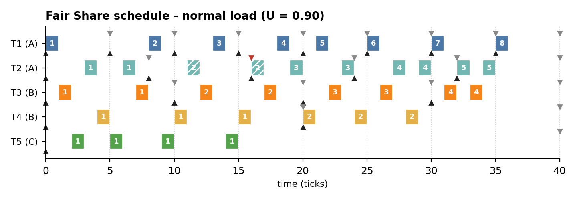
Figure 1: Fair Share schedule of the normal workload produced by the hybrid monitor + semaphore implementation.

1 Abstract, Objectives and Contents
This report designs, implements and evaluates a Fair Share CPU scheduler whose synchronization layer combines a monitor (a lock-protected object with condition variables that guards all shared scheduling state) and semaphores (a binary CPU token plus per-task start signals and an end-of-quantum signal). The scheduler is compared with two classical real-time policies, Earliest Deadline First (EDF) and Rate Monotonic (RM), on the same periodic workloads.
The hybrid design was executed with real threads in logical time, and its schedule was verified tick-by-tick against an independent discrete-time simulator for both a normal and an overloaded workload. The study reports per-job arrival, start and exit times, waiting, turnaround and response times, deadline misses, context switches, per-group CPU shares and Jain's fairness index.

Objectives
- Explain Fair Share scheduling: group entitlements, usage-based priorities and periodic usage decay.
- Design a hybrid synchronization architecture: the monitor protects state and expresses waiting; semaphores perform explicit hand-offs.
- Provide a complete, runnable implementation, a flowchart, a sequence diagram and correctness arguments.
- Define input workloads (arrival times, bursts, periods, deadlines, group weights) and report all entry and exit times.
- Compare Fair Share with EDF and RM quantitatively (tables, charts) and qualitatively under normal load and overload.

Contents
No. | Section | Page | No. | Section | Page
1 | Abstract, Objectives and Contents | 2 | 13 | Implementation, Part 2: Scheduler and Workers | 14
2 | Fundamentals of CPU and Real-Time Scheduling | 3 | 14 | Fair Share Results: Gantt Chart | 15
3 | The Fair Share Scheduling Algorithm | 4 | 15 | Fair Share Results: Input/Output Times | 16
4 | Fair Share Mathematics and a Worked Trace | 5 | 16 | EDF: Earliest Deadline First | 17
5 | Semaphores vs. Monitors | 6 | 17 | RM: Rate Monotonic | 18
6 | Hybrid Monitor + Semaphore Architecture | 7 | 18 | EDF and RM Schedules | 19
7 | System Model, Assumptions, Data Structures | 8 | 19 | Entry/Exit Times of All Algorithms | 20
8 | Input Workloads: Tasks and Arrival Times | 9 | 20 | Normal-Load Comparison | 21
9 | Experimental Setup and Evaluation Metrics | 10 | 21 | Overload Comparison | 22
10 | Flowchart of the Hybrid Fair Share Algorithm | 11 | 22 | Utilization Sweep and Fairness | 23
11 | Thread Interaction Protocol | 12 | 23 | Qualitative Comparison and Guidelines | 24
12 | Implementation, Part 1: Job and Monitor | 13 | 24 | Conclusions, Future Work, References | 25

Where to find each element of the study
Element | Location in this report
Algorithm features (tables) | Pages 4 (Fair Share), 17 (EDF), 18 (RM), 24 (side-by-side)
Input times: arrival, burst, period, deadline | Pages 9, 16 and 20
Output times: start, exit, waiting, turnaround, response | Pages 16 and 20
Flowcharts | Pages 11 (Fair Share), 17 (EDF), 18 (RM)
Architecture, state and sequence diagrams | Pages 7, 8 and 12
Source code (monitor + semaphore) | Pages 13 and 14
Charts (Gantt, bars, lines) | Pages 15, 16, 19, 20, 21, 22 and 23
Quantitative and qualitative comparison | Pages 21, 22, 23 and 24

2 Fundamentals of CPU and Real-Time Scheduling
A scheduler decides which ready job receives the processor at each instant. In a periodic real-time model every task releases a job every P ticks; each job needs C ticks of CPU and must finish before its deadline. Scheduling algorithms differ in what they optimise: deadline compliance (EDF, RM) or fairness among users (Fair Share).

Terminology and symbols used throughout the report
Term | Symbol | Definition
Arrival (release) time | r | Instant at which a job becomes ready; for task Ti the k-th job arrives at (k-1)·Pi
Burst time / WCET | C | CPU time (ticks) the job needs to complete
Period | P | Interval between two consecutive releases of the same task
Absolute deadline | d | d = r + D; here D = P (implicit deadline)
Start time | s | First tick at which the job runs on the CPU
Exit (finish) time | f | Instant at which the job completes (end of its last quantum)
Response time | s - r | Delay until the job first obtains the CPU
Waiting time | f - r - C | Time spent ready but not running
Turnaround time | f - r | Total time from arrival to exit
Lateness | f - d | Positive value means a deadline miss
Utilization | U | U = sum of Ci / Pi over all tasks
Hyperperiod | H | H = lcm(P1,...,Pn); the schedule repeats every H ticks
Quantum / tick | q | Smallest scheduling unit; decisions are taken at every tick (preemption)

Three families of algorithms compared in this report
Family | Algorithm | Priority | Primary objective
Proportional share | Fair Share | Dynamic: recomputed every tick from CPU usage | Give each user group its entitled fraction of the CPU
Dynamic-priority real-time | EDF | Dynamic: earliest absolute deadline of each job | Maximise schedulable utilization (optimal for U <= 1)
Static-priority real-time | RM | Static: shorter period = higher priority | Predictable, analysable deadline guarantees

Why compare them? EDF and RM know about deadlines but know nothing about owners; Fair Share knows about owners but nothing about deadlines. The comparison exposes the central trade-off between timeliness and fairness.

Scheduling criteria and where each algorithm stands in this study
Criterion | Goal | Best performer in the experiments
CPU utilization | Keep the CPU busy | All three are work-conserving (0.90 busy in the normal load)
Waiting / turnaround time | Minimise | EDF and RM (waiting 2.65 vs 4.10 for Fair Share)
Response time | Minimise delay to first run | EDF / RM (1.50 vs 1.70), Fair Share close
Deadline compliance | Zero deadline misses | EDF and RM (0 misses vs 1 for Fair Share)
Fairness between groups | Serve groups in proportion to weights | Fair Share (Jain 0.985 vs 0.662 in overload)
Overhead | Few context switches | EDF and RM (25 vs 35)

Preemptive vs. non-preemptive. All three algorithms are evaluated in their preemptive form: a running job can be replaced at any tick boundary. Preemption is essential for EDF and RM (urgent jobs must not wait for long ones) and for Fair Share (priorities change every tick).

3 The Fair Share Scheduling Algorithm
Fair Share scheduling (Henry, 1984; Kay and Lauder, 1988) allocates CPU time to groups of processes (for example users, departments or tenants) instead of to individual processes. If user A runs ten processes and user B runs one, a process-level round-robin would give A about 91% of the CPU; Fair Share instead gives each group the share its administrator assigned, independent of how many processes the group starts.

How it works
- Every group k has a static weight W_k (its entitlement), e.g. A = 0.40, B = 0.35, C = 0.25 in this study.
- The scheduler records how much CPU each process (CPU_j) and each group (GCPU_k) has consumed recently.
- At every tick the job with the lowest priority value P = CPU_j/2 + GCPU_k/(4·W_k) runs; heavy users therefore drift to the back of the line.
- At a fixed interval all usage counters are halved (decay), so old consumption is gradually forgotten and nobody starves.

Main features
Feature | Description
Group-level entitlement | The unit of fairness is the group; one group cannot take CPU from another by creating more processes.
Usage-based dynamic priority | Priority is recomputed every tick from consumed CPU time - not from deadlines or periods.
Usage decay | Exponential forgetting (divide by 2 every 4 ticks) keeps priorities bounded and the policy starvation-free.
Work-conserving | Unused entitlement is redistributed: if group C needs only 10% of the CPU, groups A and B share the rest.
Isolation | Overload by one group degrades mainly that group; others keep (close to) their entitlement.
Overhead | Higher than RM/EDF: per-tick priority recomputation, usage accounting and frequent preemption.
Deadline awareness | None. Deadlines can be missed even when U < 1 because the CPU order ignores urgency.

Typical application areas
- Multi-user time-sharing servers and university compute clusters.
- Multi-tenant cloud and container platforms (CPU shares / weights, e.g. Linux CFS group scheduling).
- Batch farms where departments purchase a guaranteed percentage of the machine.

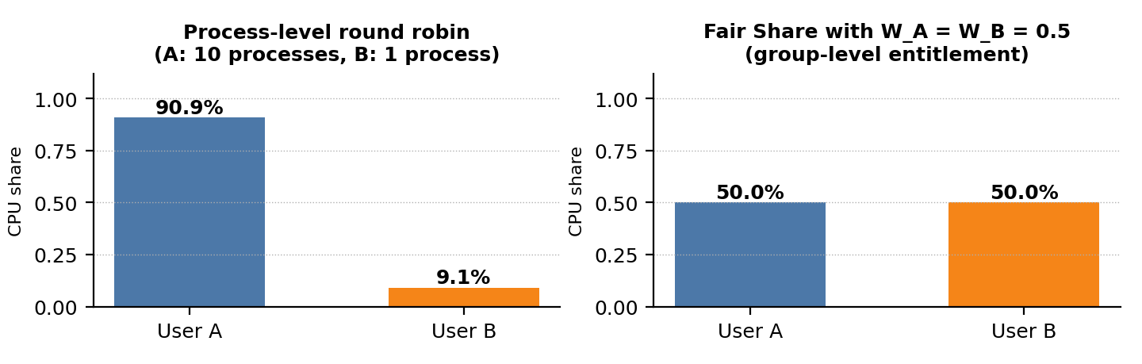
Figure A: Why group-level entitlement matters - user A starts 10 processes, user B only one.
Advantages: fair division between owners, protection against process-flooding, simple administrative model (weights). Limitations: no deadline guarantee, higher overhead, entitlements must be tuned.

4 Fair Share Mathematics and a Worked Trace

Priority, decay and fairness formulas
Priority (lower value runs first): P_j(t) = CPU_j(t) / 2 + GCPU_k(t) / ( 4 · W_k )
Usage update (job j of group k runs one tick): CPU_j <- CPU_j + 1, GCPU_k <- GCPU_k + 1
Decay (every Td = 4 ticks): CPU_j <- CPU_j / 2, GCPU_k <- GCPU_k / 2
Tie-break: earlier arrival first, then smaller task id. Entitlement: E_k = W_k / sum of W of active groups (max-min with demand cap)
Jain's fairness index: J = ( sum s_g )^2 / ( n · sum s_g^2 ), s_g = CPU received by group g / CPU demanded by group g

The group term is divided by 4·W_k, so a group with a large weight accumulates priority penalty more slowly and is chosen more often. The process term CPU_j/2 separates jobs inside a group. J equals 1 when every group is served in proportion to its demand and tends to 1/n when one group takes everything.

Worked trace: first 8 ticks of the normal workload
All five tasks release their first job at t = 0. The table shows the priority value of the oldest ready job of each task (lowest wins) and the group usage after the tick. Weights: W_A = 0.40, W_B = 0.35, W_C = 0.25.
Tick | Priority values P of ready jobs | Runs | Group usage after tick
0 | T1.1=0.000 T2.1=0.000 T3.1=0.000 T4.1=0.000 T5.1=0.000 | T1.1 | A=1.00 B=0.00 C=0.00
1 | T2.1=0.625 T3.1=0.000 T4.1=0.000 T5.1=0.000 | T3.1 | A=1.00 B=1.00 C=0.00
2 | T2.1=0.625 T3.1=1.214 T4.1=0.714 T5.1=0.000 | T5.1 | A=1.00 B=1.00 C=1.00
3 | T2.1=0.625 T3.1=1.214 T4.1=0.714 T5.1=1.500 | T2.1 | A=1.00 B=0.50 C=0.50
4 | T2.1=0.875 T3.1=0.607 T4.1=0.357 T5.1=0.750 | T4.1 | A=1.00 B=1.50 C=0.50
5 | T1.2=0.875 T2.1=0.875 T3.1=1.321 T4.1=1.571 T5.1=0.750 | T5.1 | A=1.00 B=1.50 C=1.50
6 | T1.2=0.875 T2.1=0.875 T3.1=1.321 T4.1=1.571 T5.1=2.250 | T2.1 | A=2.00 B=1.50 C=1.50
7 | T1.2=1.500 T3.1=1.321 T4.1=1.571 T5.1=2.250 | T3.1 | A=1.00 B=1.25 C=0.75

Reading the trace. Tick 0: all priorities are 0, the tie-break picks T1.1. Tick 1: group A now has usage 1, so T2 gets P = 1/(4·0.40) = 0.625 and T3 (group B, usage 0) wins. Tick 2: T5 (group C) wins for the same reason. The scheduler rotates between groups - this interleaving is the source of Fair Share's fairness and also of its higher context-switch count. At tick 4 (t+1 = 4) every counter is halved.

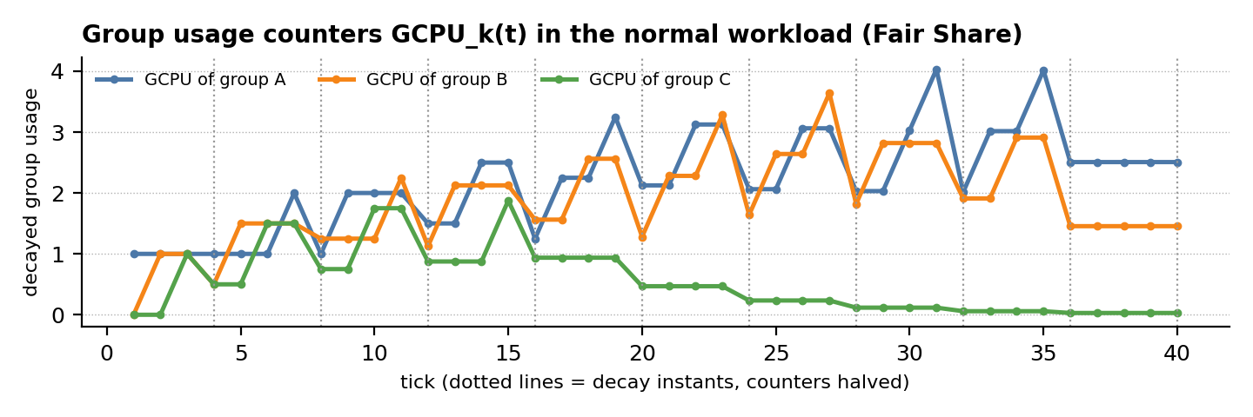
Figure B: Decayed group usage counters - they rise while a group runs and are halved every 4 ticks.

5 Semaphores vs. Monitors
Both primitives solve mutual exclusion and synchronization, but at different levels of abstraction. Dijkstra's semaphore (1965) is an integer with two atomic operations, P (wait) and V (signal). Hoare's monitor (1974) is a language-level construct that encapsulates shared data, the procedures that access it, and condition variables - only one thread can be active inside the monitor at a time.
Aspect | Semaphore | Monitor
Abstraction level | Low-level counter with P / V | High-level object: data + procedures + conditions
Mutual exclusion | Programmer must bracket every critical section with P/V | Automatic: only one thread inside entry procedures
Condition synchronization | Counting / signalling through the semaphore value | Condition variables: wait(), notify(), notify_all() with a predicate
Memory of signals | Yes - a V before a P is remembered (counter) | No - a notify with no waiter is lost (predicate must be re-checked)
Error proneness | High: forgotten V, wrong order, deadlock | Lower: structure enforces access discipline
Data encapsulation | None - data and lock are separate | Strong - state is private to the monitor
Typical Python object | threading.Semaphore | threading.Lock + threading.Condition (class with methods)
Best used for | Resource tokens, hand-off / rendezvous between threads | Complex shared state with invariants and wait predicates

Why combine them for Fair Share?
- State needs a monitor. Priorities depend on several shared variables (per-job usage, per-group usage, ready list, weights). Keeping them behind one lock and three entry procedures (release, select, charge) makes every update atomic and preserves the invariant that counters and ready list are always consistent.
- Hand-offs need semaphores. The dispatcher must wake exactly one worker per quantum and then wait for that quantum to end. A per-task grant[i] semaphore and a tick_done semaphore express this naturally and never lose a signal, even if the worker has not reached its P() yet.
- The CPU is a resource. A binary semaphore cpu (initial value 1) models the single processor and guarantees that at most one job executes at any instant.
- Waiting on a predicate needs a condition variable. The main thread blocks on the monitor condition all_done until no pending job remains.

Design rule used in this project: protect data with the monitor, coordinate threads with semaphores. The two mechanisms never hold each other's resources while blocking, which prevents deadlock (argued on page 12).

Same hand-off, two styles (Python)
Semaphore style - a signal is remembered, so the dispatcher may call release() before the worker reaches acquire():
grant = threading.Semaphore(0) # dispatcher -> worker
done = threading.Semaphore(0) # worker -> dispatcher
def dispatcher(): grant.release(); done.acquire()
def worker(): grant.acquire(); run_one_quantum(); done.release()

Monitor style - state and predicate are encapsulated; the waiter re-checks the predicate after every wake-up:
class QuantumMonitor:
def __init__(self):
self.cv = threading.Condition(); self.granted = False
def grant(self):
with self.cv: self.granted = True; self.cv.notify()
def wait_grant(self):
with self.cv: self.cv.wait_for(lambda: self.granted); self.granted = False

The semaphore version is shorter but cannot protect the priority counters; the monitor scales to compound state.

6 Hybrid Monitor + Semaphore Architecture
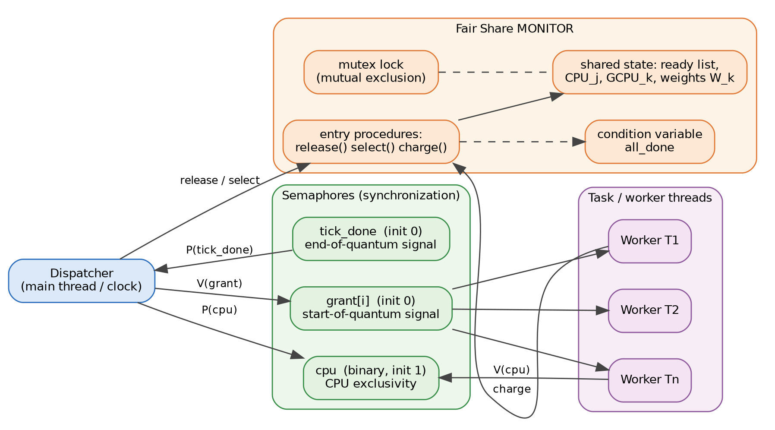
Figure 2: Components of the hybrid Fair Share scheduler. Orange = monitor, green = semaphores, purple = worker threads, blue = dispatcher.
Component | Kind | Initial value | Responsibility
Mutex lock | Monitor | unlocked | Guarantees one thread at a time inside the monitor entry procedures
Shared state | Monitor | empty / 0 | Ready list, CPU_j per task, GCPU_k per group, weights W_k, pending-job counter
release(job) | Entry procedure | - | Insert an arriving job into the ready list
select() | Entry procedure | - | Compute P for every ready job and return the one with the lowest value
charge(job, t) | Entry procedure | - | Account one quantum, detect completion, apply decay, notify all_done
all_done | Condition variable | predicate: pending = 0 | Lets the main thread wait until every job has finished
cpu | Binary semaphore | 1 | Models the single CPU: acquired by the dispatcher, released by the worker
grant[i] | Semaphore per task | 0 | Dispatcher signals worker Ti to run exactly one quantum
tick_done | Counting semaphore | 0 | Worker signals the dispatcher that the quantum has ended
Dispatcher | Main thread | - | Logical clock: releases arrivals, selects a job, performs P(cpu), V(grant), P(tick_done)
Worker Ti | Thread | - | Blocks on P(grant[i]); executes a quantum via charge(); then V(cpu), V(tick_done)

Layering. Dispatcher and workers never touch scheduler state directly; every access goes through the monitor. The monitor never blocks on a semaphore while holding its lock, so lock and semaphores form a strict acquisition order (cpu -> grant -> monitor lock).

7 System Model, Assumptions and Data Structures

Assumptions
- Single processor; the CPU can run one job per tick. Time is logical and discrete: 1 tick = 1 quantum.
- Periodic tasks with implicit deadlines (D = P), known execution time C and constant period P; all tasks start at t = 0.
- Preemption is allowed at every tick boundary; context-switch time is zero but switches are counted.
- A job that misses its deadline keeps running until completion (soft handling) so that lateness can be measured.
- Group membership and weights are static: A = {T1, T2} with W = 0.40, B = {T3, T4} with W = 0.35, C = {T5} with W = 0.25.

Data structures
Structure | Field | Type | Meaning
Job | task, group, idx | str, str, int | Owner task, owner group and job number (name = task.idx, e.g. T2.3)
Job | release, burst, deadline | int | Arrival time r, CPU demand C, absolute deadline d = r + P
Job | remaining, start, finish | int / None | Ticks left, first-run tick, completion tick (exit time)
FairShareMonitor | proc_cpu[task] | float | Decayed CPU usage CPU_j of each task
FairShareMonitor | grp_cpu[group] | float | Decayed CPU usage GCPU_k of each group
FairShareMonitor | ready, pending | list, int | Jobs eligible to run; number of unfinished jobs
FairShareMonitor | weights, decay_every | dict, int | Entitlements W_k; decay period Td = 4 ticks
FairShareScheduler | cpu, grant, tick_done | Semaphore | Synchronization objects described on page 7
FairShareScheduler | assign, timeline | dict, list | Job handed to each worker; resulting schedule (one entry per tick)

Per-decision cost (n = number of ready jobs)
Algorithm | Decision cost | Comment
Fair Share (this work) | O(n) per tick | Priority of every ready job recomputed; O(g) with per-group queues; plus O(tasks + groups) at decay
EDF | O(log n) (heap) | Ready queue ordered by absolute deadline; O(n) with a plain list
RM | O(1) - O(log n) | Static priorities; a priority bitmap gives constant-time selection

Life cycle of a job
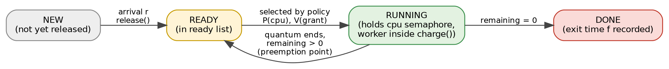
Figure C: State diagram of a job; the READY -> RUNNING decision is where the three policies differ.

Invariants guarded by the monitor
No. | Invariant | Maintained by
I1 | pending = number of jobs in the ready list | release() increments, charge() decrements on completion
I2 | A job is in the ready list if and only if remaining > 0 | charge() removes the job when remaining reaches 0
I3 | GCPU_k = sum of CPU_j over the tasks of group k | both counters are incremented and halved together
I4 | At most one quantum is charged per tick | binary semaphore cpu and the tick_done hand-shake

8 Input Workloads: Tasks, Arrival Times and Group Weights

Workload 1 - normal load (U = 0.90)
Task | Group | C (burst) | P (period) | D (deadline) | U = C/P | Arrival times r (ticks) within [0, 40)
T1 | A | 1 | 5 | 5 | 0.20 | 0, 5, 10, 15, 20, 25, 30, 35
T2 | A | 2 | 8 | 8 | 0.25 | 0, 8, 16, 24, 32
T3 | B | 2 | 10 | 10 | 0.20 | 0, 10, 20, 30
T4 | B | 3 | 20 | 20 | 0.15 | 0, 20
T5 | C | 4 | 40 | 40 | 0.10 | 0
Total |  |  |  |  | 0.90 | 20 jobs in the hyperperiod H = 40

Group weights and demand
Group | Weight W | Member tasks | Demand (normal) | Entitlement (normal)
A | 0.40 | T1, T2 | 0.45 | 0.45
B | 0.35 | T3, T4 | 0.35 | 0.35
C | 0.25 | T5 | 0.10 | 0.10

Workload 2 - overload (U = 1.225), same periods and groups
Task | Group | C (burst) | P (period) | U = C/P | Change vs. workload 1
T1 | A | 1 | 5 | 0.20 | unchanged
T2 | A | 3 | 8 | 0.38 | increased
T3 | B | 3 | 10 | 0.30 | increased
T4 | B | 4 | 20 | 0.20 | increased
T5 | C | 6 | 40 | 0.15 | increased
Total |  |  |  | 1.225 | U > 1 : overload
Group demands under overload: A = 0.575, B = 0.500, C = 0.150; weight-based entitlements (max-min, demand-capped): A = 0.453, B = 0.397, C = 0.150.
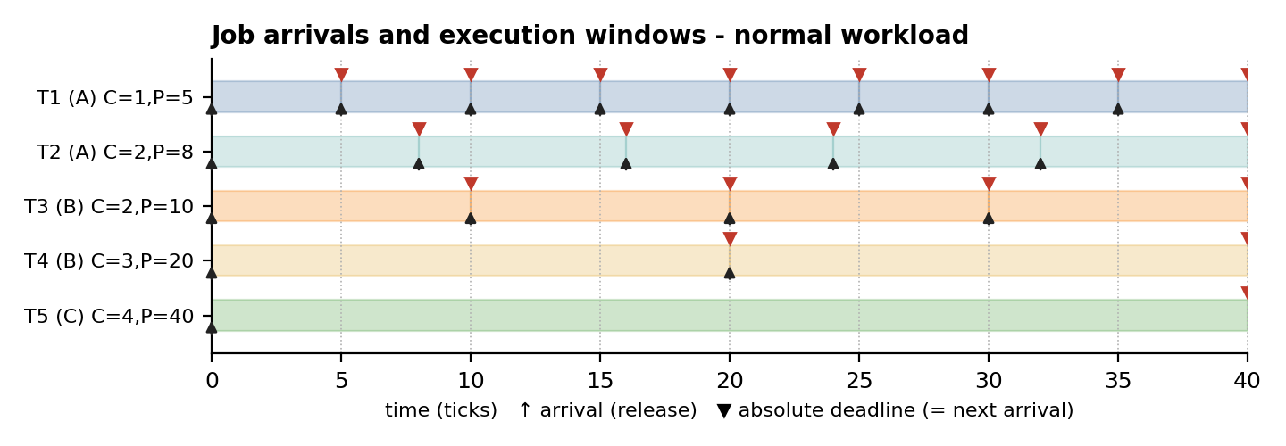
Figure 3: Arrival (up arrow) and absolute deadline (red triangle) of every job of the normal workload; shaded boxes show execution windows.

Derived quantities
Quantity | Normal (U = 0.90) | Overload (U = 1.225) | Remark
Total CPU demand in the 40-tick window | 36 ticks | 49 ticks | capacity = 40 ticks
Idle ticks if all work is done by t = 40 | 4 | 0 (9 ticks backlog) | backlog is drained after t = 40
Jobs per task T1 / T2 / T3 / T4 / T5 | 8 / 5 / 4 / 2 / 1 | 8 / 5 / 4 / 2 / 1 | 20 jobs in total
Demand per group A / B / C | 0.450 / 0.350 / 0.100 | 0.575 / 0.500 / 0.150 | fraction of the CPU

9 Experimental Setup and Evaluation Metrics

Simulation parameters
Parameter | Value
Time model | Discrete logical time; 1 tick = 1 quantum; preemption possible at every tick
Observation window | Hyperperiod H = lcm(5, 8, 10, 20, 40) = 40 ticks; after t = 40 no new jobs are released, but unfinished jobs are drained so that exit times are known
Fair Share parameters | Weights A/B/C = 0.40/0.35/0.25; usage decay: halve all counters every 4 ticks; tie-break: earlier arrival, then task id
EDF / RM tie-break | Smaller task id (deterministic)
Workloads | (1) normal: U = 0.90, 20 jobs; (2) overload: U = 1.225, 20 jobs
Random task sets | 150 sets per utilization level 0.5 ... 1.3 (step 0.1); UUniFast utilization split; periods {5, 8, 10, 20, 40}; C rounded to integers; accepted if actual U is within ±0.04 of the target
Verification | Hybrid threaded scheduler vs. independent simulator: identical Fair Share timelines on both workloads (page 14)

Metrics
Metric | Definition | Interpretation
Arrival r / start s / exit f | Recorded per job (ticks) | Raw input and output times of the schedule
Response time | s - r | Responsiveness; small = interactive feel
Waiting time | f - r - C | Time lost in the ready queue
Turnaround time | f - r | Total residence time
Lateness / miss | f - d; miss if f > d | Timeliness; deadline-miss ratio = misses / jobs
Context switches | Number of changes of running job (idle gaps excluded) | Overhead of preemption
Group CPU share | Ticks used by group in [0, 40) / 40 | Compared with entitlement E_k
Jain index J | (sum s_g)^2 / (n · sum s_g^2), s_g = received / demand | 1 = perfectly proportional service

Fairness vs. timeliness. A policy can be perfectly timely yet unfair (EDF/RM serve the most urgent tasks first, even if that means a group receives nothing) or perfectly fair yet untimely (Fair Share). The metrics above measure both sides, so neither policy is judged on one axis only.

Experimental pipeline
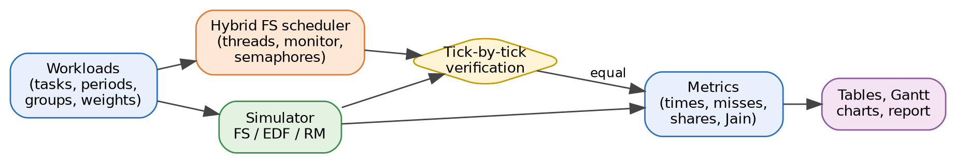
Figure D: Workflow of the experiments - both the threaded scheduler and the simulator are fed with the same workloads and compared.

10 Flowchart of the Hybrid Fair Share Algorithm
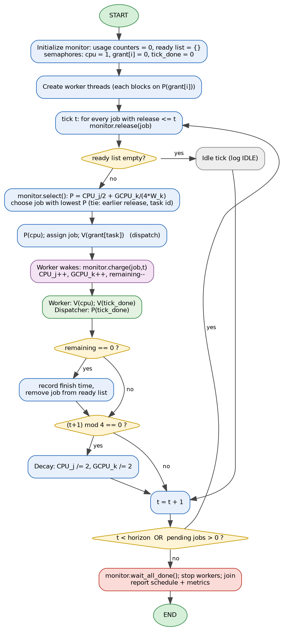  Figure 4: Flowchart of the hybrid Fair Share scheduler. | Step-by-step walkthrough  - Initialise the monitor (usage counters 0, empty ready list) and the semaphores (cpu = 1, grant[i] = 0, tick_done = 0).  - Create workers. Each task thread immediately blocks on P(grant[i]).  - Release arrivals. At tick t every job with r <= t is inserted by monitor.release().  - Idle check. If the ready list is empty the tick is idle and time advances.  - Select. Inside the monitor compute P = CPU_j/2 + GCPU_k/(4·W_k) for every ready job; the minimum wins.  - Dispatch. P(cpu) takes the CPU token, the job is assigned and V(grant[task]) wakes its worker.  - Execute. The worker calls monitor.charge(): usage counters grow, remaining decreases.  - Hand back. Worker performs V(cpu) and V(tick_done); the dispatcher's P(tick_done) returns.  - Completion. If remaining = 0 the exit time f = t + 1 is stored and the job leaves the ready list.  - Decay. When (t+1) mod 4 = 0 all usage counters are halved; then t is incremented.  - Loop or stop. Repeat while t < horizon or jobs are pending; finally wait_all_done(), stop and join the workers.

11 Thread Interaction Protocol and Correctness
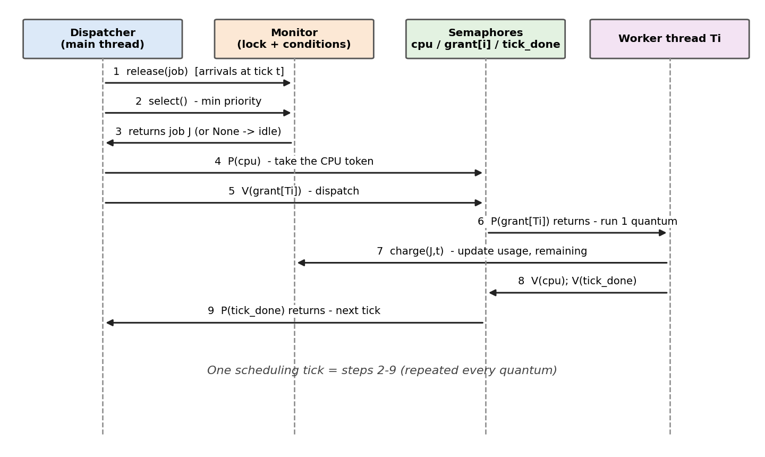
Figure 5: Message sequence of one scheduling tick between dispatcher, monitor, semaphores and a worker thread.

Correctness arguments
Property | Argument
Mutual exclusion on the CPU | Binary semaphore cpu (initial 1): the dispatcher performs P(cpu) before granting, and only the worker's V(cpu) re-opens it, so at most one job runs per tick.
Atomic scheduler state | Every read/write of usage counters and the ready list happens inside release(), select() or charge(), all guarded by the monitor lock.
No lost wake-up | grant[i] and tick_done are counting semaphores; a V performed before the matching P is remembered, so no signal is lost.
Deadlock freedom | Acquisition order is cpu -> grant -> monitor lock. The monitor never waits on a semaphore while holding its lock; the dispatcher never holds the lock while blocked on tick_done.
Progress / termination | Every dispatched quantum reduces some job's remaining time by 1; after all jobs finish, pending = 0, all_done is notified and the workers are released and joined.
Starvation freedom | Decay halves usage periodically, so the priority penalty of a heavily served job is bounded and waiting jobs eventually obtain the minimum P.

Result: the schedule is deterministic (only one worker runs at a time and the dispatcher chooses the job), which is why the threaded implementation can be compared tick-by-tick with the single-threaded simulator.

Worked example: semaphore values during ticks 0 and 1 (initially cpu = 1, all others 0)
Tick | Operation | cpu | grant[T1] | grant[T3] | tick_done | Effect
0 | select() -> T1.1 (all P = 0, tie-break) | 1 | 0 | 0 | 0 | no state change
0 | dispatcher: P(cpu) | 0 | 0 | 0 | 0 | CPU token taken
0 | dispatcher: V(grant[T1]) | 0 | 1 | 0 | 0 | worker T1 may run
0 | worker T1: P(grant[T1]); charge(T1.1, 0) | 0 | 0 | 0 | 0 | T1.1 finishes, f = 1
0 | worker T1: V(cpu); V(tick_done) | 1 | 0 | 0 | 1 | CPU free, tick done
0 | dispatcher: P(tick_done) | 1 | 0 | 0 | 0 | moves to tick 1
1 | select() -> T3.1 (P = 0 < P(T2.1) = 0.625) | 1 | 0 | 0 | 0 | group B is least used
1 | P(cpu); V(grant[T3]) | 0 | 0 | 1 | 0 | worker T3 may run
1 | worker T3: P(grant[T3]); charge(T3.1, 1) | 0 | 0 | 0 | 0 | T3.1 start = 1
1 | V(cpu); V(tick_done); P(tick_done) | 1 | 0 | 0 | 0 | tick 1 complete

12 Implementation, Part 1: Job and Monitor (Python 3)
File fs_hybrid.py - the monitor class holds all shared scheduling state behind one lock; _all_done is a condition variable bound to that lock.
"""Fair Share scheduler - hybrid Monitor + Semaphore implementation (logical time, 1 tick = 1 quantum)."""
import threading
from collections import defaultdict

class Job:
def __init__(self, task, group, idx, release, burst, deadline):
self.task, self.group, self.idx = task, group, idx
self.release, self.burst, self.deadline = release, burst, deadline
self.remaining, self.start, self.finish = burst, None, None
@property
def name(self): return f"{self.task}.{self.idx}"

class FairShareMonitor:
"""MONITOR: one lock guards ALL shared scheduler state; condition variables express waiting."""
def __init__(self, weights, decay_every=4):
self._lock = threading.Lock()
self._all_done = threading.Condition(self._lock) # condition: no pending job left
self.weights, self.decay_every = weights, decay_every
self.proc_cpu, self.grp_cpu = defaultdict(float), defaultdict(float)
self.ready, self.pending, self.expected = [], 0, 0

def _priority(self, j): # lower value = higher priority
return (self.proc_cpu[j.task] / 2
+ self.grp_cpu[j.group] / (4 * self.weights[j.group]),
j.release, j.task)

def release(self, job): # entry procedure: job arrival
with self._lock:
self.ready.append(job); self.pending += 1

def select(self): # entry procedure: pick next job
with self._lock:
return min(self.ready, key=self._priority) if self.ready else None

def charge(self, job, tick): # entry procedure: account one quantum
with self._lock:
if job.start is None: job.start = tick
job.remaining -= 1
self.proc_cpu[job.task] += 1; self.grp_cpu[job.group] += 1
if job.remaining == 0:
job.finish = tick + 1; self.ready.remove(job); self.pending -= 1
if (tick + 1) % self.decay_every == 0: # periodic usage decay
for d in (self.proc_cpu, self.grp_cpu):
for k in d: d[k] /= 2
if self.pending == 0: self._all_done.notify_all()

def wait_all_done(self): # condition wait (used by main thread)
with self._lock:
self._all_done.wait_for(lambda: self.pending == 0 and self.expected == 0)

Code element | Role
with self._lock: | Monitor entry: mutual exclusion for the whole entry procedure
_priority(j) | P = CPU_j/2 + GCPU_k/(4·W_k); the tuple adds the tie-break (release, task id)
charge(job, tick) | Accounts one quantum, records start/exit times, removes finished jobs, applies decay every 4 ticks
_all_done.notify_all() | Wakes the main thread when the last pending job has finished
wait_for(predicate) | Condition wait that re-checks the predicate, avoiding lost or spurious wake-ups

13 Implementation, Part 2: Scheduler, Workers and Dispatcher
class FairShareScheduler:
def __init__(self, jobs, tasks, weights):
self.mon = FairShareMonitor(weights)
self.jobs = sorted(jobs, key=lambda j: j.release)
self.mon.expected = len(jobs)
self.cpu = threading.Semaphore(1) # binary semaphore: the CPU
self.grant = {t: threading.Semaphore(0) for t in tasks} # per-task "run one quantum"
self.tick_done = threading.Semaphore(0) # worker -> dispatcher handshake
self.assign, self.stop, self.timeline = {}, False, []
self.workers = [threading.Thread(target=self._worker, args=(t,)) for t in tasks]

def _worker(self, task):
while True:
self.grant[task].acquire() # P(grant): wait for the CPU
if self.stop: return
job, tick = self.assign[task]
self.mon.charge(job, tick) # run 1 quantum (inside monitor)
self.cpu.release() # V(cpu): give the CPU back
self.tick_done.release() # V(tick_done)

def run(self, horizon):
for w in self.workers: w.start()
tick, nxt = 0, 0
while tick < horizon or self.mon.pending > 0:
while nxt < len(self.jobs) and self.jobs[nxt].release <= tick:
self.mon.release(self.jobs[nxt]); self.mon.expected -= 1; nxt += 1
job = self.mon.select()
if job is None: self.timeline.append(None)
else:
self.cpu.acquire() # P(cpu): CPU is exclusive
self.assign[job.task] = (job, tick)
self.grant[job.task].release() # V(grant): dispatch
self.tick_done.acquire() # P(tick_done): wait for quantum end
self.timeline.append(job)
tick += 1
self.mon.wait_all_done()
self.stop = True
for s in self.grant.values(): s.release()
for w in self.workers: w.join()
return self.timeline

Driver program and verified output
from fs_hybrid import Job, FairShareScheduler
tasks = [("T1","A",1,5), ("T2","A",2,8), ("T3","B",2,10), ("T4","B",3,20), ("T5","C",4,40)]
weights = {"A": 0.40, "B": 0.35, "C": 0.25}
jobs = [Job(n, g, k+1, k*P, C, (k+1)*P) for n, g, C, P in tasks for k in range(40 // P)]
sched = FairShareScheduler(jobs, [t[0] for t in tasks], weights)
timeline = sched.run(horizon=40)
print(" ".join(j.name if j else "--" for j in timeline))
print("jobs finished:", sum(j.finish is not None for j in jobs), "/", len(jobs))
print("deadline misses:", [j.name for j in jobs if j.finish > j.deadline])

Output (normal workload, executed on the real threaded implementation):
T1.1 T3.1 T5.1 T2.1 T4.1 T5.1 T2.1 T3.1 T1.2 T5.1 T4.1 T2.2 T3.2 T1.3 T5.1
T4.1 T2.2 T3.2 T1.4 T2.3 T4.2 T1.5 T3.3 T2.3 T4.2 T1.6 T3.3 T2.4 T4.2 T2.4
T1.7 T3.4 T2.5 T3.4 T2.5 T1.8 -- -- -- --
jobs finished: 20 / 20
deadline misses: ['T2.2']

Verification: the threaded timeline equals the simulator's Fair Share timeline tick-by-tick for the normal workload (40 ticks) and for the first 40 ticks of the overload workload (the threaded run then drains the remaining jobs until tick 49).

14 Fair Share Results: Schedule (Gantt Chart)
Figure 6: Fair Share schedule, normal load. Block label = job index; ^ = arrival, v = deadline (red = missed); hatched block = late job.

Schedule as a tick sequence
t= 0- 9: T1.1 T3.1 T5.1 T2.1 T4.1 T5.1 T2.1 T3.1 T1.2 T5.1
t=10-19: T4.1 T2.2 T3.2 T1.3 T5.1 T4.1 T2.2 T3.2 T1.4 T2.3
t=20-29: T4.2 T1.5 T3.3 T2.3 T4.2 T1.6 T3.3 T2.4 T4.2 T2.4
t=30-39: T1.7 T3.4 T2.5 T3.4 T2.5 T1.8 -- -- -- --

CPU share per group in the window [0, 40)
Group | Weight W | Demand | Received | Comment
A | 0.40 | 0.45 | 0.45 | Demand 0.45 > weight 0.40: served from C's unused entitlement
B | 0.35 | 0.35 | 0.35 | Demand 0.35 = weight 0.35: exactly satisfied
C | 0.25 | 0.10 | 0.10 | Demand 0.10 < weight 0.25: surplus redistributed

Observations
- All 20 jobs completed; 1 deadline miss (T2.2, one tick late) - Fair Share is not deadline-aware, so a job of the busiest group can lose a tick to a less urgent job.
- The CPU was busy in 36 of 40 ticks (utilization 0.90); every group received exactly its demand (Jain index = 1.000).
- The scheduler rotates among groups every tick, giving 35 context switches (EDF and RM: 25).

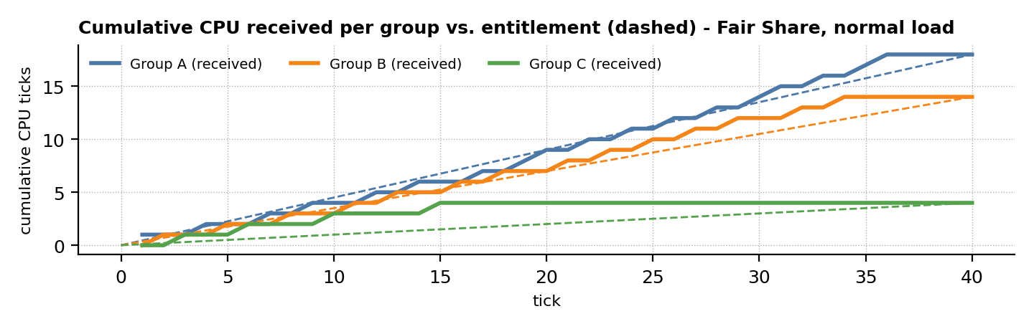
Figure E: Each group's cumulative CPU follows its entitlement line closely under Fair Share.

15 Fair Share Results: Input and Output Times of Every Job
Input times = arrival r and burst C; output times = start s and exit f (all in ticks). Waiting = f - r - C, turnaround = f - r, response = s - r.
Job | Group | Arrival r | Burst C | Start s | Exit f | Deadline d | Waiting | Turnaround | Response | Status
T1.1 | A | 0 | 1 | 0 | 1 | 5 | 0 | 1 | 0 | OK
T2.1 | A | 0 | 2 | 3 | 7 | 8 | 5 | 7 | 3 | OK
T3.1 | B | 0 | 2 | 1 | 8 | 10 | 6 | 8 | 1 | OK
T4.1 | B | 0 | 3 | 4 | 16 | 20 | 13 | 16 | 4 | OK
T5.1 | C | 0 | 4 | 2 | 15 | 40 | 11 | 15 | 2 | OK
T1.2 | A | 5 | 1 | 8 | 9 | 10 | 3 | 4 | 3 | OK
T2.2 | A | 8 | 2 | 11 | 17 | 16 | 7 | 9 | 3 | MISS (+1)
T1.3 | A | 10 | 1 | 13 | 14 | 15 | 3 | 4 | 3 | OK
T3.2 | B | 10 | 2 | 12 | 18 | 20 | 6 | 8 | 2 | OK
T1.4 | A | 15 | 1 | 18 | 19 | 20 | 3 | 4 | 3 | OK
T2.3 | A | 16 | 2 | 19 | 24 | 24 | 6 | 8 | 3 | OK
T1.5 | A | 20 | 1 | 21 | 22 | 25 | 1 | 2 | 1 | OK
T3.3 | B | 20 | 2 | 22 | 27 | 30 | 5 | 7 | 2 | OK
T4.2 | B | 20 | 3 | 20 | 29 | 40 | 6 | 9 | 0 | OK
T2.4 | A | 24 | 2 | 27 | 30 | 32 | 4 | 6 | 3 | OK
T1.6 | A | 25 | 1 | 25 | 26 | 30 | 0 | 1 | 0 | OK
T1.7 | A | 30 | 1 | 30 | 31 | 35 | 0 | 1 | 0 | OK
T3.4 | B | 30 | 2 | 31 | 34 | 40 | 2 | 4 | 1 | OK
T2.5 | A | 32 | 2 | 32 | 35 | 40 | 1 | 3 | 0 | OK
T1.8 | A | 35 | 1 | 35 | 36 | 40 | 0 | 1 | 0 | OK
Average |  |  |  |  |  |  | 4.10 | 5.90 | 1.70 | 1 miss

Per-task summary
Task | Jobs | Avg waiting | Avg turnaround | Avg response | Late jobs
T1 | 8 | 1.25 | 2.25 | 1.25 | 0
T2 | 5 | 4.60 | 6.60 | 2.40 | 1 (late)
T3 | 4 | 4.75 | 6.75 | 1.50 | 0
T4 | 2 | 9.50 | 12.50 | 2.00 | 0
T5 | 1 | 11.00 | 15.00 | 2.00 | 0
Long-running, low-weight tasks (T4, T5) show the largest waiting times, because Fair Share lets them interleave with every other group instead of finishing first.

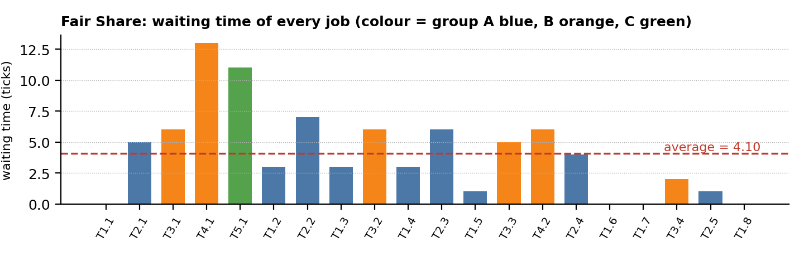
Figure F: Waiting time of each of the 20 jobs under Fair Share.

16 EDF: Earliest Deadline First
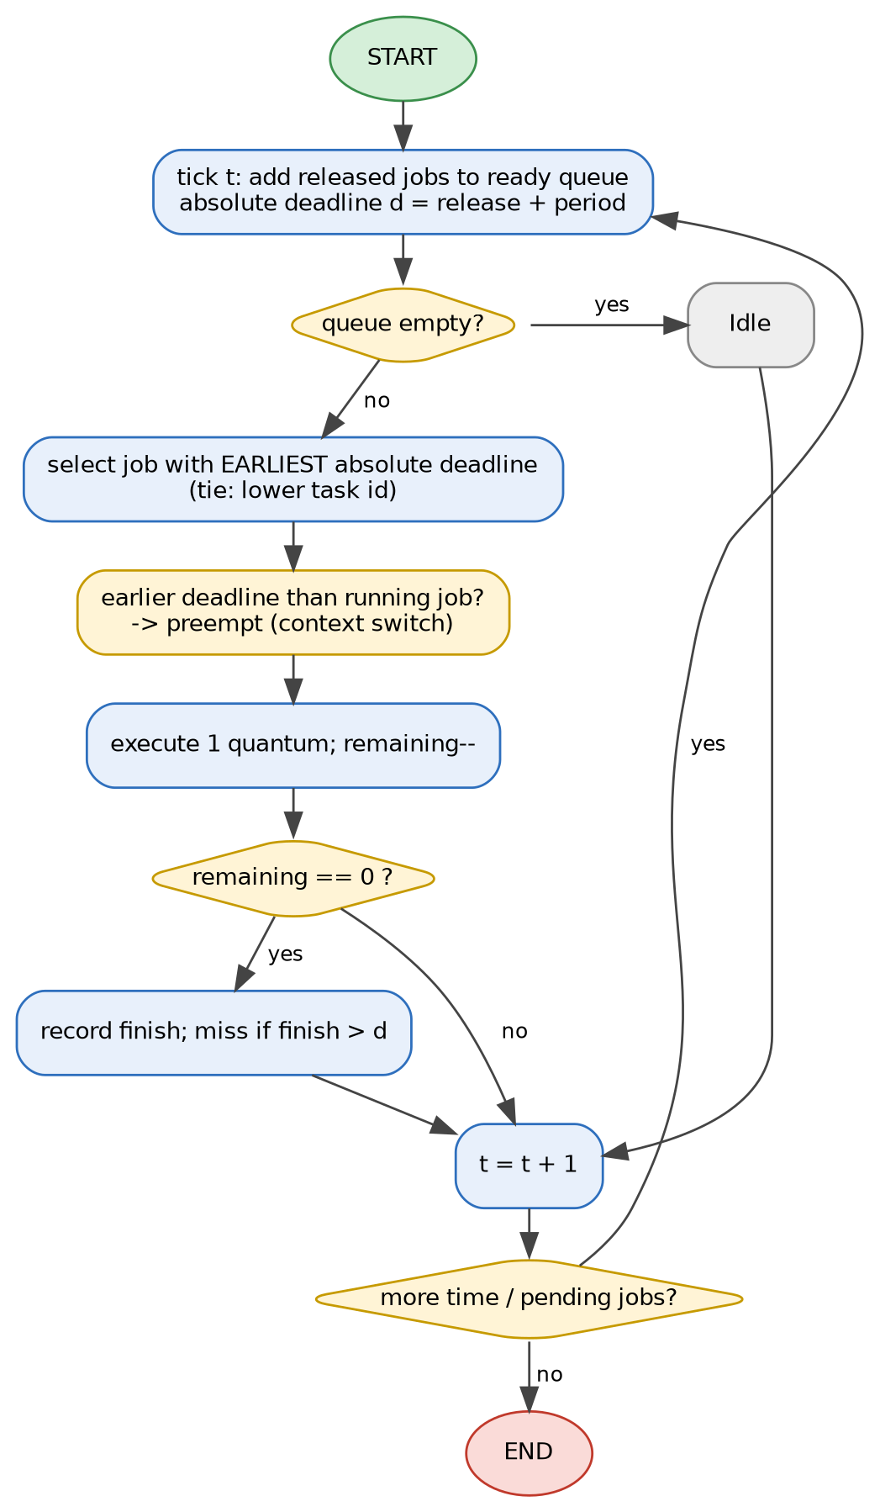  Figure 7: EDF flowchart. | Algorithm  EDF is a dynamic-priority policy: at every scheduling point the ready job whose absolute deadline is nearest runs. A newly released job with an earlier deadline preempts the running job. Liu and Layland (1973) proved EDF optimal for preemptive uniprocessor scheduling of independent periodic tasks.  Features  Pseudocode  every tick t:  ready += jobs released at t # d = r + P  if ready is empty: idle  else:  job = argmin(ready, key=(d, task_id))  run job for one quantum  if job.remaining == 0:  record exit time; miss if t+1 > d
  Property | Value
  Priority | Dynamic, per job: d = r + P
  Optimality | Optimal: finds a feasible schedule whenever one exists
  Schedulability | U <= 1 (necessary and sufficient, D = P)
  This workload | U = 0.90 <= 1: schedulable
  Overhead | Deadline comparisons; more preemptions than RM in general
  Weakness | Overload: misses are hard to predict; no per-user fairness

Result on the normal workload (U = 0.90): 0 missed deadlines, average waiting time 2.65, turnaround 4.45, response 1.50, 25 context switches.
Result under overload (U = 1.225): 2 misses (T4.2, T5.1); group C (task T5, the farthest deadline) received 0.00 of the CPU in the window - it is served only after all nearer deadlines.

Worked example: EDF decisions at selected ticks
Tick | Ready jobs (absolute deadline d, remaining ticks) | Earliest d | EDF runs
0 | T1.1 (d=5, rem 1); T2.1 (d=8, rem 2); T3.1 (d=10, rem 2); T4.1 (d=20, rem 3); T5.1 (d=40, rem 4) | d = 5 | T1.1
5 | T1.2 (d=10, rem 1); T4.1 (d=20, rem 3); T5.1 (d=40, rem 4) | d = 10 | T1.2
8 | T2.2 (d=16, rem 2); T4.1 (d=20, rem 1); T5.1 (d=40, rem 4) | d = 16 | T2.2
10 | T1.3 (d=15, rem 1); T3.2 (d=20, rem 2); T4.1 (d=20, rem 1); T5.1 (d=40, rem 4) | d = 15 | T1.3
13 | T4.1 (d=20, rem 1); T5.1 (d=40, rem 4) | d = 20 | T4.1
15 | T1.4 (d=20, rem 1); T5.1 (d=40, rem 3) | d = 20 | T1.4

17 RM: Rate Monotonic
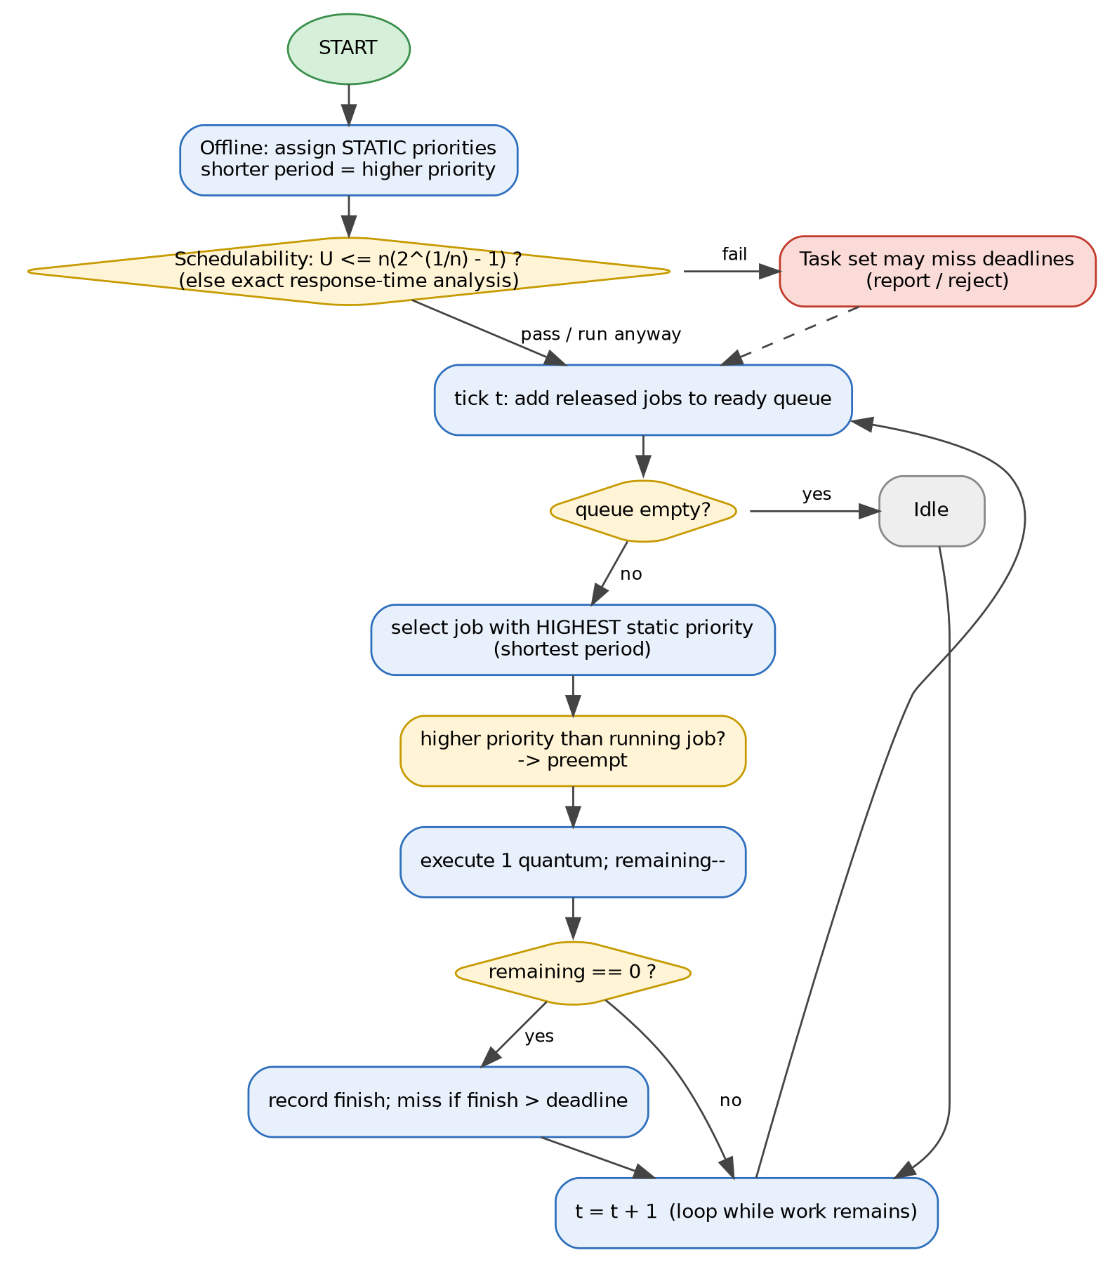  Figure 8: RM flowchart. | Algorithm  RM is a static-priority policy: priorities are fixed offline, and the task with the shortest period has the highest priority. It is optimal among static-priority algorithms for periodic tasks with D = P (Liu and Layland, 1973) and is simple to implement and analyse.  Features
  Property | Value
  Priority | Static, per task: shorter period first
  Sufficient test | U <= n(2^(1/n) - 1); n = 5 gives 0.743
  This workload | U = 0.90 > 0.743: test inconclusive; exact analysis needed
  Exact test | Response-time analysis (RTA): R = C + sum ceil(R/Pj)·Cj
  Overhead | Lowest: O(1) selection, fewest preemptions
  Weakness | Utilization bound < 100%; low-priority tasks starve in overload

Exact schedulability: response-time analysis (RTA)
Task | Priority | C | P | R (normal) | R <= P ? | R (overload) | R <= P ?
T1 | 1 | 1 | 5 | 1 | yes | 1 | yes
T2 | 2 | 2 | 8 | 3 | yes | 4 | yes
T3 | 3 | 2 | 10 | 5 | yes | 8 | yes
T4 | 4 | 3 | 20 | 14 | yes | 39 | NO
T5 | 5 | 4 | 40 | 30 | yes | diverges | NO
Under the normal workload every worst-case response time is within its period (largest: 30 <= 40), so RM is schedulable although U exceeds the Liu-Layland bound. Under overload RTA fails for the low-priority tasks, predicting the misses seen in the simulation (T4.1, T4.2, T5.1).
Result on the normal workload: 0 missed deadlines, average waiting 2.65, turnaround 4.45, response 1.50, 25 context switches.

Worked example: RM decisions at the same ticks
Tick | Ready jobs (period P = static priority key) | Shortest P | RM runs
0 | T1.1 (P=5); T2.1 (P=8); T3.1 (P=10); T4.1 (P=20); T5.1 (P=40) | P = 5 | T1.1
5 | T1.2 (P=5); T4.1 (P=20); T5.1 (P=40) | P = 5 | T1.2
8 | T2.2 (P=8); T4.1 (P=20); T5.1 (P=40) | P = 8 | T2.2
10 | T1.3 (P=5); T3.2 (P=10); T4.1 (P=20); T5.1 (P=40) | P = 5 | T1.3
13 | T4.1 (P=20); T5.1 (P=40) | P = 20 | T4.1
15 | T1.4 (P=5); T5.1 (P=40) | P = 5 | T1.4
RM and EDF choose the same job at every tick above because, for these implicit-deadline tasks, the job with the shortest period also has the earliest deadline at each decision point.

18 EDF and RM Schedules (Gantt Charts)
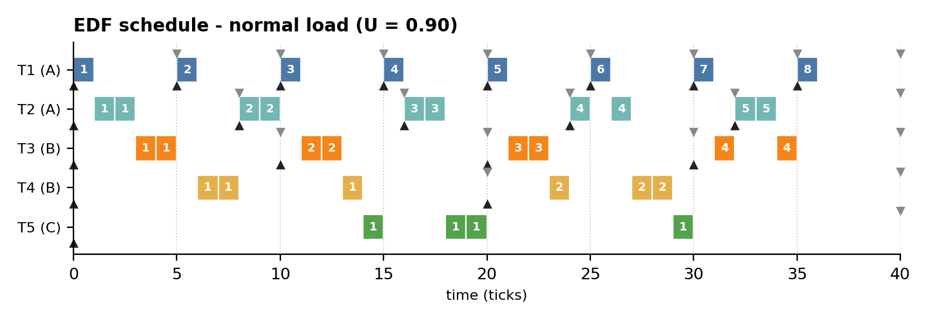
Figure 9: EDF schedule, normal load.
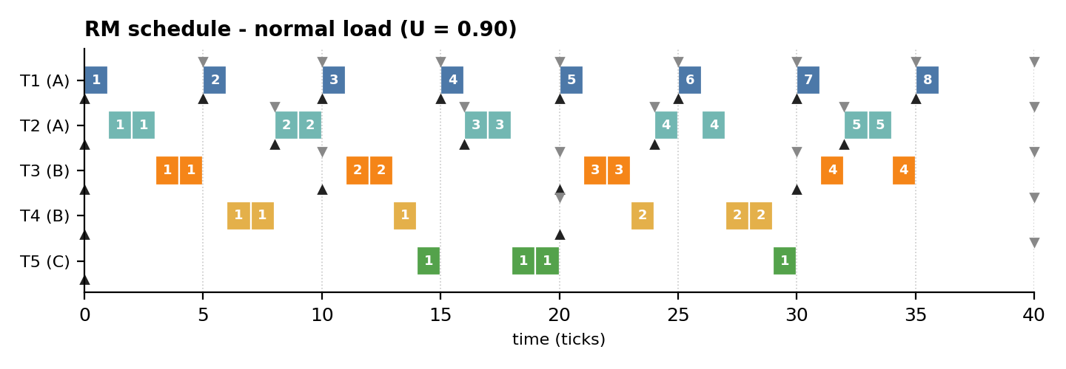
Figure 10: RM schedule, normal load.

Observations
- The EDF and RM timelines are identical tick-by-tick on this workload: at every decision the job with the earliest absolute deadline is also the job with the shortest period, so both rules choose the same job.
- Both complete all 20 jobs on time; the CPU is idle only in the last 4 ticks (utilization 0.90).
- Compared with Fair Share (Figure 6) the schedules are much more run-to-completion in nature: urgent jobs run in consecutive ticks, so there are 25 instead of 35 context switches and shorter waiting times.
- The two policies separate only when deadline order and period order disagree - for example under overload (page 22) or for task sets with constrained deadlines.

Execution statistics of the normal schedules (window of 40 ticks)
Statistic | Fair Share | EDF | RM
Busy ticks / idle ticks | 36 / 4 | 36 / 4 | 36 / 4
Context switches | 35 | 25 | 25
Preemptions (running job replaced before it finished) | 16 | 6 | 6
Longest uninterrupted run (ticks) | 1 | 2 | 2
Jobs executed in one contiguous piece (of 20) | 8 | 15 | 15

Meaning. Fair Share replaces the running job at almost every tick (16 preemptions) to keep groups balanced, whereas EDF/RM preempt only when a job with a nearer deadline or higher priority arrives (6 preemptions).

19 Entry and Exit Times of All Algorithms (Normal Load)
Arrival r and deadline d are identical for all algorithms (inputs); start s and exit f are outputs. Red bold = deadline missed.
Job | Arrival r | Deadline d | FS start | FS exit | EDF start | EDF exit | RM start | RM exit
T1.1 | 0 | 5 | 0 | 1 | 0 | 1 | 0 | 1
T2.1 | 0 | 8 | 3 | 7 | 1 | 3 | 1 | 3
T3.1 | 0 | 10 | 1 | 8 | 3 | 5 | 3 | 5
T4.1 | 0 | 20 | 4 | 16 | 6 | 14 | 6 | 14
T5.1 | 0 | 40 | 2 | 15 | 14 | 30 | 14 | 30
T1.2 | 5 | 10 | 8 | 9 | 5 | 6 | 5 | 6
T2.2 | 8 | 16 | 11 | 17 | 8 | 10 | 8 | 10
T1.3 | 10 | 15 | 13 | 14 | 10 | 11 | 10 | 11
T3.2 | 10 | 20 | 12 | 18 | 11 | 13 | 11 | 13
T1.4 | 15 | 20 | 18 | 19 | 15 | 16 | 15 | 16
T2.3 | 16 | 24 | 19 | 24 | 16 | 18 | 16 | 18
T1.5 | 20 | 25 | 21 | 22 | 20 | 21 | 20 | 21
T3.3 | 20 | 30 | 22 | 27 | 21 | 23 | 21 | 23
T4.2 | 20 | 40 | 20 | 29 | 23 | 29 | 23 | 29
T2.4 | 24 | 32 | 27 | 30 | 24 | 27 | 24 | 27
T1.6 | 25 | 30 | 25 | 26 | 25 | 26 | 25 | 26
T1.7 | 30 | 35 | 30 | 31 | 30 | 31 | 30 | 31
T3.4 | 30 | 40 | 31 | 34 | 31 | 35 | 31 | 35
T2.5 | 32 | 40 | 32 | 35 | 32 | 34 | 32 | 34
T1.8 | 35 | 40 | 35 | 36 | 35 | 36 | 35 | 36

Summary over 20 jobs | Fair Share | EDF | RM
Sum of exit times | 418 | 389 | 389
Average start delay (response) | 1.70 | 1.50 | 1.50
Latest exit time | 36 | 36 | 36
Jobs finishing after deadline | 1 | 0 | 0
All three algorithms are work-conserving and finish the last job at the same instant (36): the difference is when each individual job exits. EDF/RM finish jobs in urgency order; Fair Share postpones long jobs so that every group keeps advancing.

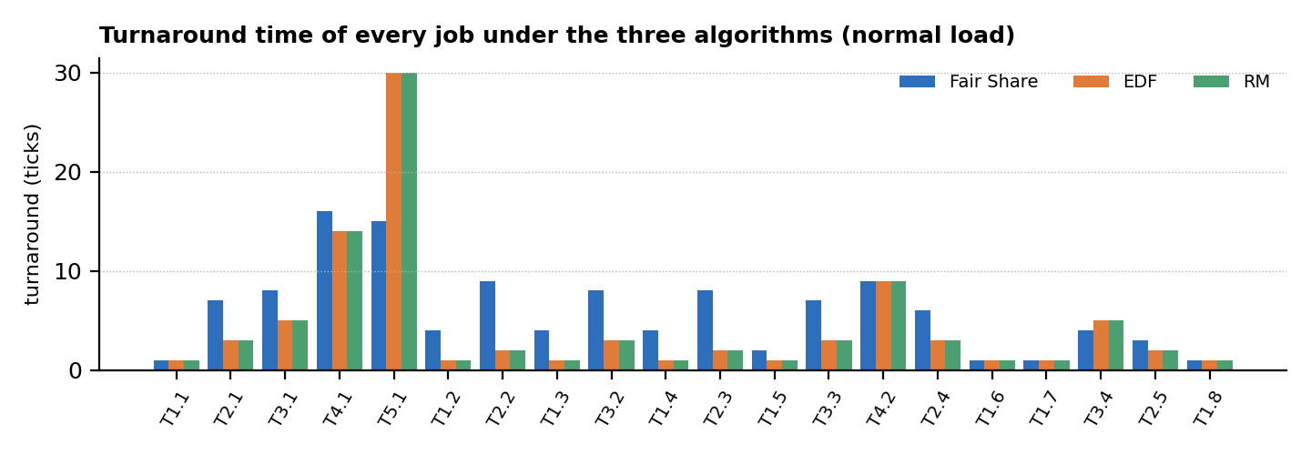
Figure G: Turnaround time of each job under the three algorithms.

20 Normal-Load Comparison (U = 0.90)
Metric | Fair Share | EDF | RM
Jobs completed | 20 | 20 | 20
Missed deadlines | 1 | 0 | 0
Deadline-miss ratio | 0.050 | 0.000 | 0.000
Average waiting time (ticks) | 4.10 | 2.65 | 2.65
Average turnaround time (ticks) | 5.90 | 4.45 | 4.45
Average response time (ticks) | 1.70 | 1.50 | 1.50
Maximum lateness (ticks) | 1 | 0 | 0
CPU utilization in [0,40) | 0.90 | 0.90 | 0.90
Context switches | 35 | 25 | 25
Jain fairness index | 1.000 | 1.000 | 1.000

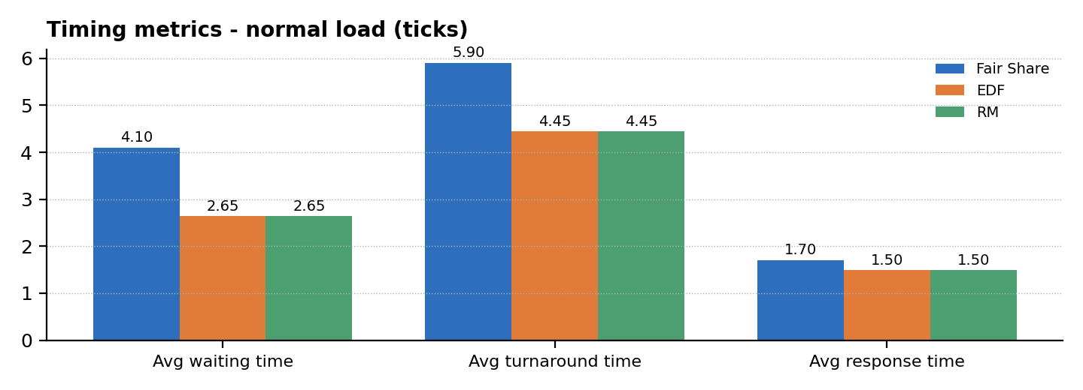
Figure 11: Average waiting, turnaround and response time under normal load.
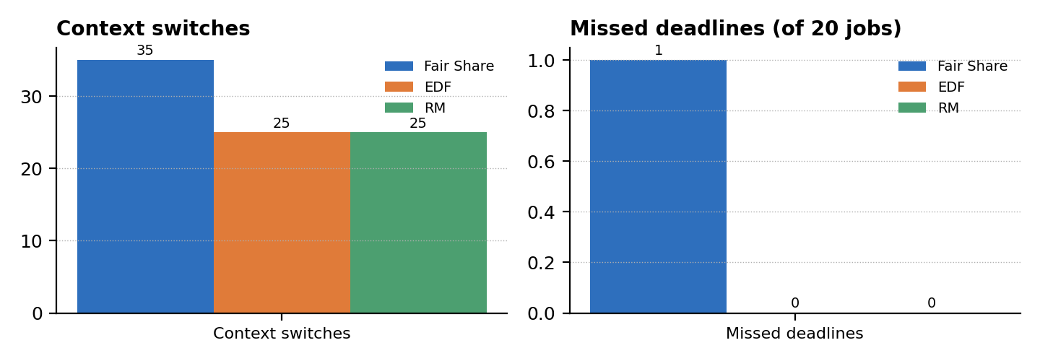
Figure 12: Context switches and missed deadlines under normal load.

Interpretation
- Fair Share's average waiting time is 55% higher than that of EDF/RM (4.10 vs 2.65 ticks); EDF/RM also need 10 fewer context switches and miss no deadline.
- Fair Share's response time is only slightly worse (1.70 vs 1.50) because every group is served within a few ticks; its price is longer turnaround for long jobs.
- With demand below capacity every policy serves every group fully (Jain index 1.000): fairness differences appear only under contention.

21 Overload Comparison (U = 1.225)
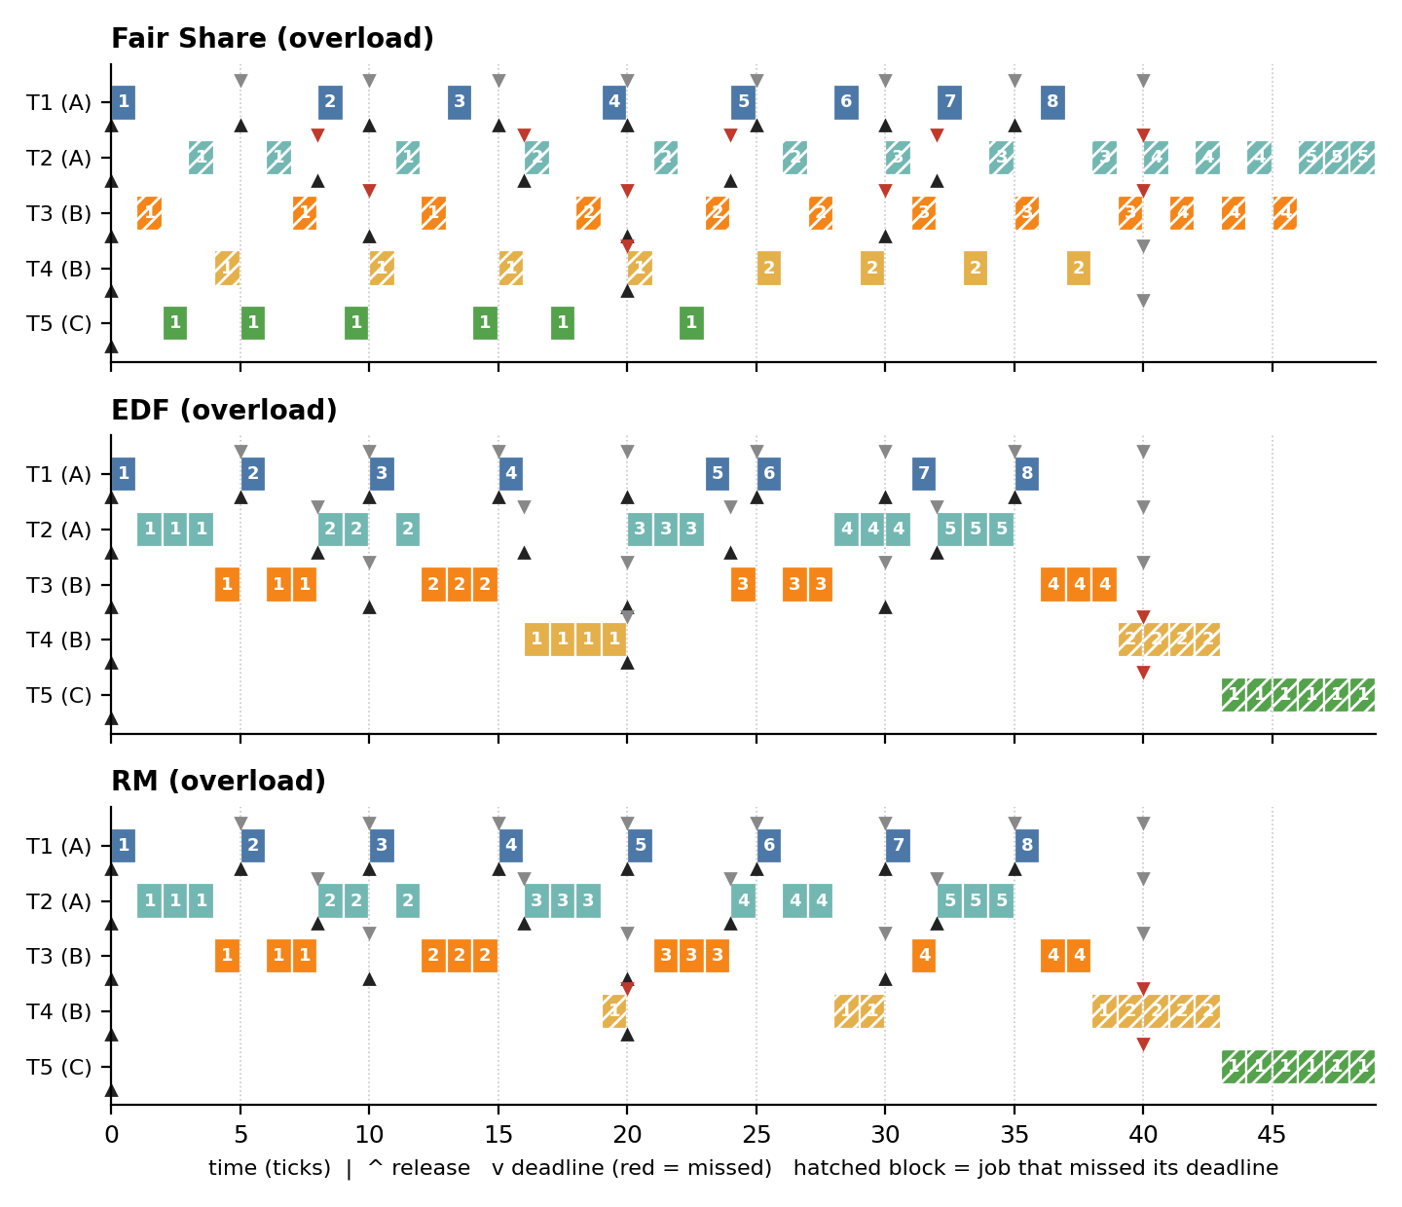
Figure 13: Schedules of the three algorithms under overload (times beyond 40 are drained backlog).
Metric (overload) | Fair Share | EDF | RM
Missed deadlines (of 20) | 10 | 2 | 3
Maximum lateness (ticks) | 15 | 9 | 19
Average waiting time | 10.00 | 5.50 | 5.65
Context switches | 46 | 22 | 25
CPU share A / B / C in [0,40) (entitled 0.45 / 0.40 / 0.15) | 0.42 / 0.42 / 0.15 | 0.57 / 0.42 / 0.00 | 0.57 / 0.42 / 0.00
Jain fairness index | 0.985 | 0.662 | 0.662
Reading. EDF and RM protect the urgent tasks and lose the rest: task T5 of group C receives no CPU before t = 40 and starts only at tick 43. Fair Share spreads the overload: group C gets its full entitlement (0.15), groups A and B are slowed proportionally (0.42 each, against demands of 0.575 and 0.500), giving J = 0.985 versus 0.662. The price is 10 late jobs, mostly T2 and T3, versus 2 (EDF) and 3 (RM).

Why does Fair Share miss more deadlines here?
- Fair Share is deadline-blind: it slows A and B in proportion to their weights, so the jobs of T2 and T3 finish late even when a nearer deadline could have been honoured.
- EDF and RM sacrifice the least urgent work (T4, T5) to keep most deadlines - good for timeliness, but group C is starved (share 0.00).
- The right choice depends on the objective: minimum number of late jobs (EDF/RM) or proportional degradation (Fair Share).

22 Utilization Sweep and Fairness
To check that the two workloads are not special cases, 150 random task sets per utilization level (periods 5, 8, 10, 20, 40; random group assignment fixed as A, A, B, B, C) were simulated with all three algorithms. The left chart shows the mean deadline-miss ratio; the right chart shows the Jain index of the two main workloads.
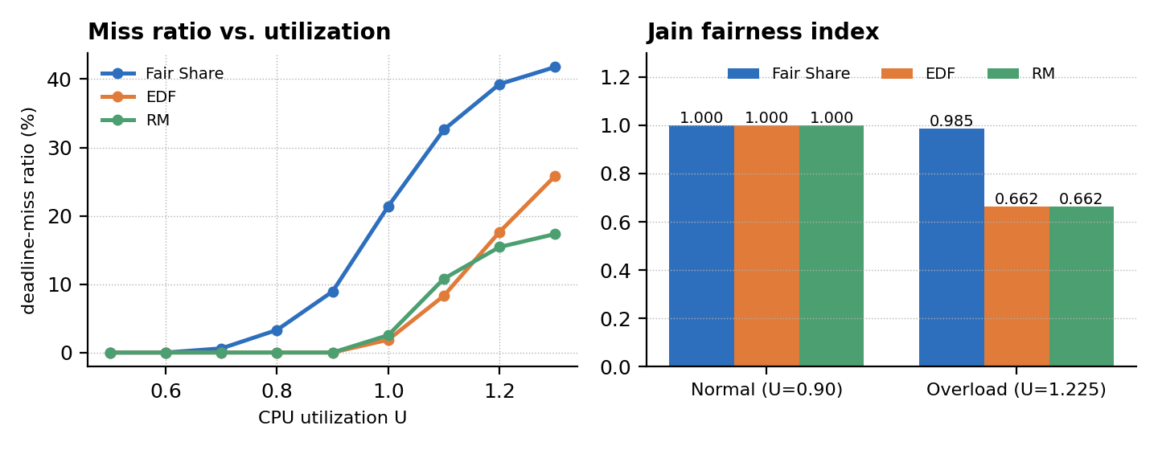
Figure 14: Deadline-miss ratio versus utilization (left) and Jain fairness index (right).
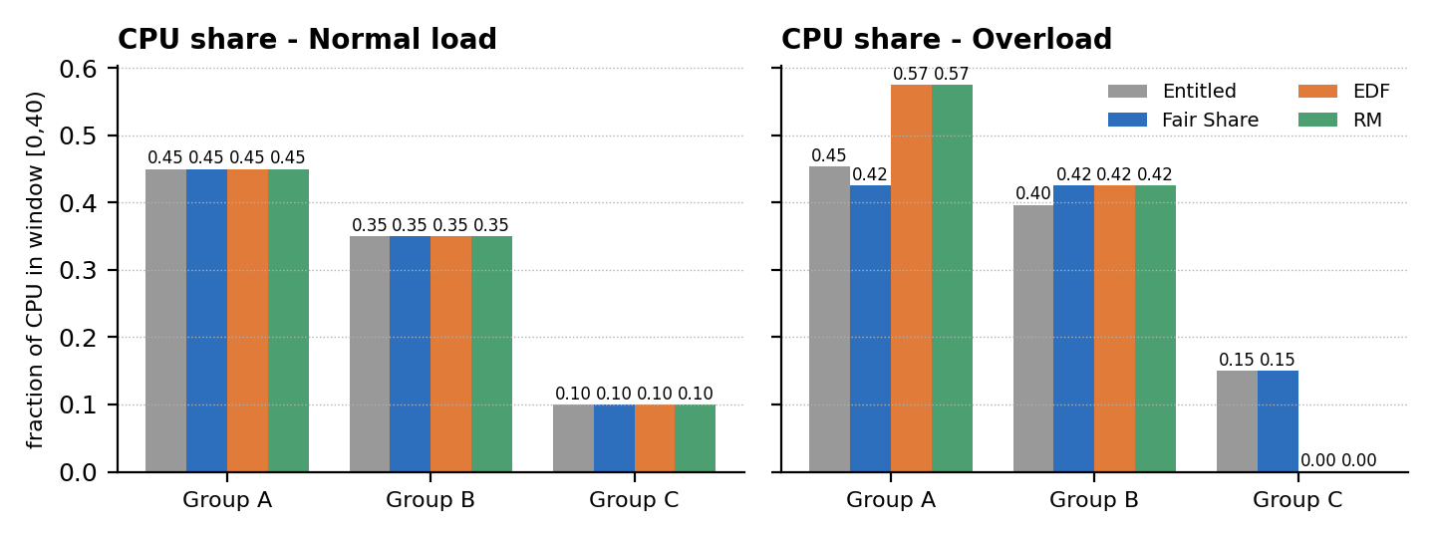
Figure 15: CPU share per group compared with the weight-based entitlement.
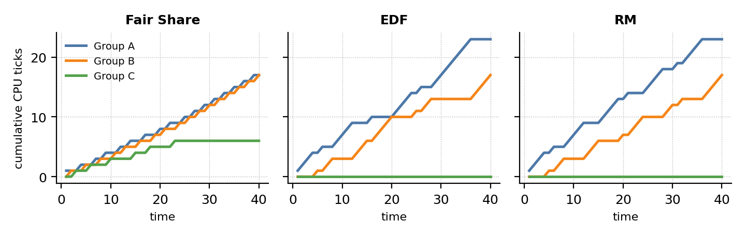
Figure 16: Cumulative CPU ticks per group under overload.
- EDF and RM are miss-free up to U = 0.9, while Fair Share already misses deadlines from U = 0.7; EDF beats RM near U = 1.0-1.1 (it can use 100% of the CPU).
- Beyond U = 1.2, RM misses fewer deadlines than EDF (high-priority tasks stay protected), in line with the known sensitivity of EDF to overload.
- Fair Share's miss ratio is highest everywhere, but it is the only policy whose group shares follow the entitlements (Figures 15 and 16).

23 Qualitative Comparison and Selection Guidelines
Criterion | Fair Share (monitor + semaphore) | EDF | RM
Priority type | Dynamic, usage-based, recomputed every tick | Dynamic, per job (absolute deadline) | Static, per task (period)
Decision basis | Recent CPU use vs. group entitlement | Nearest absolute deadline | Shortest period
Optimality | Not deadline-driven | Optimal for preemptive uniprocessor, U <= 1 | Optimal among static-priority policies
Schedulability test | None; statistical, depends on weights | U <= 1 (D = P) | U <= n(2^(1/n) - 1) sufficient; RTA exact
Deadline guarantee | None (best effort) | Hard, if U <= 1 | Hard, if RTA passes
Fairness / isolation | Excellent: J = 0.985 in overload | None | None; low priorities starve
Starvation | Impossible (usage decay) | Possible for far deadlines in overload | Possible for lowest priorities
Overload behaviour | Graceful, proportional slowdown | Unpredictable; misses can cascade | Predictable: high priorities protected
Context switches (normal) | 35 | 25 | 25
Avg waiting (normal) | 4.10 | 2.65 | 2.65
Implementation effort | Highest: monitor, semaphores, accounting | Moderate: deadline tracking | Lowest: static table
Required information | Group weights, usage history | WCET, deadlines | WCET, periods
Typical domain | Shared servers, cloud / container CPU shares | Dynamic real-time systems with high utilization | Safety-critical embedded control

Selection guidelines
- Choose Fair Share when the requirement is *who* gets the CPU (users, tenants, departments) and soft timing is acceptable.
- Choose EDF when deadlines are hard, the load is dynamic and the highest possible utilization (up to 100%) is needed.
- Choose RM when predictability, simple analysis and robust behaviour of the most critical tasks matter more than peak utilization.
- Hybrid option: run EDF or RM for real-time tasks inside each Fair Share group, so groups are isolated and each group still meets its deadlines.

Qualitative scorecard (5 = best)
Dimension | Fair Share | EDF | RM
Fairness and isolation between groups | ●●●●● 5/5 | ●○○○○ 1/5 | ●○○○○ 1/5
Deadline guarantees (U <= 1) | ●○○○○ 1/5 | ●●●●● 5/5 | ●●●●○ 4/5
Schedulable utilization | ●●○○○ 2/5 | ●●●●● 5/5 | ●●●●○ 4/5
Predictability under overload | ●●●●○ 4/5 | ●●○○○ 2/5 | ●●●●○ 4/5
Low scheduling overhead | ●●○○○ 2/5 | ●●●○○ 3/5 | ●●●●● 5/5
Implementation simplicity | ●●○○○ 2/5 | ●●●○○ 3/5 | ●●●●● 5/5
The ratings summarise the measured results and the theory above; they are a guide, not a measurement.

24 Conclusions, Future Work and References

Conclusions
- The hybrid design works: a monitor protects scheduler state, semaphores perform the CPU hand-off, and the threaded schedule matches an independent simulator tick-by-tick on both workloads.
- Under normal load (U = 0.90) EDF and RM meet all deadlines with 25 context switches and 2.65 ticks average waiting; Fair Share missed 1 of 20 deadlines, needed 35 context switches and 4.10 ticks waiting.
- Under overload (U = 1.225) EDF and RM starve group C completely (share 0.00) with Jain index 0.662, whereas Fair Share keeps each group close to its entitlement (J = 0.985) at the cost of 10 late jobs.
- No algorithm dominates: EDF maximises timeliness and utilization, RM maximises predictability, Fair Share maximises fairness and isolation.

Limitations
- Logical time and unit quantum; context-switch cost and I/O are ignored; one CPU only.
- Small task set (5 tasks, 3 groups); random-set experiment uses fixed periods and 150 samples per level.
- Python threads are used for synchronization semantics, not for parallel speed (GIL).

Future work
- Hierarchical scheduling: EDF/RM inside each Fair Share group; multiprocessor extension with per-CPU monitors.
- Weighted decay and variable quantum; measurement on a real kernel (e.g. Linux cgroup cpu.weight).

References
[1] E. W. Dijkstra, "Cooperating Sequential Processes", Technical report EWD-123, 1965.
[2] C. A. R. Hoare, "Monitors: An Operating System Structuring Concept", Communications of the ACM, 17(10), 1974.
[3] C. L. Liu and J. W. Layland, "Scheduling Algorithms for Multiprogramming in a Hard-Real-Time Environment", Journal of the ACM, 20(1), 1973.
[4] G. J. Henry, "The Fair Share Scheduler", AT&T Bell Laboratories Technical Journal, 63(8), 1984.
[5] J. Kay and P. Lauder, "A Fair Share Scheduler", Communications of the ACM, 31(1), 1988.
[6] R. Jain, D. Chiu and W. Hawe, "A Quantitative Measure of Fairness and Discrimination for Resource Allocation in Shared Computer Systems", DEC Technical Report TR-301, 1984.
[7] G. C. Buttazzo, Hard Real-Time Computing Systems, Springer.
[8] A. Silberschatz, P. B. Galvin and G. Gagne, Operating System Concepts, Wiley.

Verdict by dimension
Dimension | Best | Evidence from this study
Meeting deadlines at U = 0.90 | EDF / RM | 0 misses vs 1 for Fair Share
Average waiting time (normal load) | EDF / RM | 2.65 vs 4.10 ticks
Context-switch overhead | EDF / RM | 25 vs 35 switches
Fairness under overload | Fair Share | Jain 0.985 vs 0.662
Protection of the smallest group (C) | Fair Share | share 0.15 vs 0.00 (entitled 0.15)
Miss ratio at U >= 1.2 | RM | Lowest among the three in the random-set sweep (page 23)
Utilization near 100% with deadlines | EDF | Fewest misses at U = 1.0 - 1.1 in the sweep

How to reproduce
# save the listing of pages 13-14 as fs_hybrid.py and the driver of page 14 as driver.py
$ python3 driver.py # threaded Fair Share scheduler (monitor + semaphores), prints the timeline
$ python3 sim.py # simulator for Fair Share, EDF and RM on both workloads
$ python3 check_hybrid.py # confirms threaded timeline == simulator timeline

