OPERATING SYSTEMS / REAL-TIME SYSTEMS PROJECT
Implementation of the Fair Share Scheduling Algorithm Using Semaphores
and a Comparative Study with EDF and RM

Design | Flowcharts | Source Code | Experiments | Tables and Charts

Prepared by: ______________________________
Student ID: ______________________________
Instructor: ______________________________
Date: October 28, 2026

Table of Contents
1. Introduction 3
1.1 Motivation 3
1.2 Objectives 3
1.3 Report Organization 3
2. Background: Real-Time Task Model 3
3. The Fair Share Scheduling Algorithm 4
4. Earliest Deadline First (EDF) 5
5. Rate Monotonic (RM) 6
6. Semaphores and Synchronization 7
7. System Design 8
8. Implementation 11
9. Experimental Setup 15
10. Results: Experiment A (Normal Load) 16
11. Results: Experiment B (Overload) 19
12. Comparison and Discussion 21
13. Conclusion and Future Work 24
References 24
Appendix A: Fair Share Decision Trace 25

Abstract
This report presents the design, implementation and evaluation of a Fair Share CPU scheduler built on semaphores, and compares it with two classical real-time schedulers: Earliest Deadline First (EDF) and Rate Monotonic (RM). Each task is a thread; a dispatcher grants the CPU one tick at a time through binary semaphores (run[i], done) while a third semaphore (mutex) protects the shared accounting tables. The same semaphore-driven dispatcher is reused for all three policies so that the comparison is fair and only the selection rule changes.
Two workloads are studied: a normal-load task set (U = 0.917) and an overloaded task set (U = 1.333). Under normal load all three algorithms meet every deadline. Under overload, Fair Share is the only policy that preserves the configured CPU shares (Jain index 0.999 versus 0.803 for EDF and 0.621 for RM) and the only one that never starves a group, while RM produces the fewest deadline misses (5 of 15 jobs) and EDF suffers its well-known overload degradation. The report includes flowcharts, pseudo-code, full Python and C source code, arrival/start/exit-time tables for every job, Gantt charts and comparison charts.

1. Introduction

1.1 Motivation
CPU scheduling decides which ready task owns the processor at every instant, and it is one of the most influential design choices in an operating system. Real-time schedulers such as EDF and RM are designed around timing guarantees: they try to make every job finish before its deadline. General-purpose and multi-user systems have a different goal: they must divide the processor fairly between users or groups, so that one heavy user cannot monopolize the machine. This second goal is the purpose of the Fair Share scheduler.
When many users or applications share a single CPU, per-process fairness is not enough: a user who starts ten processes would receive ten times the CPU of a user who starts one. Fair Share scheduling lifts the accounting level from the process to the group (user): each group has a configured share, and the scheduler continuously steers the actual consumption toward that share. In this project we implement such a scheduler and study how it behaves relative to the two most famous real-time policies.
Synchronization is the second theme of the project. A scheduler is a concurrent program: the dispatcher and the tasks access shared tables (remaining execution time, consumed time, group usage). Semaphores, introduced by Dijkstra, provide both mutual exclusion and ordering (signalling) and are therefore the natural tool to implement a deterministic, race-free dispatcher.

1.2 Objectives
- Implement a Fair Share scheduler in which every task is a thread and all coordination is done with semaphores.
- Implement EDF and RM on the same semaphore-based dispatcher, so that the policies are compared under identical conditions.
- Document the design with an architecture diagram, flowcharts, state diagram, data-structure tables and pseudo-code.
- Run two experiments (normal load and overload) and report arrival, start and exit time of every job, response and waiting time, deadline misses, context switches, CPU share and fairness.
- Summarize the features, strengths and weaknesses of the three algorithms in tables and charts and discuss when each should be used.

1.3 Report Organization
Sections 2 to 6 give the theoretical background (task model, Fair Share, EDF, RM and semaphores). Section 7 presents the system design with flowcharts, and Section 8 lists the complete source code in Python and C. Section 9 describes the experimental setup; Sections 10 and 11 give the detailed results of the two experiments including arrival and exit times. Section 12 compares the algorithms with tables and charts, and Section 13 concludes. Appendix A shows the decision trace of the Fair Share scheduler tick by tick.

2. Background: Real-Time Task Model
We use the classical model of independent, preemptible, periodic tasks running on a single processor. Time is discrete and the unit of time is one tick. A task Ti is characterized by the parameters in Table 1.
Table 1: Task model parameters and notation
Symbol | Name | Meaning
Ti | Task | Periodic task i; each period it releases a new job
Pi | Period | Time between two consecutive releases of Ti
Ci | WCET | Worst-case execution time (ticks of CPU needed per job)
Di | Relative deadline | Time allowed after release; here Di = Pi (implicit deadline)
ri,k | Arrival (release) time | Time at which the k-th job of Ti becomes ready: ri,k = (k-1)Pi
si,k | Start time | First tick at which the job receives the CPU
fi,k | Exit (finish) time | Time at which the job completes its last tick
di,k | Absolute deadline | di,k = ri,k + Di
Ui | Utilization | Ui = Ci / Pi; total utilization U = sum of Ui
Gg / Sg | Group / share | Group Gg owns a fraction Sg of the CPU (sum of Sg = 1)

2.1 Derived Metrics
For every job the following quantities are derived from its arrival, start and exit times:
Response time R = f - r Waiting time W = R - C Lateness L = f - d
A job meets its deadline if L <= 0. The scheduler-level metrics are the number of deadline misses, the average response and waiting time, the number of context switches and preemptions, the CPU utilization and, for Fair Share, the fairness of the CPU distribution between groups. Fairness is measured with Jain's index computed over the normalized shares xg = (achieved share of group g) / (target share of group g):
J = ( sum xg )^2 / ( n * sum xg^2 ) 1/n <= J <= 1, J = 1 means every group receives exactly its target share

2.2 Necessary Condition
On one processor no algorithm can meet all deadlines if U > 1. This fact is used in Section 9: Experiment A has U = 0.917 (feasible), whereas Experiment B has U = 1.333 (infeasible by construction), which lets us observe how each algorithm *degrades* rather than whether it succeeds.

3. The Fair Share Scheduling Algorithm

3.1 Concept
A Fair Share scheduler allocates the CPU to groups of tasks in proportion to administratively assigned shares. The idea originates from the fair-share scheduler of Kay and Lauder (1988) for UNIX, where all processes of a user form one group, and it is the ancestor of later proportional-share schedulers such as lottery scheduling, stride scheduling and the Linux Completely Fair Scheduler with control groups. The scheduler does not look at deadlines or periods; its only input is how much CPU each group has already consumed relative to what it deserves.

3.2 Selection Rule
For each group Gg the scheduler stores a decayed usage counter Ug(t). At every tick it computes the normalized usage (also called the group priority value; lower is better):
Vg(t) = Ug(t) / Sg
The scheduler then (1) considers only groups that have at least one ready task, (2) selects the group g* with the smallest Vg(t), and (3) inside g* selects the task that has consumed the least CPU so far (ties are broken by task index). The chosen task runs for one tick, after which Ug* is incremented by one. A group that has used too much CPU therefore automatically loses priority until the others catch up, which pushes the long-run distribution toward the configured shares.

3.3 Usage Decay
Without forgetting, a group that was idle for a long time would accumulate a huge credit and could monopolize the CPU afterwards. Following the classical design, every D ticks all counters are multiplied by a decay factor delta (0 < delta < 1):
Ug <- delta * Ug every D ticks (this project: D = 6, delta = 0.5)
Decay gives the algorithm a finite memory: recent consumption matters most, and old consumption is gradually forgotten.

3.4 Features of Fair Share
Table 2: Main features of the Fair Share algorithm
Feature | Description
Scheduling unit | Group (user); tasks inside a group are scheduled by least consumed CPU
Priority | Dynamic: changes at every tick with Vg = Ug / Sg
Preemption | Yes - re-evaluated at every tick (tick-level preemption)
Input parameters | Group shares Sg, decay factor delta, decay interval D
Deadline awareness | None: deadlines and periods are ignored by the policy
Starvation | Impossible for a group with Sg > 0: its Vg stays low while it is waiting
Isolation | A greedy group cannot take more than its share while others have work
Overhead | O(n) per decision (scan of ready tasks), plus decay every D ticks
Schedulability test | No hard-real-time test exists; guarantees are statistical (share-based)
Typical use | Multi-user servers, hosting, batch clusters, soft real-time / multimedia

3.5 Strengths and Weaknesses
- Strengths: proportional allocation, protection between groups, no starvation, graceful behavior under overload, simple configuration (percentages).
- Weaknesses: no awareness of deadlines, so it cannot guarantee timing; more context switches because the decision is re-evaluated each tick; shares are achieved only over a long enough window and only if every group has enough demand.

4. Earliest Deadline First (EDF)

4.1 Principle
EDF is a dynamic-priority, preemptive algorithm: at every scheduling point the ready job with the earliest absolute deadline runs. Priorities are not fixed per task; they change from job to job because absolute deadlines move forward with time. Dertouzos (1974) proved that EDF is optimal for preemptive scheduling of independent jobs on a uniprocessor: if any algorithm can meet all deadlines, EDF can.

4.2 Schedulability Test
For periodic tasks with implicit deadlines (Di = Pi) the test is both necessary and sufficient:
sum ( Ci / Pi ) <= 1
Experiment A has U = 0.917 <= 1, therefore EDF is guaranteed to meet all deadlines, which the simulation confirms.

4.3 Behavior Under Overload
When U > 1 EDF becomes unpredictable. Jobs with a very close deadline keep the CPU even though they can no longer finish on time, and the lateness propagates to later jobs (the *domino effect*). EDF also does not isolate tasks: a task that overruns can cause others to miss deadlines. Section 11 shows this behavior experimentally.

4.4 Features of EDF
- Dynamic priority; optimal on a uniprocessor; utilization bound of 100%.
- Needs the absolute deadline of every job and a priority queue ordered by deadline: O(log n) per operation with a heap, O(n) with a simple scan.
- Fewer preemptions than tick-based Fair Share because priorities change only when new jobs are released.
- No protection against overruns, no notion of shares or fairness.

5. Rate Monotonic (RM)

5.1 Principle
Rate Monotonic is the classical fixed-priority algorithm of Liu and Layland (1973): the shorter the period, the higher the priority. Priorities are assigned once, offline, and never change. RM is optimal among all fixed-priority algorithms for periodic tasks with implicit deadlines, and it is very easy to implement because the dispatcher only needs a static ordering.

5.2 Schedulability Tests
The Liu-Layland sufficient utilization bound for n tasks is:
U <= n ( 2^(1/n) - 1 ) and the bound tends to ln 2 = 0.693 when n grows
Table 3: Liu-Layland utilization bound for RM
n | 1 | 2 | 3 | 4 | 5 | 6 | 8 | 10 | infinity
Bound | 1.000 | 0.828 | 0.780 | 0.757 | 0.743 | 0.735 | 0.724 | 0.718 | 0.693

The bound is only sufficient. An exact test is the response-time analysis (RTA): the worst-case response time of task i is the smallest fixed point of
Ri = Ci + sum over higher-priority tasks j of ceil( Ri / Pj ) * Cj , schedulable if Ri <= Di
For Experiment A the Liu-Layland bound (0.757) is smaller than U = 0.917, so the sufficient test is inconclusive; the exact RTA, however, gives R(T1) = 1, R(T2) = 3, R(T3) = 6 and R(T4) = 12 <= 12, so the set is RM-schedulable (T4 finishes exactly at its deadline). For Experiment B, RTA diverges for T4 (R > 60), i.e. T4 can never meet its deadline under RM.

5.3 Features of RM
- Static priority; extremely low run-time overhead, O(1) selection with a pre-sorted list; very predictable behavior.
- Utilization bound below 100% (about 69% for large n), so it can reject sets that EDF can schedule.
- Graceful degradation for high-priority tasks under overload, but low-priority tasks starve completely: the lowest-priority group can receive 0% of the CPU.

6. Semaphores and Synchronization

6.1 Definition
A semaphore S is an integer variable that can only be accessed through two atomic operations, defined by Dijkstra:
Semaphore operations
1 P(S) / wait(S): while S <= 0 : block; S = S - 1
2 V(S) / signal(S): S = S + 1; wake up one blocked process (if any)

A binary semaphore takes values 0 and 1 and is used for mutual exclusion or one-shot signalling. A counting semaphore can take any non-negative value and controls access to a pool of resources. Because P and V are atomic and the blocked threads sleep instead of spinning, semaphores avoid busy waiting.

6.2 Semaphores Used in the Scheduler
The scheduler needs two kinds of synchronization: mutual exclusion (protecting shared tables) and ordering (dispatcher grants, task acknowledges). Both are expressed with the three semaphores of Table 4.
Table 4: Semaphores used in the implementation
Semaphore | Type / initial value | Used by | Purpose
run[i] | Binary, 0 | Dispatcher: V; Task i: P | Dispatch grant: lets task i execute exactly one tick. Task blocks on it while not selected.
done | Binary, 0 | Task: V; Dispatcher: P | Acknowledgement: the dispatcher waits until the granted tick has been executed.
mutex | Binary, 1 | Tasks and dispatcher | Mutual exclusion on remaining[], consumed[] and usage[].

6.3 Correctness Arguments
- Single CPU: the dispatcher posts exactly one run[i] and then blocks on done; therefore at most one task thread executes at any instant, which faithfully models a single processor. The run[i] semaphores together behave like a CPU token.
- Mutual exclusion: every update of the shared tables by a worker is enclosed between P(mutex) and V(mutex); the critical section is only a few instructions long.
- No deadlock: there is only one lock (mutex) so no circular wait is possible; a worker releases mutex before it signals done, and the dispatcher never holds mutex while waiting for done.
- No lost wake-up: semaphores remember signals. Even if the dispatcher posts run[i] before the worker reaches P(run[i]), the grant is not lost.
- Determinism: because of the strict V(run) / P(done) hand-shake the schedule produced does not depend on the operating-system thread scheduler, so results are reproducible. The Python and C versions produce the identical schedule.
- Termination: the dispatcher sets a stop flag and posts every run[i] once, so all blocked workers wake up, see the flag and exit.

7. System Design

7.1 Architecture
The system has four cooperating components (Figure 1): the job generator that releases periodic jobs, the dispatcher that applies the scheduling policy (FS, EDF or RM), one worker thread per task that executes the granted tick, and the metrics logger. Components communicate only through the three semaphore types.
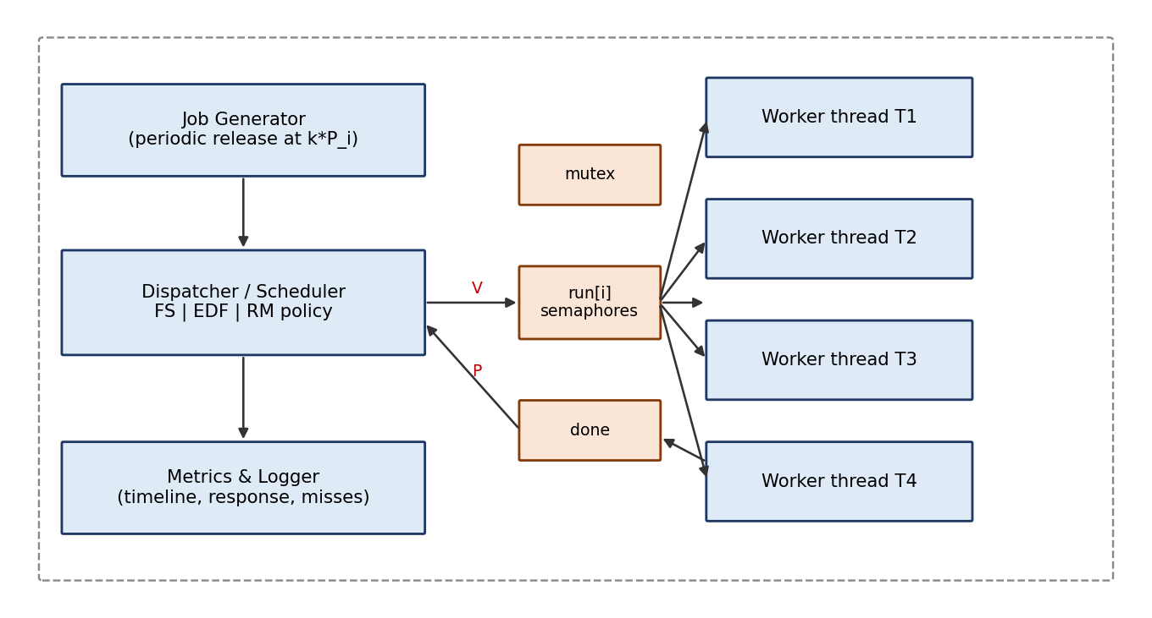
Figure 1: Architecture of the semaphore-based scheduler

7.2 Inputs and Outputs
Table 5: Program inputs and outputs
Direction | Item | Description
Input | Task set | For each task: name, group, period Pi, WCET Ci (arrival of first job = 0, Di = Pi)
Input | Group shares | Dictionary Sg, e.g. G1 = 0.40, G2 = 0.35, G3 = 0.25
Input | Policy | FS, EDF or RM
Input | Horizon, decay | Simulation length (one hyperperiod = 24 ticks), decay interval D and factor delta
Output | Timeline | Task running at each tick (or idle)
Output | Per-job record | Arrival, start, exit, deadline, response, waiting, status
Output | Summary metrics | Deadline misses, mean response/waiting, switches, preemptions, utilization, CPU share per group, Jain index

7.3 Data Structures
Table 6: Shared data structures
Name | Type | Description | Protected by
remaining[i] | int array | Ticks of work still pending for task i (incremented by Ci at each release) | mutex
consumed[i] | int array | Total ticks executed by task i | mutex
usage[g] | float array | Decayed CPU usage of group g (Ug) | mutex
share[g] | float array | Configured share Sg (read-only) | none (constant)
jobs | list of records | Release, deadline, start, finish of every job | dispatcher only
stop_flag | boolean | Tells workers to terminate | run[i] hand-shake

7.4 Main Flowchart (Dispatcher)
Figure 2 shows the flowchart of the dispatcher loop for the Fair Share policy. Semaphore operations are drawn in orange. For EDF and RM only the box *Select group / Select task* is replaced by *Select the job with the earliest deadline* or *Select the task with the shortest period*; everything else is identical.
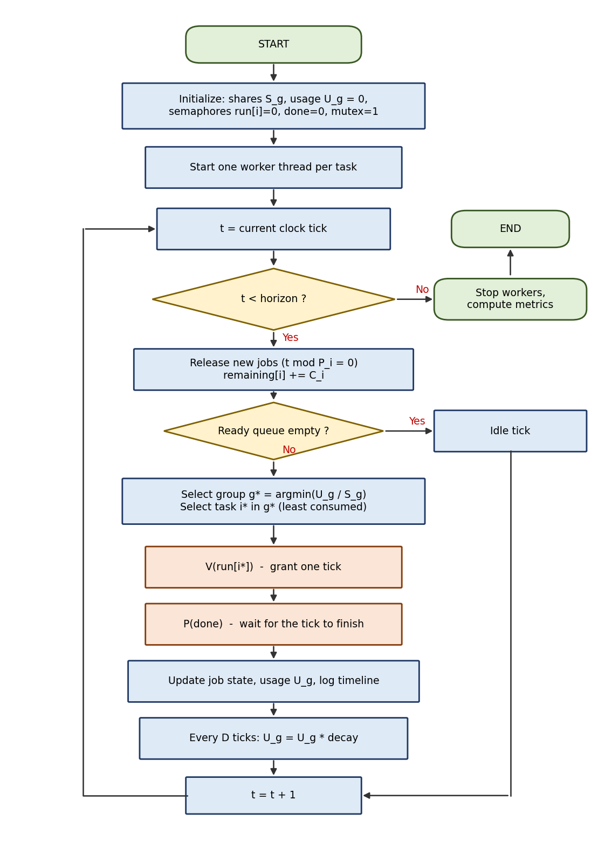
Figure 2: Flowchart of the Fair Share dispatcher

7.5 Worker Thread Flowchart
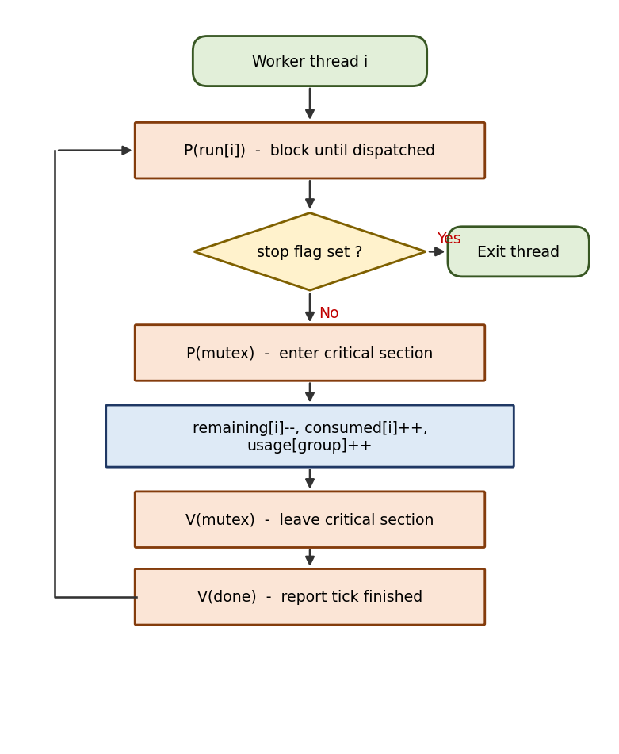
Figure 3: Flowchart of a task (worker) thread

7.6 Job State Diagram
A job moves through the states of Figure 4. It becomes READY at its arrival time. While it is not selected, its thread is blocked on run[i]. The dispatcher's V(run[i]) moves the job to RUNNING for one tick; after V(done) it either returns to READY (if work remains, which also models preemption) or becomes TERMINATED.
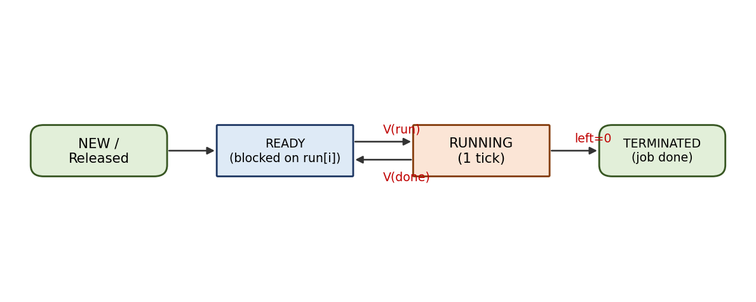
Figure 4: Job states and the semaphore operations that trigger transitions

7.7 Pseudo-code
Algorithm 1: Semaphore-based dispatcher
1 procedure DISPATCH(policy, tasks, shares, horizon):
2 init run[i] = 0, done = 0, mutex = 1; start worker threads
3 for t = 0 .. horizon-1:
4 for each task i with t mod P[i] == 0: release job, remaining[i] += C[i]
5 ready = { i | remaining[i] > 0 }
6 if ready is empty: log idle; continue
7 if policy == FS:
8 g* = argmin over groups with ready tasks of usage[g] / share[g]
9 sel = task in g* with minimum consumed[i]
10 elif policy == EDF: sel = ready task with earliest absolute deadline
11 elif policy == RM: sel = ready task with smallest period
12 V(run[sel]); P(done) # one tick of CPU for 'sel'
13 update job record, log timeline
14 if (t+1) mod D == 0: P(mutex); usage[g] *= delta for all g; V(mutex)
15 stop workers; compute metrics

7.8 Complexity
Let n be the number of tasks and m the number of groups. Fair Share needs O(n + m) per tick (scan the ready tasks and the groups), EDF needs O(n) with a linear scan (O(log n) with a heap), and RM needs O(1) with a pre-sorted ready list. Every tick costs two semaphore operations pairs (V(run)/P(done) in the dispatcher and P(run)/V(done) in the worker) plus one mutex pair, so the synchronization cost per tick is constant for all three policies.

8. Implementation
The complete implementation is given below. The Python version (Listing 1) contains the three policies, the semaphore-based dispatcher, the metric computation and the two workloads. It uses threading.Semaphore. The C version (Listing 2) implements the Fair Share policy with POSIX semaphores (sem_t) and pthreads. Both versions produce the identical schedule for Experiment B: 124324124321423214324123.

8.1 Python Implementation (all three policies)
Listing 1: fs_sim.py
1 #!/usr/bin/env python3
2 """
3 Semaphore-based CPU scheduling simulator: Fair Share vs. EDF vs. RM.
4
5 Each task is a thread. The dispatcher grants one CPU tick at a time by
6 releasing the semaphore of the selected task and then blocking on the
7 'done' semaphore until the task has executed that tick.
8
9 Semaphores used:
10 run[i] - binary semaphore, task i may execute ONE tick (dispatch grant)
11 done - binary semaphore, signalled by task when its tick is finished
12 mutex - binary semaphore protecting shared tables (remaining, usage)
13 """
14 import threading
15 from math import gcd
16 from functools import reduce
17
18 # ------------------------------------------------------------------ model
19 class Task:
20 def __init__(self, tid, name, group, period, wcet):
21 self.tid, self.name, self.group = tid, name, group
22 self.period, self.wcet = period, wcet # deadline == period
23
24 # ---------------------------------------------------------- policy classes
25 def pick_rm(ready, ctx):
26 return min(ready, key=lambda j: (j["task"].period, j["task"].tid))
27
28 def pick_edf(ready, ctx):
29 return min(ready, key=lambda j: (j["deadline"], j["task"].tid))
30
31 def pick_fs(ready, ctx):
32 """Fair share: choose the group with the lowest usage/share ratio,
33 then inside the group the task that has consumed the least CPU."""
34 usage, share, consumed = ctx["usage"], ctx["share"], ctx["consumed"]
35 groups = {j["task"].group for j in ready}
36 g = min(groups, key=lambda x: (usage[x] / share[x], x))
37 cand = [j for j in ready if j["task"].group == g]
38 return min(cand, key=lambda j: (consumed[j["task"].tid], j["task"].tid))
39
40 POLICIES = {"FS": pick_fs, "EDF": pick_edf, "RM": pick_rm}
41
42 # --------------------------------------------------------------- simulator
43 def simulate(policy, tasks, shares, horizon, decay_every=6, decay=0.5):
44 # The run is cut at 'horizon' (one hyperperiod); unfinished jobs count as missed.
45 mutex = threading.Semaphore(1)
46 done = threading.Semaphore(0)
47 run = {t.tid: threading.Semaphore(0) for t in tasks}
48 stop = {"flag": False}
49 remaining = {t.tid: 0 for t in tasks}
50 consumed = {t.tid: 0 for t in tasks}
51 usage = {g: 0.0 for g in shares}
52 raw_usage = {g: 0 for g in shares}
53
54 def worker(tid):
55 while True:
56 run[tid].acquire() # P(run[i]) - wait for grant
57 if stop["flag"]:
58 return
59 mutex.acquire() # P(mutex)
60 remaining[tid] -= 1 # execute one tick
61 consumed[tid] += 1
62 g = tasks[tid].group
63 usage[g] += 1
64 raw_usage[g] += 1
65 mutex.release() # V(mutex)
66 done.release() # V(done)
67
68 threads = [threading.Thread(target=worker, args=(t.tid,), daemon=True)
69 for t in tasks]
70 for th in threads:
71 th.start()
72
73 pick = POLICIES[policy]
74 jobs, active, timeline = [], [], []
75 last, switches, preempts = None, 0, 0
76 t = 0
77 while True:
78 # ---- release jobs
79 for tk in tasks:
80 if t < horizon and t % tk.period == 0:
81 j = dict(task=tk, k=t // tk.period + 1, release=t,
82 deadline=t + tk.period, start=None, finish=None)
83 jobs.append(j)
84 active.append(j)
85 remaining[tk.tid] += tk.wcet
86 ready = [j for j in active if j["finish"] is None]
87 if t >= horizon:
88 break
89 if ready:
90 ctx = dict(usage=usage, share=shares, consumed=consumed)
91 # a task's oldest unfinished job is the one that runs
92 heads = {}
93 for j in ready:
94 heads.setdefault(j["task"].tid, j)
95 sel = pick(list(heads.values()), ctx)
96 tid = sel["task"].tid
97 if last is not None and last != tid:
98 switches += 1
99 prev = [j for j in ready if j["task"].tid == last]
100 if prev:
101 preempts += 1
102 if sel["start"] is None:
103 sel["start"] = t
104 run[tid].release() # V(run[i]) - dispatch
105 done.acquire() # P(done)
106 sel["left"] = sel.get("left", sel["task"].wcet) - 1
107 if sel["left"] == 0:
108 sel["finish"] = t + 1
109 timeline.append((t, tid))
110 last = tid
111 else:
112 timeline.append((t, None))
113 last = None
114 t += 1
115 if decay_every and t % decay_every == 0: # usage decay (fair share)
116 mutex.acquire()
117 for g in usage:
118 usage[g] *= decay
119 mutex.release()
120
121 stop["flag"] = True
122 for tk in tasks:
123 run[tk.tid].release()
124 for th in threads:
125 th.join()
126 return dict(jobs=jobs, timeline=timeline, switches=switches,
127 preempts=preempts, raw_usage=raw_usage)
128
129 # ------------------------------------------------------------------ metrics
130 def metrics(res, tasks, shares):
131 jobs = res["jobs"]
132 n = len(jobs)
133 done_jobs = [j for j in jobs if j["finish"] is not None]
134 resp = [j["finish"] - j["release"] for j in done_jobs]
135 wait = [r - j["task"].wcet for r, j in zip(resp, done_jobs)]
136 late = [j["finish"] - j["deadline"] for j in done_jobs]
137 miss = sum(1 for j in jobs
138 if j["finish"] is None or j["finish"] > j["deadline"])
139 busy = sum(1 for _, x in res["timeline"] if x is not None)
140 total = len(res["timeline"])
141 ru = res["raw_usage"]
142 tot = sum(ru.values())
143 achieved = {g: ru[g] / tot for g in ru}
144 ratio = [achieved[g] / shares[g] for g in shares]
145 jain = sum(ratio) ** 2 / (len(ratio) * sum(r * r for r in ratio))
146 dev = sum(abs(achieved[g] - shares[g]) for g in shares) / 2
147 return dict(n=n, completed=len(done_jobs), misses=miss,
148 avg_resp=sum(resp) / len(resp), avg_wait=sum(wait) / len(wait),
149 max_late=max(0, max(late)), util=busy / total,
150 switches=res["switches"], preempts=res["preempts"],
151 achieved=achieved, jain=jain, dev=dev, makespan=total)
152
153 # ----------------------------------------------------------------- workload
154 TASKS_A = [ # normal load, U = 0.917
155 Task(0, "T1", "G1", 4, 1),
156 Task(1, "T2", "G2", 6, 2),
157 Task(2, "T3", "G1", 8, 2),
158 Task(3, "T4", "G3", 12, 1),
159 ]
160 TASKS_B = [ # overload, U = 1.333
161 Task(0, "T1", "G1", 4, 2),
162 Task(1, "T2", "G2", 6, 2),
163 Task(2, "T3", "G1", 8, 2),
164 Task(3, "T4", "G3", 12, 3),
165 ]
166 SHARES = {"G1": 0.40, "G2": 0.35, "G3": 0.25}
167
168 def hyperperiod(tasks):
169 return reduce(lambda a, b: a * b // gcd(a, b), [t.period for t in tasks])
170
171 if __name__ == "__main__":
172 for label, TS in (("A", TASKS_A), ("B", TASKS_B)):
173 H = hyperperiod(TS)
174 print("SET", label, "H", H, "U =", round(sum(t.wcet / t.period for t in TS), 3))
175 for name in ("FS", "EDF", "RM"):
176 r = simulate(name, TS, SHARES, H)
177 m = metrics(r, TS, SHARES)
178 print(name, {k: (round(v, 3) if isinstance(v, float) else v)
179 for k, v in m.items() if k != "achieved"},
180 {g: round(v, 3) for g, v in m["achieved"].items()})
181 print(" ", "".join("." if x is None else str(x + 1)
182 for _, x in r["timeline"]))

8.2 C Implementation with POSIX Semaphores (Fair Share)
Listing 2: fs_sem.c
1 /* Fair Share scheduler using POSIX semaphores (pthreads).
2 * Build: gcc -O2 -pthread fs_sem.c -o fs_sem */
3 #include <stdio.h>
4 #include <pthread.h>
5 #include <semaphore.h>
6
7 #define N 4 /* tasks */
8 #define NG 3 /* groups */
9 #define HORIZ 24 /* one hyperperiod */
10 #define DECAY_EVERY 6
11 #define DECAY 0.5
12
13 typedef struct { int id, group, period, wcet; } Task;
14 static Task T[N] = {{0,0,4,2},{1,1,6,2},{2,0,8,2},{3,2,12,3}};
15 static double share[NG] = {0.40, 0.35, 0.25};
16
17 static sem_t run[N]; /* dispatch grant, one per task */
18 static sem_t done; /* tick-finished signal */
19 static sem_t mutex; /* protects remaining/consumed/usage */
20 static int remaining[N], consumed[N], stop_flag = 0;
21 static double usage[NG];
22
23 static void *worker(void *arg) {
24 int i = (int)(long)arg;
25 for (;;) {
26 sem_wait(&run[i]); /* P(run[i]) */
27 if (stop_flag) return NULL;
28 sem_wait(&mutex); /* P(mutex) */
29 remaining[i]--; consumed[i]++; usage[T[i].group] += 1.0;
30 sem_post(&mutex); /* V(mutex) */
31 sem_post(&done); /* V(done) */
32 }
33 }
34
35 static int pick_fair_share(void) {
36 int bestg = -1, besti = -1;
37 for (int g = 0; g < NG; g++) { /* group with min usage/share */
38 int has = 0;
39 for (int i = 0; i < N; i++) if (T[i].group == g && remaining[i] > 0) has = 1;
40 if (has && (bestg < 0 || usage[g]/share[g] < usage[bestg]/share[bestg]))
41 bestg = g;
42 }
43 if (bestg < 0) return -1;
44 for (int i = 0; i < N; i++) /* least-consumed task in it */
45 if (T[i].group == bestg && remaining[i] > 0 &&
46 (besti < 0 || consumed[i] < consumed[besti])) besti = i;
47 return besti;
48 }
49
50 int main(void) {
51 pthread_t th[N];
52 sem_init(&done, 0, 0); sem_init(&mutex, 0, 1);
53 for (int i = 0; i < N; i++) {
54 sem_init(&run[i], 0, 0);
55 pthread_create(&th[i], NULL, worker, (void *)(long)i);
56 }
57 for (int t = 0; t < HORIZ; t++) {
58 for (int i = 0; i < N; i++) /* periodic job release */
59 if (t % T[i].period == 0) remaining[i] += T[i].wcet;
60 int s = pick_fair_share();
61 if (s >= 0) { sem_post(&run[s]); sem_wait(&done); printf("%d", s+1); }
62 else printf(".");
63 if ((t+1) % DECAY_EVERY == 0)
64 for (int g = 0; g < NG; g++) usage[g] *= DECAY;
65 }
66 printf("\n");
67 stop_flag = 1;
68 for (int i = 0; i < N; i++) { sem_post(&run[i]); pthread_join(th[i], NULL); }
69 return 0;
70 }

8.3 How to Run
Commands
1 python3 fs_sim.py # runs Experiments A and B for FS, EDF, RM
2 gcc -O2 -pthread fs_sem.c -o fs_sem # build the C version
3 ./fs_sem # prints the Fair Share timeline of Exp. B

The timeline string uses one character per tick: the digit k means that task Tk executed during that tick and a dot means that the CPU was idle.

9. Experimental Setup
Two task sets with the same four tasks and the same group structure are used. The hyperperiod is lcm(4, 6, 8, 12) = 24 ticks, and each experiment simulates exactly one hyperperiod. All tasks arrive for the first time at t = 0 and deadlines are implicit (Di = Pi). Task T1 and T3 belong to group G1 (share 40%), T2 to G2 (35%) and T4 to G3 (25%). The decay parameters are D = 6 and delta = 0.5.
Table 7: Experiment A - normal load (U = 0.917)
Task | Group | First arrival | Period P | WCET C | Deadline D | Utilization C/P
T1 | G1 (40%) | 0 | 4 | 1 | 4 | 0.250
T2 | G2 (35%) | 0 | 6 | 2 | 6 | 0.333
T3 | G1 (40%) | 0 | 8 | 2 | 8 | 0.250
T4 | G3 (25%) | 0 | 12 | 1 | 12 | 0.083
Total |  |  |  |  |  | 0.917
Table 8: Experiment B - overload (U = 1.333)
Task | Group | First arrival | Period P | WCET C | Deadline D | Utilization C/P
T1 | G1 (40%) | 0 | 4 | 2 | 4 | 0.500
T2 | G2 (35%) | 0 | 6 | 2 | 6 | 0.333
T3 | G1 (40%) | 0 | 8 | 2 | 8 | 0.250
T4 | G3 (25%) | 0 | 12 | 3 | 12 | 0.250
Total |  |  |  |  |  | 1.333

Over one hyperperiod 15 jobs are released: 6 of T1, 4 of T2, 3 of T3 and 2 of T4. In Experiment A the total demand is 22 ticks out of 24, so the CPU is idle for 2 ticks if all jobs are served. In Experiment B the demand is 32 ticks for 24 ticks of CPU, so at least one third of the work cannot be finished in the window and some deadlines must be missed by every algorithm. In this overloaded situation the question is not who meets all deadlines, but how the damage is distributed.
Jobs not finished by the end of the window are counted as missed (status *Unfinished*). Average response and waiting times are computed over completed jobs only. CPU share is the fraction of busy ticks consumed by each group.

10. Results: Experiment A (Normal Load)
Figures 5 to 7 show the schedules produced by the three algorithms. Each coloured block is one tick of execution; the black marks on each row are the release and deadline instants of the task.
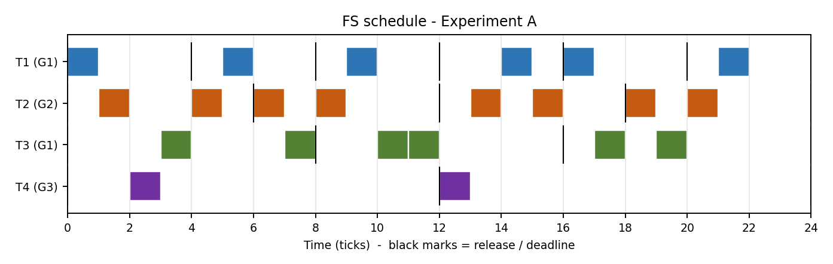
Figure 5: FS schedule, Experiment A
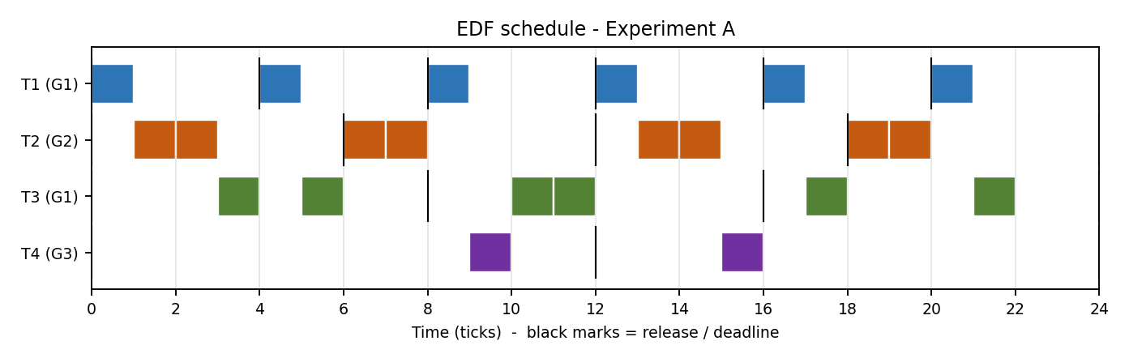
Figure 6: EDF schedule, Experiment A
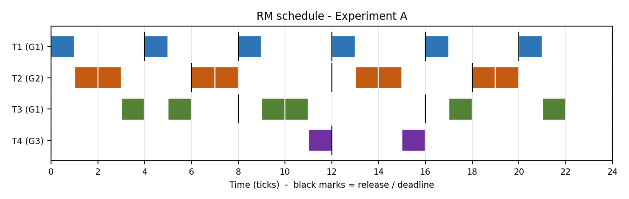
Figure 7: RM schedule, Experiment A
Observation. All three algorithms meet all 15 deadlines, as predicted by the schedulability analysis (EDF: U <= 1; RM: RTA gives R(T4) = 12 <= 12). EDF and Fair Share obtain the same average response time (3.07 ticks), RM is slightly slower (3.13). The visible difference is in the *shape* of the schedule: EDF and RM run each job almost without interruption, while Fair Share interleaves tasks tick by tick because its decision depends on group usage, which causes more switches (20 versus 16).
Table 9: Fair Share - arrival, start and exit times (Experiment A)
Job | Group | Arrival | Start | Exit | Deadline | Response | Waiting | Status
T1-1 | G1 | 0 | 0 | 1 | 4 | 1 | 0 | Met
T2-1 | G2 | 0 | 1 | 5 | 6 | 5 | 3 | Met
T3-1 | G1 | 0 | 3 | 8 | 8 | 8 | 6 | Met
T4-1 | G3 | 0 | 2 | 3 | 12 | 3 | 2 | Met
T1-2 | G1 | 4 | 5 | 6 | 8 | 2 | 1 | Met
T2-2 | G2 | 6 | 6 | 9 | 12 | 3 | 1 | Met
T1-3 | G1 | 8 | 9 | 10 | 12 | 2 | 1 | Met
T3-2 | G1 | 8 | 10 | 12 | 16 | 4 | 2 | Met
T1-4 | G1 | 12 | 14 | 15 | 16 | 3 | 2 | Met
T2-3 | G2 | 12 | 13 | 16 | 18 | 4 | 2 | Met
T4-2 | G3 | 12 | 12 | 13 | 24 | 1 | 0 | Met
T1-5 | G1 | 16 | 16 | 17 | 20 | 1 | 0 | Met
T3-3 | G1 | 16 | 17 | 20 | 24 | 4 | 2 | Met
T2-4 | G2 | 18 | 18 | 21 | 24 | 3 | 1 | Met
T1-6 | G1 | 20 | 21 | 22 | 24 | 2 | 1 | Met

Table 10: EDF - arrival, start and exit times (Experiment A)
Job | Group | Arrival | Start | Exit | Deadline | Response | Waiting | Status
T1-1 | G1 | 0 | 0 | 1 | 4 | 1 | 0 | Met
T2-1 | G2 | 0 | 1 | 3 | 6 | 3 | 1 | Met
T3-1 | G1 | 0 | 3 | 6 | 8 | 6 | 4 | Met
T4-1 | G3 | 0 | 9 | 10 | 12 | 10 | 9 | Met
T1-2 | G1 | 4 | 4 | 5 | 8 | 1 | 0 | Met
T2-2 | G2 | 6 | 6 | 8 | 12 | 2 | 0 | Met
T1-3 | G1 | 8 | 8 | 9 | 12 | 1 | 0 | Met
T3-2 | G1 | 8 | 10 | 12 | 16 | 4 | 2 | Met
T1-4 | G1 | 12 | 12 | 13 | 16 | 1 | 0 | Met
T2-3 | G2 | 12 | 13 | 15 | 18 | 3 | 1 | Met
T4-2 | G3 | 12 | 15 | 16 | 24 | 4 | 3 | Met
T1-5 | G1 | 16 | 16 | 17 | 20 | 1 | 0 | Met
T3-3 | G1 | 16 | 17 | 22 | 24 | 6 | 4 | Met
T2-4 | G2 | 18 | 18 | 20 | 24 | 2 | 0 | Met
T1-6 | G1 | 20 | 20 | 21 | 24 | 1 | 0 | Met

Table 11: RM - arrival, start and exit times (Experiment A)
Job | Group | Arrival | Start | Exit | Deadline | Response | Waiting | Status
T1-1 | G1 | 0 | 0 | 1 | 4 | 1 | 0 | Met
T2-1 | G2 | 0 | 1 | 3 | 6 | 3 | 1 | Met
T3-1 | G1 | 0 | 3 | 6 | 8 | 6 | 4 | Met
T4-1 | G3 | 0 | 11 | 12 | 12 | 12 | 11 | Met
T1-2 | G1 | 4 | 4 | 5 | 8 | 1 | 0 | Met
T2-2 | G2 | 6 | 6 | 8 | 12 | 2 | 0 | Met
T1-3 | G1 | 8 | 8 | 9 | 12 | 1 | 0 | Met
T3-2 | G1 | 8 | 9 | 11 | 16 | 3 | 1 | Met
T1-4 | G1 | 12 | 12 | 13 | 16 | 1 | 0 | Met
T2-3 | G2 | 12 | 13 | 15 | 18 | 3 | 1 | Met
T4-2 | G3 | 12 | 15 | 16 | 24 | 4 | 3 | Met
T1-5 | G1 | 16 | 16 | 17 | 20 | 1 | 0 | Met
T3-3 | G1 | 16 | 17 | 22 | 24 | 6 | 4 | Met
T2-4 | G2 | 18 | 18 | 20 | 24 | 2 | 0 | Met
T1-6 | G1 | 20 | 20 | 21 | 24 | 1 | 0 | Met

Table 12: Summary of Experiment A
Metric | Fair Share | EDF | RM
Jobs released | 15 | 15 | 15
Deadline misses | 0 | 0 | 0
Average response time | 3.07 | 3.07 | 3.13
Average waiting time | 1.60 | 1.60 | 1.67
Maximum lateness | 0 | 0 | 0
CPU utilization | 91.7% | 91.7% | 91.7%
Context switches | 20 | 16 | 16
Preemptions | 7 | 2 | 3
CPU share G1 / G2 / G3 (%) | 54.5 / 36.4 / 9.1 | 54.5 / 36.4 / 9.1 | 54.5 / 36.4 / 9.1

In Experiment A the CPU shares are identical for all algorithms (54.5 / 36.4 / 9.1 percent) because every job is completed: the shares are dictated by the demand of the groups, not by the policy. G3 receives only 9.1% instead of its 25% entitlement simply because T4 needs only one tick per 12. Fair Share does not waste or reserve the unused entitlement; it lets other groups use it (work-conserving behavior). Differences between policies become visible only when the CPU is contended, which is the subject of the next section.

11. Results: Experiment B (Overload)
With U = 1.333 the CPU is saturated (100% busy) and no algorithm can finish all jobs. Figures 8 to 10 show how each algorithm distributes the available ticks.
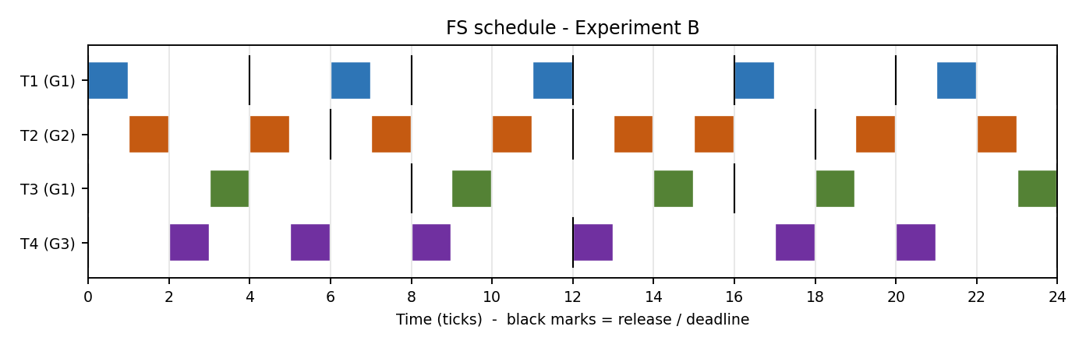
Figure 8: FS schedule, Experiment B (overload)
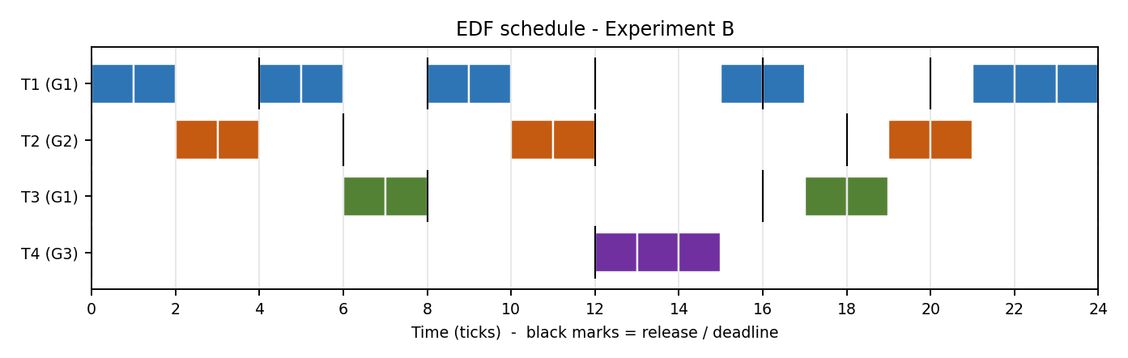
Figure 9: EDF schedule, Experiment B (overload)
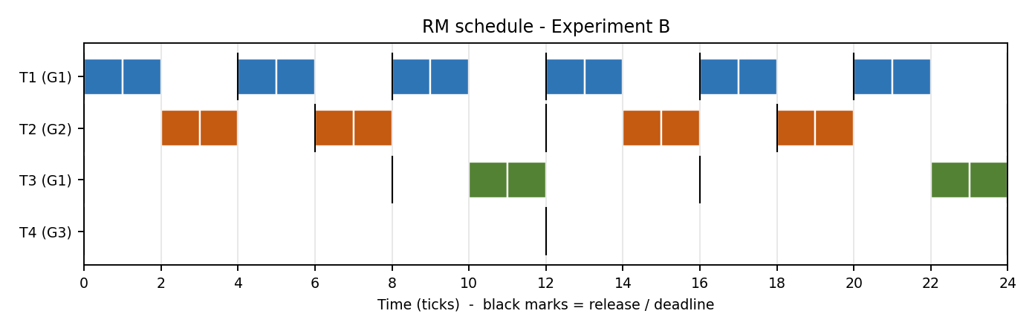
Figure 10: RM schedule, Experiment B (overload)
Observation. The three schedules are very different. RM serves T1 and T2 (shortest periods) almost perfectly and gives the remaining ticks to T3; T4 is never executed - complete starvation of group G3. EDF serves whichever deadline is closest; it works on T1 and T2 but also spends ticks on jobs that are already late, and T4 receives only a small number of ticks. Fair Share rotates between the groups in proportion to their shares: all four tasks make progress in every part of the window, at the price of finishing fewer jobs on time.
Table 13: Fair Share - arrival, start and exit times (Experiment B)
Job | Group | Arrival | Start | Exit | Deadline | Response | Waiting | Status
T1-1 | G1 | 0 | 0 | 7 | 4 | 7 | 5 | Missed
T2-1 | G2 | 0 | 1 | 5 | 6 | 5 | 3 | Met
T3-1 | G1 | 0 | 3 | 10 | 8 | 10 | 8 | Missed
T4-1 | G3 | 0 | 2 | 9 | 12 | 9 | 6 | Met
T1-2 | G1 | 4 | 11 | 17 | 8 | 13 | 11 | Missed
T2-2 | G2 | 6 | 7 | 11 | 12 | 5 | 3 | Met
T1-3 | G1 | 8 | 21 | - | 12 | - | - | Unfinished
T3-2 | G1 | 8 | 14 | 19 | 16 | 11 | 9 | Missed
T1-4 | G1 | 12 | - | - | 16 | - | - | Unfinished
T2-3 | G2 | 12 | 13 | 16 | 18 | 4 | 2 | Met
T4-2 | G3 | 12 | 12 | 21 | 24 | 9 | 6 | Met
T1-5 | G1 | 16 | - | - | 20 | - | - | Unfinished
T3-3 | G1 | 16 | 23 | - | 24 | - | - | Unfinished
T2-4 | G2 | 18 | 19 | 23 | 24 | 5 | 3 | Met
T1-6 | G1 | 20 | - | - | 24 | - | - | Unfinished

Table 14: EDF - arrival, start and exit times (Experiment B)
Job | Group | Arrival | Start | Exit | Deadline | Response | Waiting | Status
T1-1 | G1 | 0 | 0 | 2 | 4 | 2 | 0 | Met
T2-1 | G2 | 0 | 2 | 4 | 6 | 4 | 2 | Met
T3-1 | G1 | 0 | 6 | 8 | 8 | 8 | 6 | Met
T4-1 | G3 | 0 | 12 | 15 | 12 | 15 | 12 | Missed
T1-2 | G1 | 4 | 4 | 6 | 8 | 2 | 0 | Met
T2-2 | G2 | 6 | 10 | 12 | 12 | 6 | 4 | Met
T1-3 | G1 | 8 | 8 | 10 | 12 | 2 | 0 | Met
T3-2 | G1 | 8 | 17 | 19 | 16 | 11 | 9 | Missed
T1-4 | G1 | 12 | 15 | 17 | 16 | 5 | 3 | Missed
T2-3 | G2 | 12 | 19 | 21 | 18 | 9 | 7 | Missed
T4-2 | G3 | 12 | - | - | 24 | - | - | Unfinished
T1-5 | G1 | 16 | 21 | 23 | 20 | 7 | 5 | Missed
T3-3 | G1 | 16 | - | - | 24 | - | - | Unfinished
T2-4 | G2 | 18 | - | - | 24 | - | - | Unfinished
T1-6 | G1 | 20 | 23 | - | 24 | - | - | Unfinished

Table 15: RM - arrival, start and exit times (Experiment B)
Job | Group | Arrival | Start | Exit | Deadline | Response | Waiting | Status
T1-1 | G1 | 0 | 0 | 2 | 4 | 2 | 0 | Met
T2-1 | G2 | 0 | 2 | 4 | 6 | 4 | 2 | Met
T3-1 | G1 | 0 | 10 | 12 | 8 | 12 | 10 | Missed
T4-1 | G3 | 0 | - | - | 12 | - | - | Unfinished
T1-2 | G1 | 4 | 4 | 6 | 8 | 2 | 0 | Met
T2-2 | G2 | 6 | 6 | 8 | 12 | 2 | 0 | Met
T1-3 | G1 | 8 | 8 | 10 | 12 | 2 | 0 | Met
T3-2 | G1 | 8 | 22 | 24 | 16 | 16 | 14 | Missed
T1-4 | G1 | 12 | 12 | 14 | 16 | 2 | 0 | Met
T2-3 | G2 | 12 | 14 | 16 | 18 | 4 | 2 | Met
T4-2 | G3 | 12 | - | - | 24 | - | - | Unfinished
T1-5 | G1 | 16 | 16 | 18 | 20 | 2 | 0 | Met
T3-3 | G1 | 16 | - | - | 24 | - | - | Unfinished
T2-4 | G2 | 18 | 18 | 20 | 24 | 2 | 0 | Met
T1-6 | G1 | 20 | 20 | 22 | 24 | 2 | 0 | Met

Table 16: Summary of Experiment B (overload)
Metric | Fair Share | EDF | RM
Jobs released / completed | 15 / 10 | 15 / 11 | 15 / 12
Deadline misses (incl. unfinished) | 9 | 9 | 5
Average response time (completed) | 7.80 | 6.45 | 4.33
Average waiting time (completed) | 5.60 | 4.36 | 2.33
Maximum lateness (completed) | 9 | 3 | 8
CPU utilization | 100% | 100% | 100%
Context switches | 23 | 10 | 11
Preemptions | 17 | 6 | 1
CPU share G1 (target 40%) | 41.7% | 62.5% | 66.7%
CPU share G2 (target 35%) | 33.3% | 25.0% | 33.3%
CPU share G3 (target 25%) | 25.0% | 12.5% | 0.0%
Total deviation from targets | 1.7 pts | 22.5 pts | 26.7 pts
Jain fairness index | 0.999 | 0.803 | 0.621

12. Comparison and Discussion

12.1 Charts
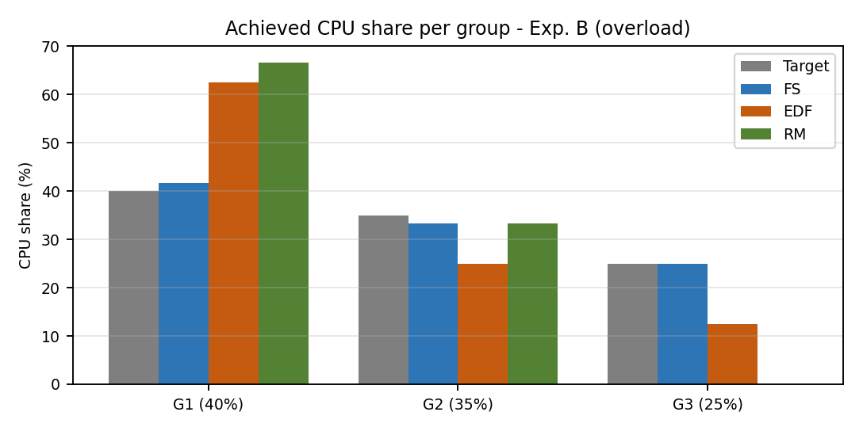
Figure 11: CPU share per group versus the configured target (Experiment B)
Figure 11 is the central result of the study: Fair Share allocates 41.7%, 33.3% and 25.0% of the CPU to the three groups, almost exactly the 40/35/25 configuration. EDF gives 62.5/25.0/12.5 and RM gives 66.7/33.3/0.0: RM's fixed priorities hand the whole CPU surplus to the short-period group and nothing to G3.
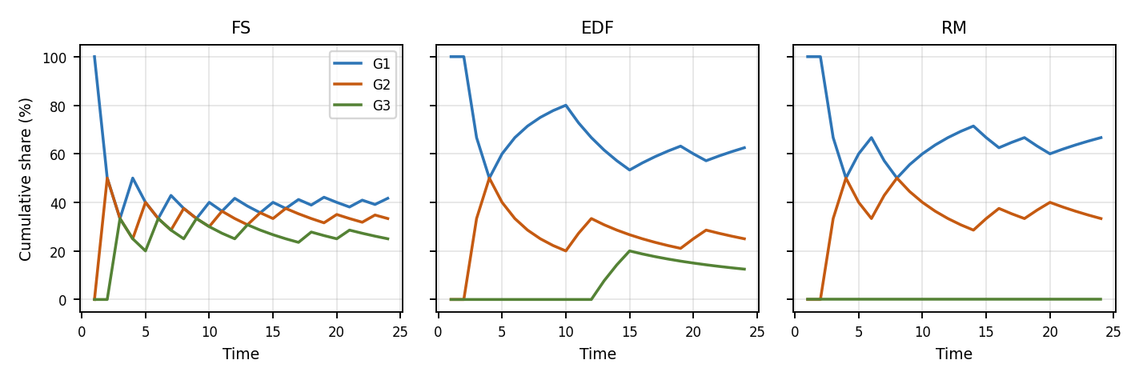
Figure 12: Cumulative CPU share of each group over time (Experiment B)
Figure 12 shows how the cumulative shares evolve. Under Fair Share the curves converge quickly to the target values; under RM the share of G1 grows and G3 stays at zero; under EDF the curves oscillate depending on which deadlines are close.
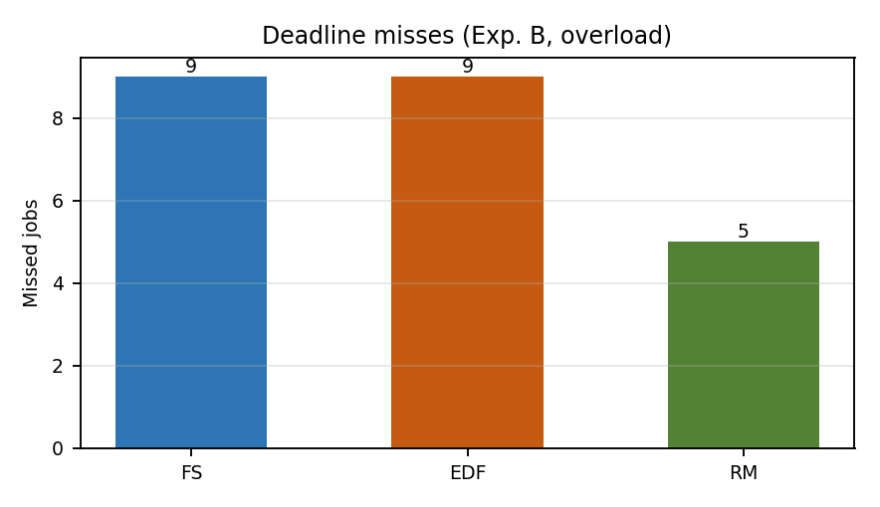  Figure 13: Deadline misses (Experiment B) | 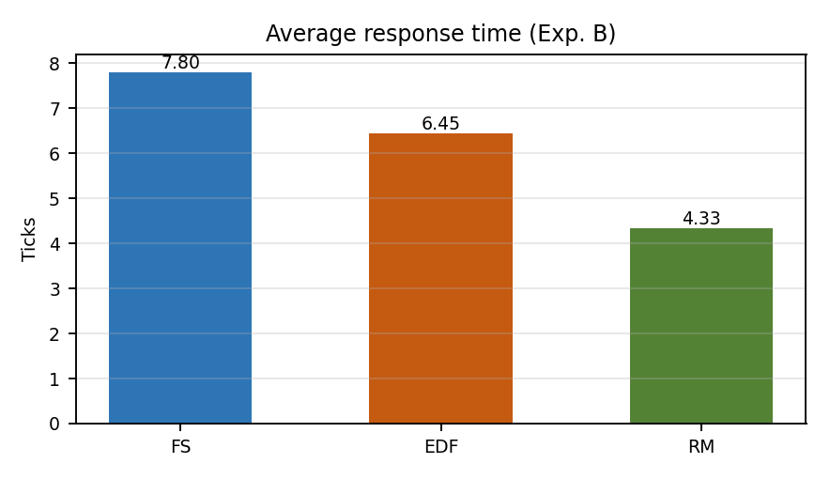  Figure 14: Average response time (Experiment B)
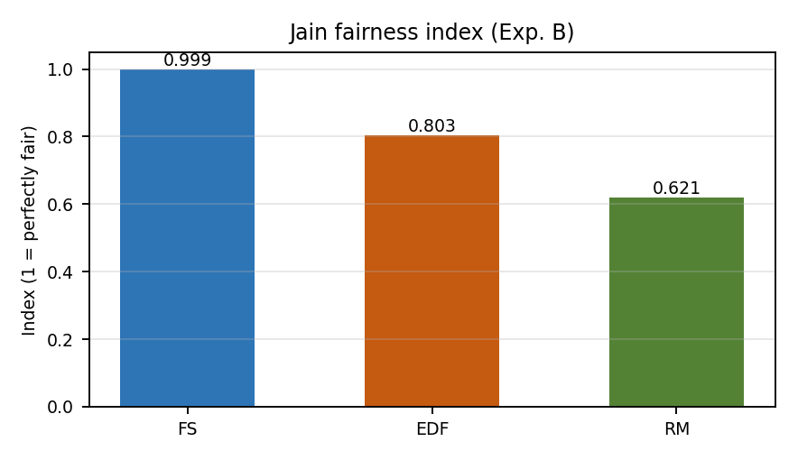  Figure 15: Jain fairness index (Experiment B) | 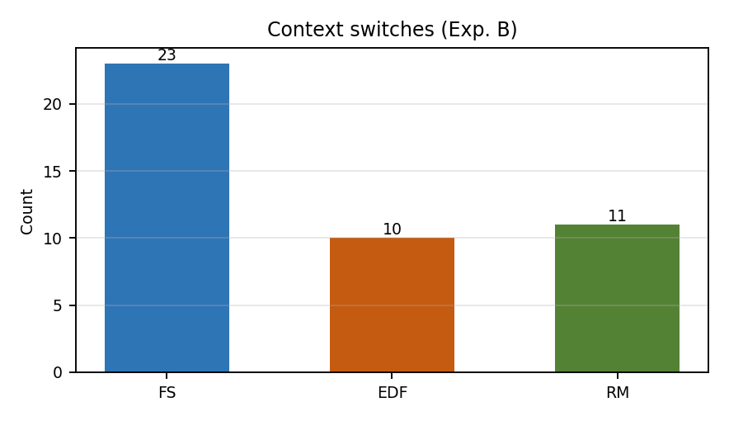  Figure 16: Context switches (Experiment B)

12.2 Quantitative Comparison
Table 17: Experiment B at a glance (best value in green)
Criterion | Fair Share | EDF | RM
Deadline misses (lower is better) | 9 | 9 | 5
Average response (lower is better) | 7.80 | 6.45 | 4.33
Jain fairness (higher is better) | 0.999 | 0.803 | 0.621
Largest share deviation | 1.7 pts | 22.5 pts | 26.7 pts
Starved group | none | none (G3 12.5%) | G3 (0%)
Context switches (lower is better) | 23 | 10 | 11
Preemptions (lower is better) | 17 | 6 | 1

12.3 Qualitative Comparison of Features
Table 18: Feature comparison of Fair Share, EDF and RM
Feature | Fair Share | EDF | RM
Scheduling criterion | Group usage / share | Earliest absolute deadline | Shortest period
Priority type | Dynamic (per tick) | Dynamic (per job) | Static (per task)
Preemptive | Yes | Yes | Yes
Optimality | None for deadlines; fair by design | Optimal (uniprocessor) | Optimal among fixed priority
Utilization bound | No hard bound | 100% | 69%-100% (exact RTA)
Schedulability test | Not applicable | U <= 1 | Liu-Layland bound / RTA
Needs deadlines | No | Yes | No (periods only)
Fairness / shares | Excellent | None | None
Starvation | No | Possible for late jobs | Yes (low priority)
Overload behavior | Graceful, proportional | Domino effect | Low-priority tasks lost
Run-time overhead | O(n+m) per tick | O(n) / O(log n) | O(1)
Context switches | Highest | Low | Low
Implementation effort | Medium (usage + decay) | Medium (deadlines) | Low
Best suited for | Multi-user / multi-tenant systems, soft real-time | Hard real-time with U <= 1 | Simple, predictable embedded systems

12.4 Discussion
Timing guarantees. The experiments confirm the textbook results. When the load is feasible, EDF (and here also RM) deliver all deadlines. Fair Share also met all deadlines in Experiment A, but this is not guaranteed by its design: it ignores deadlines, so with a different share configuration it could miss deadlines even at low utilization.
Overload. In Experiment B, RM produced the fewest deadline misses (5), because its fixed priorities sacrifice the least important task completely and keep the important ones on time. This is exactly the behavior wanted in a hard real-time system in which tasks have a clear importance ordering, but it is unacceptable if G3 is a paying customer or a different user: it would receive nothing. EDF had the same number of misses as Fair Share (9), with a lower mean response time; its schedule is difficult to predict because it continuously changes priorities toward jobs that are already late.
Fairness. Fair Share is the only algorithm that follows the configured shares (Jain 0.999, total deviation 1.7 points). Its price is more context switches (23 versus 10 and 11), because the group with the lowest normalized usage changes frequently. The tick-level switching can be reduced by granting a time quantum of q ticks instead of one tick, or by adding hysteresis, at the cost of coarser fairness.
Synchronization cost. In the semaphore implementation the synchronization cost is the same for all three policies (two semaphore round trips per tick), so the comparison above isolates the effect of the scheduling rule. The hand-shake makes the dispatcher the only active thread outside the one-tick execution window, which removes data races on the usage table and makes the results reproducible.

12.5 Threats to Validity
- Only one hyperperiod (24 ticks) and two small task sets were used; the numbers illustrate behavior and are not statistical averages.
- Ticks are logical; real context-switch and semaphore costs are not charged to the tasks.
- Deadlines are not enforced by aborting late jobs; late jobs keep running until the window ends.
- Fair Share parameters (D = 6, delta = 0.5) were chosen once and not tuned.

13. Conclusion and Future Work
We implemented a Fair Share scheduler in which tasks are threads and the dispatcher, the tasks and the shared accounting tables are coordinated exclusively by semaphores: one binary semaphore per task for dispatching, one done semaphore for acknowledgement and one mutex for the shared data. The same dispatcher was used to implement EDF and RM, and the Python and C versions of Fair Share produce the same schedule.
The evaluation shows that the three algorithms solve different problems. EDF is the right choice when hard deadlines must be met and the utilization does not exceed one. RM is the simplest and most predictable choice when tasks have a natural priority order. Fair Share is the right choice when the CPU must be divided between independent owners: it reached a Jain index of 0.999 under overload, never starved any group and respected the configured 40/35/25 split to within 1.7 percentage points, but it offers no deadline guarantee and incurs more context switches.
- Future work 1: hybrid schedulers that use Fair Share between groups and EDF inside each group, giving isolation and deadline awareness together.
- Future work 2: a time quantum larger than one tick to reduce context switches, and automatic tuning of the decay parameters.
- Future work 3: multi-core extension with per-core run queues and a counting semaphore for the pool of CPUs, and randomized task sets for statistically significant results.

References
- E. W. Dijkstra, "Cooperating Sequential Processes," Technical report EWD-123, Technische Hogeschool Eindhoven, 1965.
- J. Kay and P. Lauder, "A Fair Share Scheduler," Communications of the ACM, vol. 31, no. 1, 1988.
- C. L. Liu and J. W. Layland, "Scheduling Algorithms for Multiprogramming in a Hard-Real-Time Environment," Journal of the ACM, vol. 20, no. 1, 1973.
- M. L. Dertouzos, "Control Robotics: The Procedural Control of Physical Processes," Proc. IFIP Congress, 1974.
- C. A. Waldspurger and W. E. Weihl, "Lottery Scheduling: Flexible Proportional-Share Resource Management," Proc. OSDI, 1994.
- R. Jain, D. Chiu and W. Hawe, "A Quantitative Measure of Fairness and Discrimination for Resource Allocation in Shared Computer Systems," DEC Technical Report TR-301, 1984.
- G. C. Buttazzo, Hard Real-Time Computing Systems: Predictable Scheduling Algorithms and Applications, Springer.
- A. Silberschatz, P. B. Galvin and G. Gagne, Operating System Concepts, Wiley.
- A. S. Tanenbaum and H. Bos, Modern Operating Systems, Pearson.

Appendix A: Fair Share Decision Trace
Table 19 lists the decision of the Fair Share scheduler at every tick of Experiment B. Vg = Ug / Sg is the normalized usage before the decision; the group with the smallest Vg among groups with ready tasks is chosen (bold). The usage counters are halved after ticks 6, 12, 18 and 24 (decay).
Table 19: Tick-by-tick trace of the Fair Share scheduler, Experiment B
Tick | Ready tasks | V(G1) | V(G2) | V(G3) | Chosen group | Chosen task
0 | T1,T2,T3,T4 | 0.00 | 0.00 | 0.00 | G1 | T1
1 | T1,T2,T3,T4 | 2.50 | 0.00 | 0.00 | G2 | T2
2 | T1,T2,T3,T4 | 2.50 | 2.86 | 0.00 | G3 | T4
3 | T1,T2,T3,T4 | 2.50 | 2.86 | 4.00 | G1 | T3
4 | T1,T2,T3,T4 | 5.00 | 2.86 | 4.00 | G2 | T2
5 | T1,T3,T4 | 5.00 | 5.71 | 4.00 | G3 | T4
6 | T1,T2,T3,T4 | 2.50 | 2.86 | 4.00 | G1 | T1
7 | T1,T2,T3,T4 | 5.00 | 2.86 | 4.00 | G2 | T2
8 | T1,T2,T3,T4 | 5.00 | 5.71 | 4.00 | G3 | T4
9 | T1,T2,T3 | 5.00 | 5.71 | 8.00 | G1 | T3
10 | T1,T2,T3 | 7.50 | 5.71 | 8.00 | G2 | T2
11 | T1,T3 | 7.50 | 8.57 | 8.00 | G1 | T1
12 | T1,T2,T3,T4 | 5.00 | 4.29 | 4.00 | G3 | T4
13 | T1,T2,T3,T4 | 5.00 | 4.29 | 8.00 | G2 | T2
14 | T1,T2,T3,T4 | 5.00 | 7.14 | 8.00 | G1 | T3
15 | T1,T2,T3,T4 | 7.50 | 7.14 | 8.00 | G2 | T2
16 | T1,T3,T4 | 7.50 | 10.00 | 8.00 | G1 | T1
17 | T1,T3,T4 | 10.00 | 10.00 | 8.00 | G3 | T4
18 | T1,T2,T3,T4 | 5.00 | 5.00 | 6.00 | G1 | T3
19 | T1,T2,T3,T4 | 7.50 | 5.00 | 6.00 | G2 | T2
20 | T1,T2,T3,T4 | 7.50 | 7.86 | 6.00 | G3 | T4
21 | T1,T2,T3 | 7.50 | 7.86 | 10.00 | G1 | T1
22 | T1,T2,T3 | 10.00 | 7.86 | 10.00 | G2 | T2
23 | T1,T3 | 10.00 | 10.71 | 10.00 | G1 | T3

Reading the first rows: at t = 0 all normalized usages are 0, so the tie is resolved in favor of G1 and task T1 runs. At t = 1, V(G1) = 1/0.40 = 2.5 while the others are 0, so G2 is chosen; at t = 2, V(G2) = 1/0.35 = 2.86 and V(G3) = 0, so G3 (task T4) runs. This round-robin-like rotation, weighted by the shares, is what produces the near-perfect 41.7 / 33.3 / 25.0 distribution.
Complete execution timelines (one character per tick, digit = task number):
1 Experiment A
2 A - FS 1243212321334212132321..
3 A - EDF 1223132214331224132213..
4 A - RM 1223132213341224132213..
5
6 Experiment B
7 B - FS 124324124321423214324123
8 B - EDF 112211331122444113322111
9 B - RM 112211221133112211221133

