OPERATING SYSTEMS · CONCURRENCY CONTROL
Comparison of the Readers–Writers Algorithm
Semaphore · Monitor · Dekker · Peterson

Report overview
Algorithms compared | Dekker (1965), Peterson (1981), Semaphores (Dijkstra), Monitors (Hoare / Brinch Hansen)
Implementation | Real C11 / POSIX programs, compiled with gcc and executed
Contents | Pseudocode, flowcharts, code listings, execution output, Gantt charts, benchmark, simulation, comparison tables, pros and cons
Time units | ns per operation (benchmark) · ms (traces) · ticks (simulation)
Date | November 2026
Prepared by: ______________________________
Course / Instructor: ______________________

Table of Contents
1. Introduction 3
2. The Readers–Writers Problem 3
3. Theoretical Background 5
4. Dekker's Algorithm 6
5. Peterson's Algorithm 9
6. Semaphore Solutions 11
7. Monitor Solution 14
8. Execution Traces and Behaviour 16
9. Time and Performance Analysis 18
10. Comprehensive Comparison 20
11. Advantages and Disadvantages 21
12. Qualitative Evaluation and Selection Guide 22
13. Correctness Pitfalls 23
14. Use in Real Systems 23
15. Conclusion 23
References 25
Figures and tables
This report contains 19 figures (flowcharts, code listings, execution output, Gantt charts and charts) and 18 tables.

1. Introduction
Modern operating systems, databases and multi-core applications execute many activities at the same time. As soon as two of those activities touch the same data, the order in which their individual steps interleave decides whether the program is correct. A race condition occurs when the final result depends on that unpredictable order. Synchronization primitives exist to remove such races while still letting the hardware do as much useful work in parallel as possible.
The Readers–Writers problem, formulated by Courtois, Heymans and Parnas in 1971, is one of the three classical synchronization problems (together with the Producer–Consumer and the Dining Philosophers problems). It models any shared resource that is accessed in two different ways: some activities only read it and cannot damage it, while others write it and must therefore be alone. Because readers do not interfere with each other, a good solution allows many readers at once; because a writer interferes with everybody, it forces every other activity out while it works.
This report compares four well-known ways of solving the problem: two software-only busy-waiting algorithms (Dekker's and Peterson's), and two higher-level synchronization abstractions (semaphores and monitors). For every technique the report gives the idea, the pseudocode, a flowchart, a working C implementation compiled and executed for this report, the real execution output, a timing analysis, and a list of strengths and weaknesses. The report ends with a side-by-side comparison and recommendations on when each technique should be used.
What is new in this report
All programs shown here were written, compiled with gcc and executed on a test machine. The execution traces, the Gantt charts and the micro-benchmark numbers are therefore real measurements, not invented examples. Where a discrete-time simulation is used (Section 9), it is labelled as a simulation.

1.1 Scope and methodology
- Algorithms compared: Dekker (1965), Peterson (1981), counting/binary semaphores (Dijkstra, 1965) and monitors with condition variables (Hoare 1974 / Brinch Hansen).
- Implementation language: C11 with POSIX threads, <semaphore.h>, <stdatomic.h> and pthread_mutex_t / pthread_cond_t.
- Criteria: safety (mutual exclusion), progress, bounded waiting / starvation, reader concurrency, scalability to N processes, hardware requirements, overhead and code complexity.
- Time units: nanoseconds per protected operation (micro-benchmark), milliseconds (execution traces) and abstract ticks (simulation).
- Test machine: a Linux container with one virtual CPU, gcc 13 and glibc POSIX threads. Absolute numbers will differ on other hardware; relative trends are what matter.

2. The Readers–Writers Problem

2.1 Formal definition
A shared resource (a file, a database record, a cache, a data structure) is used by an unbounded number of reader threads and writer threads. A correct protocol must guarantee the following rules at all times:
- Reader–reader sharing: any number of readers may be inside the critical section simultaneously.
- Writer exclusion: at most one writer may be inside the critical section.
- Reader–writer exclusion: a writer and a reader must never be inside together.
- Progress: if the resource is free, a waiting thread that is allowed in must eventually enter.
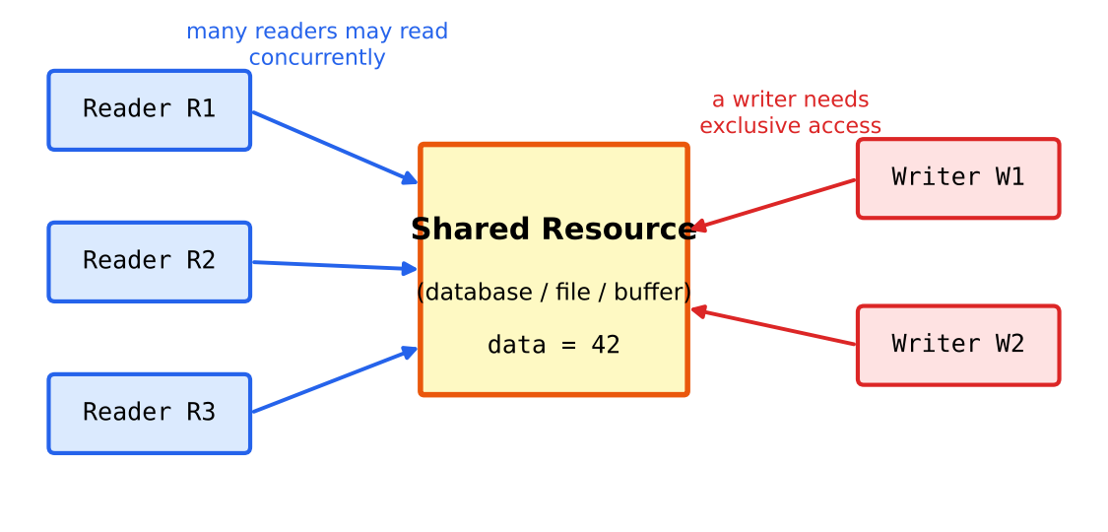
Figure 1: The Readers–Writers model: shared access for readers, exclusive access for writers

2.2 The three classical variants
The rules above leave a policy question open: when readers and writers are both waiting, who goes first? Courtois et al. identified two answers and a third variant is usually added in textbooks.
Table 1: Variants of the Readers–Writers problem
Variant | Policy | Consequence
First (reader preference) | No reader waits unless a writer is already writing. New readers may join an ongoing read phase. | Maximum read concurrency, but writers can starve under a continuous stream of readers.
Second (writer preference) | Once a writer is waiting, no new reader may start. Writers are served as soon as possible. | Writers never starve, but readers may starve under a continuous stream of writers; read concurrency is lower.
Third (fair / no starvation) | Requests are served roughly in arrival order. Consecutive readers are batched together. | Nobody starves; throughput is somewhat below the reader-preference solution.

2.3 Where the problem appears in practice
- Databases: shared (S) locks for SELECT and exclusive (X) locks for UPDATE in two-phase locking.
- File systems and kernels: inode and directory metadata, routing tables, page-cache structures (Linux rwsem, rwlock_t).
- Language runtimes: pthread_rwlock_t, Java ReentrantReadWriteLock, C++ std::shared_mutex, Go sync.RWMutex.
- Caches and configuration stores: read-mostly data that is occasionally refreshed by a background writer.
In a read-mostly workload (for example 95 % reads) a plain mutex wastes parallelism because it serialises readers that could safely run together. This is the motivation for reader–writer locks.

3. Theoretical Background

3.1 The critical-section problem
Each process has an entry section, a critical section (CS), an exit section and a remainder section. A solution has to satisfy three classical requirements:
Table 2: Requirements for a critical-section solution
Requirement | Meaning
Mutual exclusion | If process Pi is executing in its critical section, no other process can be executing in theirs.
Progress | If no process is in its CS and some want to enter, only processes outside their remainder sections take part in choosing the next one, and the choice cannot be postponed forever.
Bounded waiting | There is a bound on the number of times other processes may enter their CS after a process has requested entry and before that request is granted.

3.2 Busy waiting versus blocking
Busy waiting (spinning) keeps the CPU executing a loop until a condition becomes true. It needs no operating-system support and has very low latency when the wait is short, but it burns CPU cycles. Blocking primitives (semaphores, monitors) ask the kernel to deschedule the thread and wake it later; this costs a system call and a context switch, but the CPU is free for other work during the wait.
Dekker's and Peterson's algorithms are pure busy-waiting algorithms. Semaphores and monitors, as implemented in POSIX, first try a user-space atomic operation and fall back to a kernel wait (futex) only when there is contention.

3.3 Memory model and atomicity
Both software algorithms assume sequential consistency: every read and write of the shared variables flag[] and turn becomes visible to the other processor in program order. Real CPUs and compilers reorder memory operations, so the C11 programs in this report declare the variables atomic_int and use the default memory_order_seq_cst. Without that, Peterson's algorithm is incorrect on modern hardware: the store flag[i]=1 may be delayed behind the load of flag[j] in a store buffer, letting both processes enter.
Warning
Never implement Dekker or Peterson with plain int or volatile variables on a multi-core processor. Use atomic types with sequential consistency or explicit memory fences.

3.4 What the four techniques provide
Table 3: Level of abstraction of the four techniques
Technique | Needs hardware / OS support? | Processes supported | Waiting style
Dekker | No (atomic loads/stores only) | 2 | Busy waiting
Peterson | No (atomic loads/stores only) | 2 (N with filter / tournament) | Busy waiting
Semaphore | OS or library support | N | Blocking (queue)
Monitor | Language / library support | N | Blocking (condition queues)

4. Dekker's Algorithm

4.1 History and idea
Dekker's algorithm is the first known correct software solution to the two-process mutual-exclusion problem. It was devised by the Dutch mathematician Th. J. Dekker and described by Edsger Dijkstra in 1965. It combines two ideas: a flag array where each process announces its intention to enter, and a turn variable that breaks the tie when both announce at the same time. The key trick is that the process whose turn it is not temporarily withdraws its flag, so that the other process can proceed.

4.2 Pseudocode (process i, j = 1 − i)
Mini code — Dekker's entry and exit protocol
flag[i] = true;
while (flag[j]) { // other process also wants to enter
if (turn == j) { // it is the other's turn: back off
flag[i] = false;
while (turn == j) ; // wait until the turn changes
flag[i] = true; // try again
}
}
/* ---------- CRITICAL SECTION ---------- */
turn = j; // give the turn to the other process
flag[i] = false;

4.3 Flowchart
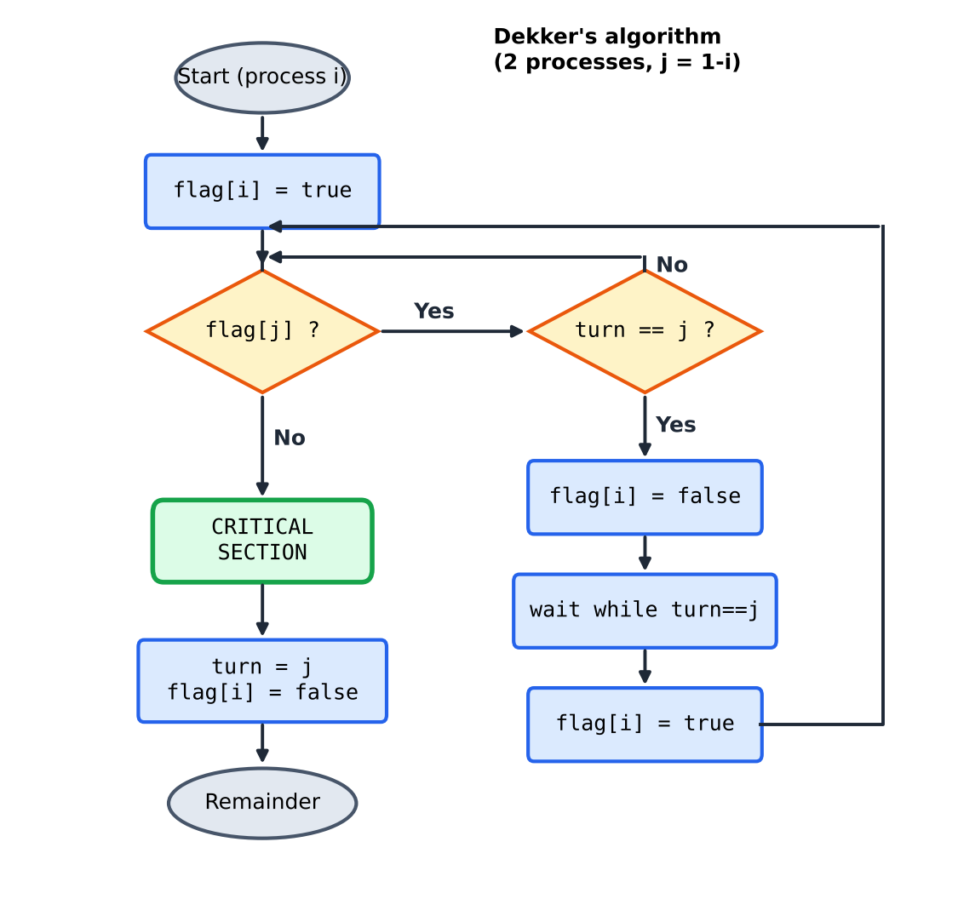
Figure 2: Flowchart of Dekker's algorithm for process i

4.4 Applying Dekker's algorithm to Readers–Writers
Dekker's algorithm only arbitrates between two processes. The natural mapping is process 0 = reader side and process 1 = writer side: the reader calls lock(0) before reading and the writer calls lock(1) before writing. This gives correct reader–writer exclusion, but, with only one reader process, the concept of several simultaneous readers does not arise. To support many readers one would have to protect a readcount variable with an N-process lock, which Dekker's algorithm does not offer; Peterson's filter lock or a hardware primitive is needed instead.
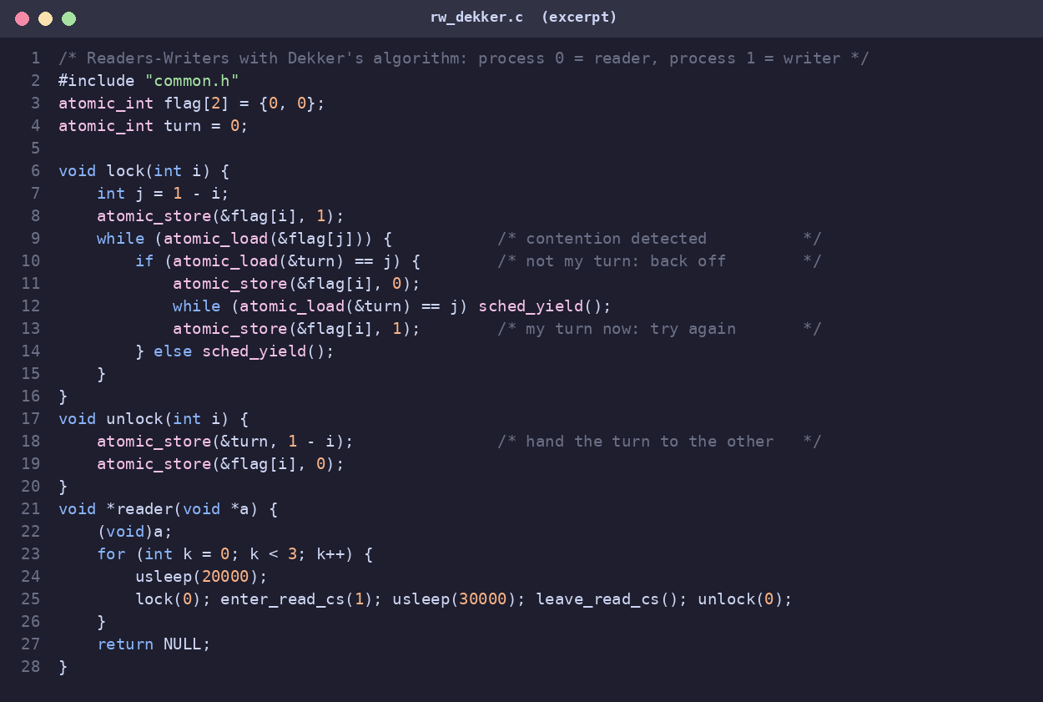
Figure 3: C11 implementation of Dekker's algorithm used for the Readers–Writers test (rw_dekker.c)

4.5 Execution result
The program runs one reader and one writer for three iterations each. The line “invariant violations=0” is produced by assertions inside the critical sections that count every moment a reader and a writer are inside simultaneously.
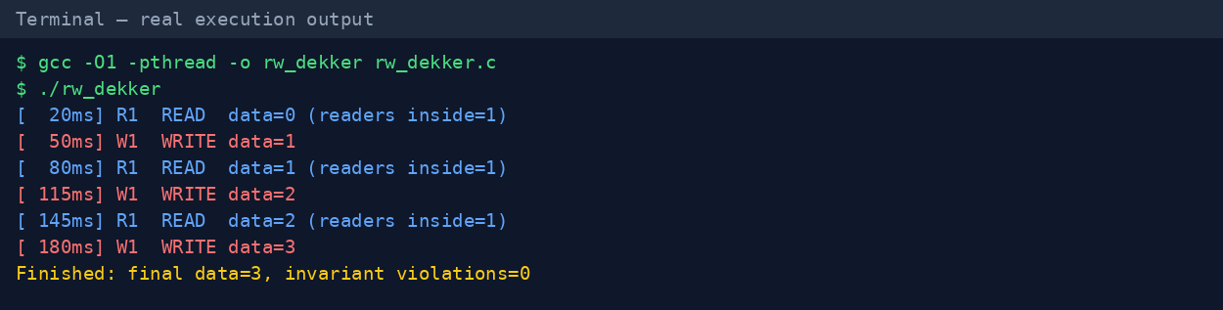
Figure 4: Real execution output of rw_dekker

4.6 Properties of Dekker's algorithm
Table 4: Characteristics of Dekker's algorithm
Property | Value
Mutual exclusion | Guaranteed (under sequential consistency)
Progress | Guaranteed: a process outside its CS never blocks the other
Bounded waiting | Yes: the other process can enter at most once before the waiting process
Shared memory | 2 flags + 1 turn variable (O(1))
Entry cost (no contention) | 1 store + 1 load (very cheap)
Contended behaviour | Back-off loop; waiting is busy waiting
Number of processes | Exactly 2; no simple generalisation
Reader concurrency | None in the 1R + 1W setup

Advantages: needs no special instruction, no operating system and no library; entry cost is minimal when there is no contention; it is a classical example for understanding mutual exclusion proofs. Disadvantages: the control flow with a nested loop and temporary flag withdrawal is hard to read and hard to prove; it wastes CPU while waiting; it does not extend to N processes; it is unsafe without atomic, ordered memory accesses.

5. Peterson's Algorithm

5.1 History and idea
Gary L. Peterson published his algorithm in 1981 (“Myths about the Mutual Exclusion Problem”, Information Processing Letters). It solves the same two-process problem as Dekker's algorithm with a much simpler structure. A process first sets its flag, then politely gives the turn to the other process, and finally waits only while the other process wants to enter and has the turn. Because the last writer of turn is the one who yields, one of the two processes is always able to proceed.

5.2 Pseudocode
Mini code — Peterson's entry and exit protocol
flag[i] = true; // I want to enter
turn = j; // but you may go first
while (flag[j] && turn == j) ; // wait only if you want in AND it is your turn
/* ---------- CRITICAL SECTION ---------- */
flag[i] = false; // I am done

5.3 Flowchart
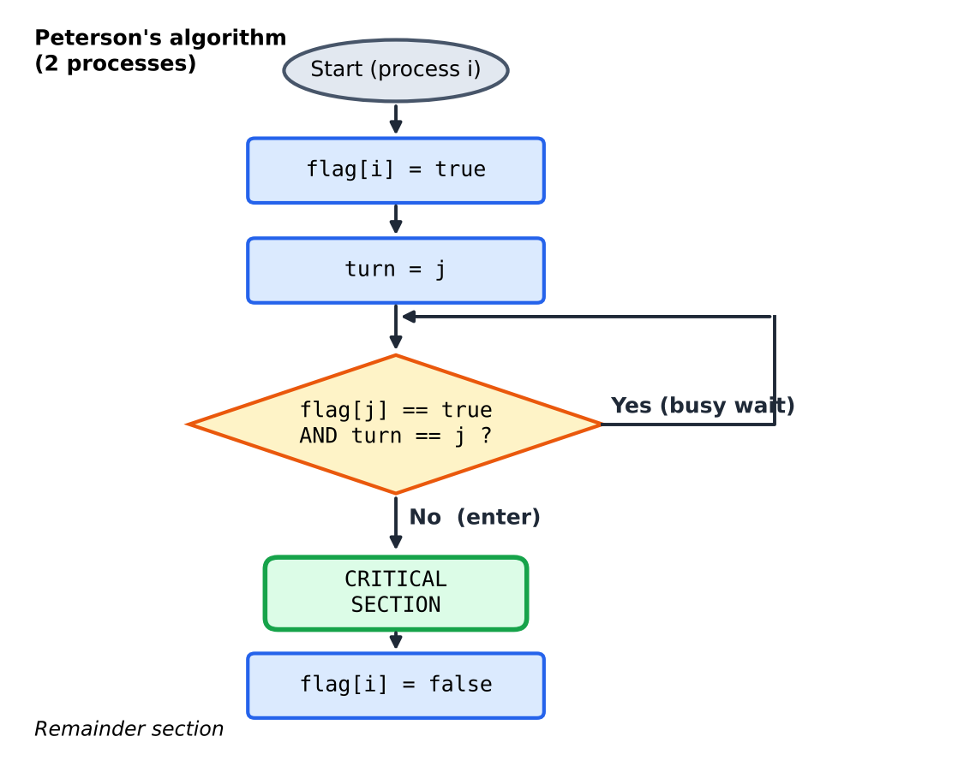
Figure 5: Flowchart of Peterson's algorithm for process i

5.4 Correctness argument
Mutual exclusion. Suppose both processes are in the critical section. Each had to pass the while test, so for P0 either flag[1] was false or turn was 0 at that moment, and symmetrically for P1. Since both flags were true when both were inside, both processes must have passed because of turn. But turn holds only one value, and each process writes the other's index into it just before testing. The process that wrote turn last therefore sees turn pointing at the other process and cannot pass. Contradiction.
Progress and bounded waiting. If P1 is in its remainder section then flag[1] is false and P0 passes immediately. If both compete, the value of turn decides and the loser enters right after the winner leaves; when the winner tries again it writes turn = j and therefore lets the waiting process go first. So a process waits for at most one critical section of the other.

5.5 Peterson's algorithm for Readers–Writers
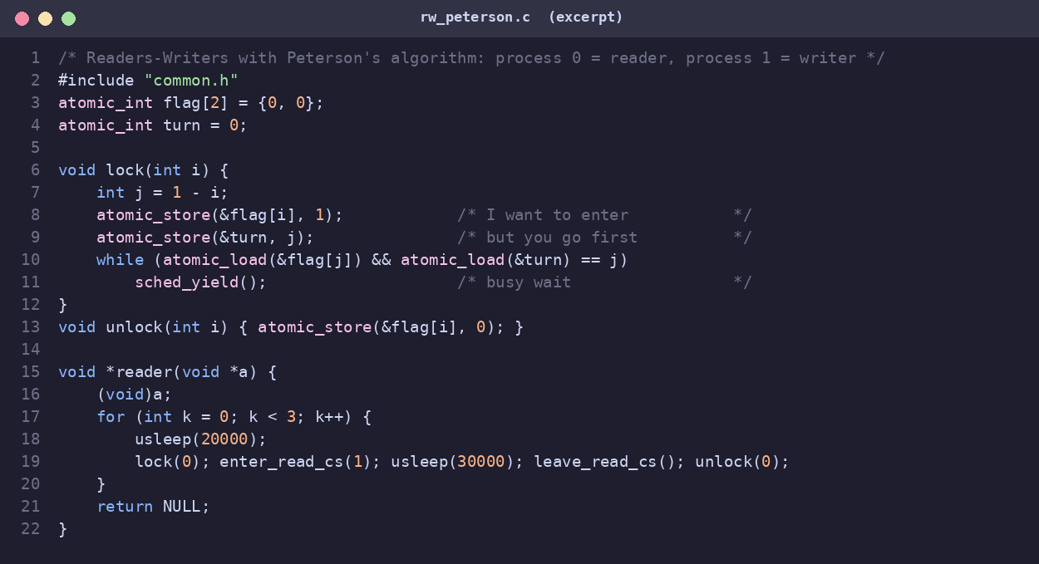
Figure 6: C11 implementation of Peterson's algorithm used for the Readers–Writers test (rw_peterson.c)
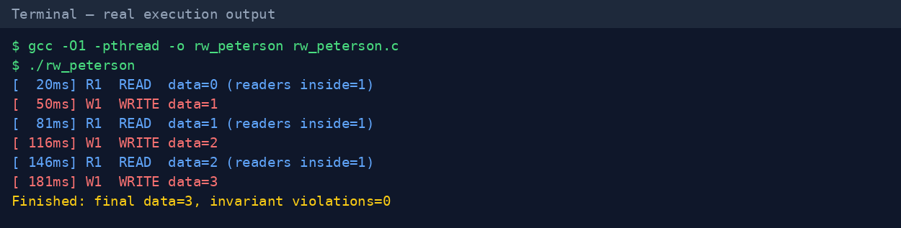
Figure 7: Real execution output of rw_peterson
The trace shows a strict alternation Read → Write → Read → Write: because both processes keep competing, turn hands the resource back and forth. This alternation is exactly the bounded-waiting guarantee in action.

5.6 Generalisation to N processes
The filter lock extends Peterson's idea to N processes by creating N − 1 “waiting rooms”. At each level one process is held back (the “victim”), so after N − 1 levels only one process remains. It needs two arrays of size N (level[], victim[]), gives mutual exclusion and starvation freedom but not first-come-first-served fairness, and its entry cost grows linearly with N. A tournament tree of two-process Peterson locks reduces the entry cost to O(log N). Lamport's bakery algorithm is the other classical N-process software solution.
Table 5: Characteristics of Peterson's algorithm
Property | Value
Mutual exclusion / progress / bounded waiting | All three satisfied (sequential consistency assumed)
Shared memory | 2 flags + 1 turn variable; O(N) for the filter lock
Lines of code | 3 lines of entry, 1 line of exit
Contended behaviour | Busy waiting, strict alternation
Hardware caveat | Needs sequential consistency; store→load reordering breaks it
Reader concurrency | None with only two processes

Advantages: extremely simple and elegant; easy to prove; no OS or atomic read-modify-write instruction required; smallest entry/exit cost of all four techniques in our benchmark. Disadvantages: two processes only (the filter version is slow for large N); busy waiting wastes CPU and is dangerous when a lock holder is preempted; correctness depends on memory ordering, so it is rarely used directly in production code.

6. Semaphore Solutions

6.1 Semaphores in brief
A semaphore is an integer variable that can be changed only through two atomic operations, introduced by Dijkstra: wait(S) (P, from proberen) decrements S and blocks the caller if the result would be negative, and signal(S) (V, from verhogen) increments S and wakes one blocked process. A binary semaphore (values 0/1) works as a lock; a counting semaphore counts available units of a resource. Waiting processes are kept in a queue by the operating system, so they do not consume CPU while blocked.

6.2 First problem — reader preference
The classic solution uses two binary semaphores and one counter. mutex protects the shared counter readcount; wrt gives exclusive access to the data. The first reader to arrive locks wrt, which keeps writers out for the whole read phase; the last reader to leave unlocks it. Writers simply lock wrt around their update.
Mini code — reader-preference solution
semaphore mutex = 1, wrt = 1; int readcount = 0;

Reader: Writer:
wait(mutex); wait(wrt);
readcount++; /* WRITE */
if (readcount == 1) wait(wrt); signal(wrt);
signal(mutex);
/* READ */
wait(mutex);
readcount--;
if (readcount == 0) signal(wrt);
signal(mutex);

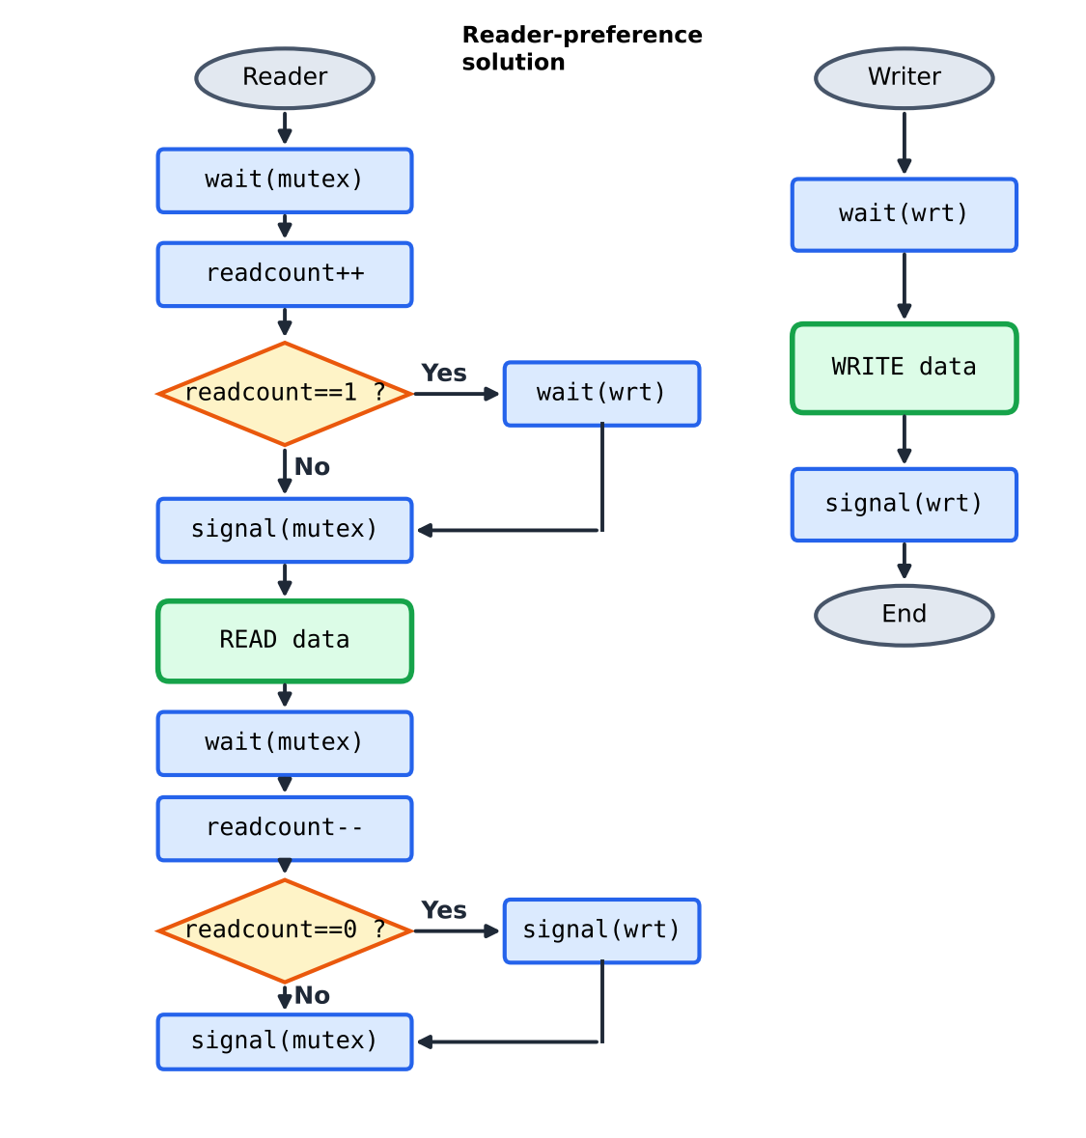
Figure 8: Flowchart of the semaphore solution (reader preference)
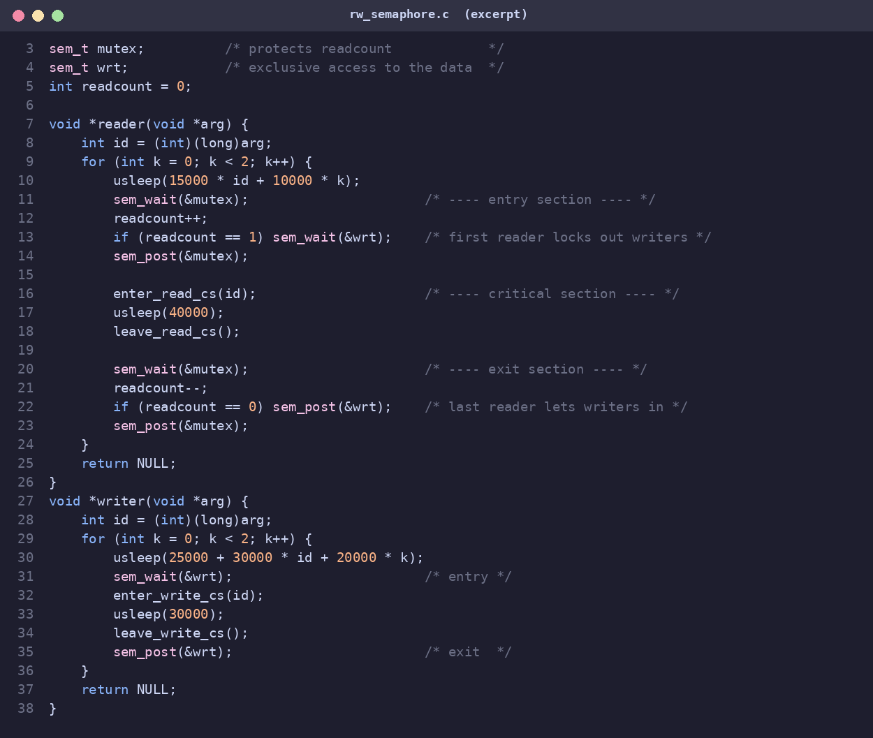
Figure 9: C implementation with POSIX semaphores (rw_semaphore.c)
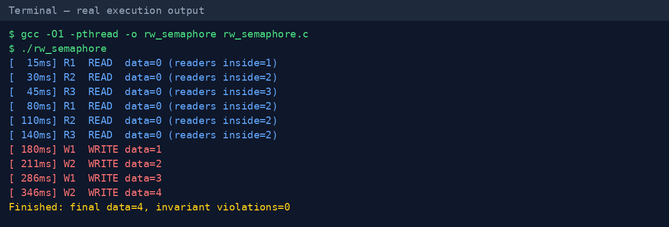
Figure 10: Real execution output of rw_semaphore (3 readers, 2 writers)
In the trace above all six read operations happen first, and both writers have to wait until every reader has finished (first write at 180 ms). This is reader preference in action: it maximises read concurrency (up to three readers inside simultaneously) but would starve writers if readers kept arriving.

6.3 Second problem — writer preference
To give writers priority, a second gate readTry is added. The first writer closes it, so no new reader can even start the entry protocol; the last writer reopens it.
Mini code — writer-preference solution
semaphore rmutex = 1, wmutex = 1, readTry = 1, resource = 1;
int readcount = 0, writecount = 0;

Reader: Writer:
wait(readTry); wait(wmutex);
wait(rmutex); writecount++;
readcount++; if (writecount == 1) wait(readTry);
if (readcount == 1) wait(resource); signal(wmutex);
signal(rmutex); wait(resource);
signal(readTry); /* WRITE */
/* READ */ signal(resource);
wait(rmutex); wait(wmutex);
readcount--; writecount--;
if (readcount == 0) signal(resource); if (writecount == 0) signal(readTry);
signal(rmutex); signal(wmutex);

6.4 Third problem — no starvation
A service queue semaphore forces every request, reader or writer, to pass one FIFO turnstile first. If the semaphore implementation wakes waiters in FIFO order (strong semaphores), no class of process can overtake the other indefinitely.
Mini code — fair solution with a turnstile
semaphore service = 1, rmutex = 1, resource = 1; int readcount = 0;

Reader: Writer:
wait(service); wait(service);
wait(rmutex); wait(resource);
readcount++; signal(service);
if (readcount == 1) wait(resource); /* WRITE */
signal(service); signal(resource);
signal(rmutex);
/* READ */ ... (same exit as before)

6.5 Properties of the semaphore approach
Table 6: Characteristics of the semaphore solutions
Property | Value
Mutual exclusion | Guaranteed by the atomicity of wait/signal
Number of processes | Any N
Reader concurrency | Yes (all readers share wrt)
Starvation | Writers (problem 1), readers (problem 2); none in the fair variant
Waiting style | Blocking: waiting threads sleep in a queue
Typical entry cost | 1 atomic op uncontended; futex syscall when contended
Risks | Forgotten signal (deadlock), reversed order (deadlock), priority inversion

Advantages: works for any number of processes; no CPU is wasted while waiting; direct, well-understood solution; available in every operating system. Disadvantages: the synchronization logic is spread over several semaphores and counters and is easy to get wrong; a single missing signal can deadlock the system; there is no automatic protection (unlike a monitor) – the programmer must remember to pair every wait with a signal; the first variant starves writers.

7. Monitor Solution

7.1 What is a monitor?
A monitor (Hoare 1974, Brinch Hansen 1973) is a programming-language construct that bundles shared data with the procedures that access it and guarantees that only one thread executes inside the monitor at any time. Mutual exclusion is therefore automatic. For conditional waiting the monitor offers condition variables with two operations: wait(cond) releases the monitor lock and sleeps, and signal(cond) wakes one sleeping thread (broadcast wakes all). In C, a monitor is built from a pthread_mutex_t plus pthread_cond_t variables; in Java every object is a monitor (synchronized, wait, notify).

7.2 Writer-preference monitor
The monitor stores three variables: readers (active readers), writing (is a writer active?) and waitingW (number of waiting writers). A reader may enter only if nobody is writing and no writer is waiting; this is what gives writers priority. When a writer finishes it wakes the next writer if there is one, otherwise it wakes all waiting readers with broadcast, which lets them enter together.
Mini code — Java monitor with synchronized / wait / notifyAll
class RWMonitor {
private int readers = 0, waitingWriters = 0;
private boolean writing = false;

public synchronized void startRead() throws InterruptedException {
while (writing || waitingWriters > 0) wait();
readers++;
}
public synchronized void endRead() {
if (--readers == 0) notifyAll();
}
public synchronized void startWrite() throws InterruptedException {
waitingWriters++;
while (writing || readers > 0) wait();
waitingWriters--; writing = true;
}
public synchronized void endWrite() {
writing = false; notifyAll();
}
}

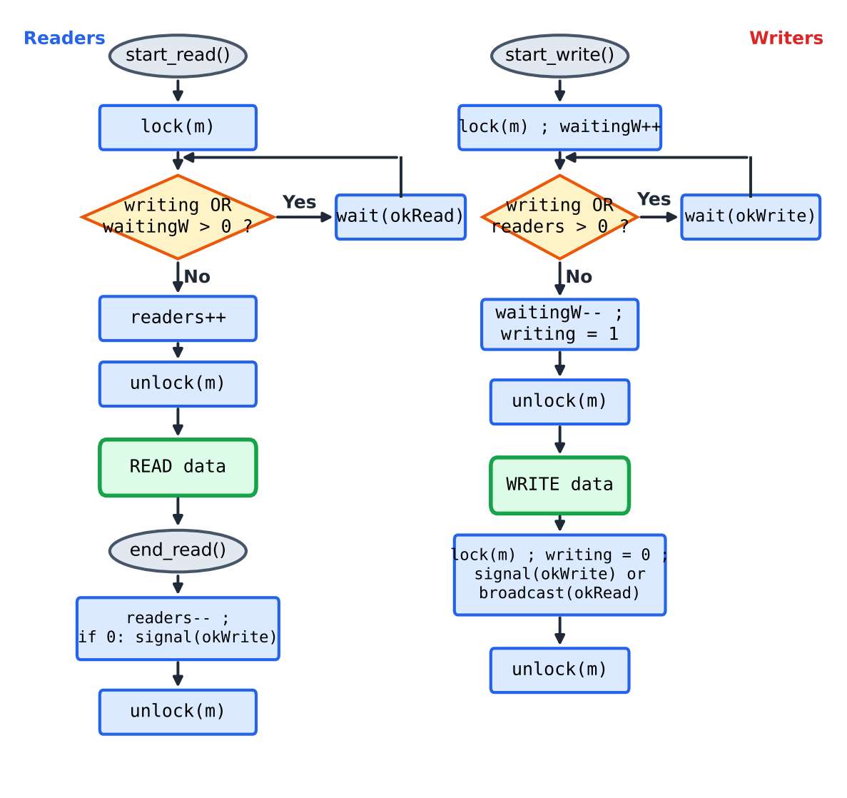
Figure 11: Flowchart of the monitor solution (start/end procedures for readers and writers)
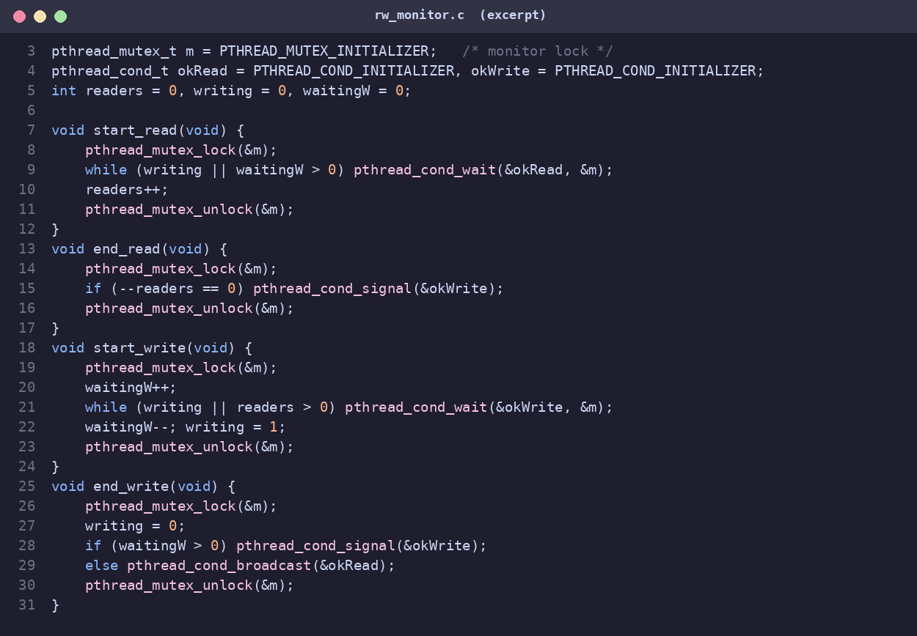
Figure 12: C implementation with pthread mutex and condition variables (rw_monitor.c)
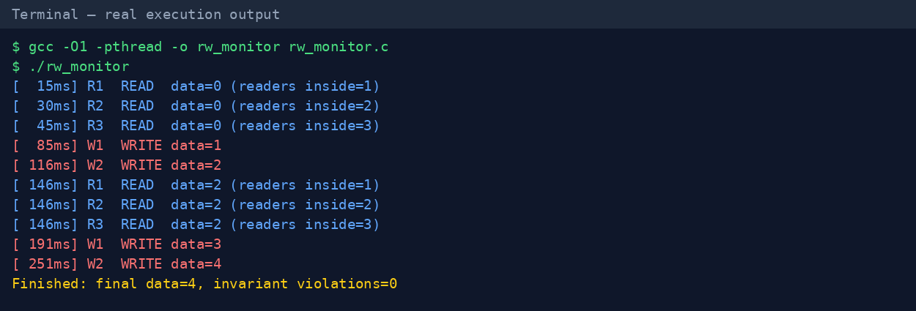
Figure 13: Real execution output of rw_monitor (3 readers, 2 writers)
Compared with the semaphore trace, the order is different: the three readers finish first, then both writers run back to back (85 ms and 116 ms) while the second round of readers has to wait, and only then the readers re-enter together at 146 ms. This is the writer-preference policy: waiting writers block new readers.

7.3 Properties of the monitor approach
Table 7: Characteristics of the monitor solution
Property | Value
Mutual exclusion | Automatic: one thread inside the monitor
Number of processes | Any N
Reader concurrency | Yes (readers run outside the monitor lock)
Starvation | Readers can starve under continuous writers; fixable with a turn flag
Waiting style | Blocking on condition variables
Wake-up cost | signal: O(1); broadcast: O(k) for k waiting readers
Risks | Lost wake-ups (wrong condition), using if instead of while, nested monitor calls

Advantages: the clearest and safest structure – locking is hidden in the procedures, so callers cannot forget it; the waiting conditions are written explicitly as boolean expressions, which makes policies (reader/writer/fair) easy to change; supported natively by Java, C#, Python and Go-style runtimes. Disadvantages: needs language or library support; condition-variable semantics (Mesa vs Hoare) are subtle; broadcast may wake many threads that immediately sleep again (thundering herd); a little more overhead per operation than a spin lock.

8. Execution Traces and Behaviour
The Gantt charts below are drawn from the real execution logs. Each bar starts when a thread enters the critical section; blue bars are reads, red bars are writes. Overlapping blue bars show reader concurrency; the position of the red bars shows the policy.
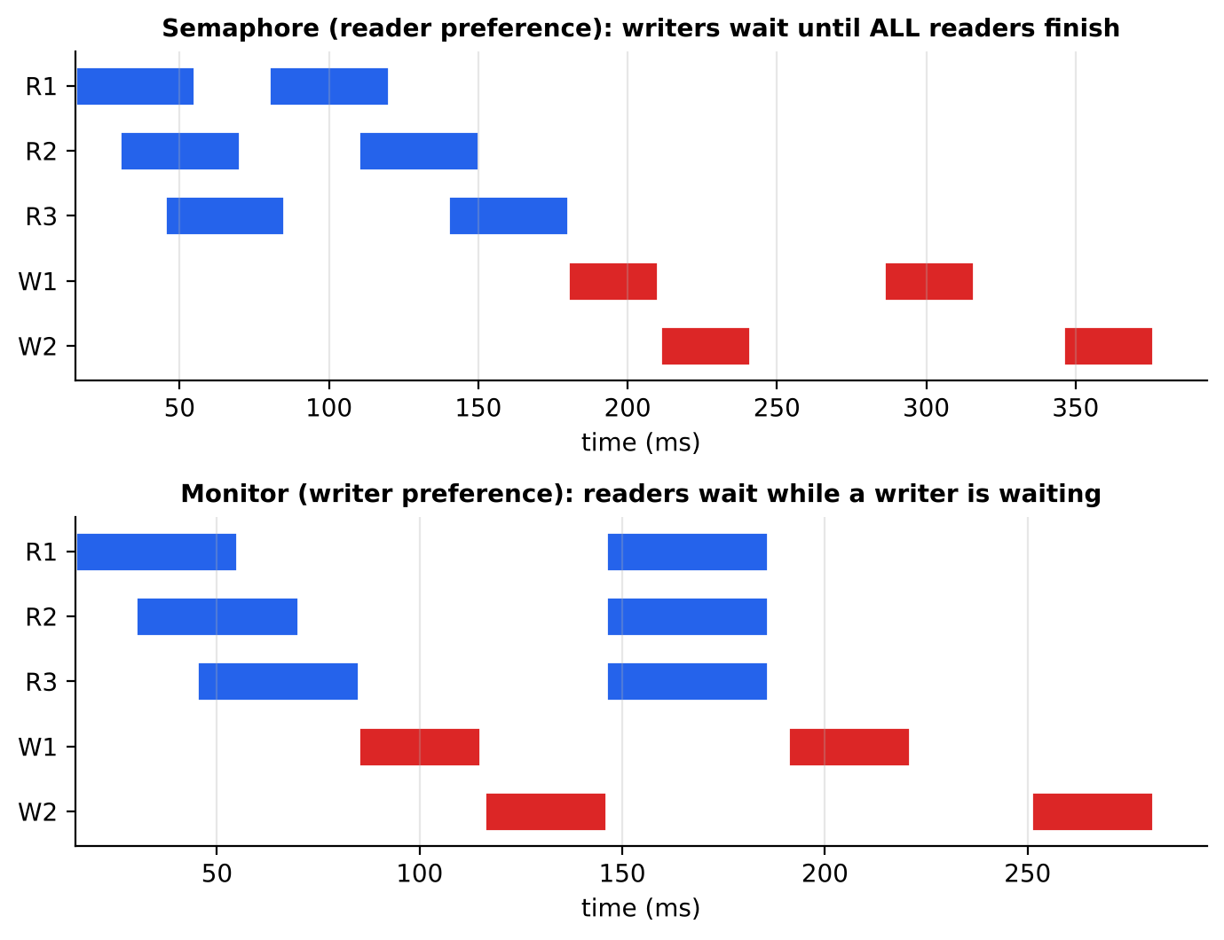
Figure 14: Gantt charts of the semaphore (reader preference) and monitor (writer preference) executions
Table 8: What the semaphore and monitor traces show
Observation | Semaphore (reader pref.) | Monitor (writer pref.)
Max readers inside together | 3 (R1, R2, R3 overlap at 45 ms) | 3 (at 45 ms and again at 146 ms)
First write starts at | 180 ms (after all 6 reads) | 85 ms (right after the first read phase)
Second read round starts at | 80 ms (before any write) | 146 ms (after both writers)
Final data value | 4 | 4
Violations of exclusion | 0 | 0

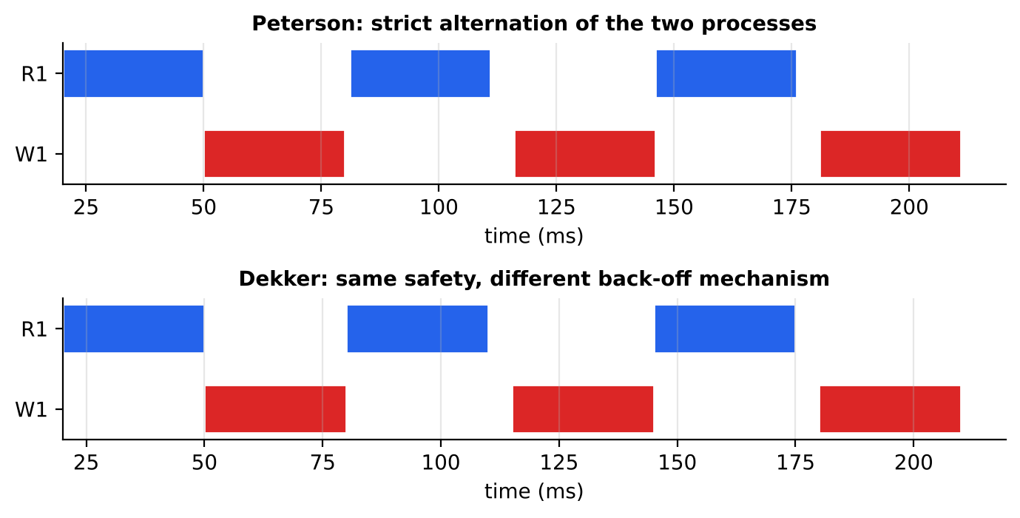
Figure 15: Gantt charts of Peterson and Dekker executions (one reader process, one writer process)
For Dekker and Peterson the Gantt charts are almost identical: the two processes strictly alternate and never overlap. With a single reader process there are no concurrent readers, so there is nothing to gain from shared access. Both algorithms nevertheless guarantee that the final value is the same (3) and that no violation occurred. The small timing differences (for example 115 ms versus 116 ms) come from usleep scheduling jitter, not from the algorithms.

8.1 Summary of the behaviours
- Semaphore (reader preference): high read parallelism, writers delayed – good for read-mostly data, risky for update latency.
- Monitor (writer preference): bounded writer delay, readers wait while a writer is queued – good when data freshness matters.
- Peterson / Dekker: perfect exclusion for exactly two parties, strictly alternating service, no shared reading.

9. Time and Performance Analysis

9.1 Time units used
Table 9: Time units in this report
Unit | Used for | Meaning
ns / operation | Micro-benchmark (Section 9.2) | Wall-clock time of one complete protected operation: entry section + tiny critical section + exit section, averaged over 100 000 operations per thread.
ms | Execution traces (Section 8) | Milliseconds since program start, measured with CLOCK_MONOTONIC.
tick | Simulation (Section 9.3) | One abstract time step; a read takes 5 ticks and a write 4 ticks.

9.2 Micro-benchmark: cost of one protected operation
Each thread executes 100 000 protected operations; a reader reads a shared counter and a writer increments it. The experiment was repeated five times for each configuration, and the chart shows the mean and the standard deviation. The test machine has one virtual CPU, so spinning threads use sched_yield() to give the other thread a chance to run.
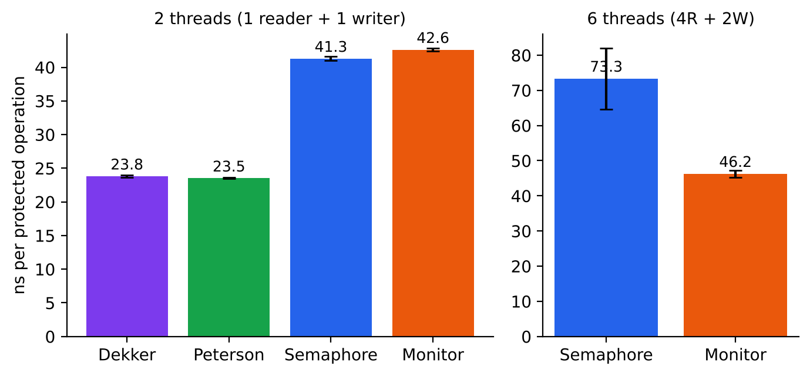
Figure 16: Measured cost per protected operation (lower is better)
Table 10: Measured results (ns per operation, mean ± standard deviation of 5 runs)
Algorithm | 2 threads (1R + 1W) | 6 threads (4R + 2W)
Dekker | 23.8 ± 0.2 | not applicable (2 processes)
Peterson | 23.5 ± 0.1 | not applicable (2 processes)
Semaphore (reader pref.) | 41.3 ± 0.3 | 73.3 ± 8.6
Monitor (writer pref.) | 42.6 ± 0.2 | 46.2 ± 1.0

Interpretation. With two threads the software algorithms are about 43–45 % cheaper than the library primitives (23.5 ns against 41–43 ns), because they consist of a few atomic loads and stores and no function-call or queueing overhead. As soon as there are six threads, Dekker and Peterson cannot be used directly at all. Between the two blocking solutions the monitor was more stable (±1.0 ns versus ±8.6 ns), because its mutex/condition-variable pair serialises state changes, whereas the semaphore solution has several lock acquisitions per reader operation (mutex twice plus wrt).

9.3 Policy simulation: waiting time in ticks
The micro-benchmark cannot show fairness, because the critical sections are tiny. A discrete-time simulation was therefore written to compare the waiting times produced by the four policies on the same random workload: 20 000 ticks, readers arriving at 0.12 per tick (each reading for 5 ticks) and writers arriving at 0.04 per tick (each writing for 4 ticks), same random seed for every policy. “Mutex only” models Dekker/Peterson used as a plain exclusive lock for every access.
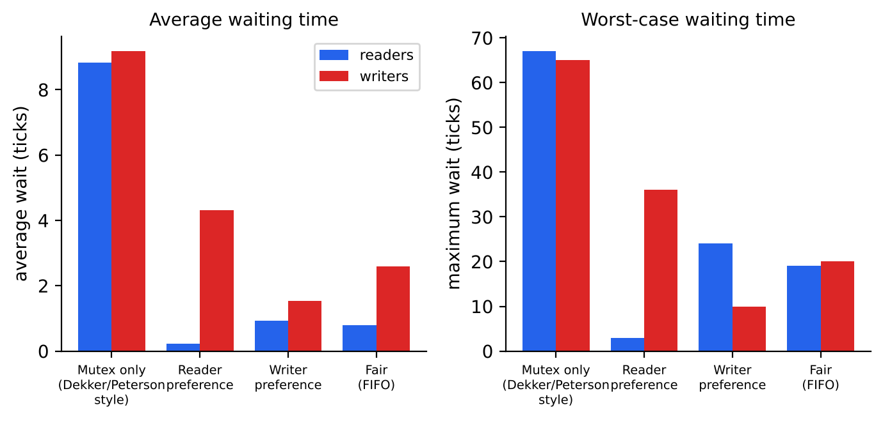
Figure 17: Simulated average and maximum waiting time for each policy
Table 11: Simulation results (ticks)
Policy | Avg reader wait | Avg writer wait | Max reader wait | Max writer wait
Mutex only (Dekker / Peterson style) | 8.8 | 9.2 | 67 | 65
Reader preference (semaphore 1) | 0.2 | 4.3 | 3 | 36
Writer preference (monitor / semaphore 2) | 0.9 | 1.5 | 24 | 10
Fair FIFO (turnstile) | 0.8 | 2.6 | 19 | 20

All four policies finish the same 3 253 requests, so throughput is identical in this under-loaded system; the difference is who waits. Treating every access as exclusive (the only option for Dekker/Peterson without extension) multiplies the reader waiting time by roughly 10–40 compared with the shared-read policies, because readers no longer overlap. Reader preference gives readers almost zero wait but the worst case for writers; writer preference reverses that; the fair policy lies in between and has the most balanced worst cases.

9.4 Starvation experiment
To expose starvation, the reader arrival rate was increased from 0.05 to 0.35 readers per tick while keeping writers constant.
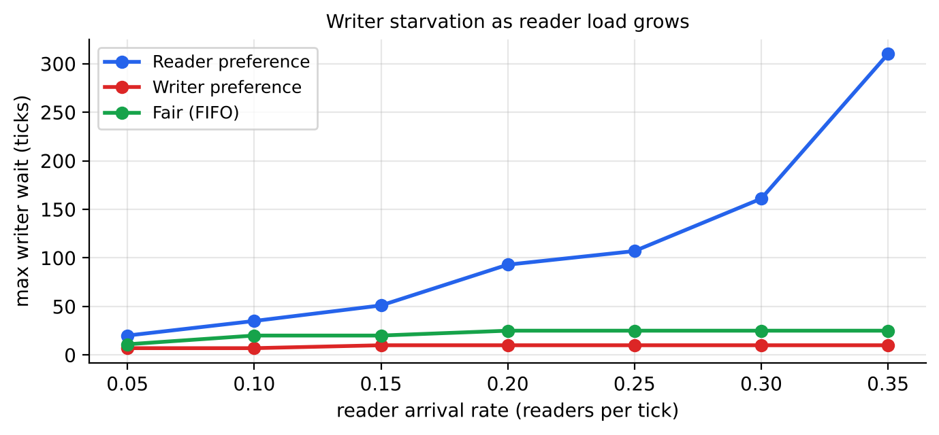
Figure 18: Maximum writer waiting time as the reader load increases
Under reader preference the worst writer wait grows from 20 ticks to 310 ticks as the read load increases, a clear sign of writer starvation (the experiment ends at a fixed horizon, so the true wait would be unbounded under a permanent stream of readers). Under writer preference it stays at about 10 ticks, one read duration plus a write, and under the fair policy it saturates at 25 ticks.

9.5 Time complexity summary
Table 12: Complexity of entry and exit sections
Technique | Entry (no contention) | Waiting under contention | Memory
Dekker | O(1): 1 store, 1 load | Spin; at most 1 turn of the other process | O(1): 3 variables
Peterson | O(1): 2 stores, 1–2 loads | Spin; at most 1 turn of the other process | O(1); O(N) for filter lock
Semaphore | O(1): 1–3 atomic ops | Sleep in FIFO queue, wake-up via kernel | O(1) + waiting queue
Monitor | O(1): lock + test | Sleep on condition; broadcast O(k) | O(1) + condition queues

10. Comprehensive Comparison
Table 13: Side-by-side comparison of the four techniques
Criterion | Dekker | Peterson | Semaphore | Monitor
Year / author | 1965, Dekker / Dijkstra | 1981, Peterson | 1965, Dijkstra | 1974, Hoare / Brinch Hansen
Abstraction level | Low (algorithm) | Low (algorithm) | Medium (OS primitive) | High (language construct)
Processes | 2 | 2 (N: filter lock) | N | N
Mutual exclusion | Yes | Yes | Yes | Yes (automatic)
Progress | Yes | Yes | Yes | Yes
Bounded waiting | Yes (1 turn) | Yes (1 turn) | Depends on variant | Depends on variant
Reader concurrency | No (2 procs.) | No (2 procs.) | Yes | Yes
Starvation | No | No | Writers (variant 1) / readers (variant 2) | Readers (writer pref.)
Waiting method | Busy waiting | Busy waiting | Blocking | Blocking
CPU use while waiting | High | High | None | None
Needs OS / language support | No | No | Yes (OS) | Yes (language/library)
Needs memory ordering | Yes (seq. cst.) | Yes (seq. cst.) | Handled inside library | Handled inside library
Measured cost, 2 threads | 23.8 ns | 23.5 ns | 41.3 ns | 42.6 ns
Code complexity | High (nested loops) | Very low | Medium (3 sem + counter) | Low–medium (4 procedures)
Error proneness | High | Medium (memory model) | High (missed signal) | Low (while-loop rule)
Typical use today | Teaching, proofs | Teaching, tiny spin locks | POSIX / kernel code | Java, C#, Python, C++ runtimes

10.1 Policy comparison
Table 14: Which readers–writers policy does each technique naturally give?
Technique | Natural policy and how to change it
Dekker / Peterson | Strict alternation between the two sides. Policy cannot be tuned without adding more state outside the algorithm.
Semaphore | Reader preference in the simplest form; writer preference needs a readTry gate; fairness needs a service turnstile. Each change needs additional semaphores and counters.
Monitor | Policy is the boolean condition in the while loop: remove waitingW > 0 for reader preference, keep it for writer preference, or add a ticket number for FIFO fairness.

11. Advantages and Disadvantages
Table 15: Advantages and disadvantages summary
Technique | Advantages | Disadvantages
Dekker | First correct software solution  No special hardware or OS support  Minimal cost without contention  Bounded waiting | Only two processes  Complicated control flow  Busy waiting wastes CPU  Breaks without atomic ordered memory
Peterson | Very simple and easy to prove  No special hardware or OS support  Lowest measured overhead  Bounded waiting (one turn) | Only two processes (filter lock slow for large N)  Busy waiting  Depends on memory ordering  No reader concurrency in 2-process form
Semaphore | Works for any N  No CPU spent while waiting  Available everywhere  Allows true reader concurrency | Error-prone: missed signal means deadlock  Logic scattered over many variables  First variant starves writers  Higher overhead than spin locks
Monitor | Mutual exclusion is automatic  Conditions are explicit and easy to change  Safest and most readable  Stable timing in our test | Needs language/library support  Mesa vs Hoare semantics are subtle  broadcast can cause a thundering herd  Slightly higher per-operation cost

12. Qualitative Evaluation and Selection Guide
The radar chart condenses the comparison into six criteria. The scores (1 = poor, 5 = excellent) are the author's qualitative judgement based on the analysis, the traces and the measurements of this report; they are not measured values.
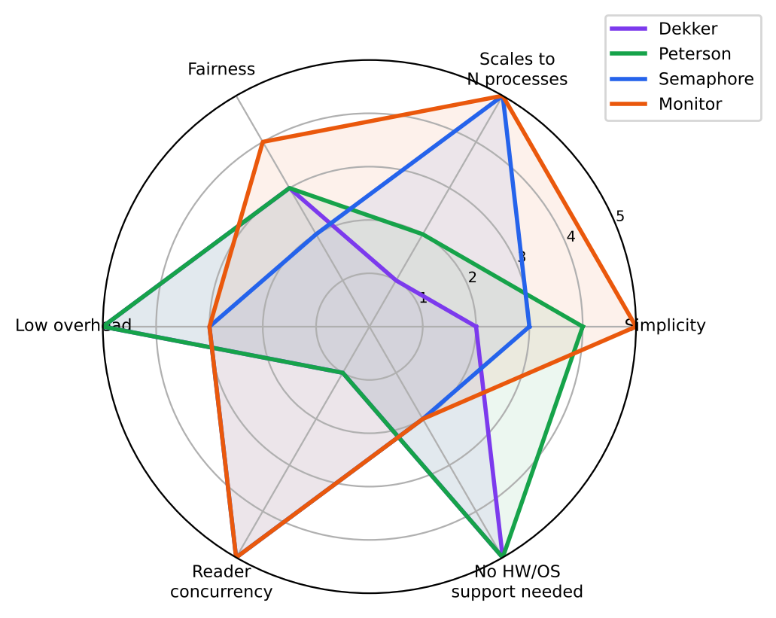
Figure 19: Qualitative scores of the four techniques on six criteria
Table 16: Decision guide
Situation | Recommended technique
Teaching mutual exclusion or proving a protocol | Peterson (simplest), then Dekker (historical interest)
Two threads, very short critical sections, no OS available (bare metal, firmware) | Peterson with atomic variables and fences
Many threads, read-mostly data, writers can wait | Semaphore reader-preference or pthread_rwlock with reader preference
Many threads, data freshness matters | Monitor / semaphore with writer preference
Must guarantee that nobody starves | Fair FIFO solution (turnstile semaphore or ticket-based monitor)
Application code in Java, C#, Python, C++ | Monitor-style library lock (ReentrantReadWriteLock, shared_mutex)
Extremely read-heavy workloads on multi-core | Consider lock-free techniques: seqlock or RCU

13. Correctness Pitfalls
Table 17: Common problems and how each technique is affected
Problem | Description | Affected techniques and remedy
Deadlock | Threads wait for each other forever, e.g. wait(wrt) before wait(mutex) in one place and the opposite in another. | Semaphores mostly. Remedy: one global lock order, code review, timeouts.
Starvation | A thread is overtaken forever by others. | Reader/writer preference solutions. Remedy: fair turnstile or ticket numbers.
Priority inversion | A low-priority lock holder blocks a high-priority waiter while a medium-priority thread runs. | Semaphores, monitors, and especially spin locks. Remedy: priority inheritance.
Lost wake-up | A signal is sent before the other thread waits, so the sleeper never wakes. | Monitors. Remedy: always test the predicate in a while loop under the lock.
Memory reordering | CPU or compiler reorders stores and loads and breaks the flag/turn logic. | Dekker, Peterson. Remedy: atomics with seq_cst or fences.
Busy-wait with preemption | The lock holder is descheduled while others spin for a whole time slice. | Dekker, Peterson. Remedy: yield/backoff or blocking locks.
Thundering herd | broadcast wakes many readers that immediately sleep again. | Monitors. Remedy: signal selectively or use separate condition variables.

14. Use in Real Systems
- POSIX: pthread_rwlock_t is a reader–writer lock built from a mutex and condition variables (monitor style), with selectable preference.
- Linux kernel: rw_semaphore (blocking) and rwlock_t (spinning) – a mix of the semaphore and the spin-lock approaches; RCU for read-mostly data.
- Java: ReentrantReadWriteLock supports reader sharing, optional fairness and lock downgrading; StampedLock adds optimistic reads.
- C++17: std::shared_mutex with std::shared_lock (readers) and std::unique_lock (writers).
- Databases: shared and exclusive locks with two-phase locking; MVCC avoids blocking readers entirely by giving them a snapshot.
Dekker's and Peterson's algorithms rarely appear in production, but their ideas live on: the tie-breaking turn variable and the “announce, then yield” pattern are the foundation of ticket locks, queue locks and the filter/tournament locks studied in multiprocessor programming.

15. Conclusion
All four techniques solve the safety side of the Readers–Writers problem; they differ in generality, policy, cost and risk. Dekker's and Peterson's algorithms prove that mutual exclusion is possible with nothing but atomic reads and writes, and Peterson's version is the simplest and, in our benchmark, the cheapest (about 23.5 ns per operation) – but both handle only two processes, spin while waiting, and cannot by themselves give the shared access that makes readers–writers locks valuable. Semaphores generalise to any number of processes and enable reader concurrency, at the price of scattered logic, deadlock risk and, in the simplest form, writer starvation. Monitors present the same functionality in the safest and most readable form: the policy is just a boolean condition, and the measured timing was the most stable with several threads.
The practical recommendation is therefore: use the reader–writer lock of your language or operating system (a monitor-style construct) for application code; choose the policy (reader, writer or fair) according to whether read latency, write freshness or fairness matters most; use semaphores when you work close to the kernel or implement your own primitive; and study Dekker and Peterson to understand why synchronization works at all.
Key results of this report
1) Real runs of all four programs produced 0 exclusion violations. 2) Peterson ≈ 23.5 ns, Dekker ≈ 23.8 ns, semaphore ≈ 41.3 ns, monitor ≈ 42.6 ns per operation with two threads; with six threads the monitor (46.2 ns) was faster and steadier than the semaphore (73.3 ns). 3) In the simulation, reader preference let the worst writer wait grow to 310 ticks, while writer preference kept it near 10 ticks.

Glossary
Table 18: Key terms
Term | Definition
Race condition | A bug in which the result depends on the unpredictable interleaving of concurrent operations.
Critical section | A code region that accesses shared data and must not be executed by conflicting processes at the same time.
Starvation | A process waits indefinitely because others are always preferred.
Deadlock | A set of processes each wait for an event that only another one in the set can cause.
Spin lock | A lock where the waiting thread repeatedly tests a condition in a loop (busy waiting).
Condition variable | A queue on which threads sleep until another thread signals that a monitor condition may have changed.
Sequential consistency | Memory model in which all operations appear to execute in one global order that respects each program's order.
Futex | Linux kernel facility that lets user-space locks sleep and wake only when there is contention.

Appendix: reproducing the experiments
All programs used in this report are short, self-contained C files that share one small header (common.h) with the invariant checks. They can be rebuilt and re-run on any Linux machine with gcc and POSIX threads:
Commands used to build and run the programs
gcc -O1 -pthread -o rw_semaphore rw_semaphore.c && ./rw_semaphore
gcc -O1 -pthread -o rw_monitor rw_monitor.c && ./rw_monitor
gcc -O1 -pthread -o rw_peterson rw_peterson.c && ./rw_peterson
gcc -O1 -pthread -o rw_dekker rw_dekker.c && ./rw_dekker

gcc -O2 -pthread -o bench bench.c
./bench 0 1 1 # Dekker, 1 reader + 1 writer
./bench 1 1 1 # Peterson, 1 reader + 1 writer
./bench 2 4 2 # Semaphore, 4 readers + 2 writers
./bench 3 4 2 # Monitor, 4 readers + 2 writers

- Each program prints a line of the form [ time ms] R1 READ data=… or W1 WRITE data=… when a thread enters its critical section, and a final line with the number of invariant violations.
- Timing results vary with the machine, the number of CPU cores and the scheduler; run each experiment several times and report mean and standard deviation, as done in Section 9.
- To explore other policies, change the while condition of start_read() in the monitor (remove waitingW > 0 for reader preference) and compare the new trace with Figure 13.

References
- P. J. Courtois, F. Heymans, D. L. Parnas, “Concurrent Control with ‘Readers’ and ‘Writers’”, Communications of the ACM 14(10), 1971.
- E. W. Dijkstra, “Solution of a Problem in Concurrent Programming Control”, Communications of the ACM 8(9), 1965.
- E. W. Dijkstra, “Cooperating Sequential Processes”, 1965 (technical report EWD123).
- G. L. Peterson, “Myths About the Mutual Exclusion Problem”, Information Processing Letters 12(3), 1981.
- C. A. R. Hoare, “Monitors: An Operating System Structuring Concept”, Communications of the ACM 17(10), 1974.
- L. Lamport, “A New Solution of Dijkstra's Concurrent Programming Problem”, Communications of the ACM 17(8), 1974.
- A. Silberschatz, P. B. Galvin, G. Gagne, Operating System Concepts, Wiley.
- A. S. Tanenbaum, H. Bos, Modern Operating Systems, Pearson.
- M. Herlihy, N. Shavit, The Art of Multiprocessor Programming, Morgan Kaufmann.

