OPERATING SYSTEMS | PROCESS SCHEDULING & SYNCHRONIZATION
Implementation of the Fair Share Scheduling Algorithm Using a Monitor
and Its Comparison with the EDF and RM Real-Time Algorithms

Item | Description
Document type | Technical report - design, implementation, flowcharts, tables, charts and experimental comparison
Date | October 2026
Algorithms studied | Fair Share (monitor-based implementation), Earliest Deadline First (EDF), Rate Monotonic (RM)
Implementation | Python 3: threading.Lock and three kinds of threading.Condition variables forming one monitor (no semaphores)
Evaluation method | Discrete-time simulation, 1 tick = 1 quantum; two workloads (normal U = 0.90, overload U = 1.225) and 150 random task sets per utilization level
Metrics | Arrival / start / exit times, waiting, turnaround and response time, lateness, deadline misses, context switches, group CPU share, Jain fairness index

Results at a glance
Measure | Fair Share | EDF | RM
Normal load - missed deadlines (of 20 jobs) | 1 | 0 | 0
Normal load - average waiting time (ticks) | 4.10 | 2.65 | 2.65
Normal load - context switches | 35 | 25 | 25
Overload - CPU share received by group C (entitled 0.15) | 0.15 | 0.00 | 0.00
Overload - Jain fairness index | 0.985 | 0.662 | 0.662
Overload - missed deadlines (of 20 jobs) | 10 | 2 | 3

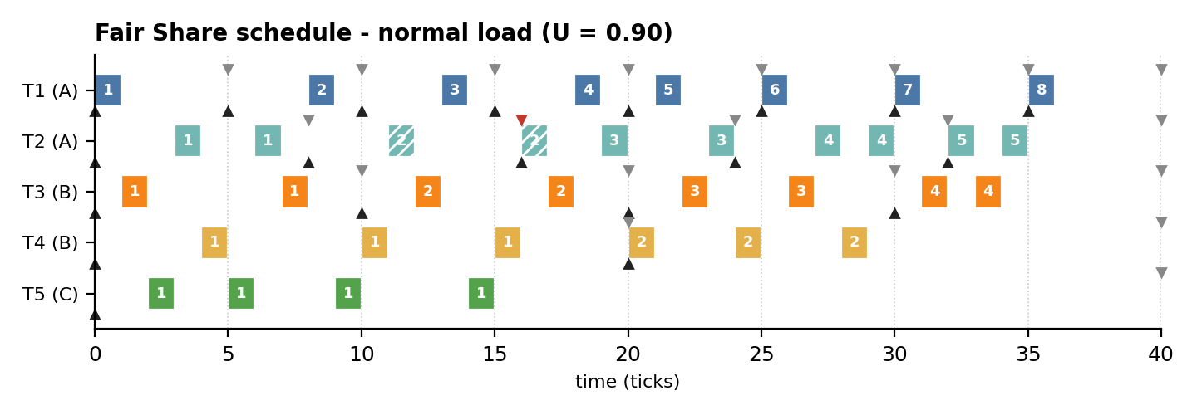
Figure 1: Fair Share schedule of the normal workload produced by the monitor-based implementation.

1 Abstract, Objectives and Contents
This report designs, implements and evaluates a Fair Share CPU scheduler whose synchronization is built entirely on a monitor: one mutex lock guarding all scheduling state, three kinds of condition variables (a per-task turn, quantum-done and all-done) and a set of entry procedures. No semaphores are used. The scheduler is compared with two classical real-time policies, Earliest Deadline First (EDF) and Rate Monotonic (RM), on the same periodic workloads.
The monitor-based design was executed with real threads in logical time, and its schedule was verified tick-by-tick against an independent discrete-time simulator for both a normal and an overloaded workload. The study reports per-job arrival, start and exit times, waiting, turnaround and response times, deadline misses, context switches, per-group CPU shares and Jain's fairness index.

Objectives
- Explain Fair Share scheduling: group entitlements, usage-based priorities and periodic usage decay.
- Design a monitor-only synchronization architecture: entry procedures protect the state and condition variables express every wait (turn, quantum end, completion).
- Provide a complete, runnable implementation, a flowchart, a sequence diagram and correctness arguments.
- Define input workloads (arrival times, bursts, periods, deadlines, group weights) and report all entry and exit times.
- Compare Fair Share with EDF and RM quantitatively (tables, charts) and qualitatively under normal load and overload.

Contents
No. | Section | Page | No. | Section | Page
1 | Abstract, Objectives and Contents | 2 | 13 | Implementation, Part 2: Workers, Scheduler | 14
2 | Fundamentals of CPU and Real-Time Scheduling | 3 | 14 | Fair Share Results: Gantt Chart | 15
3 | The Fair Share Scheduling Algorithm | 4 | 15 | Fair Share Results: Input/Output Times | 16
4 | Fair Share Mathematics and a Worked Trace | 5 | 16 | EDF: Earliest Deadline First | 17
5 | Monitors: Concepts and Semantics | 6 | 17 | RM: Rate Monotonic | 18
6 | Monitor-Based Architecture | 7 | 18 | EDF and RM Schedules | 19
7 | System Model, Assumptions, Data Structures | 8 | 19 | Entry/Exit Times of All Algorithms | 20
8 | Input Workloads: Tasks and Arrival Times | 9 | 20 | Normal-Load Comparison | 21
9 | Experimental Setup and Evaluation Metrics | 10 | 21 | Overload Comparison | 22
10 | Flowchart of the Monitor-Based Algorithm | 11 | 22 | Utilization Sweep and Fairness | 23
11 | Monitor Protocol and Correctness | 12 | 23 | Qualitative Comparison and Guidelines | 24
12 | Implementation, Part 1: Job and Monitor | 13 | 24 | Conclusions, Future Work, References | 25

Where to find each element of the study
Element | Location in this report
Algorithm features (tables) | Pages 4 (Fair Share), 17 (EDF), 18 (RM), 24 (side-by-side)
Input times: arrival, burst, period, deadline | Pages 9, 16 and 20
Output times: start, exit, waiting, turnaround, response | Pages 16 and 20
Flowcharts | Pages 11 (Fair Share), 17 (EDF), 18 (RM)
Architecture, state and sequence diagrams | Pages 7, 8 and 12
Source code (monitor) | Pages 13 and 14
Charts (Gantt, bars, lines) | Pages 15, 16, 19, 20, 21, 22 and 23
Quantitative and qualitative comparison | Pages 21, 22, 23 and 24

2 Fundamentals of CPU and Real-Time Scheduling
A scheduler decides which ready job receives the processor at each instant. In a periodic real-time model every task releases a job every P ticks; each job needs C ticks of CPU and must finish before its deadline. Scheduling algorithms differ in what they optimise: deadline compliance (EDF, RM) or fairness among users (Fair Share).

Terminology and symbols used throughout the report
Term | Symbol | Definition
Arrival (release) time | r | Instant at which a job becomes ready; for task Ti the k-th job arrives at (k-1)·Pi
Burst time / WCET | C | CPU time (ticks) the job needs to complete
Period | P | Interval between two consecutive releases of the same task
Absolute deadline | d | d = r + D; here D = P (implicit deadline)
Start time | s | First tick at which the job runs on the CPU
Exit (finish) time | f | Instant at which the job completes (end of its last quantum)
Response time | s - r | Delay until the job first obtains the CPU
Waiting time | f - r - C | Time spent ready but not running
Turnaround time | f - r | Total time from arrival to exit
Lateness | f - d | Positive value means a deadline miss
Utilization | U | U = sum of Ci / Pi over all tasks
Hyperperiod | H | H = lcm(P1,...,Pn); the schedule repeats every H ticks
Quantum / tick | q | Smallest scheduling unit; decisions are taken at every tick (preemption)

Three families of algorithms compared in this report
Family | Algorithm | Priority | Primary objective
Proportional share | Fair Share | Dynamic: recomputed every tick from CPU usage | Give each user group its entitled fraction of the CPU
Dynamic-priority real-time | EDF | Dynamic: earliest absolute deadline of each job | Maximise schedulable utilization (optimal for U <= 1)
Static-priority real-time | RM | Static: shorter period = higher priority | Predictable, analysable deadline guarantees

Why compare them? EDF and RM know about deadlines but know nothing about owners; Fair Share knows about owners but nothing about deadlines. The comparison exposes the central trade-off between timeliness and fairness.

Scheduling criteria and where each algorithm stands in this study
Criterion | Goal | Best performer in the experiments
CPU utilization | Keep the CPU busy | All three are work-conserving (0.90 busy in the normal load)
Waiting / turnaround time | Minimise | EDF and RM (waiting 2.65 vs 4.10 for Fair Share)
Response time | Minimise delay to first run | EDF / RM (1.50 vs 1.70), Fair Share close
Deadline compliance | Zero deadline misses | EDF and RM (0 misses vs 1 for Fair Share)
Fairness between groups | Serve groups in proportion to weights | Fair Share (Jain 0.985 vs 0.662 in overload)
Overhead | Few context switches | EDF and RM (25 vs 35)

Preemptive vs. non-preemptive. All three algorithms are evaluated in their preemptive form: a running job can be replaced at any tick boundary. Preemption is essential for EDF and RM (urgent jobs must not wait for long ones) and for Fair Share (priorities change every tick).

3 The Fair Share Scheduling Algorithm
Fair Share scheduling (Henry, 1984; Kay and Lauder, 1988) allocates CPU time to groups of processes (for example users, departments or tenants) instead of to individual processes. If user A runs ten processes and user B runs one, a process-level round-robin would give A about 91% of the CPU; Fair Share instead gives each group the share its administrator assigned, independent of how many processes the group starts.

How it works
- Every group k has a static weight W_k (its entitlement), e.g. A = 0.40, B = 0.35, C = 0.25 in this study.
- The scheduler records how much CPU each process (CPU_j) and each group (GCPU_k) has consumed recently.
- At every tick the job with the lowest priority value P = CPU_j/2 + GCPU_k/(4·W_k) runs; heavy users therefore drift to the back of the line.
- At a fixed interval all usage counters are halved (decay), so old consumption is gradually forgotten and nobody starves.

Main features
Feature | Description
Group-level entitlement | The unit of fairness is the group; one group cannot take CPU from another by creating more processes.
Usage-based dynamic priority | Priority is recomputed every tick from consumed CPU time - not from deadlines or periods.
Usage decay | Exponential forgetting (divide by 2 every 4 ticks) keeps priorities bounded and the policy starvation-free.
Work-conserving | Unused entitlement is redistributed: if group C needs only 10% of the CPU, groups A and B share the rest.
Isolation | Overload by one group degrades mainly that group; others keep (close to) their entitlement.
Overhead | Higher than RM/EDF: per-tick priority recomputation, usage accounting and frequent preemption.
Deadline awareness | None. Deadlines can be missed even when U < 1 because the CPU order ignores urgency.

Typical application areas
- Multi-user time-sharing servers and university compute clusters.
- Multi-tenant cloud and container platforms (CPU shares / weights, e.g. Linux CFS group scheduling).
- Batch farms where departments purchase a guaranteed percentage of the machine.

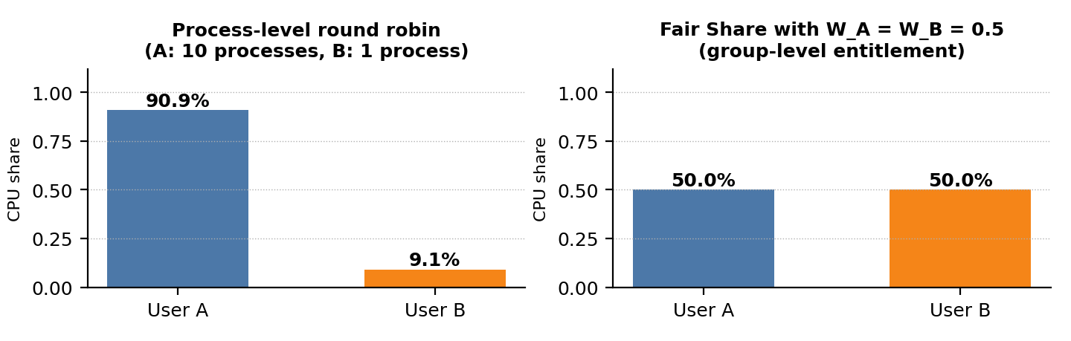
Figure A: Why group-level entitlement matters - user A starts 10 processes, user B only one.
Advantages: fair division between owners, protection against process-flooding, simple administrative model (weights). Limitations: no deadline guarantee, higher overhead, entitlements must be tuned.

4 Fair Share Mathematics and a Worked Trace

Priority, decay and fairness formulas
Priority (lower value runs first): P_j(t) = CPU_j(t) / 2 + GCPU_k(t) / ( 4 · W_k )
Usage update (job j of group k runs one tick): CPU_j <- CPU_j + 1, GCPU_k <- GCPU_k + 1
Decay (every Td = 4 ticks): CPU_j <- CPU_j / 2, GCPU_k <- GCPU_k / 2
Tie-break: earlier arrival first, then smaller task id. Entitlement: E_k = W_k / sum of W of active groups (max-min with demand cap)
Jain's fairness index: J = ( sum s_g )^2 / ( n · sum s_g^2 ), s_g = CPU received by group g / CPU demanded by group g

The group term is divided by 4·W_k, so a group with a large weight accumulates priority penalty more slowly and is chosen more often. The process term CPU_j/2 separates jobs inside a group. J equals 1 when every group is served in proportion to its demand and tends to 1/n when one group takes everything.

Worked trace: first 8 ticks of the normal workload
All five tasks release their first job at t = 0. The table shows the priority value of the oldest ready job of each task (lowest wins) and the group usage after the tick. Weights: W_A = 0.40, W_B = 0.35, W_C = 0.25.
Tick | Priority values P of ready jobs | Runs | Group usage after tick
0 | T1.1=0.000 T2.1=0.000 T3.1=0.000 T4.1=0.000 T5.1=0.000 | T1.1 | A=1.00 B=0.00 C=0.00
1 | T2.1=0.625 T3.1=0.000 T4.1=0.000 T5.1=0.000 | T3.1 | A=1.00 B=1.00 C=0.00
2 | T2.1=0.625 T3.1=1.214 T4.1=0.714 T5.1=0.000 | T5.1 | A=1.00 B=1.00 C=1.00
3 | T2.1=0.625 T3.1=1.214 T4.1=0.714 T5.1=1.500 | T2.1 | A=1.00 B=0.50 C=0.50
4 | T2.1=0.875 T3.1=0.607 T4.1=0.357 T5.1=0.750 | T4.1 | A=1.00 B=1.50 C=0.50
5 | T1.2=0.875 T2.1=0.875 T3.1=1.321 T4.1=1.571 T5.1=0.750 | T5.1 | A=1.00 B=1.50 C=1.50
6 | T1.2=0.875 T2.1=0.875 T3.1=1.321 T4.1=1.571 T5.1=2.250 | T2.1 | A=2.00 B=1.50 C=1.50
7 | T1.2=1.500 T3.1=1.321 T4.1=1.571 T5.1=2.250 | T3.1 | A=1.00 B=1.25 C=0.75

Reading the trace. Tick 0: all priorities are 0, the tie-break picks T1.1. Tick 1: group A now has usage 1, so T2 gets P = 1/(4·0.40) = 0.625 and T3 (group B, usage 0) wins. Tick 2: T5 (group C) wins for the same reason. The scheduler rotates between groups - this interleaving is the source of Fair Share's fairness and also of its higher context-switch count. At tick 4 (t+1 = 4) every counter is halved.

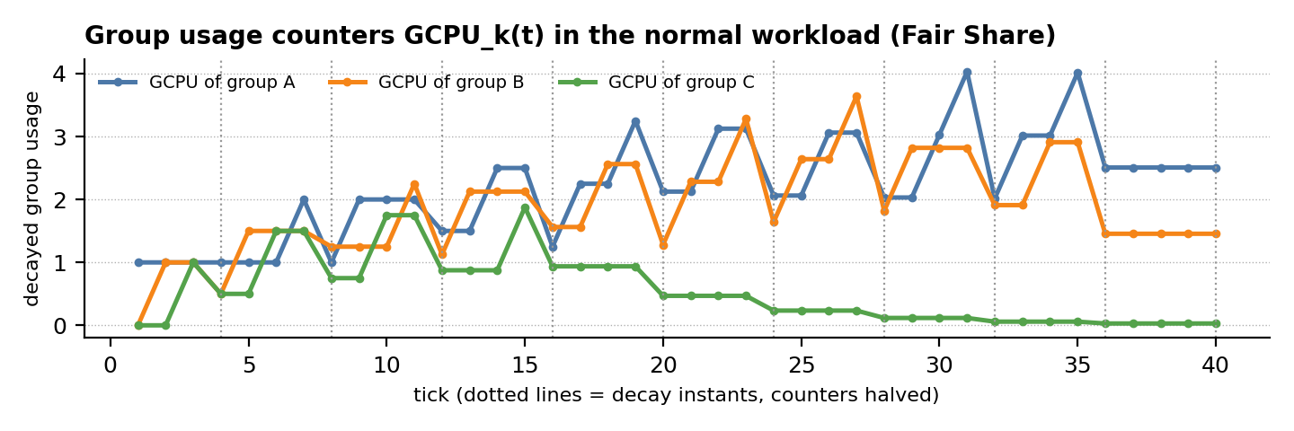
Figure B: Decayed group usage counters - they rise while a group runs and are halved every 4 ticks.

5 Monitors: Concepts and Semantics
A monitor (Hoare, 1974; Brinch Hansen, 1973) is a synchronization construct that bundles shared data, the procedures that operate on it and one or more condition variables. A single mutex guarantees that only one thread is active inside the monitor at a time, so the programmer never writes explicit lock/unlock pairs around critical sections.
Concept | Meaning | In the Fair Share scheduler
Mutual exclusion | One thread at a time inside the monitor | with self._lock: in every entry procedure
Entry procedure | Public method that accesses monitor data | release, dispatch, await_turn, end_quantum, finish
Condition variable | Queue of threads waiting for a predicate | turn[i], quantum_done, all_done
wait / wait_for(p) | Atomically release the lock and sleep until woken; re-check predicate p | worker: granted[i] is set; dispatcher: not cpu_busy
notify / notify_all | Wake one / all waiting threads | dispatch() notifies turn[i]; end_quantum() notifies quantum_done
Signal semantics | Hoare: signaller hands the monitor over at once. Mesa (Python): signaller continues, waiter re-checks | Mesa style, hence predicate loops (wait_for)
Encapsulation | State is private; only entry procedures touch it | proc_cpu, grp_cpu, ready, granted, cpu_busy

Monitor vs. semaphore in one view
Aspect | Semaphore | Monitor
Mutual exclusion | Explicit P/V around every critical section | Automatic: one thread inside entry procedures
Waiting | Counter value (signal is remembered) | Condition variable + predicate (re-checked after wake-up)
Encapsulation | None: data and lock are separate | Data, procedures and conditions in one unit
Typical error | Forgotten V, wrong order, deadlock | Forgotten notify, predicate not re-checked

From the hybrid design to a monitor-only design
The previous exercise used a monitor for state and three semaphore families for hand-offs. Here every semaphore is replaced by a predicate over monitor state plus a condition variable:
Previous (semaphore) | Monitor-only replacement | Why it is equivalent
cpu (binary semaphore, init 1) | boolean cpu_busy | set in dispatch(), cleared in end_quantum(): at most one running job
grant[i] (per-task semaphore) | granted[i] + condition turn[i] | the worker sleeps until granted[i] is not None; a notify before the wait is harmless
tick_done (semaphore) | condition quantum_done | the dispatcher sleeps until cpu_busy is False

# generic monitor idiom used for every wait in the scheduler
with self._lock: # enter the monitor
self._cond.wait_for(lambda: predicate) # releases the lock while asleep
... # predicate is True and the lock is held again
other_cond.notify() # wake a waiter; it runs after we leave

Design rule: every shared variable lives inside the monitor; every wait is written as a predicate; every state change that can make a predicate true is followed by a notify.

6 Monitor-Based Architecture
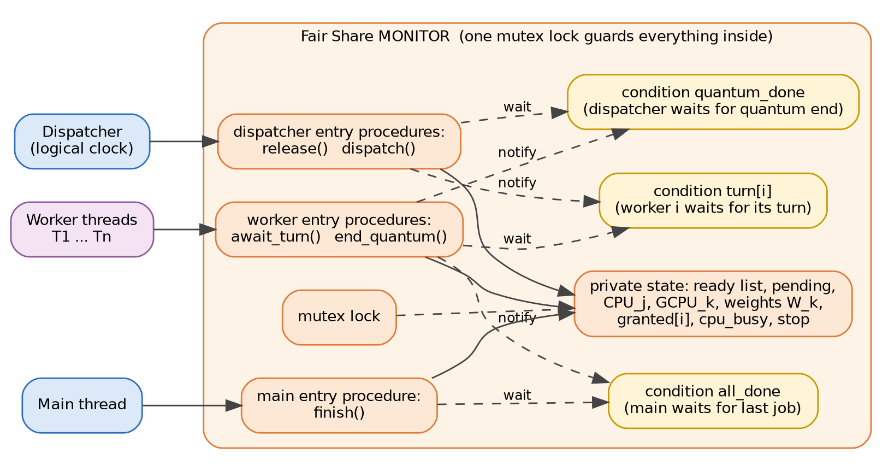
Figure 2: The monitor encloses all scheduler state; dispatcher, workers and main thread communicate only through its entry procedures.
Component | Kind | Responsibility
mutex lock | Monitor | Guarantees one thread at a time inside any entry procedure
ready, pending, expected | State | Ready list, number of unfinished jobs, jobs not yet released
proc_cpu[task], grp_cpu[group] | State | Decayed CPU usage CPU_j and GCPU_k; weights W_k
granted[i], cpu_busy, stop | State | Job handed to worker i; CPU-in-use flag; shutdown flag
release(job) | Entry procedure | Insert an arriving job into the ready list
dispatch(t) | Entry procedure | Select min P, set cpu_busy, grant, notify turn[i], wait for quantum_done
await_turn(task) | Entry procedure | Worker blocks until granted[task] is set (or stop); returns the grant
end_quantum(job,t) | Entry procedure | Charge usage, detect completion, decay, clear cpu_busy, notify
finish() | Entry procedure | Wait for all_done, set stop, notify_all so workers exit
turn[i] | Condition | Worker i waits here for its turn
quantum_done | Condition | Dispatcher waits here until the running quantum has ended
all_done | Condition | Main thread waits here until no job is pending
Dispatcher / Worker Ti | Threads | Logical clock and per-task executors; they never touch state directly

Contract of the entry procedures
Procedure | Waits until (predicate) | Notifies / effect | Called by
release | - | adds job to ready list | Dispatcher
dispatch | not cpu_busy (after granting) | turn[i].notify() | Dispatcher
await_turn | granted[i] set or stop | - | Worker
end_quantum | - | quantum_done.notify(); all_done.notify_all() when pending = 0 | Worker
finish | pending = 0 and expected = 0 | turn[i].notify_all() | Main

Single-lock design. There is exactly one lock, so no lock ordering problem exists; a thread that waits releases the lock atomically, which lets the other side make progress.

7 System Model, Assumptions and Data Structures

Assumptions
- Single processor; the CPU can run one job per tick. Time is logical and discrete: 1 tick = 1 quantum.
- Periodic tasks with implicit deadlines (D = P), known execution time C and constant period P; all tasks start at t = 0.
- Preemption is allowed at every tick boundary; context-switch time is zero but switches are counted.
- A job that misses its deadline keeps running until completion (soft handling) so that lateness can be measured.
- Group membership and weights are static: A = {T1, T2} with W = 0.40, B = {T3, T4} with W = 0.35, C = {T5} with W = 0.25.

Data structures
Structure | Field | Type | Meaning
Job | task, group, idx | str, str, int | Owner task, owner group and job number (name = task.idx, e.g. T2.3)
Job | release, burst, deadline | int | Arrival time r, CPU demand C, absolute deadline d = r + P
Job | remaining, start, finish | int / None | Ticks left, first-run tick, completion tick (exit time)
FairShareMonitor | proc_cpu[task] | float | Decayed CPU usage CPU_j of each task
FairShareMonitor | grp_cpu[group] | float | Decayed CPU usage GCPU_k of each group
FairShareMonitor | ready, pending | list, int | Jobs eligible to run; number of unfinished jobs
FairShareMonitor | weights, decay_every | dict, int | Entitlements W_k; decay period Td = 4 ticks
FairShareMonitor | granted, cpu_busy, stop | dict, bool | Grant handed to each worker; CPU-in-use flag; shutdown flag
FairShareScheduler | timeline, workers | list | Resulting schedule (one entry per tick); worker threads

Per-decision cost (n = number of ready jobs)
Algorithm | Decision cost | Comment
Fair Share (this work) | O(n) per tick | Priority of every ready job recomputed; O(g) with per-group queues; plus O(tasks + groups) at decay
EDF | O(log n) (heap) | Ready queue ordered by absolute deadline; O(n) with a plain list
RM | O(1) - O(log n) | Static priorities; a priority bitmap gives constant-time selection

Life cycle of a job
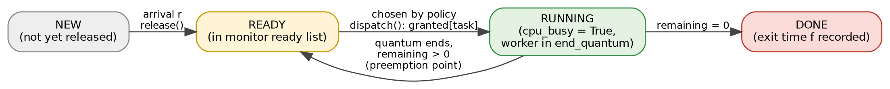
Figure C: State diagram of a job; the READY -> RUNNING decision is where the three policies differ.

Invariants guarded by the monitor
No. | Invariant | Maintained by
I1 | pending = number of jobs in the ready list | release() increments, charge() decrements on completion
I2 | A job is in the ready list if and only if remaining > 0 | charge() removes the job when remaining reaches 0
I3 | GCPU_k = sum of CPU_j over the tasks of group k | both counters are incremented and halved together
I4 | At most one quantum is charged per tick | cpu_busy flag and the quantum_done wait

8 Input Workloads: Tasks, Arrival Times and Group Weights

Workload 1 - normal load (U = 0.90)
Task | Group | C (burst) | P (period) | D (deadline) | U = C/P | Arrival times r (ticks) within [0, 40)
T1 | A | 1 | 5 | 5 | 0.20 | 0, 5, 10, 15, 20, 25, 30, 35
T2 | A | 2 | 8 | 8 | 0.25 | 0, 8, 16, 24, 32
T3 | B | 2 | 10 | 10 | 0.20 | 0, 10, 20, 30
T4 | B | 3 | 20 | 20 | 0.15 | 0, 20
T5 | C | 4 | 40 | 40 | 0.10 | 0
Total |  |  |  |  | 0.90 | 20 jobs in the hyperperiod H = 40

Group weights and demand
Group | Weight W | Member tasks | Demand (normal) | Entitlement (normal)
A | 0.40 | T1, T2 | 0.45 | 0.45
B | 0.35 | T3, T4 | 0.35 | 0.35
C | 0.25 | T5 | 0.10 | 0.10

Workload 2 - overload (U = 1.225), same periods and groups
Task | Group | C (burst) | P (period) | U = C/P | Change vs. workload 1
T1 | A | 1 | 5 | 0.20 | unchanged
T2 | A | 3 | 8 | 0.38 | increased
T3 | B | 3 | 10 | 0.30 | increased
T4 | B | 4 | 20 | 0.20 | increased
T5 | C | 6 | 40 | 0.15 | increased
Total |  |  |  | 1.225 | U > 1 : overload
Group demands under overload: A = 0.575, B = 0.500, C = 0.150; weight-based entitlements (max-min, demand-capped): A = 0.453, B = 0.397, C = 0.150.
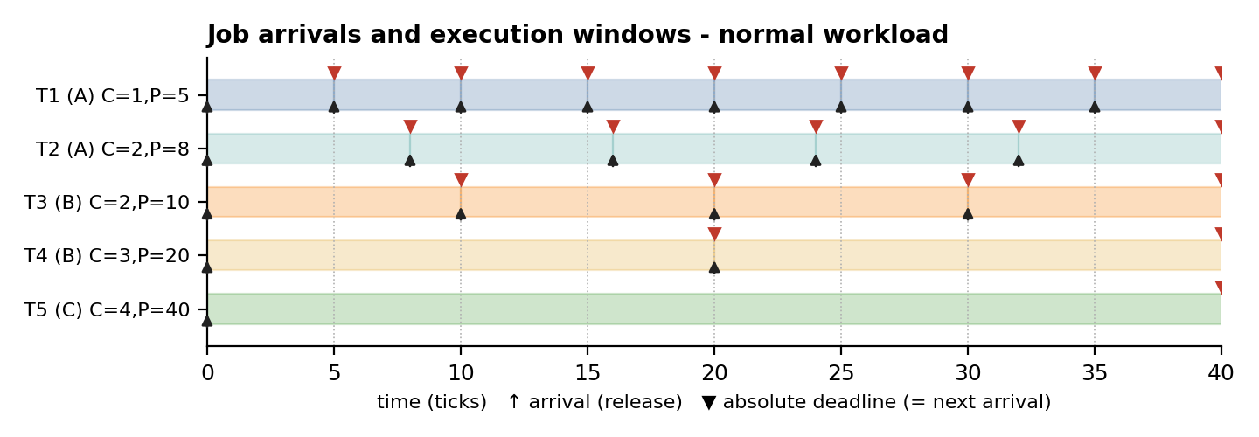
Figure 3: Arrival (up arrow) and absolute deadline (red triangle) of every job of the normal workload; shaded boxes show execution windows.

Derived quantities
Quantity | Normal (U = 0.90) | Overload (U = 1.225) | Remark
Total CPU demand in the 40-tick window | 36 ticks | 49 ticks | capacity = 40 ticks
Idle ticks if all work is done by t = 40 | 4 | 0 (9 ticks backlog) | backlog is drained after t = 40
Jobs per task T1 / T2 / T3 / T4 / T5 | 8 / 5 / 4 / 2 / 1 | 8 / 5 / 4 / 2 / 1 | 20 jobs in total
Demand per group A / B / C | 0.450 / 0.350 / 0.100 | 0.575 / 0.500 / 0.150 | fraction of the CPU

9 Experimental Setup and Evaluation Metrics

Simulation parameters
Parameter | Value
Time model | Discrete logical time; 1 tick = 1 quantum; preemption possible at every tick
Observation window | Hyperperiod H = lcm(5, 8, 10, 20, 40) = 40 ticks; after t = 40 no new jobs are released, but unfinished jobs are drained so that exit times are known
Fair Share parameters | Weights A/B/C = 0.40/0.35/0.25; usage decay: halve all counters every 4 ticks; tie-break: earlier arrival, then task id
EDF / RM tie-break | Smaller task id (deterministic)
Workloads | (1) normal: U = 0.90, 20 jobs; (2) overload: U = 1.225, 20 jobs
Random task sets | 150 sets per utilization level 0.5 ... 1.3 (step 0.1); UUniFast utilization split; periods {5, 8, 10, 20, 40}; C rounded to integers; accepted if actual U is within ±0.04 of the target
Verification | Monitor-based threaded scheduler vs. independent simulator: identical Fair Share timelines on both workloads (page 14)

Metrics
Metric | Definition | Interpretation
Arrival r / start s / exit f | Recorded per job (ticks) | Raw input and output times of the schedule
Response time | s - r | Responsiveness; small = interactive feel
Waiting time | f - r - C | Time lost in the ready queue
Turnaround time | f - r | Total residence time
Lateness / miss | f - d; miss if f > d | Timeliness; deadline-miss ratio = misses / jobs
Context switches | Number of changes of running job (idle gaps excluded) | Overhead of preemption
Group CPU share | Ticks used by group in [0, 40) / 40 | Compared with entitlement E_k
Jain index J | (sum s_g)^2 / (n · sum s_g^2), s_g = received / demand | 1 = perfectly proportional service

Fairness vs. timeliness. A policy can be perfectly timely yet unfair (EDF/RM serve the most urgent tasks first, even if that means a group receives nothing) or perfectly fair yet untimely (Fair Share). The metrics above measure both sides, so neither policy is judged on one axis only.

Experimental pipeline
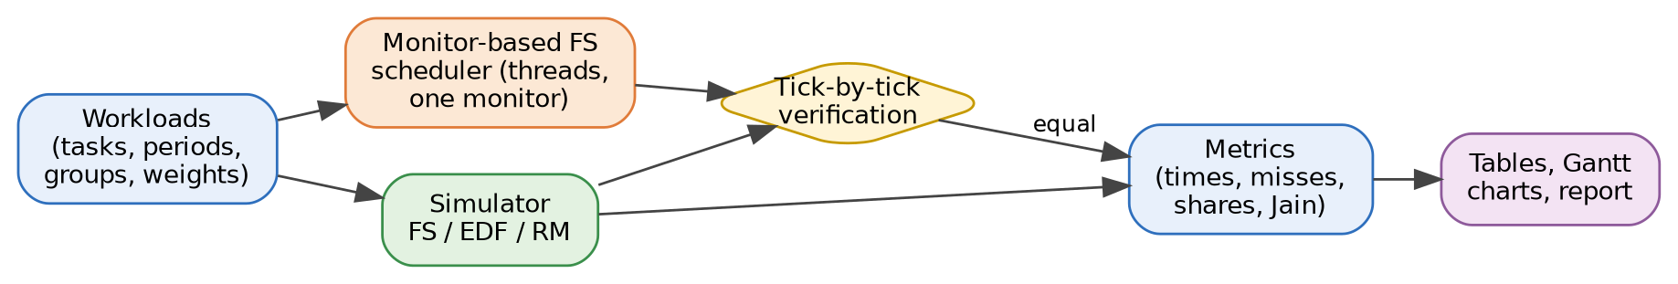
Figure D: Workflow of the experiments - both the threaded scheduler and the simulator are fed with the same workloads and compared.

10 Flowchart of the Monitor-Based Fair Share Algorithm
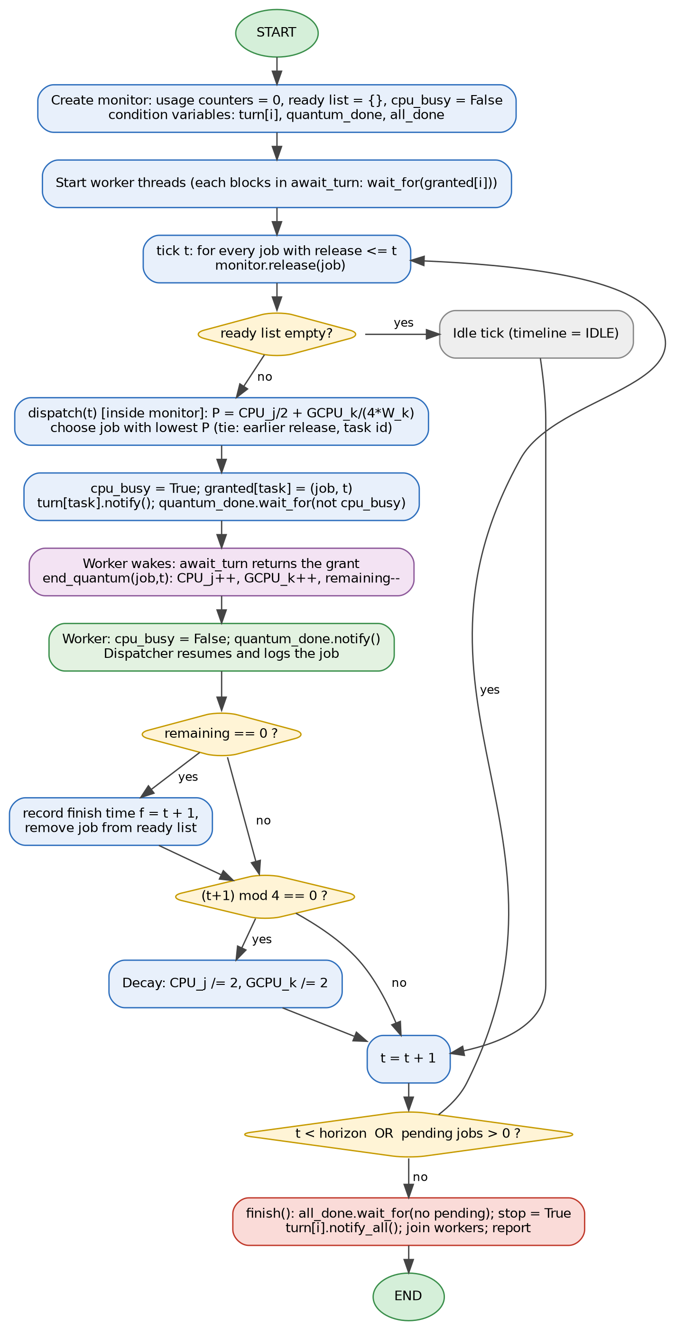  Figure 4: Flowchart of the monitor-based Fair Share scheduler. | Step-by-step walkthrough  - Create the monitor: usage counters 0, empty ready list, cpu_busy = False, conditions turn[i], quantum_done, all_done.  - Start workers. Each blocks in await_turn() on its condition turn[i].  - Release arrivals. At tick t every job with r <= t enters the ready list through release().  - Idle check. An empty ready list gives an idle tick.  - Select inside dispatch(): P = CPU_j/2 + GCPU_k/(4·W_k); the minimum wins.  - Grant. cpu_busy = True, granted[task] = job, turn[task].notify(); the dispatcher then waits on quantum_done.  - Execute. The worker returns from await_turn() and calls end_quantum(): usage grows, remaining decreases.  - Hand back. end_quantum() clears cpu_busy and notifies quantum_done; the dispatcher resumes.  - Completion. If remaining = 0 the exit time f = t + 1 is stored and the job leaves the ready list.  - Decay. When (t+1) mod 4 = 0 all counters are halved; then t is incremented.  - Stop. When no work remains, finish() waits on all_done, sets stop and notifies all workers, which exit.

11 Monitor Protocol and Correctness
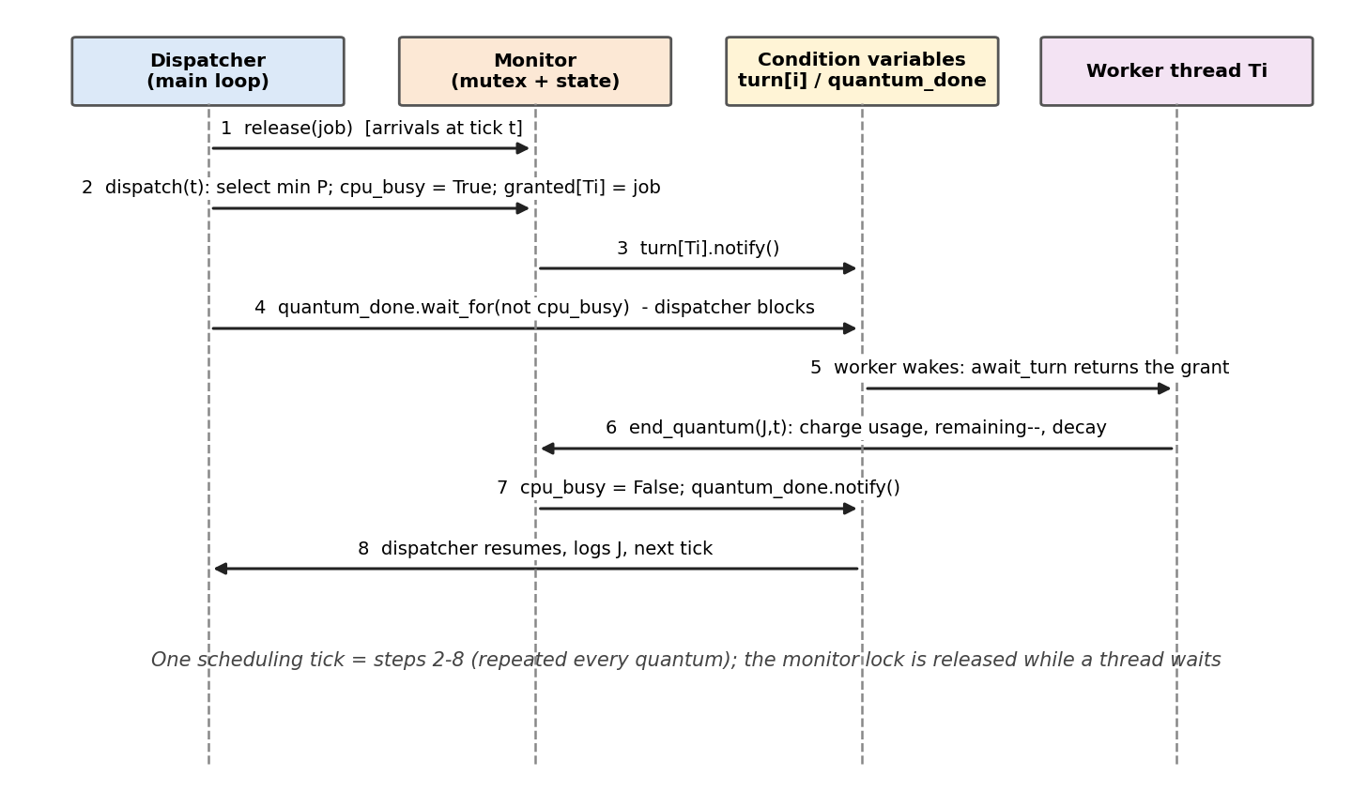
Figure 5: Message sequence of one scheduling tick between dispatcher, monitor, condition variables and a worker thread.
Property | Argument
Mutual exclusion on the CPU | cpu_busy is set in dispatch() and cleared only in end_quantum(), both inside the lock; dispatch() does not return before cpu_busy is False, so at most one job runs per tick.
Atomic scheduler state | Every access to usage counters and the ready list happens in an entry procedure holding the single lock.
No lost wake-up | Every wait is predicate-guarded (wait_for). If notify happens before the worker waits, granted[task] is already set and the wait returns at once.
Spurious wake-ups | Mesa semantics: a woken thread re-checks its predicate, so an early or extra wake-up is harmless.
Deadlock freedom | One lock, no nested locking; wait releases the lock atomically, so the dispatcher and the worker can never block each other.
Progress / termination | Each granted quantum reduces some remaining time by 1; finish() sets stop and notifies all turn[i], so workers exit.

Worked example: monitor state during ticks 0 and 1
Tick | Operation | cpu_busy | granted[T1] | granted[T3] | Effect
0 | dispatch(0): select T1.1 (all P = 0); grant; notify turn[T1] | True | (T1.1, 0) | None | dispatcher waits
0 | worker T1: await_turn returns, grant cleared | True | None | None | worker runs
0 | end_quantum(T1.1, 0): remaining 0, f = 1; notify quantum_done | False | None | None | T1.1 done
0 | dispatcher resumes, timeline[0] = T1.1 | False | None | None | next tick
1 | dispatch(1): T3.1 (P = 0 < P(T2.1) = 0.625); grant; notify | True | None | (T3.1, 1) | dispatcher waits
1 | worker T3: await_turn; end_quantum(T3.1, 1) | False | None | None | start = 1
1 | dispatcher resumes, timeline[1] = T3.1 | False | None | None | tick 1 done

12 Implementation, Part 1: Job and Monitor (Python 3)
File fs_monitor.py (part 1) - the monitor holds all shared scheduling state behind one lock; turn[i], quantum_done and all_done are condition variables bound to that lock.
"""Fair Share scheduler - MONITOR-ONLY implementation (logical time, 1 tick = 1 quantum)."""
import threading
from collections import defaultdict

class Job:
def __init__(self, task, group, idx, release, burst, deadline):
self.task, self.group, self.idx = task, group, idx
self.release, self.burst, self.deadline = release, burst, deadline
self.remaining, self.start, self.finish = burst, None, None
@property
def name(self): return f"{self.task}.{self.idx}"

class FairShareMonitor:
"""One lock, three kinds of condition variables, all state private to the monitor."""
def __init__(self, tasks, weights, decay_every=4):
self._lock = threading.Lock()
self._turn = {t: threading.Condition(self._lock) for t in tasks} # worker waits for its turn
self._quantum_done = threading.Condition(self._lock) # dispatcher waits for quantum end
self._all_done = threading.Condition(self._lock) # main waits for last job
self.weights, self.decay_every = weights, decay_every
self.proc_cpu, self.grp_cpu = defaultdict(float), defaultdict(float)
self.ready, self.pending, self.expected = [], 0, 0
self.granted = {t: None for t in tasks} # (job, tick) handed to a worker
self.cpu_busy, self.stop = False, False # replaces the CPU semaphore

def _priority(self, j): # lower value = higher priority
return (self.proc_cpu[j.task] / 2
+ self.grp_cpu[j.group] / (4 * self.weights[j.group]), j.release, j.task)

# ---------- entry procedures called by the dispatcher ----------
def release(self, job):
with self._lock:
self.ready.append(job); self.pending += 1; self.expected -= 1

def dispatch(self, tick):
with self._lock:
if not self.ready: return None
job = min(self.ready, key=self._priority)
self.cpu_busy = True
self.granted[job.task] = (job, tick)
self._turn[job.task].notify() # wake the chosen worker
self._quantum_done.wait_for(lambda: not self.cpu_busy)
return job

# ---------- entry procedures called by workers ----------
def await_turn(self, task):
with self._lock:
self._turn[task].wait_for(lambda: self.granted[task] is not None or self.stop)
grant, self.granted[task] = self.granted[task], None
return grant # None means shut down

Code element | Role
with self._lock: | Monitor entry: mutual exclusion for the whole entry procedure
_priority(j) | P = CPU_j/2 + GCPU_k/(4·W_k); the tuple adds the tie-break (release, task id)
dispatch(tick) | Selects the job, sets cpu_busy, grants it, notifies turn[i], then waits on quantum_done
release(job) | Appends an arriving job to the ready list and updates the counters
wait_for(predicate) | Releases the lock while asleep and re-checks the predicate on every wake-up (Mesa semantics)

13 Implementation, Part 2: Worker Entry Points, Scheduler and Dispatcher
def end_quantum(self, job, tick):
with self._lock:
if job.start is None: job.start = tick
job.remaining -= 1
self.proc_cpu[job.task] += 1; self.grp_cpu[job.group] += 1
if job.remaining == 0:
job.finish = tick + 1; self.ready.remove(job); self.pending -= 1
if (tick + 1) % self.decay_every == 0: # periodic usage decay
for d in (self.proc_cpu, self.grp_cpu):
for k in d: d[k] /= 2
self.cpu_busy = False
self._quantum_done.notify() # wake the dispatcher
if self.pending == 0: self._all_done.notify_all()

def finish(self):
with self._lock:
self._all_done.wait_for(lambda: self.pending == 0 and self.expected == 0)
self.stop = True
for c in self._turn.values(): c.notify_all()

class FairShareScheduler:
def __init__(self, jobs, tasks, weights):
self.mon = FairShareMonitor(tasks, weights)
self.jobs = sorted(jobs, key=lambda j: j.release)
self.mon.expected = len(jobs)
self.timeline = []
self.workers = [threading.Thread(target=self._worker, args=(t,)) for t in tasks]

def _worker(self, task):
while (grant := self.mon.await_turn(task)) is not None:
job, tick = grant
self.mon.end_quantum(job, tick) # run 1 quantum

def run(self, horizon):
for w in self.workers: w.start()
tick, nxt = 0, 0
while tick < horizon or self.mon.pending > 0 or nxt < len(self.jobs):
while nxt < len(self.jobs) and self.jobs[nxt].release <= tick:
self.mon.release(self.jobs[nxt]); nxt += 1
self.timeline.append(self.mon.dispatch(tick))
tick += 1
self.mon.finish()
for w in self.workers: w.join()
return self.timeline

Driver program and verified output
from fs_monitor import Job, FairShareScheduler
tasks = [("T1","A",1,5), ("T2","A",2,8), ("T3","B",2,10), ("T4","B",3,20), ("T5","C",4,40)]
weights = {"A": 0.40, "B": 0.35, "C": 0.25}
jobs = [Job(n, g, k+1, k*P, C, (k+1)*P) for n, g, C, P in tasks for k in range(40 // P)]
sched = FairShareScheduler(jobs, [t[0] for t in tasks], weights)
timeline = sched.run(horizon=40)
print(" ".join(j.name if j else "--" for j in timeline))
print("jobs finished:", sum(j.finish is not None for j in jobs), "/", len(jobs))
print("deadline misses:", [j.name for j in jobs if j.finish > j.deadline])

Output (normal workload, executed on the real threaded implementation):
T1.1 T3.1 T5.1 T2.1 T4.1 T5.1 T2.1 T3.1 T1.2 T5.1 T4.1 T2.2 T3.2 T1.3 T5.1 T4.1 T2.2 T3.2 T1.4 T2.3
T4.2 T1.5 T3.3 T2.3 T4.2 T1.6 T3.3 T2.4 T4.2 T2.4 T1.7 T3.4 T2.5 T3.4 T2.5 T1.8 -- -- -- --
jobs finished: 20 / 20
deadline misses: ['T2.2']

Verification: the threaded timeline equals the simulator tick-by-tick (normal: 40 ticks; overload: 49 ticks incl. drained backlog).

14 Fair Share Results: Schedule (Gantt Chart)
Figure 6: Fair Share schedule, normal load. Block label = job index; ^ = arrival, v = deadline (red = missed); hatched block = late job.

Schedule as a tick sequence
t= 0- 9: T1.1 T3.1 T5.1 T2.1 T4.1 T5.1 T2.1 T3.1 T1.2 T5.1
t=10-19: T4.1 T2.2 T3.2 T1.3 T5.1 T4.1 T2.2 T3.2 T1.4 T2.3
t=20-29: T4.2 T1.5 T3.3 T2.3 T4.2 T1.6 T3.3 T2.4 T4.2 T2.4
t=30-39: T1.7 T3.4 T2.5 T3.4 T2.5 T1.8 -- -- -- --

CPU share per group in the window [0, 40)
Group | Weight W | Demand | Received | Comment
A | 0.40 | 0.45 | 0.45 | Demand 0.45 > weight 0.40: served from C's unused entitlement
B | 0.35 | 0.35 | 0.35 | Demand 0.35 = weight 0.35: exactly satisfied
C | 0.25 | 0.10 | 0.10 | Demand 0.10 < weight 0.25: surplus redistributed

Observations
- All 20 jobs completed; 1 deadline miss (T2.2, one tick late) - Fair Share is not deadline-aware, so a job of the busiest group can lose a tick to a less urgent job.
- The CPU was busy in 36 of 40 ticks (utilization 0.90); every group received exactly its demand (Jain index = 1.000).
- The scheduler rotates among groups every tick, giving 35 context switches (EDF and RM: 25).

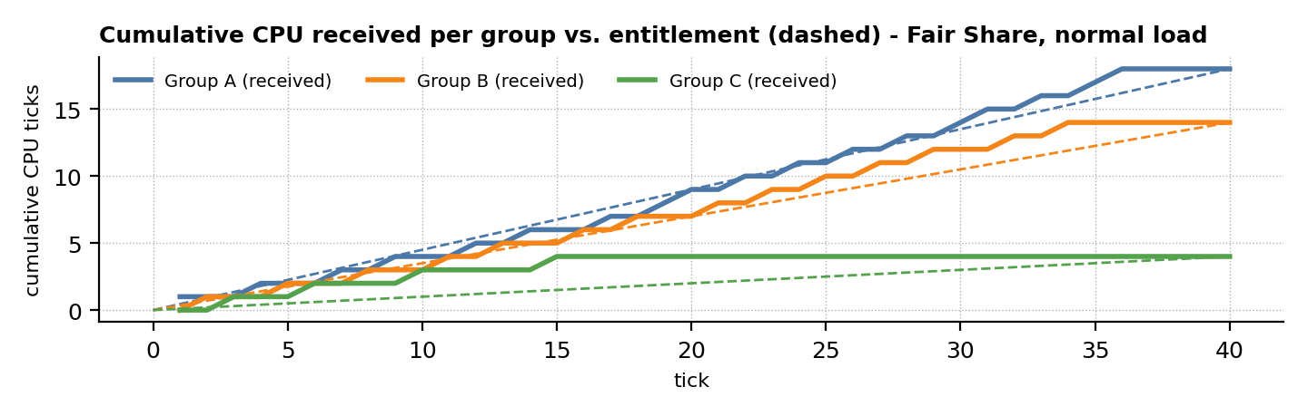
Figure E: Each group's cumulative CPU follows its entitlement line closely under Fair Share.

15 Fair Share Results: Input and Output Times of Every Job
Input times = arrival r and burst C; output times = start s and exit f (all in ticks). Waiting = f - r - C, turnaround = f - r, response = s - r.
Job | Group | Arrival r | Burst C | Start s | Exit f | Deadline d | Waiting | Turnaround | Response | Status
T1.1 | A | 0 | 1 | 0 | 1 | 5 | 0 | 1 | 0 | OK
T2.1 | A | 0 | 2 | 3 | 7 | 8 | 5 | 7 | 3 | OK
T3.1 | B | 0 | 2 | 1 | 8 | 10 | 6 | 8 | 1 | OK
T4.1 | B | 0 | 3 | 4 | 16 | 20 | 13 | 16 | 4 | OK
T5.1 | C | 0 | 4 | 2 | 15 | 40 | 11 | 15 | 2 | OK
T1.2 | A | 5 | 1 | 8 | 9 | 10 | 3 | 4 | 3 | OK
T2.2 | A | 8 | 2 | 11 | 17 | 16 | 7 | 9 | 3 | MISS (+1)
T1.3 | A | 10 | 1 | 13 | 14 | 15 | 3 | 4 | 3 | OK
T3.2 | B | 10 | 2 | 12 | 18 | 20 | 6 | 8 | 2 | OK
T1.4 | A | 15 | 1 | 18 | 19 | 20 | 3 | 4 | 3 | OK
T2.3 | A | 16 | 2 | 19 | 24 | 24 | 6 | 8 | 3 | OK
T1.5 | A | 20 | 1 | 21 | 22 | 25 | 1 | 2 | 1 | OK
T3.3 | B | 20 | 2 | 22 | 27 | 30 | 5 | 7 | 2 | OK
T4.2 | B | 20 | 3 | 20 | 29 | 40 | 6 | 9 | 0 | OK
T2.4 | A | 24 | 2 | 27 | 30 | 32 | 4 | 6 | 3 | OK
T1.6 | A | 25 | 1 | 25 | 26 | 30 | 0 | 1 | 0 | OK
T1.7 | A | 30 | 1 | 30 | 31 | 35 | 0 | 1 | 0 | OK
T3.4 | B | 30 | 2 | 31 | 34 | 40 | 2 | 4 | 1 | OK
T2.5 | A | 32 | 2 | 32 | 35 | 40 | 1 | 3 | 0 | OK
T1.8 | A | 35 | 1 | 35 | 36 | 40 | 0 | 1 | 0 | OK
Average |  |  |  |  |  |  | 4.10 | 5.90 | 1.70 | 1 miss

Per-task summary
Task | Jobs | Avg waiting | Avg turnaround | Avg response | Late jobs
T1 | 8 | 1.25 | 2.25 | 1.25 | 0
T2 | 5 | 4.60 | 6.60 | 2.40 | 1 (late)
T3 | 4 | 4.75 | 6.75 | 1.50 | 0
T4 | 2 | 9.50 | 12.50 | 2.00 | 0
T5 | 1 | 11.00 | 15.00 | 2.00 | 0
Long-running, low-weight tasks (T4, T5) show the largest waiting times, because Fair Share lets them interleave with every other group instead of finishing first.

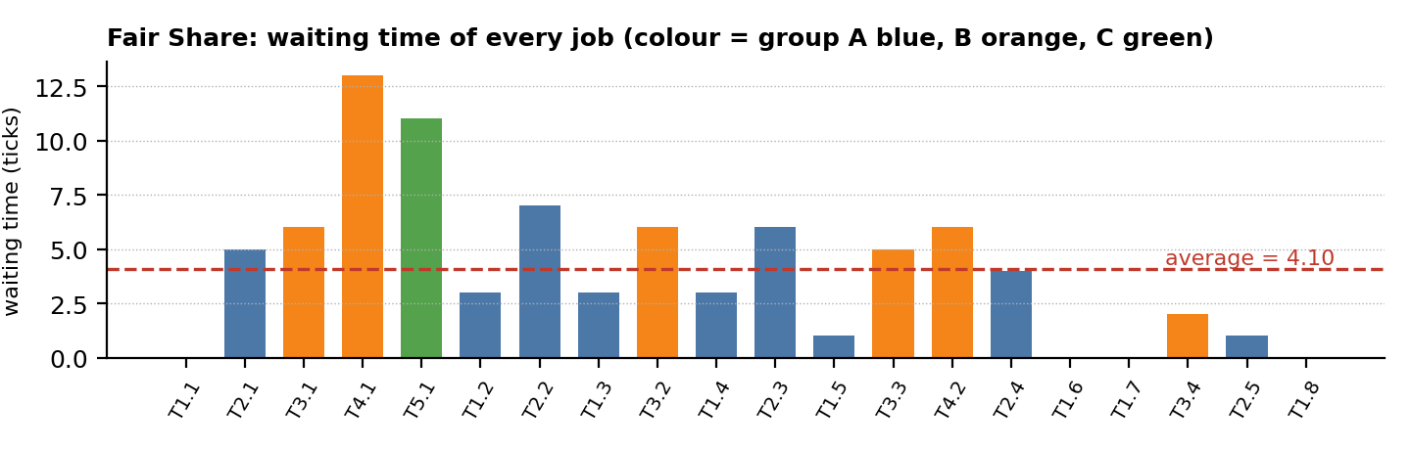
Figure F: Waiting time of each of the 20 jobs under Fair Share.

16 EDF: Earliest Deadline First
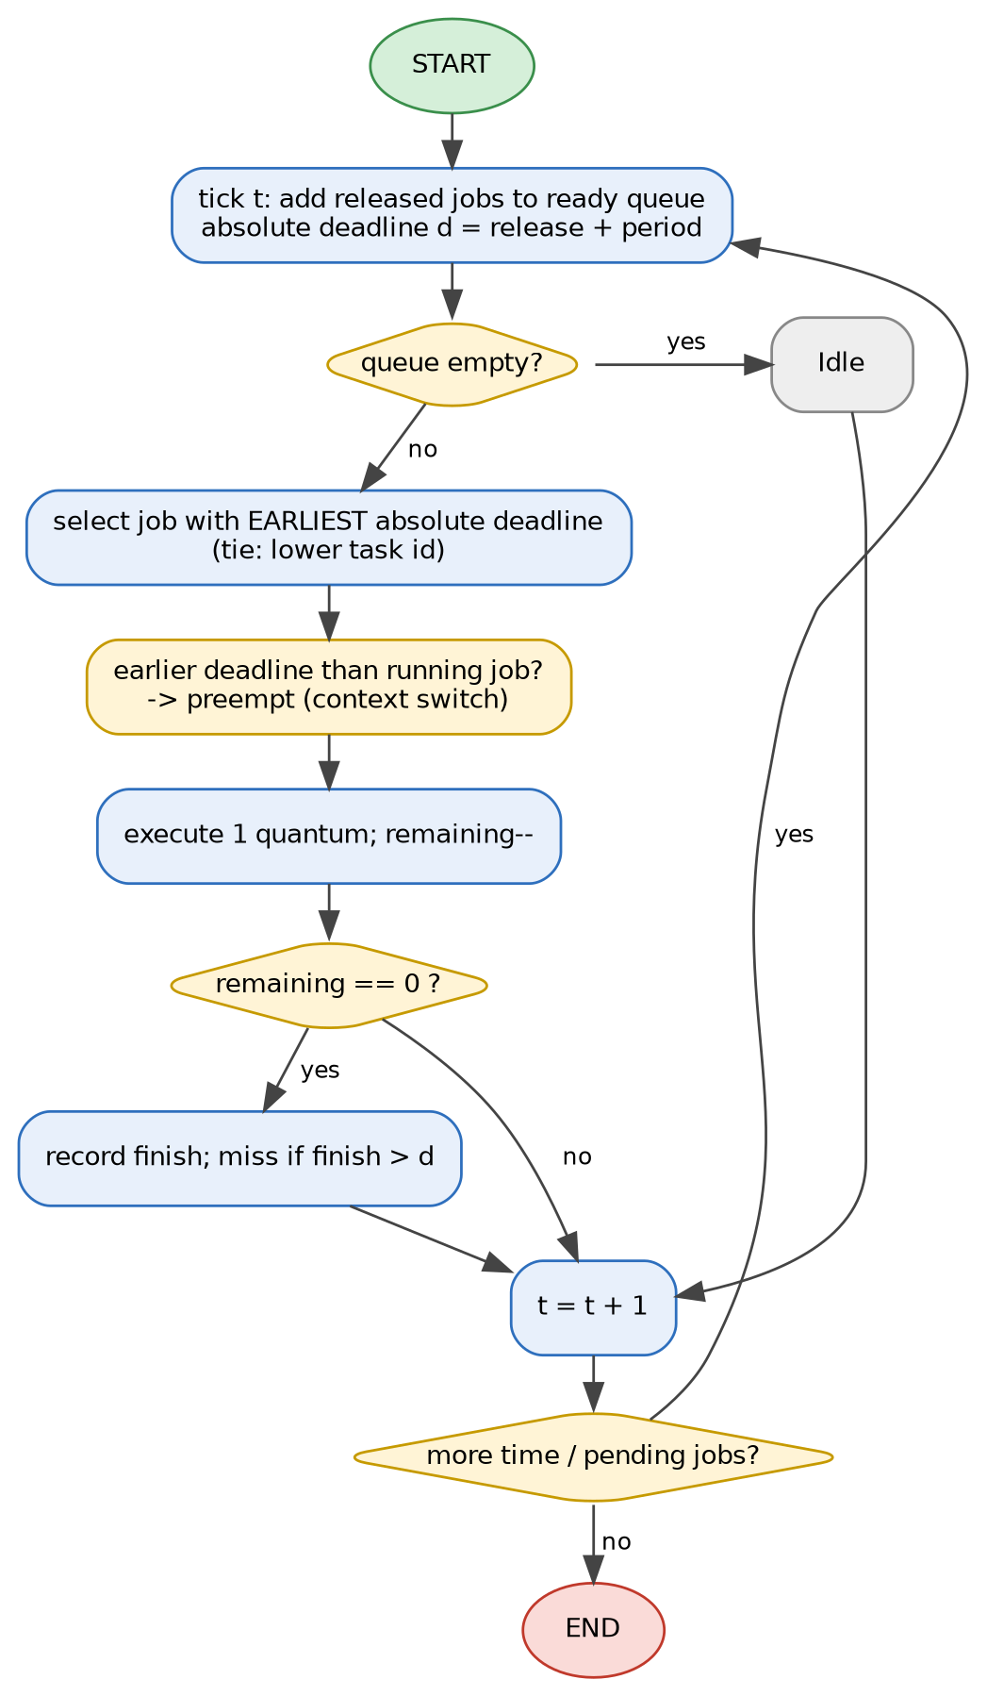  Figure 7: EDF flowchart. | Algorithm  EDF is a dynamic-priority policy: at every scheduling point the ready job whose absolute deadline is nearest runs. A newly released job with an earlier deadline preempts the running job. Liu and Layland (1973) proved EDF optimal for preemptive uniprocessor scheduling of independent periodic tasks.  Features  Pseudocode  every tick t:  ready += jobs released at t # d = r + P  if ready is empty: idle  else:  job = argmin(ready, key=(d, task_id))  run job for one quantum  if job.remaining == 0:  record exit time; miss if t+1 > d
  Property | Value
  Priority | Dynamic, per job: d = r + P
  Optimality | Optimal: finds a feasible schedule whenever one exists
  Schedulability | U <= 1 (necessary and sufficient, D = P)
  This workload | U = 0.90 <= 1: schedulable
  Overhead | Deadline comparisons; more preemptions than RM in general
  Weakness | Overload: misses are hard to predict; no per-user fairness

Result on the normal workload (U = 0.90): 0 missed deadlines, average waiting time 2.65, turnaround 4.45, response 1.50, 25 context switches.
Result under overload (U = 1.225): 2 misses (T4.2, T5.1); group C (task T5, the farthest deadline) received 0.00 of the CPU in the window - it is served only after all nearer deadlines.

Worked example: EDF decisions at selected ticks
Tick | Ready jobs (absolute deadline d, remaining ticks) | Earliest d | EDF runs
0 | T1.1 (d=5, rem 1); T2.1 (d=8, rem 2); T3.1 (d=10, rem 2); T4.1 (d=20, rem 3); T5.1 (d=40, rem 4) | d = 5 | T1.1
5 | T1.2 (d=10, rem 1); T4.1 (d=20, rem 3); T5.1 (d=40, rem 4) | d = 10 | T1.2
8 | T2.2 (d=16, rem 2); T4.1 (d=20, rem 1); T5.1 (d=40, rem 4) | d = 16 | T2.2
10 | T1.3 (d=15, rem 1); T3.2 (d=20, rem 2); T4.1 (d=20, rem 1); T5.1 (d=40, rem 4) | d = 15 | T1.3
13 | T4.1 (d=20, rem 1); T5.1 (d=40, rem 4) | d = 20 | T4.1
15 | T1.4 (d=20, rem 1); T5.1 (d=40, rem 3) | d = 20 | T1.4

17 RM: Rate Monotonic
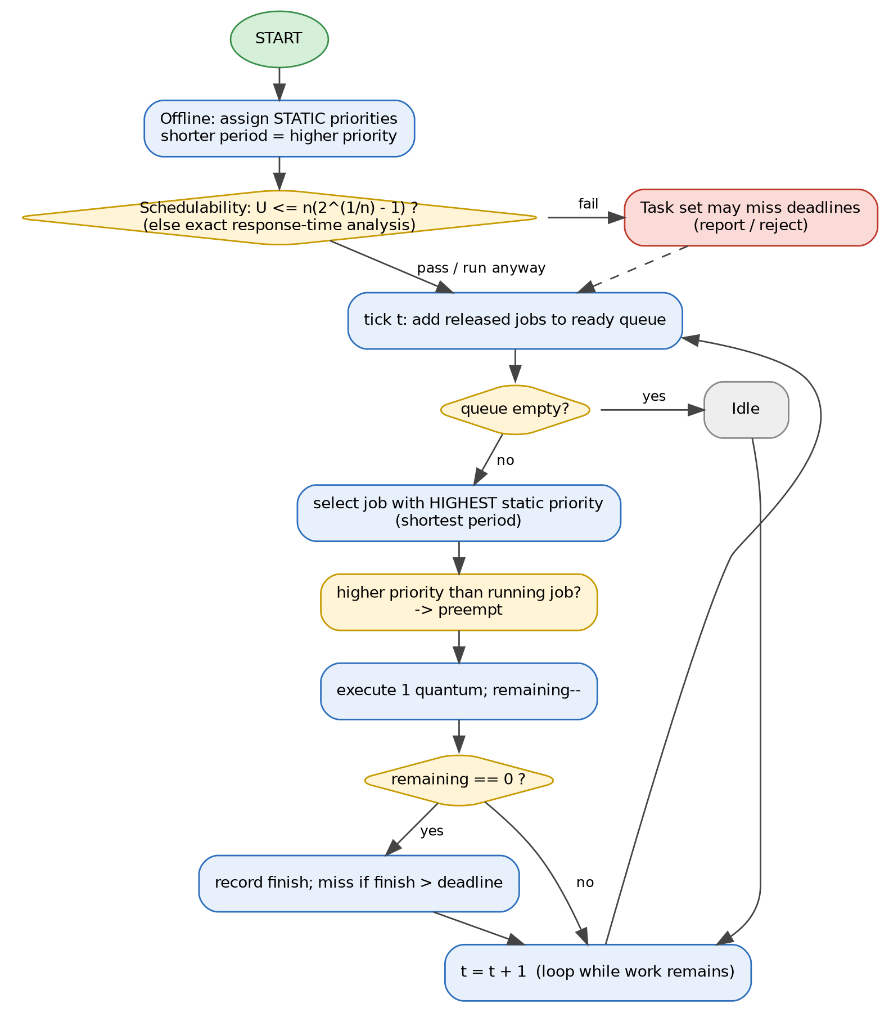  Figure 8: RM flowchart. | Algorithm  RM is a static-priority policy: priorities are fixed offline, and the task with the shortest period has the highest priority. It is optimal among static-priority algorithms for periodic tasks with D = P (Liu and Layland, 1973) and is simple to implement and analyse.  Features
  Property | Value
  Priority | Static, per task: shorter period first
  Sufficient test | U <= n(2^(1/n) - 1); n = 5 gives 0.743
  This workload | U = 0.90 > 0.743: test inconclusive; exact analysis needed
  Exact test | Response-time analysis (RTA): R = C + sum ceil(R/Pj)·Cj
  Overhead | Lowest: O(1) selection, fewest preemptions
  Weakness | Utilization bound < 100%; low-priority tasks starve in overload

Exact schedulability: response-time analysis (RTA)
Task | Priority | C | P | R (normal) | R <= P ? | R (overload) | R <= P ?
T1 | 1 | 1 | 5 | 1 | yes | 1 | yes
T2 | 2 | 2 | 8 | 3 | yes | 4 | yes
T3 | 3 | 2 | 10 | 5 | yes | 8 | yes
T4 | 4 | 3 | 20 | 14 | yes | 39 | NO
T5 | 5 | 4 | 40 | 30 | yes | diverges | NO
Under the normal workload every worst-case response time is within its period (largest: 30 <= 40), so RM is schedulable although U exceeds the Liu-Layland bound. Under overload RTA fails for the low-priority tasks, predicting the misses seen in the simulation (T4.1, T4.2, T5.1).
Result on the normal workload: 0 missed deadlines, average waiting 2.65, turnaround 4.45, response 1.50, 25 context switches.

Worked example: RM decisions at the same ticks
Tick | Ready jobs (period P = static priority key) | Shortest P | RM runs
0 | T1.1 (P=5); T2.1 (P=8); T3.1 (P=10); T4.1 (P=20); T5.1 (P=40) | P = 5 | T1.1
5 | T1.2 (P=5); T4.1 (P=20); T5.1 (P=40) | P = 5 | T1.2
8 | T2.2 (P=8); T4.1 (P=20); T5.1 (P=40) | P = 8 | T2.2
10 | T1.3 (P=5); T3.2 (P=10); T4.1 (P=20); T5.1 (P=40) | P = 5 | T1.3
13 | T4.1 (P=20); T5.1 (P=40) | P = 20 | T4.1
15 | T1.4 (P=5); T5.1 (P=40) | P = 5 | T1.4
RM and EDF choose the same job at every tick above because, for these implicit-deadline tasks, the job with the shortest period also has the earliest deadline at each decision point.

18 EDF and RM Schedules (Gantt Charts)
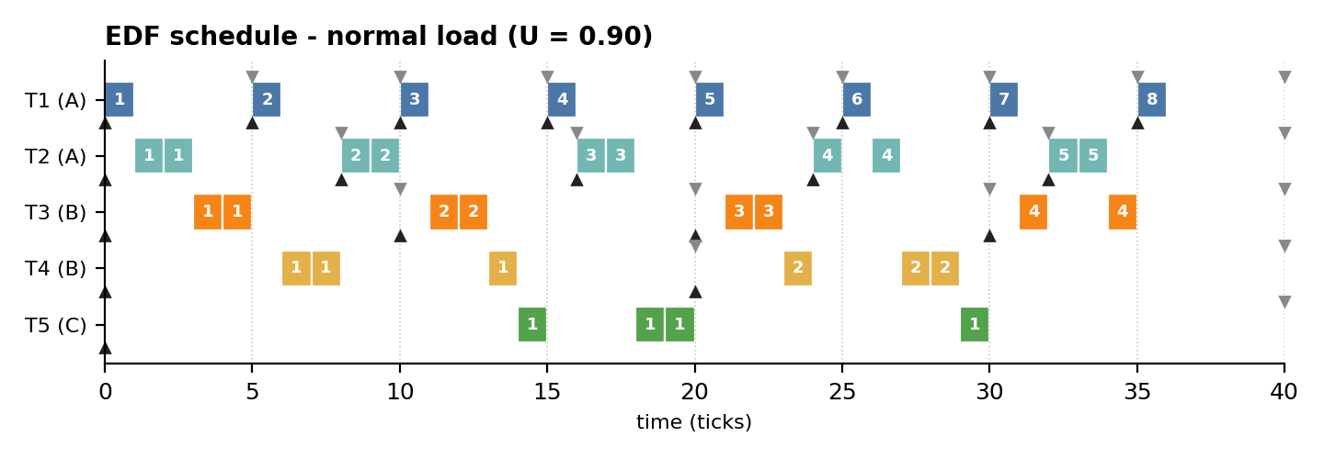
Figure 9: EDF schedule, normal load.
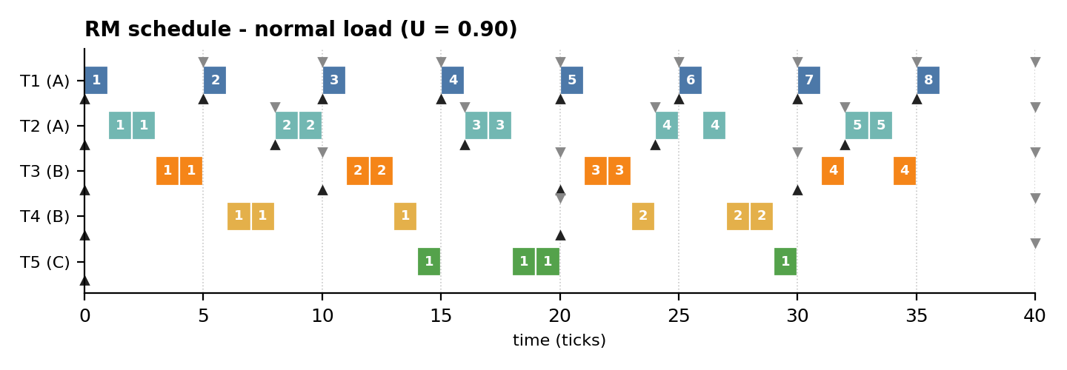
Figure 10: RM schedule, normal load.

Observations
- The EDF and RM timelines are identical tick-by-tick on this workload: at every decision the job with the earliest absolute deadline is also the job with the shortest period, so both rules choose the same job.
- Both complete all 20 jobs on time; the CPU is idle only in the last 4 ticks (utilization 0.90).
- Compared with Fair Share (Figure 6) the schedules are much more run-to-completion in nature: urgent jobs run in consecutive ticks, so there are 25 instead of 35 context switches and shorter waiting times.
- The two policies separate only when deadline order and period order disagree - for example under overload (page 22) or for task sets with constrained deadlines.

Execution statistics of the normal schedules (window of 40 ticks)
Statistic | Fair Share | EDF | RM
Busy ticks / idle ticks | 36 / 4 | 36 / 4 | 36 / 4
Context switches | 35 | 25 | 25
Preemptions (running job replaced before it finished) | 16 | 6 | 6
Longest uninterrupted run (ticks) | 1 | 2 | 2
Jobs executed in one contiguous piece (of 20) | 8 | 15 | 15

Meaning. Fair Share replaces the running job at almost every tick (16 preemptions) to keep groups balanced, whereas EDF/RM preempt only when a job with a nearer deadline or higher priority arrives (6 preemptions).

19 Entry and Exit Times of All Algorithms (Normal Load)
Arrival r and deadline d are identical for all algorithms (inputs); start s and exit f are outputs. Red bold = deadline missed.
Job | Arrival r | Deadline d | FS start | FS exit | EDF start | EDF exit | RM start | RM exit
T1.1 | 0 | 5 | 0 | 1 | 0 | 1 | 0 | 1
T2.1 | 0 | 8 | 3 | 7 | 1 | 3 | 1 | 3
T3.1 | 0 | 10 | 1 | 8 | 3 | 5 | 3 | 5
T4.1 | 0 | 20 | 4 | 16 | 6 | 14 | 6 | 14
T5.1 | 0 | 40 | 2 | 15 | 14 | 30 | 14 | 30
T1.2 | 5 | 10 | 8 | 9 | 5 | 6 | 5 | 6
T2.2 | 8 | 16 | 11 | 17 | 8 | 10 | 8 | 10
T1.3 | 10 | 15 | 13 | 14 | 10 | 11 | 10 | 11
T3.2 | 10 | 20 | 12 | 18 | 11 | 13 | 11 | 13
T1.4 | 15 | 20 | 18 | 19 | 15 | 16 | 15 | 16
T2.3 | 16 | 24 | 19 | 24 | 16 | 18 | 16 | 18
T1.5 | 20 | 25 | 21 | 22 | 20 | 21 | 20 | 21
T3.3 | 20 | 30 | 22 | 27 | 21 | 23 | 21 | 23
T4.2 | 20 | 40 | 20 | 29 | 23 | 29 | 23 | 29
T2.4 | 24 | 32 | 27 | 30 | 24 | 27 | 24 | 27
T1.6 | 25 | 30 | 25 | 26 | 25 | 26 | 25 | 26
T1.7 | 30 | 35 | 30 | 31 | 30 | 31 | 30 | 31
T3.4 | 30 | 40 | 31 | 34 | 31 | 35 | 31 | 35
T2.5 | 32 | 40 | 32 | 35 | 32 | 34 | 32 | 34
T1.8 | 35 | 40 | 35 | 36 | 35 | 36 | 35 | 36

Summary over 20 jobs | Fair Share | EDF | RM
Sum of exit times | 418 | 389 | 389
Average start delay (response) | 1.70 | 1.50 | 1.50
Latest exit time | 36 | 36 | 36
Jobs finishing after deadline | 1 | 0 | 0
All three algorithms are work-conserving and finish the last job at the same instant (36): the difference is when each individual job exits. EDF/RM finish jobs in urgency order; Fair Share postpones long jobs so that every group keeps advancing.

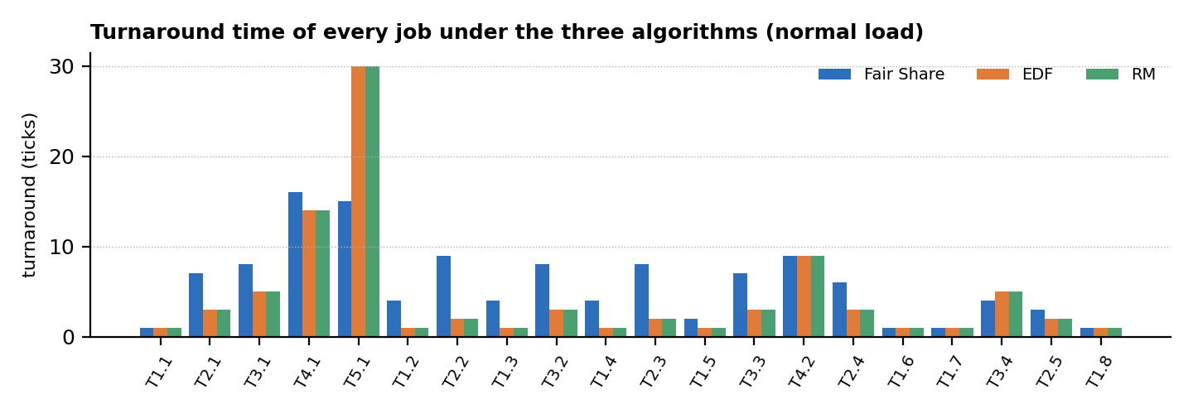
Figure G: Turnaround time of each job under the three algorithms.

20 Normal-Load Comparison (U = 0.90)
Metric | Fair Share | EDF | RM
Jobs completed | 20 | 20 | 20
Missed deadlines | 1 | 0 | 0
Deadline-miss ratio | 0.050 | 0.000 | 0.000
Average waiting time (ticks) | 4.10 | 2.65 | 2.65
Average turnaround time (ticks) | 5.90 | 4.45 | 4.45
Average response time (ticks) | 1.70 | 1.50 | 1.50
Maximum lateness (ticks) | 1 | 0 | 0
CPU utilization in [0,40) | 0.90 | 0.90 | 0.90
Context switches | 35 | 25 | 25
Jain fairness index | 1.000 | 1.000 | 1.000

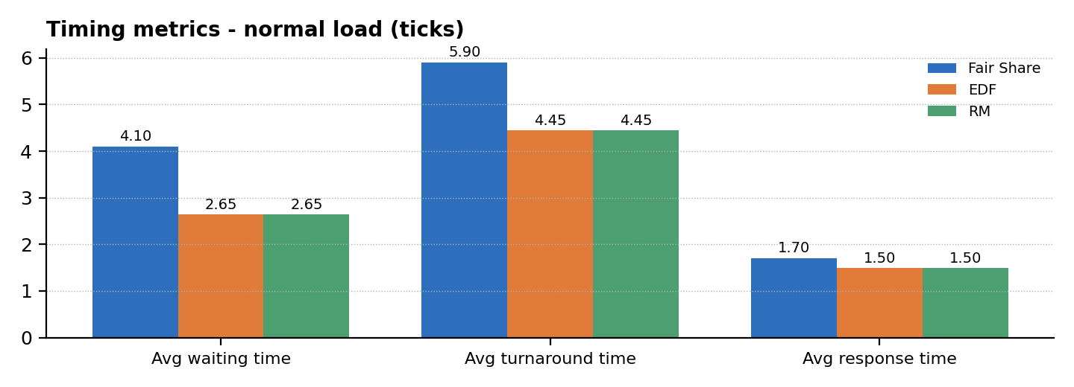
Figure 11: Average waiting, turnaround and response time under normal load.
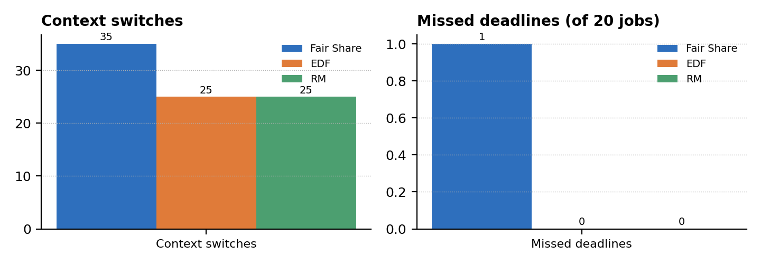
Figure 12: Context switches and missed deadlines under normal load.

Interpretation
- Fair Share's average waiting time is 55% higher than that of EDF/RM (4.10 vs 2.65 ticks); EDF/RM also need 10 fewer context switches and miss no deadline.
- Fair Share's response time is only slightly worse (1.70 vs 1.50) because every group is served within a few ticks; its price is longer turnaround for long jobs.
- With demand below capacity every policy serves every group fully (Jain index 1.000): fairness differences appear only under contention.

21 Overload Comparison (U = 1.225)
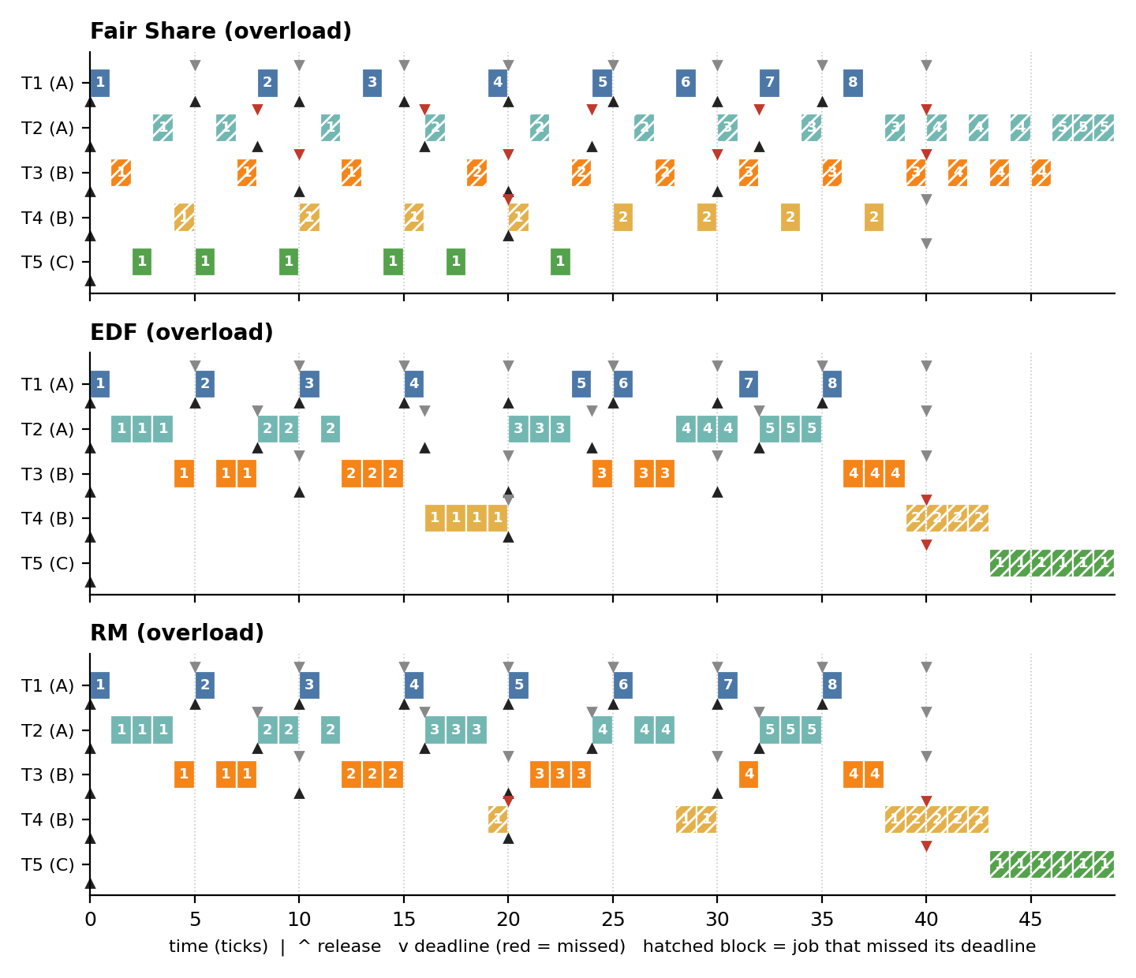
Figure 13: Schedules of the three algorithms under overload (times beyond 40 are drained backlog).
Metric (overload) | Fair Share | EDF | RM
Missed deadlines (of 20) | 10 | 2 | 3
Maximum lateness (ticks) | 15 | 9 | 19
Average waiting time | 10.00 | 5.50 | 5.65
Context switches | 46 | 22 | 25
CPU share A / B / C in [0,40) (entitled 0.45 / 0.40 / 0.15) | 0.42 / 0.42 / 0.15 | 0.57 / 0.42 / 0.00 | 0.57 / 0.42 / 0.00
Jain fairness index | 0.985 | 0.662 | 0.662
Reading. EDF and RM protect the urgent tasks and lose the rest: task T5 of group C receives no CPU before t = 40 and starts only at tick 43. Fair Share spreads the overload: group C gets its full entitlement (0.15), groups A and B are slowed proportionally (0.42 each, against demands of 0.575 and 0.500), giving J = 0.985 versus 0.662. The price is 10 late jobs, mostly T2 and T3, versus 2 (EDF) and 3 (RM).

Why does Fair Share miss more deadlines here?
- Fair Share is deadline-blind: it slows A and B in proportion to their weights, so the jobs of T2 and T3 finish late even when a nearer deadline could have been honoured.
- EDF and RM sacrifice the least urgent work (T4, T5) to keep most deadlines - good for timeliness, but group C is starved (share 0.00).
- The right choice depends on the objective: minimum number of late jobs (EDF/RM) or proportional degradation (Fair Share).

22 Utilization Sweep and Fairness
To check that the two workloads are not special cases, 150 random task sets per utilization level (periods 5, 8, 10, 20, 40; random group assignment fixed as A, A, B, B, C) were simulated with all three algorithms. The left chart shows the mean deadline-miss ratio; the right chart shows the Jain index of the two main workloads.
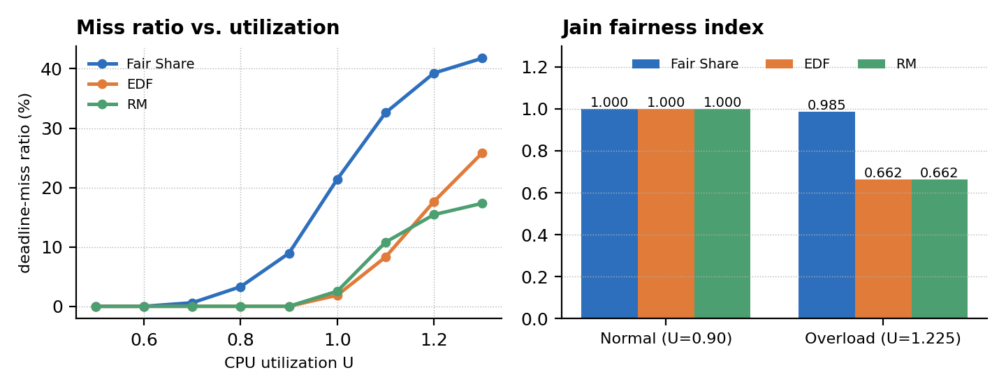
Figure 14: Deadline-miss ratio versus utilization (left) and Jain fairness index (right).
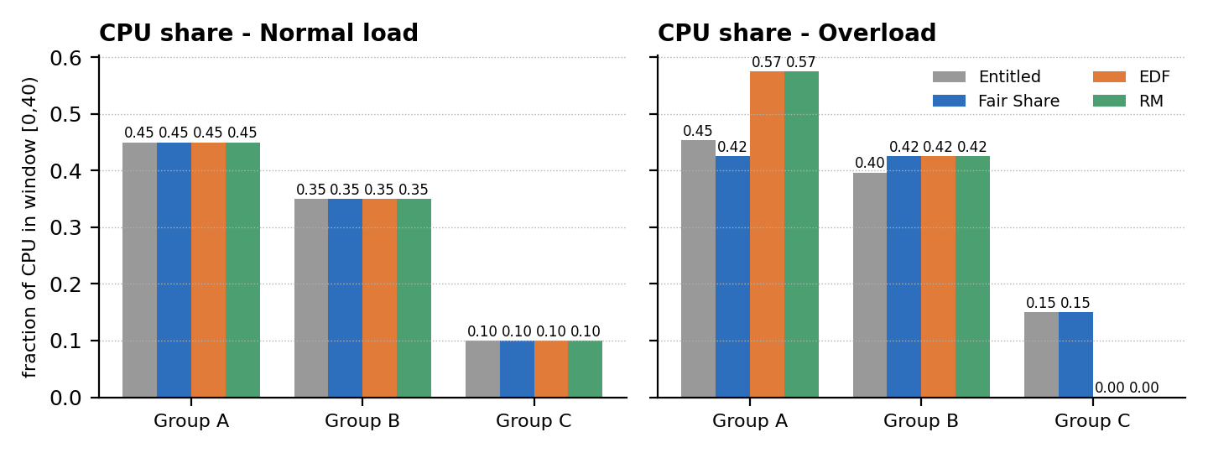
Figure 15: CPU share per group compared with the weight-based entitlement.
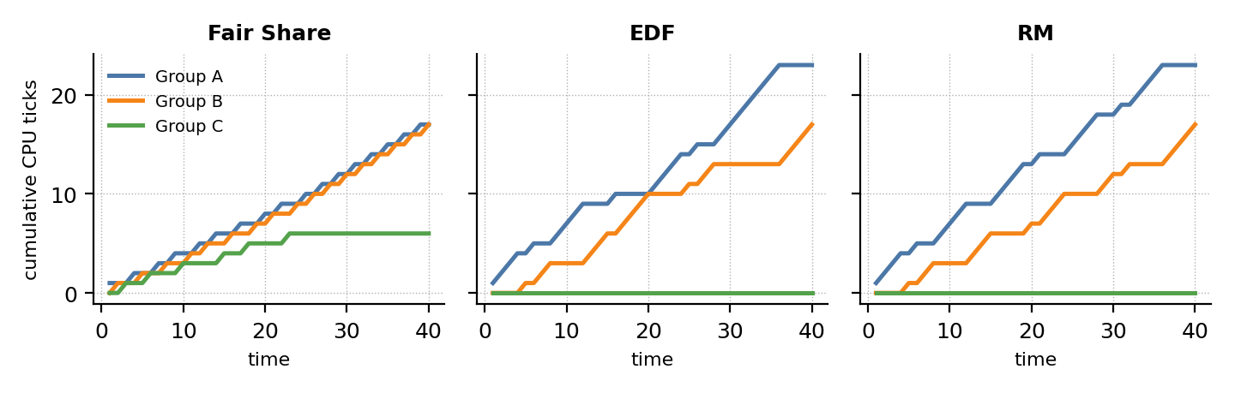
Figure 16: Cumulative CPU ticks per group under overload.
- EDF and RM are miss-free up to U = 0.9, while Fair Share already misses deadlines from U = 0.7; EDF beats RM near U = 1.0-1.1 (it can use 100% of the CPU).
- Beyond U = 1.2, RM misses fewer deadlines than EDF (high-priority tasks stay protected), in line with the known sensitivity of EDF to overload.
- Fair Share's miss ratio is highest everywhere, but it is the only policy whose group shares follow the entitlements (Figures 15 and 16).

23 Qualitative Comparison and Selection Guidelines
Criterion | Fair Share (monitor) | EDF | RM
Priority type | Dynamic, usage-based, recomputed every tick | Dynamic, per job (absolute deadline) | Static, per task (period)
Decision basis | Recent CPU use vs. group entitlement | Nearest absolute deadline | Shortest period
Optimality | Not deadline-driven | Optimal for preemptive uniprocessor, U <= 1 | Optimal among static-priority policies
Schedulability test | None; statistical, depends on weights | U <= 1 (D = P) | U <= n(2^(1/n) - 1) sufficient; RTA exact
Deadline guarantee | None (best effort) | Hard, if U <= 1 | Hard, if RTA passes
Fairness / isolation | Excellent: J = 0.985 in overload | None | None; low priorities starve
Starvation | Impossible (usage decay) | Possible for far deadlines in overload | Possible for lowest priorities
Overload behaviour | Graceful, proportional slowdown | Unpredictable; misses can cascade | Predictable: high priorities protected
Context switches (normal) | 35 | 25 | 25
Avg waiting (normal) | 4.10 | 2.65 | 2.65
Implementation effort | Highest: monitor, conditions, accounting | Moderate: deadline tracking | Lowest: static table
Required information | Group weights, usage history | WCET, deadlines | WCET, periods
Typical domain | Shared servers, cloud / container CPU shares | Dynamic real-time systems with high utilization | Safety-critical embedded control

Selection guidelines
- Choose Fair Share when the requirement is *who* gets the CPU (users, tenants, departments) and soft timing is acceptable.
- Choose EDF when deadlines are hard, the load is dynamic and the highest possible utilization (up to 100%) is needed.
- Choose RM when predictability, simple analysis and robust behaviour of the most critical tasks matter more than peak utilization.
- Hybrid option: run EDF or RM for real-time tasks inside each Fair Share group, so groups are isolated and each group still meets its deadlines.

Implementation level: monitor-only vs. monitor + semaphore (previous exercise)
Aspect | Monitor-only (this report) | Monitor + semaphore
Synchronization objects | 1 lock, 3 kinds of condition variables | 1 lock, 1 condition, 3 kinds of semaphores
Source lines (non-blank, no comments) | 80 | 78
Mean run time, 40-tick normal workload | 0.80 ms | 0.93 ms
Schedule produced | identical | identical

Qualitative scorecard (5 = best)
Dimension | Fair Share | EDF | RM
Fairness and isolation between groups | ●●●●● 5/5 | ●○○○○ 1/5 | ●○○○○ 1/5
Deadline guarantees (U <= 1) | ●○○○○ 1/5 | ●●●●● 5/5 | ●●●●○ 4/5
Schedulable utilization | ●●○○○ 2/5 | ●●●●● 5/5 | ●●●●○ 4/5
Predictability under overload | ●●●●○ 4/5 | ●●○○○ 2/5 | ●●●●○ 4/5
Low scheduling overhead | ●●○○○ 2/5 | ●●●○○ 3/5 | ●●●●● 5/5
Implementation simplicity | ●●○○○ 2/5 | ●●●○○ 3/5 | ●●●●● 5/5
The ratings summarise the measured results and the theory above; they are a guide, not a measurement.

24 Conclusions, Future Work and References

Conclusions
- The monitor-only design works: one lock, entry procedures and three kinds of condition variables suffice for state protection, CPU hand-off and termination, and the threaded schedule matches an independent simulator tick-by-tick on both workloads.
- Under normal load (U = 0.90) EDF and RM meet all deadlines with 25 context switches and 2.65 ticks average waiting; Fair Share missed 1 of 20 deadlines, needed 35 context switches and 4.10 ticks waiting.
- Under overload (U = 1.225) EDF and RM starve group C completely (share 0.00) with Jain index 0.662, whereas Fair Share keeps each group close to its entitlement (J = 0.985) at the cost of 10 late jobs.
- No algorithm dominates: EDF maximises timeliness and utilization, RM maximises predictability, Fair Share maximises fairness and isolation.

Limitations
- Logical time and unit quantum; context-switch cost and I/O are ignored; one CPU only.
- Small task set (5 tasks, 3 groups); random-set experiment uses fixed periods and 150 samples per level.
- Python threads are used for synchronization semantics, not for parallel speed (GIL); Mesa-style conditions are assumed.

Future work
- Hierarchical scheduling: EDF/RM inside each Fair Share group; multiprocessor extension with per-CPU monitors.
- Weighted decay and variable quantum; measurement on a real kernel (e.g. Linux cgroup cpu.weight).

References
[1] E. W. Dijkstra, "Cooperating Sequential Processes", Technical report EWD-123, 1965.
[2] C. A. R. Hoare, "Monitors: An Operating System Structuring Concept", Communications of the ACM, 17(10), 1974.
[3] C. L. Liu and J. W. Layland, "Scheduling Algorithms for Multiprogramming in a Hard-Real-Time Environment", Journal of the ACM, 20(1), 1973.
[4] G. J. Henry, "The Fair Share Scheduler", AT&T Bell Laboratories Technical Journal, 63(8), 1984.
[5] J. Kay and P. Lauder, "A Fair Share Scheduler", Communications of the ACM, 31(1), 1988.
[6] R. Jain, D. Chiu and W. Hawe, "A Quantitative Measure of Fairness and Discrimination for Resource Allocation in Shared Computer Systems", DEC Technical Report TR-301, 1984.
[7] G. C. Buttazzo, Hard Real-Time Computing Systems, Springer.
[8] A. Silberschatz, P. B. Galvin and G. Gagne, Operating System Concepts, Wiley.

Verdict by dimension
Dimension | Best | Evidence from this study
Meeting deadlines at U = 0.90 | EDF / RM | 0 misses vs 1 for Fair Share
Average waiting time (normal load) | EDF / RM | 2.65 vs 4.10 ticks
Context-switch overhead | EDF / RM | 25 vs 35 switches
Fairness under overload | Fair Share | Jain 0.985 vs 0.662
Protection of the smallest group (C) | Fair Share | share 0.15 vs 0.00 (entitled 0.15)
Miss ratio at U >= 1.2 | RM | Lowest among the three in the random-set sweep (page 23)
Utilization near 100% with deadlines | EDF | Fewest misses at U = 1.0 - 1.1 in the sweep

How to reproduce
# save the listing of pages 13-14 as fs_monitor.py and the driver of page 14 as driver.py
$ python3 driver.py # threaded Fair Share scheduler (monitor only), prints the timeline
$ python3 sim.py # simulator for Fair Share, EDF and RM on both workloads
$ python3 check_monitor.py # confirms threaded timeline == simulator timeline

