**Making 2D Games with Unity**

**Tutorial 1**

Objectives:

* Using sprites
* Controlling sprites using simple code

**1. Importing/Organizing Assets into Unity**

1. Create a new project called **UT-2D-1** inside a folder named **UT-2D-1.**
2. Change “Setup defaults for:” to 2D instead of 3D, and click create.
3. Once created navigate to the project tab and create 3 folders, named: Images, Scenes, and Scripts.
   1. Project tab>right click “Assets”>Create>Folder.

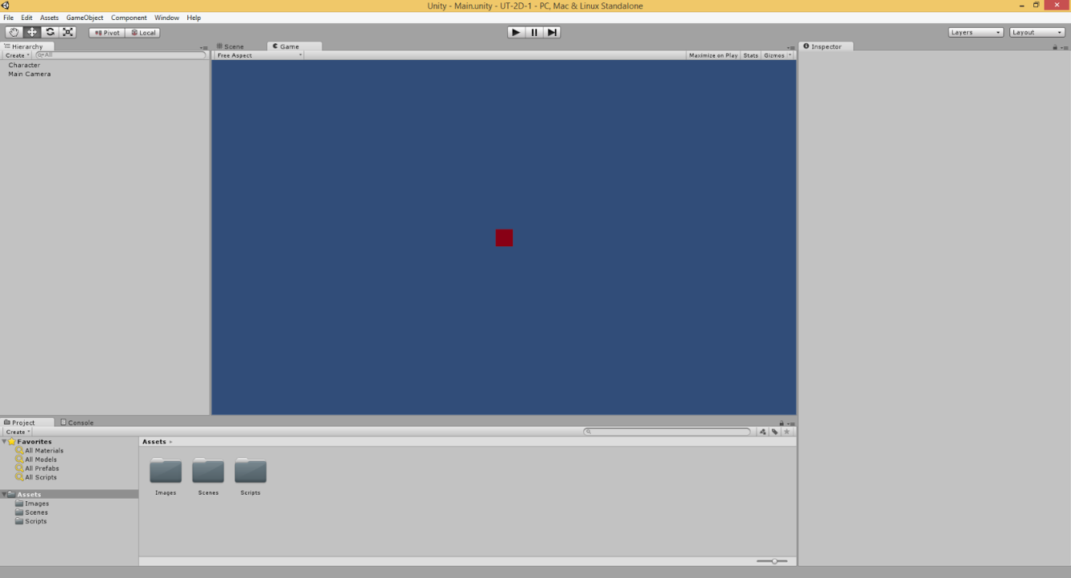

1. With the 3 folders created, import an image
   1. Open the “Images” folder we just created via the Project tab>right click in the blank space>Import New Asset>Navigate to your image>Import
2. Now let’s save the scene
   1. File>Save Scene>Open the Scenes folder we created earlier>Name it whatever you like, in this case I’ll call it “Main” for simplicity>Save

**2. Creating/Implementing a Sprite**

1. With the scene saved and the asset imported let’s put the asset in the scene
   1. GameObject>Create Other>Sprite
2. Right click the newly created sprite “New Sprite” and rename it “Character”.
3. With the Character selected you’ll notice the Inspector has 2 new components: Transform, and Sprite Renderer. To apply the image we imported earlier onto the Sprite, simply click the small circle to the far right of where it says “Sprite” under the Sprite Renderer component.

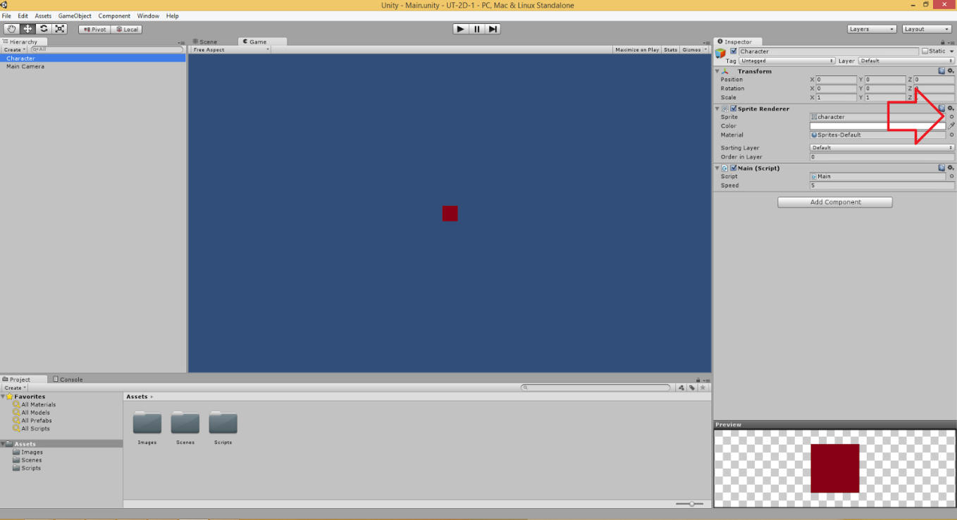

1. When clicked, a new window will appear. Click the “assets” tab on the new window and your image should appear. Click on the image we imported earlier and press enter.
2. You’ll notice your image appears in the center of the screen, now let’s make it move.

**3. Creating/Implementing a Script**

1. Now to create the script which will control the character
   1. Open the “Scripts” folder we created earlier via the Project tab>right click in the blank space>Create>C# Script>Name it whatever you like, in this case I’ll call it “Main” for simplicity
2. Attach the script onto the sprite
   1. Select the Sprite in the scene via the Hierarchy tab>Click “Add Component” button inside the Inspector Tab>Scripts>Main (Or whatever you called it).
3. Writing a script to move the sprite
   1. Under the Project tab open the folder we created called “Scripts”>Double-click on the script we created>This should open MonoDevelop
4. With MonoDevelop open, let’s make our character move.
5. Copy this code to apply controls to the character. What we did was create a public variable to store the characters speed*. Then we created a function called “controller” which checks if the arrow keys are pressed and moves the character.

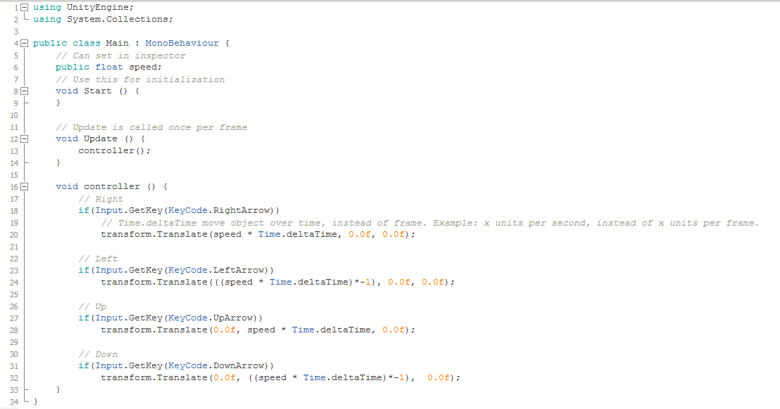

*Generally we want to have as little public variables as possible and define the values within the scripts, however for the case of this tutorial it’s much easier to visualize doing it this way.

1. Save the script: file>save, and head back to unity.
2. With unity open, before we can start to move our character around we need to define the variable we created earlier which controls the characters speed.
   1. Select “Character from the hierarchy tab>Under the “Main (Script)” tab in the inspector change the value for “Speed” (for example 5, anything higher is probably too fast.)

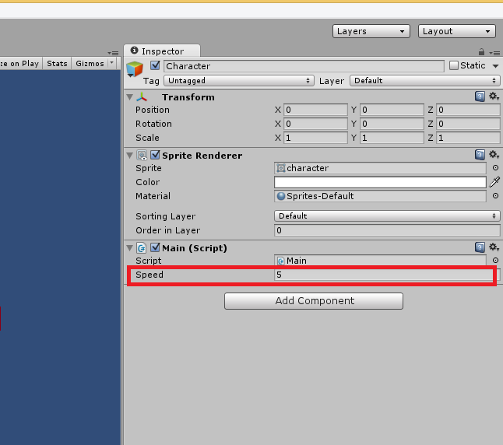

1. With the speed added, let’s play the scene
   1. Click the Arrow at the top center of the screen.
2. Now, while the scene is playing you can adjust the speed variable. However, any changes made to variables/the scene while in play mode will NOT save.