Making 2D Games with Unity

Tutorial 4

Objectives:

* Creating a background
* Parallax effect

**1. Moving the background - Parallax Effect**

1. Via the project tab open up the scripts folder and create a new script called “CameraFollow”.
   1. Project tab>Assets>Scripts>Right click blank space>Create>C# Script>”Camera Follow”
2. With the script created go back to the Hierarchy tab and attach the script to the Main Camera game object and change the camera projection to “Perspective”.
   1. Hierarchy tab>left click Main Camera>Inspector>Add Component>CameraFollow
   2. Hierarchy tab>left click Main Camera>Inspector>Projection>Perspective
3. Open up the script and copy the following code: (this is a very simple follow script, it solely mimics the linear movement of the main character)

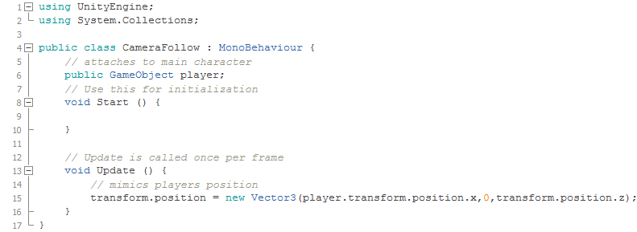

1. Head back into unity and attach the player variable to the main character
   1. Hierarchy tab>left click Main Camera>Inspector>Player>Small circle next to it>Scene>Character
2. Play the scene and the camera will follow the character (always centering the character).

**2. Adding Parallax**

1. The easiest and most efficient way to add parallax is to simply add sprites and change their z values. *please note, if the background is never ending look into scrolling textures or doing it this way will slow your game down.
   1. Project tab>Sprites>Right click blank space>Import new asset>Locate the assets and import them (bg1, bg2, and foreground)
2. Open the import settings of all the sprites and change the format to “True Color” and Size to 4096.
   1. Left click sprite in the sprites folder>Inspector>format>True Color
   2. Left click sprite in the sprites folder>Inspector>Max Size>4096
3. With the assets imported let’s add them into the scene
   1. Hierarchy tab>left click “Floor”>Inspector>Sprite>Change from background to foreground (the new assets are green, it would be hard to see the floor).
   2. In the Project Tab>Scripts>Select>bg1>drag into the Hierarchy tab
   3. In the Project Tab>Scripts>Select>bg2>drag into the Hierarchy tab
4. Click off 2D so we can alter the z values of bg1 and bg2:

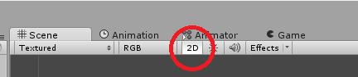

1. Maneuver the camera and sprites in 3D to create the parallax effect:

