**Making 3D Games with Unity**

**Tutorial 1**

Objectives:

* Creating new projects
* Camera control

**1. Movement and Camera Control**

1. Create a new project called **UT-3D-1**
2. Create a few Game Objects in the world
   1. Go to Menu>GameObject>Create Other>Cube to create a cube.
   2. You can zoom in/out of the cube with the mouse wheel, and press F with the mouse over the scene window to center the selected object.
   3. You can duplicate the cube by pressing Control+D or going to Menu>Edit>Duplicate. You can move the cube to another position using the Move tool or scale it by using the Scale tool (press W or R).
   4. You can also create other primitives and place them around the scene using Menu>GameObject>Create Other>... For now, only use cubes, spheres, capsules and cylinders.
   5. Your scene should look something like this: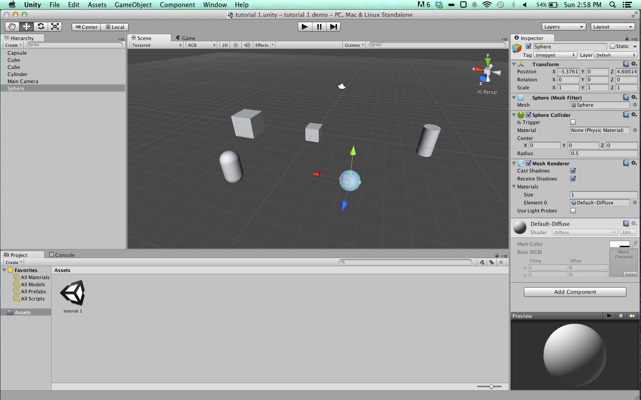
3. Save the scene by pressing Control+S or going to Menu>File>Save Scene. Save it to the Assets folder inside of your project folder and name it **UT-3D-1**.
4. Play the game by pressing the play button above the Scene window. The game will show the Main Camera’s view by default, which is looking at the objects. There is no lighting yet, so all of the objects appear grey.
   1. Add a Directional Light to your scene by going to Menu>GameObject>Create Other>Directional Light.
   2. You may click play again to see the effects.
5. Where the Main Camera is positioned right now it may be hard to see the objects. It would be better to have a top down view of the objects to be able to see more.
   1. Select the Camera in the Hierarchy window. Move the camera up in the Z axis. This can also be done in the Inspector window with the Main Camera selected, under the Transform component, by changing the Z value and pressing Enter.
   2. Now the camera needs to be rotated to look at the objects. Using the Rotate tool (E), rotate the camera. This can also be done in the inspector by entering X, Y and Z rotation values.
   3. Play the game, and ensure you can see all of your objects in the Game view. It should look something like this: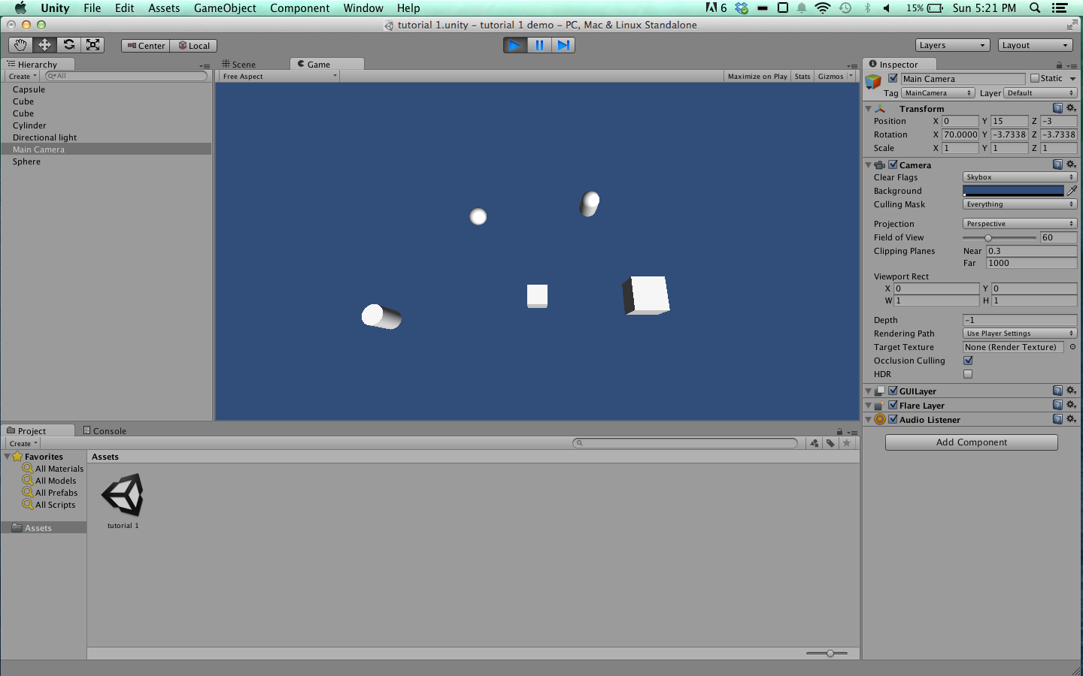
6. Now we will make one of the objects move using the WASD keys. This must be done by creating a custom script and attaching it to one of the objects.
   1. Go to Menu>Assets>Create>C# Script. Do not click anything. A new script has appeared in the Project window. Name the script “Movement” and hit enter.
   2. Select the first cube we created (any object will do though). In the Inspector window, scroll to the bottom and click the “Add Component” button.
   3. Start typing the name of the movement script. It will appear in the list, select it with the arrow keys and hit enter. This will add that script to the object, and will cause any functions created in the script to be applied to this object.
7. Now open the script by double clicking it in the Project window, and Monodevelop will open with the script open.
   1. This file contains a default class called Movement (or whatever you named the file) which includes a Start and Update function. All of the code we will need to write to make an object move will be written in the Update function.
   2. All that needs to be done is to get the keyboard input and if a key is pressed, move the object a certain amount in the right direction. See example Movement.cs file for explanation.
   3. After entering the code, save the file and play the game in unity. You should be able to press the WASD keys and see your object moving. You may need to refresh the script by right-clicking on it in the Project window and using the Refresh command.
8. Now we will make the camera look around with the mouse, like most FPS games do.
   1. In Unity, create a new script and name it “CameraLook”. Attach it to the Main Camera object, then open it in Monodevelop.
   2. See example CameraLook.cs file for explanation.
   3. After entering the code and saving the file, play the game in Unity. The camera will move with the mouse.
9. You should be able to move the cube with the WASD keys and follow it with the mouse at the same time.

## 2. Camera Movement

1. Select the object (the cube) with the Movement script attached, and in the Inspector window, uncheck the checkbox next the Movement (Script) component. This will disable the script without removing it from the object.
2. Add the Movement script to the Camera so that you can look and move around the objects. Select the Main Camera object in the Hierarchy window. In the Inspector, scroll to the bottom and click Add Component, and type the name of the movement script, “Movement” and hit enter.
3. Play the game. You can move the camera with the WASD keys and look around.

## 3. Standard Unity Asset FPS Controller

1. Unity provides some default assets for basic functionality in some types of games. A simple FPS character controller can be imported and used in any project. It has much of the same functionality that we just created, plus some extra things.
   1. In the Hierarchy window, select the Main Camera and disable it with the check box to the left of its name in the Inspector.
   2. Go to Menu>Assets>Import Package>Character Controller. In the new “Importing Package” window, make sure all items are selected and hit Import in the bottom right corner of the window.
   3. In the Project window, navigate to Standard Assets>Character Controllers.
   4. Click and drag the First Person Controller prefab to the scene window or hierarchy window. You should see a capsule with a camera in it in your scene window, this is the default First Person Controller.
   5. Center the First Person Controller in the scene so that it is positioned with the other objects. In the Inspector window with the First Person Controller selected, set the Transform position to be X:0, Y:0, Z:0. Hit tab after each 0 to make this easier.
2. You can play the game now, but the character controller will fall and you will not be able to see anything. The standard FPS controller has gravity applied to it by default, and therefore needs something to catch it from falling. A cube will work.
   1. Create a cube by going to Menu>GameObjects>Create Other>Cube.
   2. Scale the cube to be much larger than your character with the scale tool or entering values in the Inspector. Move the cube directly underneath your First Person Controller, so that the controller will fall onto the cube.
   3. Your scene should look something like this: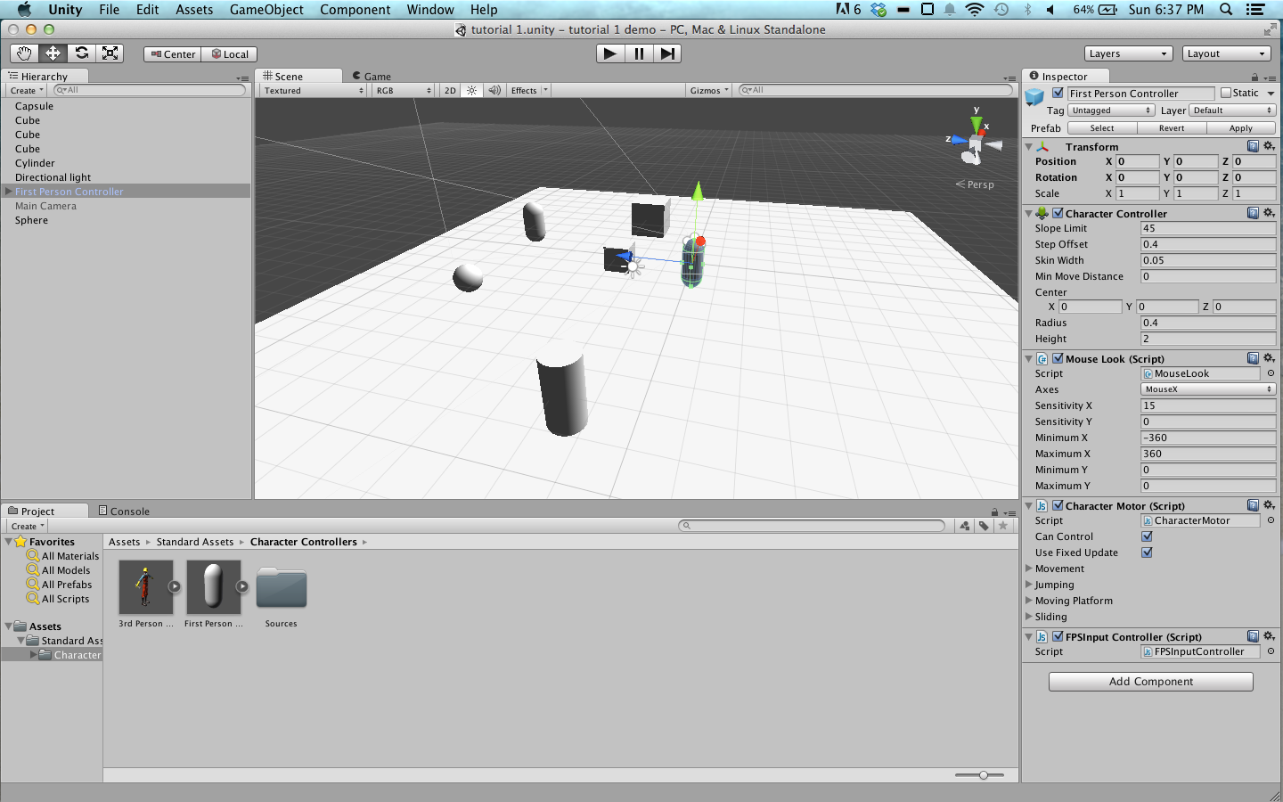
3. Play the game again and see that the camera does not keep falling. You can move with the WASD keys and look around with the mouse. You can also jump with the space bar.