**Making 3D Games with Unity**

**Tutorial 2**

Objectives:

* Importing assets with animations and materials
  + Importing a skybox
  + Importing a character with animations
* Collision
  + With distance
  + With Unity colliders

**1. Asset Importing and Animated Characters**

1. Create a new project called **UT-3D-2**
   1. Import the standard character controller package. We will use the standard FPS controller for this tutorial.
2. Add the standard First Person Controller to the scene.
   1. Navigate to Assets>Standard Assets>Character Controllers and drag the First Person Controller to the scene window.
   2. Add ground for the player to walk on. Navigate to Menu>GameObject>Create Other>Terrain.
   3. Move the FPS controller to the center of the terrain and up slightly so that it does not fall through the ground.
   4. Add light to the scene by navigating to Menu>GameObject>Directional Light.
   5. Play the game to make sure it works.
3. Import and add a skybox to the scene.
   1. In windows explorer, copy the Skybox folder from the tutorial files to the Assets folder of your Unity project.
   2. When switching back to Unity, it will automatically import the assets.
   3. In the project window, navigate to the skybox folder under Assets>Skybox. In this folder, right click and select Create>Material. Name this material Skybox.
   4. With the Skybox material selected, in the Inspector window, change the shader dropdown from Diffuse to RenderFX>Skybox.
   5. Drag the Skybox_front.png file from the project window to the Front (+Z) item’s square in the Inspector window. The Skybox material must be selected to see these options in the Inspector. Repeat for each of the six skybox image files. See the image below: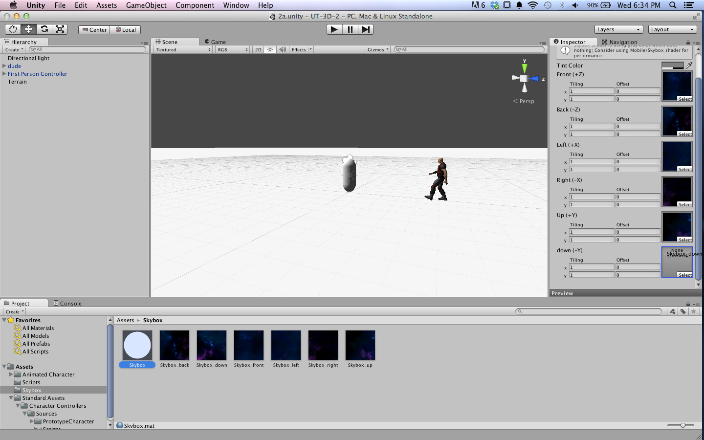
   6. Navigate to Menu>Edit>Render Settings. Under the Skybox item, click the small circle next to the text field. in the popup window, double click the item called “Skybox”.
   7. You should now be able to see the skybox in the scene window. You can also play the game and look around. It should look something like this: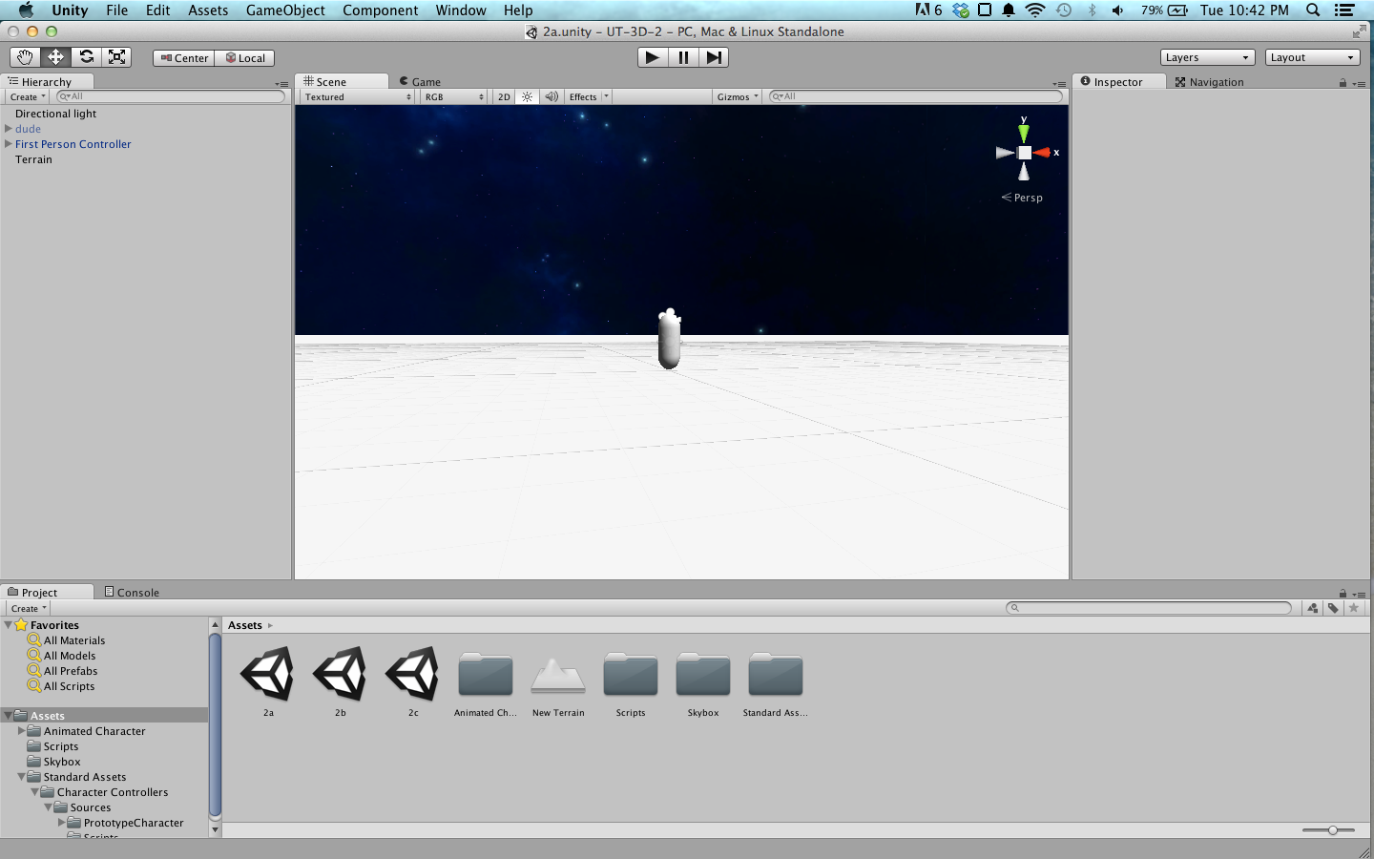
4. Import an animated character to the game.
   1. In windows explorer, copy the Animated Character folder to the Assets folder of your Unity project.
   2. Switch back to Unity and let Unity import the character. Once complete, navigate to Assets>Animated Character in Unity and drag dude.fbx to the scene window.
   3. The dude is too small, so scale him 3x larger. Do this in the inspector window after selecting dude in the hierarchy window and changing its transform’s scale to X:3, Y:3, Z:3.
   4. You can play the game and see the dude, but there is no animation yet.
   5. With dude.fbx selected in the project window, in the inspector window click the Rig button. Under Animation Type, change the drop down to Legacy, then click Apply. Unity supports complex animation including IK rigs, but we will not be using those in this tutorial. Legacy supports animations baked as a timeline animation.
   6. Click the Animation button. Scroll down, under Take 001, change the drop down for Wrap Mode to Loop. and click Apply. This will make the animation repeat once it has started.
   7. Click the dude in the scene window or hierarchy window. In the Inspector, under the Animation component, ensure Play Automatically is checked.
   8. Play the game. If you look at the dude, he should now be walking in place. The scene should look like this: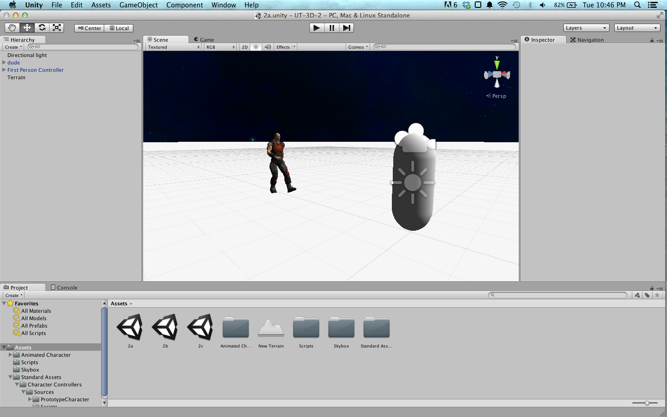

**2. Collisions (Custom)**

1. We will start by making our own basic collision script. In the Project window, create a new folder for Scripts and inside this folder, create a new script called “BasicCollision”.
2. Add the BasicCollision script to the dude.
   1. Click dude in the scene window
   2. In the Inspector window, click Add Component and start typing BasicCollision. Click BasicCollision to add the script to dude.
3. Now we will create a simple collision when the player collides with the dude.
   1. Open the BasicCollision script by double clicking it in the Project window. This will open MonoDevelop with the BasicCollision script open. See example BasicCollision.cs file for explanation.
   2. After creating the script, if you play the game you should get pushed back when you move close to dude.

**3. Unity Colliders**

1. For smoother collisions, we can use Unity’s built in colliders to facilitate collisions. They include everything we would need for collisions for a physics simulation.
   1. Drag a new instance of dude.fbx from the project window to the scene and position and scale him appropriately.
   2. In the Hierarchy window, click the arrow next to the new dude to expand his child objects. He should have two children, named “him” and “Root”. Select him.
   3. In the Inspector window, scroll to the bottom and click Add Component. Search for “collider” to bring up a list of the default colliders Unity supports. Select capsule collider, and Unity will automatically make a capsule shape around dude’s mesh. It should look like this: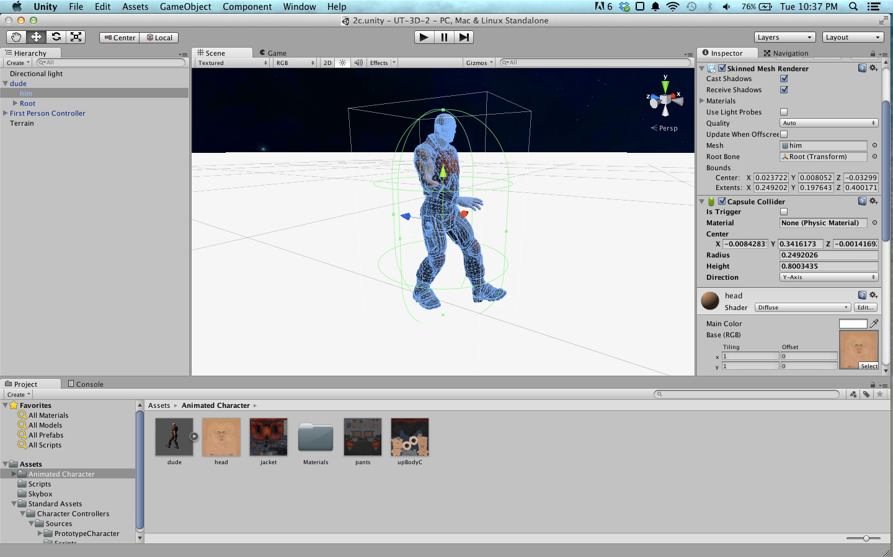
   4. The capsule collider fits around the entire mesh. If you wish the collider be smaller, you can change the values under the Capsule Collider component.
      1. You can change the radius to be smaller so it only fits around dude’s torso, around 0.15.
   5. If you play the game, you should be able to move up to but not through dude, with no jittery motion as you collide.