Introduction to Unity
1. Highlights
- Browser-based
- Easy-to-use editor
- Using different asset types
- Scripting in Javascript and C#
- References:
  - http://unity3d.com/learn/tutorials/modules/beginner/architecture/folders-in-version-control
  - http://unity3d.com/learn
  - http://blogs.unity3d.com/2013/11/12/unity-4-3-2d-game-development-overview/
  - http://unity3d.com/learn/tutorials/modules
2. Unity Editor Interface
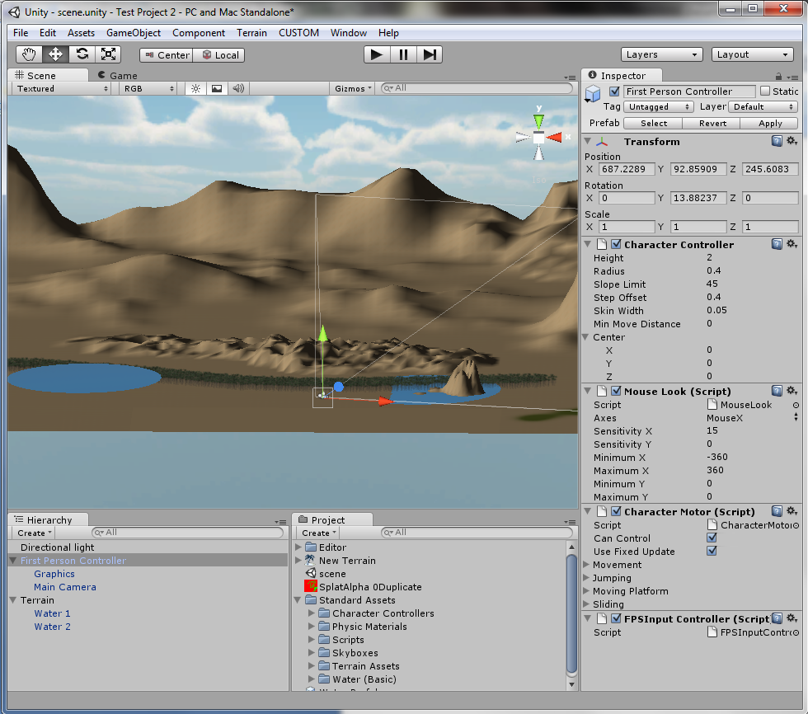
The Scene Window is your design environment. Viewing Controls are similar to common 3D tools. Use Scene Control at top-left. Pay attention to Layers drop box!
Game Window is where you see the running game. Click on Play button to run. Click again to end. You change properties during the run but they will go back to previous values after you end.
Hierarchy is the list of game objects
Project is where you see available assets.
Inspector is for setting and viewing parameters (properties) of selected objects.

3. Creating a New Project
- Use File->New Project
- Select standard assets you want. Older versions had one Standard Assets. Now we have them separately. You can add later.
- You can have more than one Scene in each project.
- Use GameObject menu to add light, camera, and simple objects (Ball and Paddle).
- Check the Properties in Inspector.
- Add RigidBody to the Ball from the Component menu and make sure Use Gravity is selected.
- Make the Ball material Bouncy (under Collider)
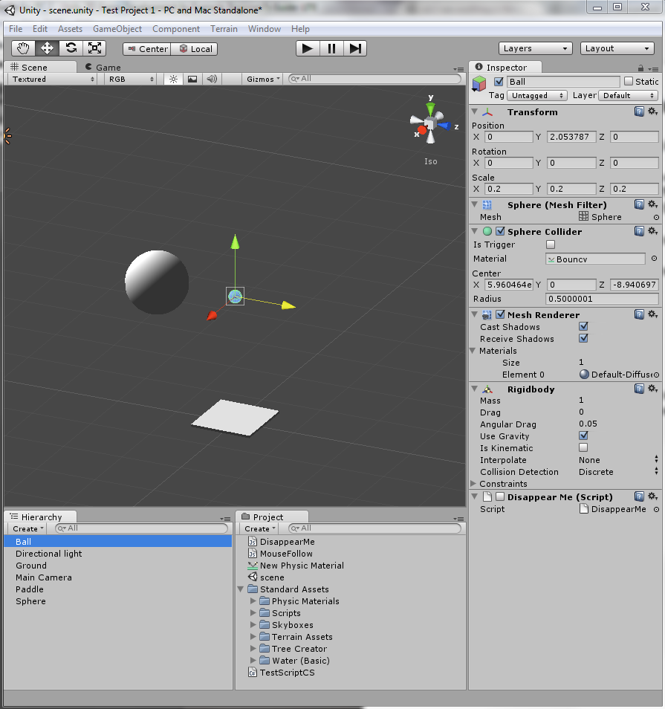
4. Adding Terrain and First Person Camera
- Use Terrain -> Create to add terrain to your game.
- Use terrain tools to modify the terrain.
- Use Water asset in Project window and add water
- Use First Person Controller from the Project window to add a standard first person camera with all related controls.

5. Adding Code
- Unity is based on Mono framework, an open-source implementation of .NET.
- Scripts can be written in Javascript, C#, and Boo. Functionality is almost the same as they all use the underlying Mono framework and its classes.
- Javascript code is relatively easier and you’ll find more examples. For differences see the Scripting Reference -> Overview -> C#.
- Right-click on an empty space in Project window and select Create -> Javascript. Click on small Icon to rename. Drag to move. Try C#.
- All scripts are derived from MonoBehaviour class. For Javascript you don’t need to write that, but for C# you need to use inheritance and define MonoBehaviour as base class.
- Update is the main function of the script that will be called automatically.
- Select an object in Hierarchy, then drag and drop a script to Inspector in order to attach the script to the object.
- Add the following script to the Paddle object in the example:

function Update () {
var halfW : float = Screen.width/2;
transform.position.x = (Input.mousePosition.x - halfW) / halfW;
}

6. Adding Prefabs (prefabricated objects)
- A Prefab is a type of asset -- a reusable GameObject stored in Project View. Prefabs can be inserted into any number of scenes, multiple times per scene. When you add a Prefab to a scene, you create an instance of it. All Prefab instances are linked to the original Prefab and are essentially clones of it. No matter how many instances exist in your project, when you make any changes to the Prefab you will see the change applied to all instances.
- Right-click in Project window and choose Create->Prefab from the menu and name the Prefab.
- In Hierarchy View, select the GameObject you wish to make into a Prefab.
- Drag & drop the GameObject from the Hierarchy onto the new Prefab in Project View.
- After you have performed these steps, the GameObject and all its children have been copied into the Prefab data. The Prefab can now be re-used in multiple instances. The original GameObject in the Hierarchy has now become an instance of the Prefab.

