Figure 1. Conceptual Radar Model of DET

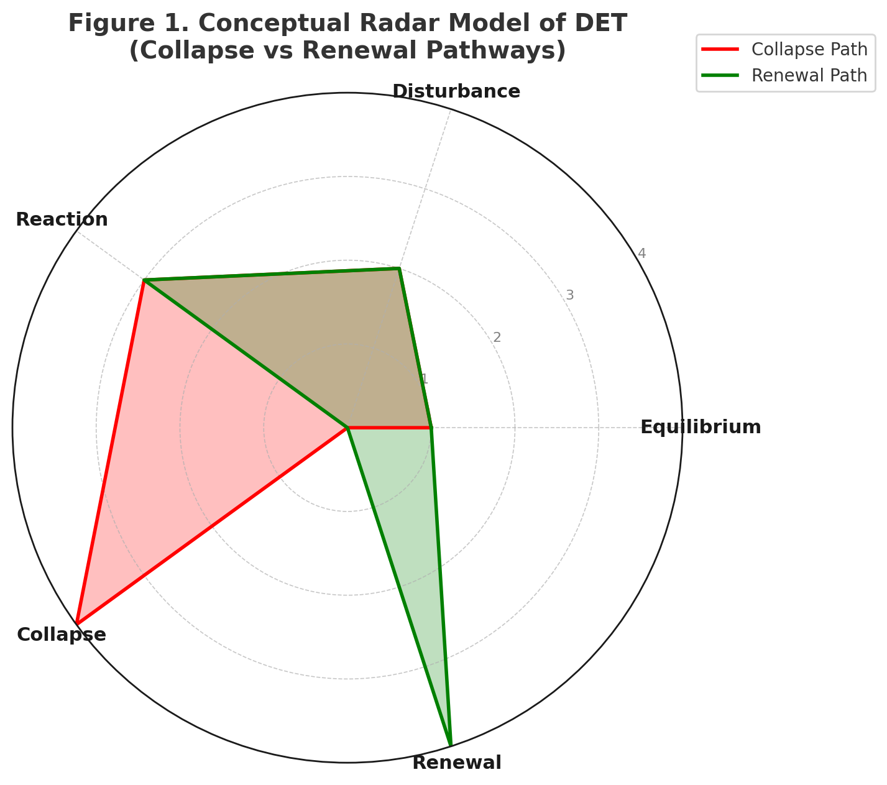

Caption: Conceptual radar model of the Disturbed Equilibrium Theory (DET). The five axes represent the systemic stages: Equilibrium → Disturbance → Reaction → Collapse → Renewal. The red pathway illustrates a trajectory toward collapse, while the green pathway shows potential renewal and establishment of a new equilibrium.

Figure 2. Flow Diagram of the Disturbed Equilibrium Index (DEI)

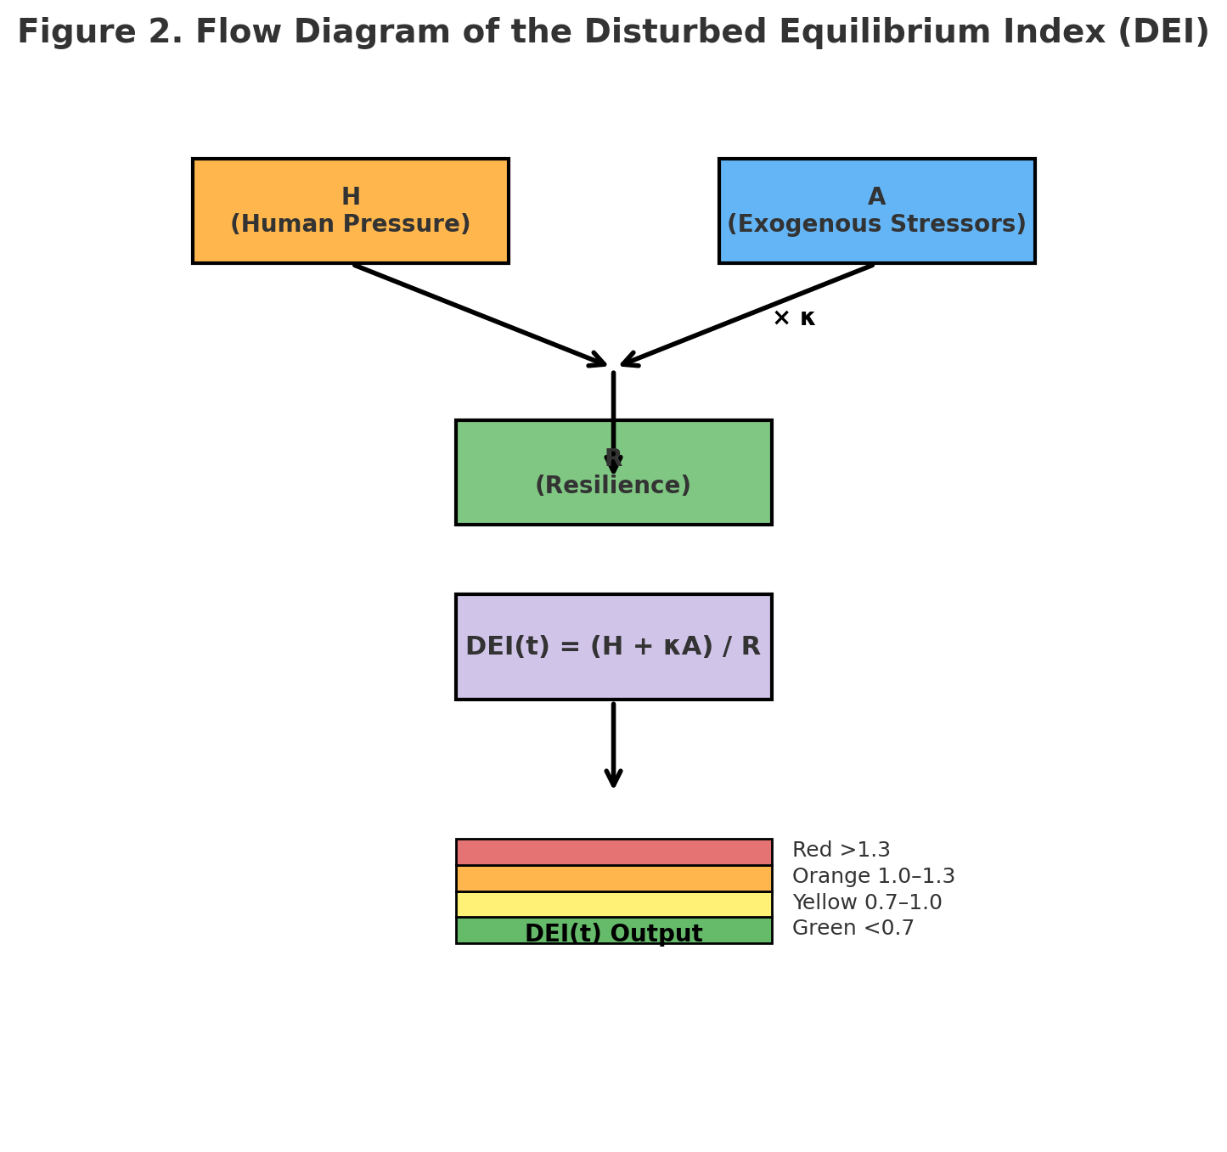

Caption: Flow diagram of the Disturbed Equilibrium Index (DEI). Inputs include H (Human Pressure) and A (Exogenous Stressors), with κ weighting the relative impact of A. These combine with R (Resilience) as a denominator, producing the operational formula: DEI(t) = (H + κA)/R. The output is represented as a risk scale (Green <0.7, Yellow 0.7–1.0, Orange 1.0–1.3, Red >1.3), providing an intuitive classification for ecosystem states from safe to crisis regimes.

Figure 3. Comparative Radar Chart of Case Studies

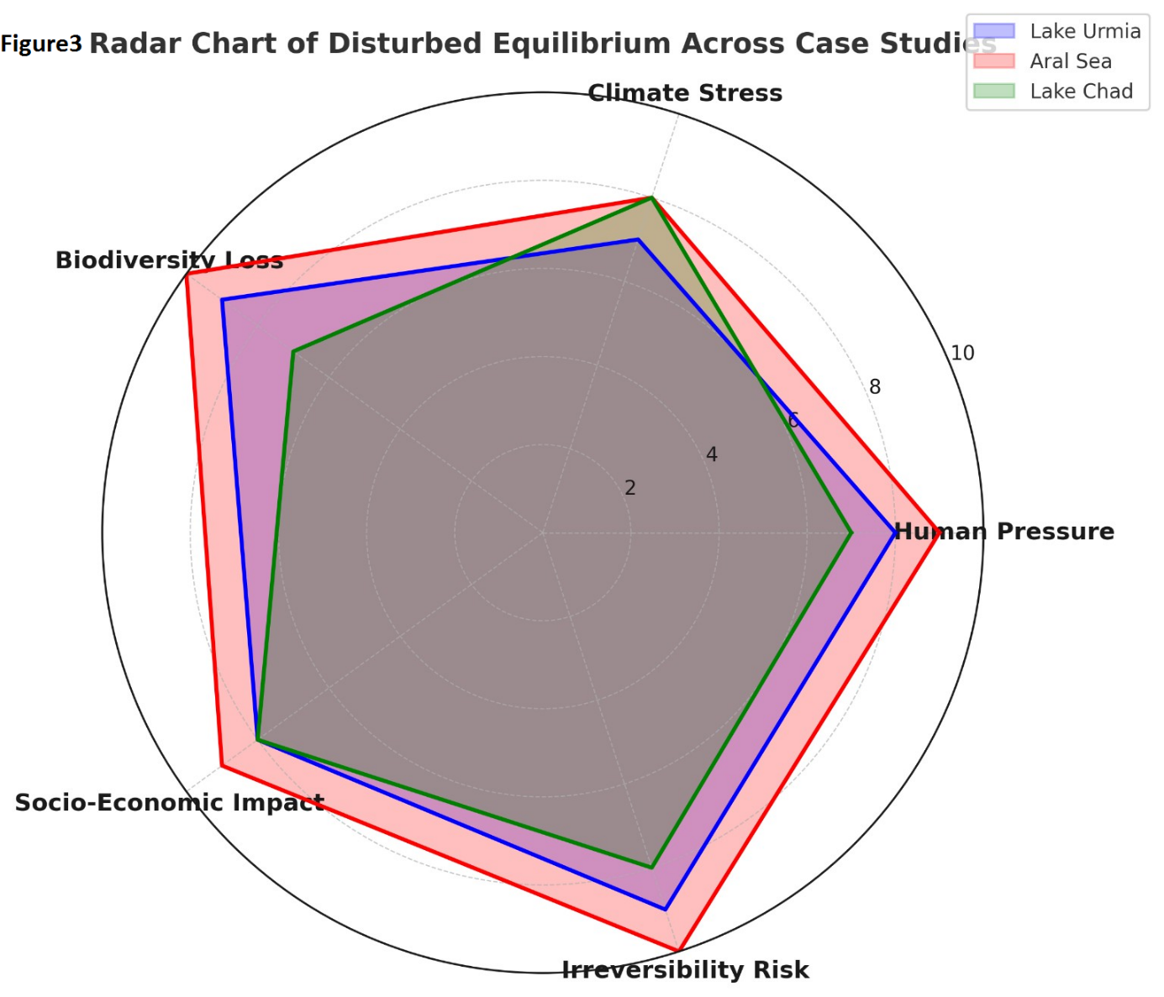

Caption: Comparative radar chart of six case studies (Lake Urmia, Aral Sea, Shiraz Flood, Amazon Rainforest, Great Barrier Reef, Hurricane Ian) under the Disturbed Equilibrium Index (DEI) framework. The axes represent the three components H (Human Pressure), A (Exogenous Stress), and R (Resilience). Red-shaded areas indicate high DEI values (collapse/crisis regimes), while green areas highlight more resilient trajectories. This figure visualizes how different ecosystems exhibit divergent pathways under DET, reinforcing the global applicability of the DEI framework.

Figure 4. Policy Action Pathway under DET/DEI

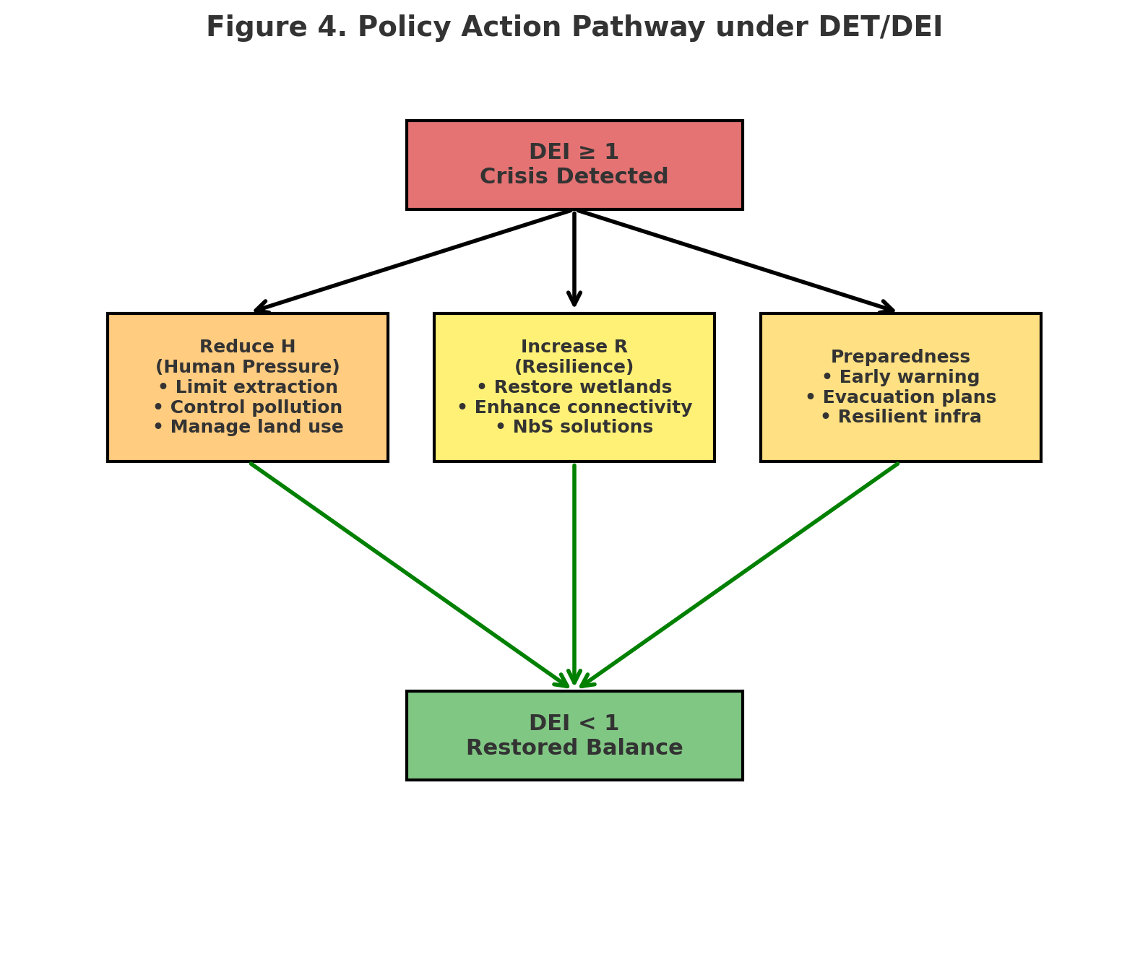
Caption: Policy action pathway derived from DET/DEI. Input: Crisis state (DEI ≥ 1, red). Middle layer: Three intervention domains—Reduce H (limit extraction, control pollution, manage land use), Increase R (restore wetlands, enhance connectivity, NbS solutions), and Preparedness (early warning, evacuation, resilient infrastructure). Output: Restored equilibrium (DEI < 1, green). Black arrows show progression from crisis to interventions; green arrows highlight recovery pathways toward restored balance.

