* ***Figures***

**Figure1:** **The conceptual model illustrates the theoretical structure of Sustainable Livability**

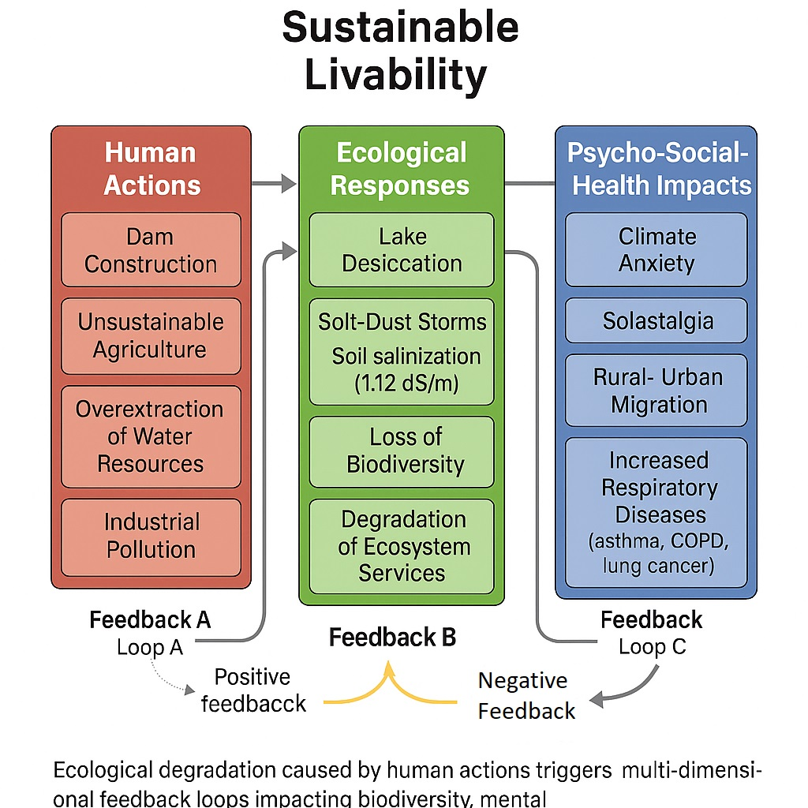

The conceptual model illustrates the theoretical structure of Sustainable Livability in three vertical pillars:

1. Human Actions, 2. Ecological Responses, and 3. Psycho-Social and Health Impacts.

In this framework, unsustainable human activities—such as dam construction, intensive agriculture, and overextraction of water resources—trigger environmental responses including lake desiccation, salt-dust storms, and biodiversity loss. These ecological changes then lead to profound health and psychosocial consequences, such as climate anxiety, solastalgia, migration, and increased respiratory illnesses.

These processes operate through three systemic feedback loops:

Loop A (Positive Feedback):

A reinforcing loop in which the socio-environmental impacts further perpetuate unsustainable actions. For example, environmental collapse may lead to governance failure or economic desperation, resulting in more pressure on ecosystems.

Here, **positive refers** to "amplification" of the cycle—not a normative judgment.

Loop C (Negative Feedback):

A balancing loop where negative health outcomes (e.g., rising respiratory disease) lead to behavioral changes, public awareness, or policy shifts that mitigate environmental degradation.

In this context, *negative* implies **dampening** the destabilizing dynamics and restoring balance.

Feedback B (Transitional Feedback):

A mediating loop linking ecological responses to human perceptions and reactions. It functions as a channel for either reinforcing (Loop A) or balancing (Loop C) dynamics.

It is important to note that the terms "**positive"** and "**negative"** do not imply moral or ethical value. Instead, they describe the **direction of systemic change:

🔹 **Positive feedback** intensifies instability (drives the system away from equilibrium)

🔹 **Negative feedback** counteracts disruption (restores system balance)

**Clarification on Positive and Negative Feedback in the Sustainable Livability Model**

In the conceptual model of Sustainable Livability Theory, the terms *positive feedback* and *negative feedback* are used in the context of systems science—not to imply moral or evaluative judgments (e.g., “good” or “bad”) but to describe the **behavior of feedback loops** in dynamic systems.

* A **positive feedback loop** amplifies the initial change. For instance, in our model, environmental degradation (e.g., lake desiccation) leads to dust storms, which in turn intensify health and social crises such as migration and anxiety. These conditions may further weaken institutional capacity or exacerbate unsustainable practices. This self-reinforcing dynamic is what systems theory defines as *positive feedback*—a cycle that pushes the system away from equilibrium.
* A **negative feedback loop**, by contrast, counters the initial change. In our model, rising respiratory diseases may lead to social awareness, policy responses, or behavioral shifts aimed at restoring ecological balance. These reactions, though triggered by harmful impacts, serve to *dampen the disruption* and reorient the system toward stability. Hence, the loop is described as *negative feedback*.

It is crucial to emphasize that in systems thinking:

* **Positive feedback is not necessarily beneficial**, as it may lead to collapse or runaway effects.
* **Negative feedback is not necessarily undesirable**, as it can enable resilience, adaptation, and recovery.

Understanding this distinction helps interpret the dynamics of livability systems where ecological, psychological, and social domains interact in complex and nonlinear ways.

**Figure 2.** Measurement model (CFA) of the Sustainable Livability Index **(SLI)**

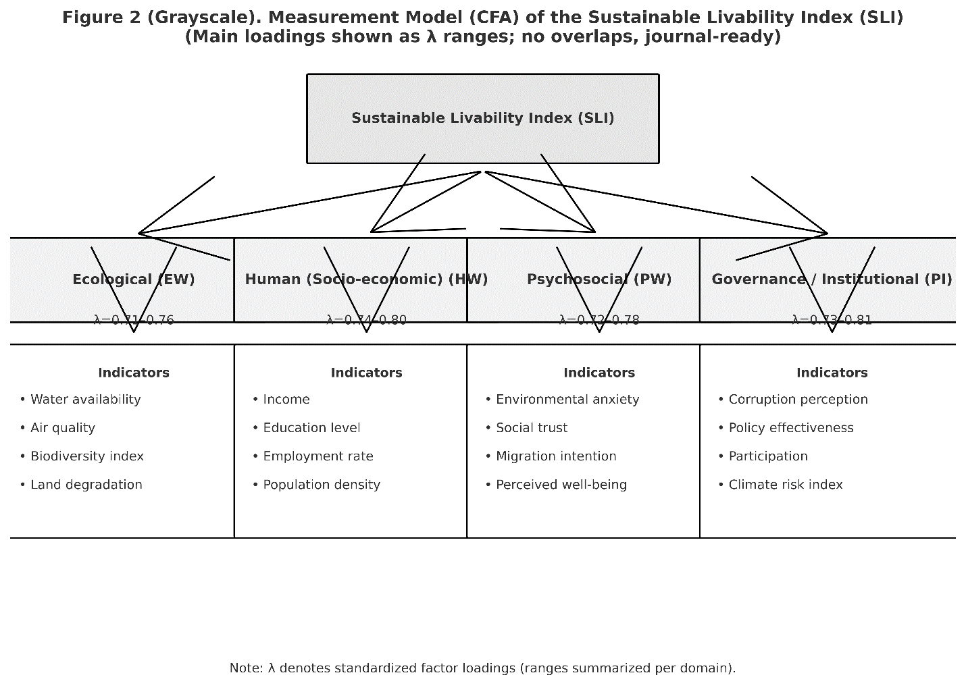

**Figure 2.** Measurement model (CFA) of the Sustainable Livability Index **(SLI).** SLI is specified as a higher-order construct reflected by four domains—Ecological **(EW)**, Human/Socio-economic **(HW)**, Psychosocial **(PW)**, and Governance/Institutional **(PI)**. Each domain is measured by multiple observed indicators (listed in panels). Arrows denote reflective loadings; labels show the range of standardized loadings **(λ)** per domain. Error variances are omitted for clarity.

**Figure 3:**

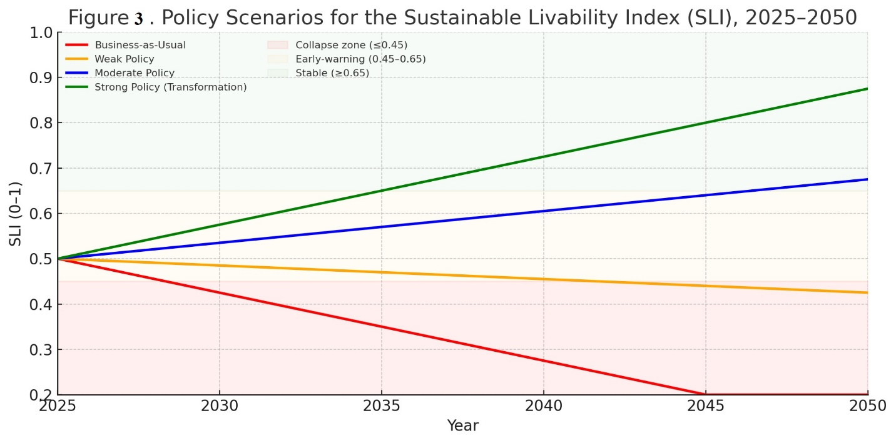

**Figure 3.** Policy scenarios for the Sustainable Livability Index (SLI), 2025–2050. Different trajectories illustrate Business-as-Usual, Weak Policy, Moderate Policy, and Strong Policy (Transformation) pathways, with shaded bands indicating collapse, early-warning, and stability thresholds.

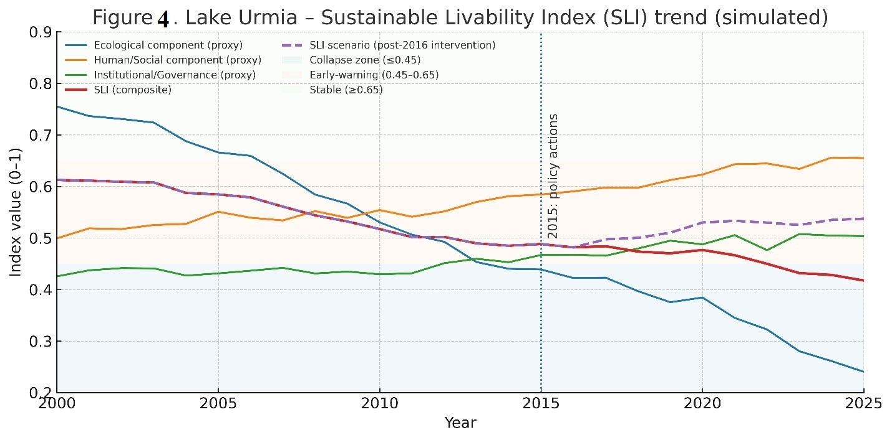

**Figure 4.** Lake Urmia – Sustainable Livability Index (SLI) trend (simulated), 2000–2025. Components include ecological, human/social, and governance proxies, along with the composite SLI and post-2016 intervention scenario. Shaded zones indicate collapse, early-warning, and stability thresholds.