Automatic TimeTable Generator
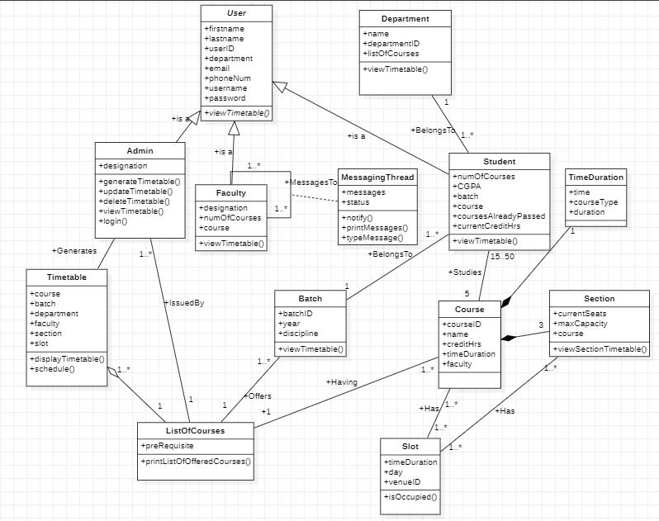
Analysis Class Diagram
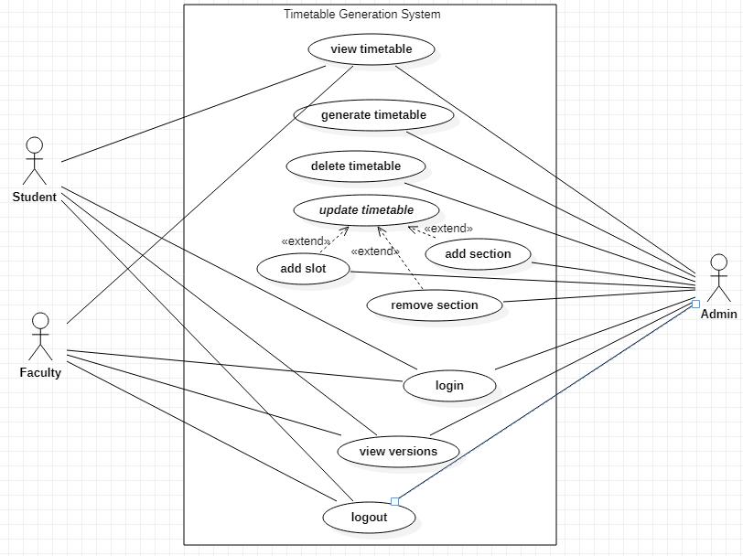
Used Case Diagram
Used Case Templates

Identifier |  |  | UC-1
Name |  |  | view timetable
Summary |  |  | Displays the timetable to the users.
Priority |  |  | High
Actors |  |  | Admin, Faculty, Student
Pre-condition(s) |  |  | Actor is logged in.
Post-condition(s) |  |  | System displays the timetable successfully.
 |  |  | Typical Course of Action
S# |  | Actor Action |  | System Response
1. | Clicks on the “view timetable” button.
2. |  |  |  | Displays message to the user.
3. | Selects from the provided options.
4. |  |  |  | Displays the timetable on screen
4. |  |  |  | in the desired form
 | Alternate Course of Action#01 (Timetable is not yet available)
S# |  | Actor Action |  | System Response
2. |  |  |  | Displays the error message.

Alternate Course of Action#02 (Student is not registered in any course)

S# | Actor Action | System Response
4. |  | Displays the error message.

Identifier |  | UC-2
Name |  | generate timetable
Summary |  | The system generates timetable with all the details.
Priority |  | High
Actors |  | Admin
Pre-condition(s) |  | Actor is logged in.
Post-condition(s) |  | Timetable is generated successfully.
 |  | Typical Course of Action
S# | Actor Action |  | System Response
1. | Clicks on generate timetable button.
2. |  |  | Displays timetable.
Identifier |  | UC-3
Name |  | delete timetable
Summary |  | This allows the actor to delete a timetable.
Priority |  | Medium
Actors |  | Admin
Pre-condition(s) |  | Actor must is logged in and exists a timetable which
 |  | the actor wants to delete.
Post-condition(s) |  | System successfully deletes the timetable.
 |  | Typical Course of Action
S# | Actor Action |  | System Response
1. | Clicks on the delete option.
2. |  |  | Opens the list of timetables.
3. | Clicks on the timetable which needs
3. | to be deleted.
4. |  |  | Opens the timetable and asks for
4. |  |  | confirmation to delete.
5. | Clicks on “yes” button.
6. |  |  | Deletes the timetable.
7. |  |  | Displays message.

8. |  |  |  | Goes back to home page.
 |  | Alternate Course of Action (Clicks on “No” button)
S# |  | Actor Action |  | System Response
6. |  |  |  | Goes back to home page.
Identifier |  |  | UC-4
Name |  |  | add slot
Summary |  |  | Adds a time slot to the timetable.
Priority |  |  | High
Actors |  |  | Admin
Pre-condition(s) |  |  | Admin is logged in.
Post-condition(s) |  |  | Time slot is added successfully to the timetable.
 |  |  | Typical Course of Action
S# |  | Actor Action |  | System Response
1. | Enters time slot.
2. |  |  |  | Checks for time slot.
3. |  |  |  | Adds the given time slot.
 |  | Alternate Course of Action (Time slot already exists)
S# |  | Actor Action |  | System Response
3. |  |  |  | Prints error message.

Identifier |  |  | UC-5
Name |  |  | add section
Summary |  |  | Adds a new section for a course.
Priority |  |  | Medium
Actors |  |  | Admin
Pre-condition(s) |  |  | Admin is logged in.
Post-condition(s) |  |  | New section is added for a course.
 |  |  | Typical Course of Action
S# |  | Actor Action |  | System Response
1. | Enters section name.
2. |  |  |  | Checks whether the section
 |  |  |  | already exists or not.
3. |  |  |  | Adds section.
 |  | Alternate Course of Action (Section already exists)
S# |  | Actor Action |  | System Response
3. |  |  |  | Print error message.
Identifier |  |  | UC-6
Name |  |  | remove section
Summary |  |  | Removes a section of a registered course.
Priority |  |  | Medium
Actors |  |  | Admin
Pre-condition(s) |  |  | The section exists for that course.
Post-condition(s) |  |  | Section is removed for that registered course.
 |  |  | Typical Course of Action
S# |  | Actor Action |  | System Response
1. | Enters section name.
2. |  |  |  | Checks whether the section
 |  |  |  | already exists or not.

3. | Removes section.

Alternate Course of Action (Section does not exist)

 | S# |  |  |  |  | Actor Action |  |  | System Response
3. |  |  |  |  |  |  |  |  | Prints error message.
Identifier |  |  |  |  |  |  | UC-7
Name |  |  |  |  |  |  | login
Summary |  |  |  |  |  |  | Actor logs in after verification of username and
 |  |  |  |  |  |  | password.
Priority |  |  |  |  |  |  | High
Actors |  |  |  |  |  |  | Admin, Faculty, Student.
Pre-condition(s) |  |  |  |  |  |  | Actor is able to login.
Post-condition(s) |  |  |  |  |  |  | Actor can generate timetable.
 |  |  |  |  |  |  | Typical Course of Action
S# |  |  |  |  | Actor Action |  |  |  | System Response
1. |  |  | Enters username and password.
2. |  |  | Clicks on login button.
3. |  |  |  |  |  |  |  | Verifies credentials.
4. |  |  |  |  |  |  |  | Redirects to home page.
 |  |  |  |  | Alternate Course of Action (Invalid Credentials)
S# |  |  |  |  | Actor Action |  |  |  | System Response
4. |  |  |  |  |  |  |  | Displays error message.
5. |  |  |  |  |  |  |  | Prompts to enter valid credentials.

Go back to step 1.

Identifier | UC-8
Name | logout
Summary | Actor logs out from system.
Priority | High
Actors | Admin
Pre-condition(s) | Actor is logged in.
Post-condition(s) | Actor can login.

Typical Course of Action

S# |  |  |  |  | Actor Action |  |  |  | System Response
1. |  |  | Clicks on log out button.
2. |  |  |  |  |  |  |  | Redirects to home page.
 |  |  |  |  | Alternate Course of Action (Session Expired)
S# |  |  |  |  | Actor Action |  |  |  | System Response
2. |  |  |  |  |  |  |  | Displays “Session Already Expired”
 |  |  |  |  |  |  |  | message.
 | Identifier |  |  |  |  | UC-9
 | Name |  |  |  |  | view version
 | Summary |  |  |  |  | The system allows to view different versions of the
 |  |  |  |  |  | timetable.
 | Priority |  |  |  |  | Low
 | Actors |  |  |  |  | Admin, Faculty, Student.
 | Pre-condition(s) |  |  |  |  | System is running.
 | Post-condition(s) |  |  |  |  | System is running.
 |  |  |  |  |  | Typical Course of Action
 | S# |  |  |  | Actor Action |  |  |  | System Response
 | 1. |  |  | Click on “view versions button.
 | 2. |  |  |  |  |  |  |  | Opens up the list of versions.

UC1
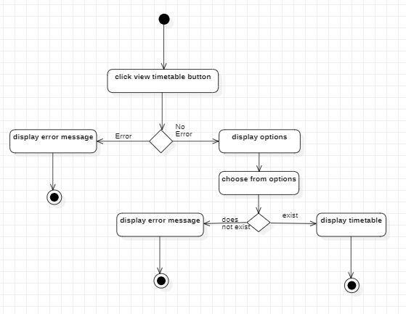
UC2
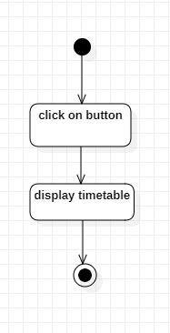
UC3
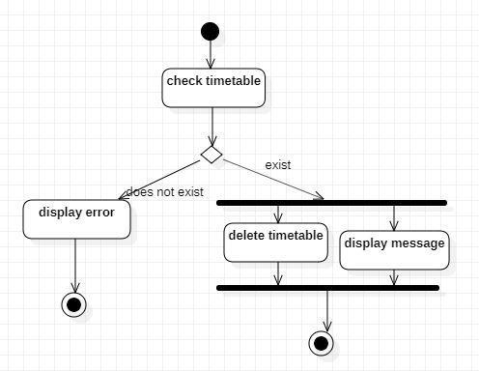
UC4
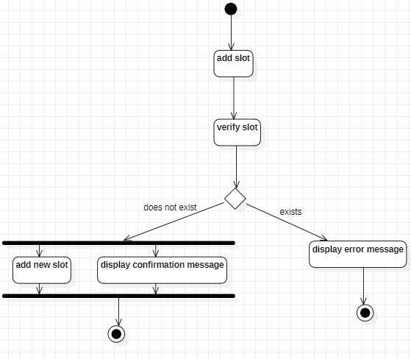
UC5
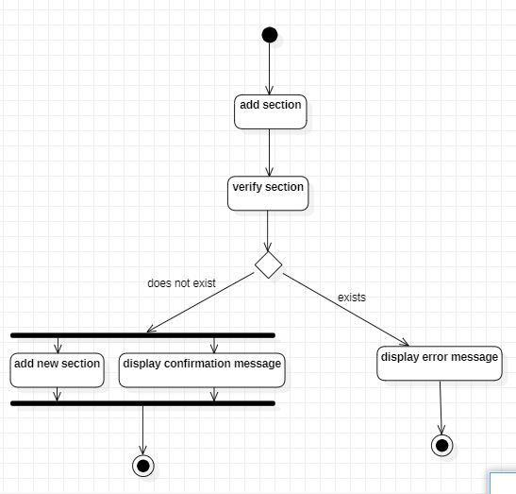
UC6
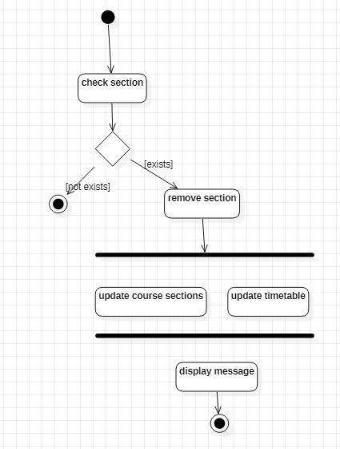
UC7
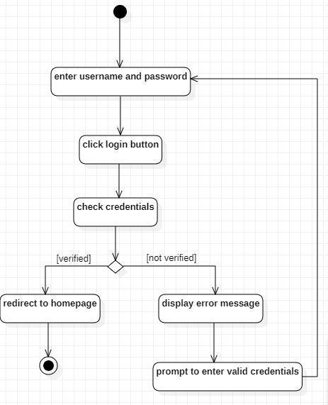
UC8
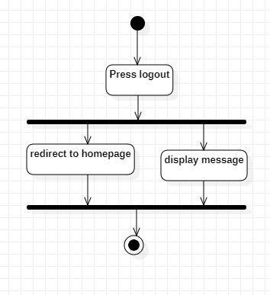
UC9
