Automatic TimeTable Generator

Overall Design Class Diagram:
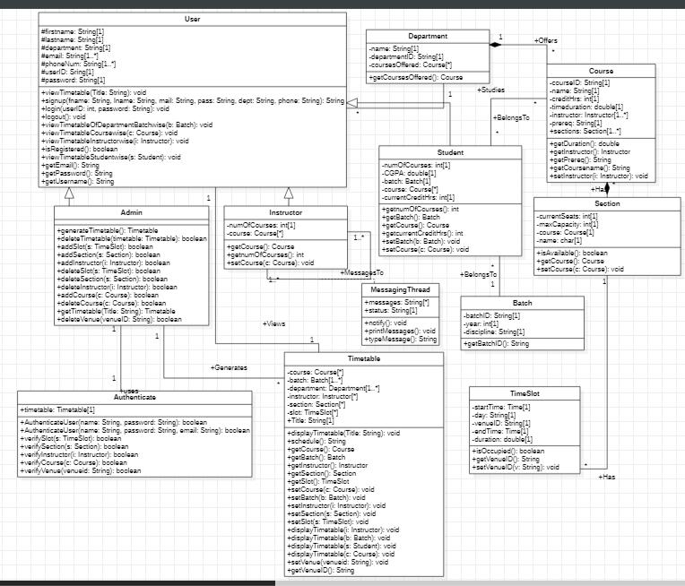
Close ups:
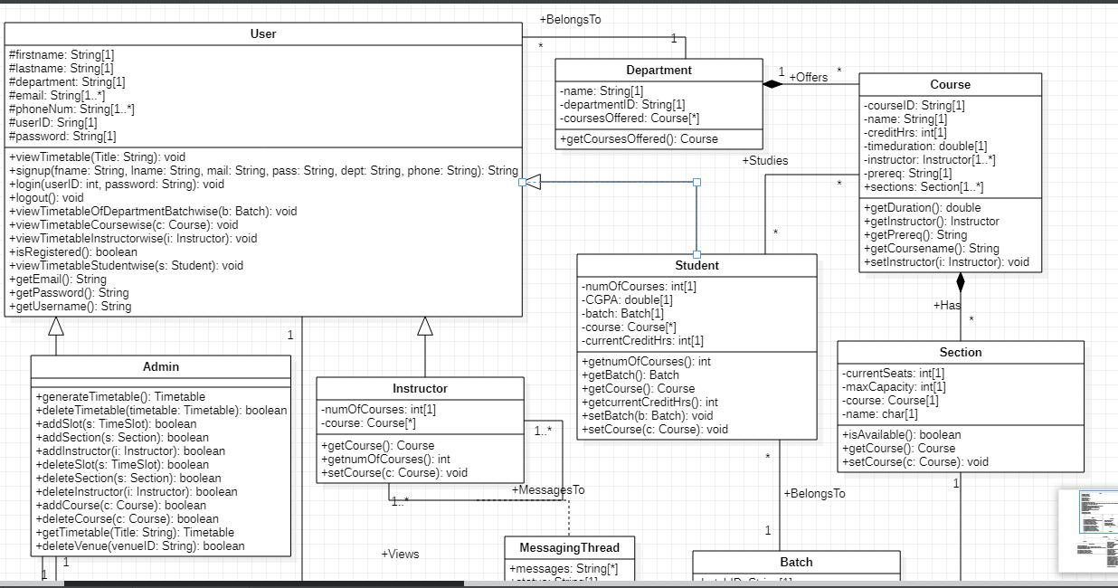
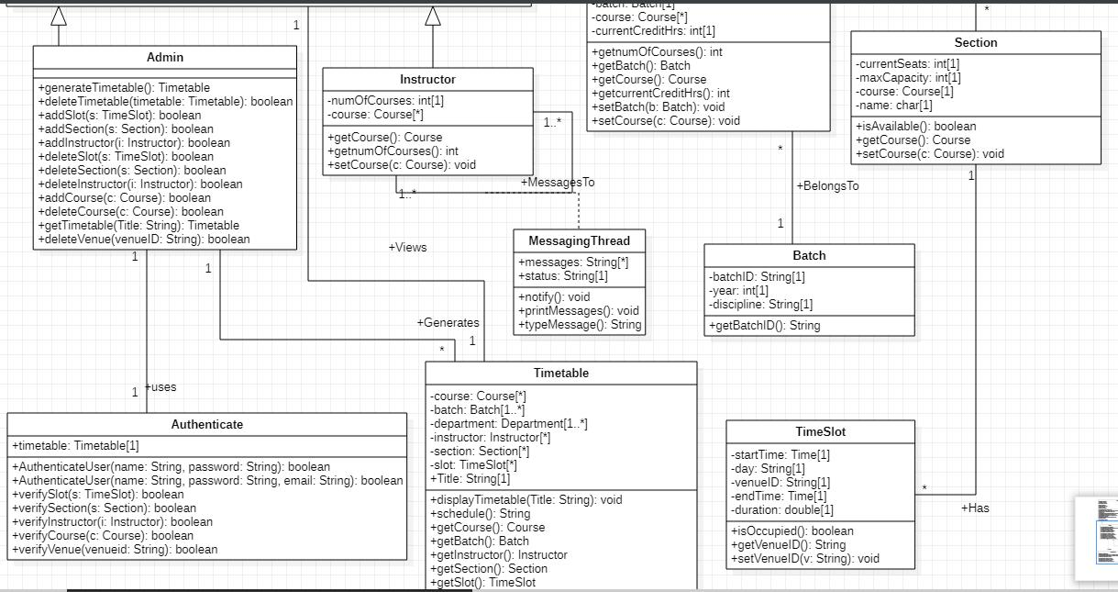
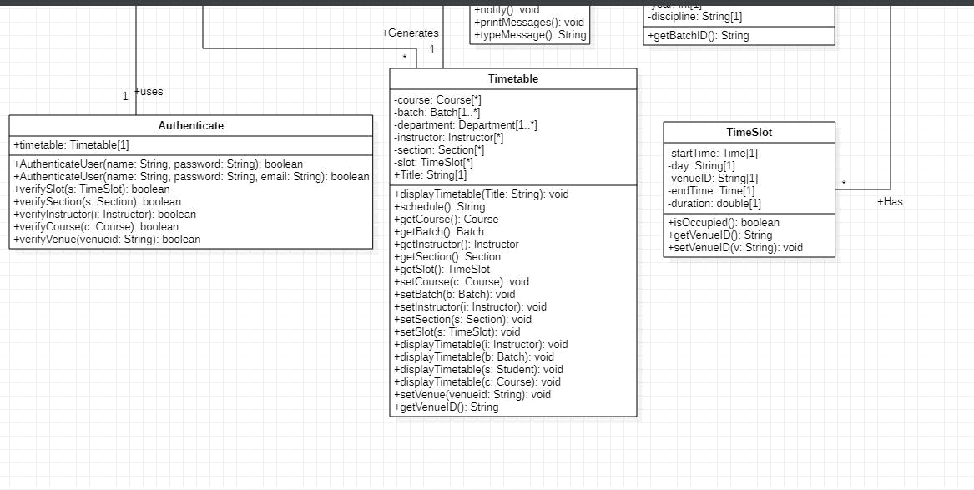
Sequence Diagrams:

Design Sequence Diagram of UC1: view timetable
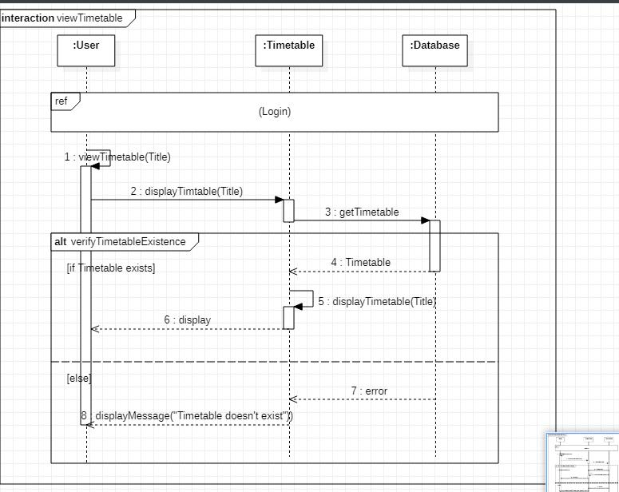

Design Sequence Diagram of UC2: generate timetable
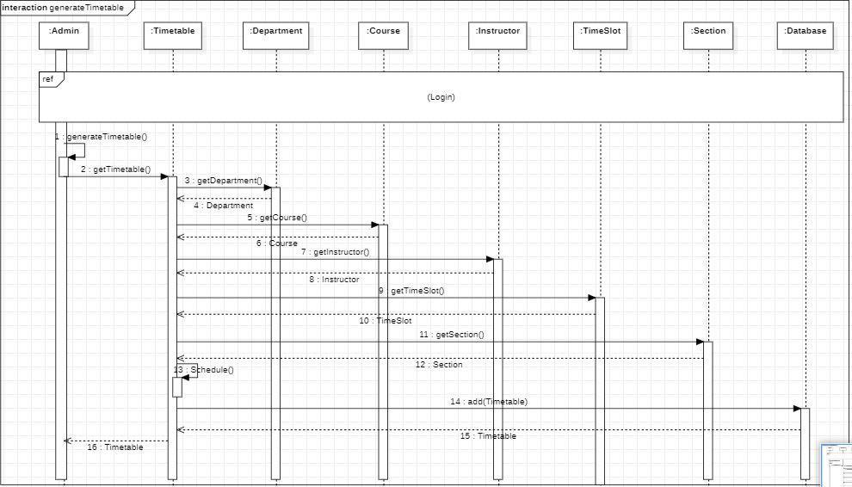

Design Sequence Diagram of UC3: delete timetable
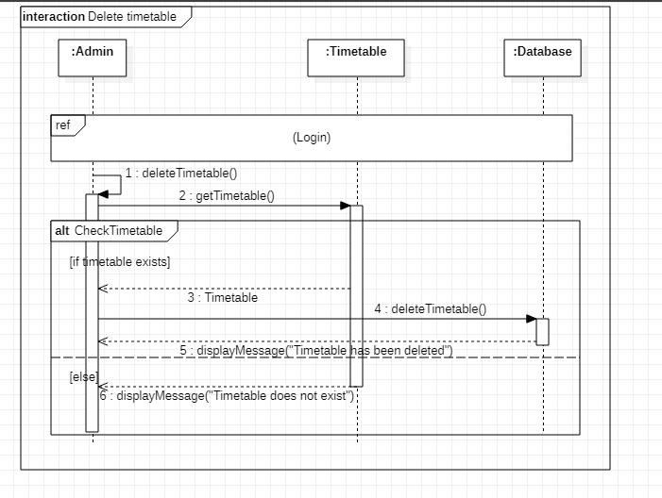

Design Sequence Diagram of UC4: add slot
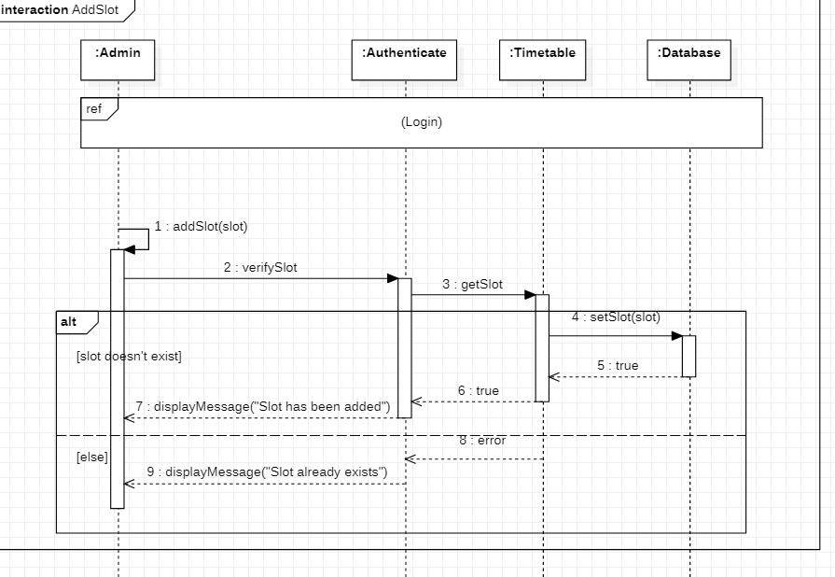

Design Sequence Diagram of UC5: add section
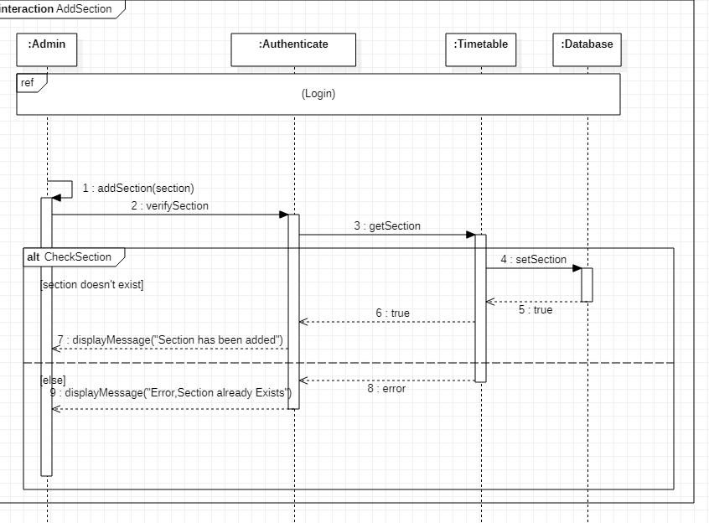

Design Sequence Diagram of UC6: delete section
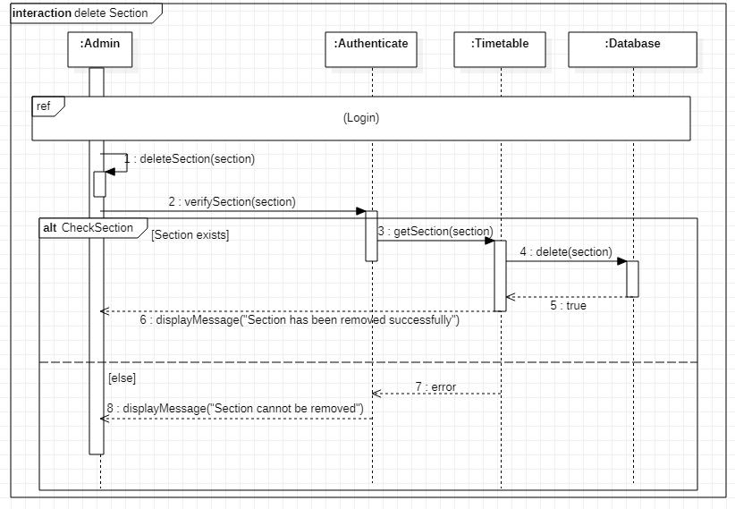

Design Sequence Diagram of UC7: login
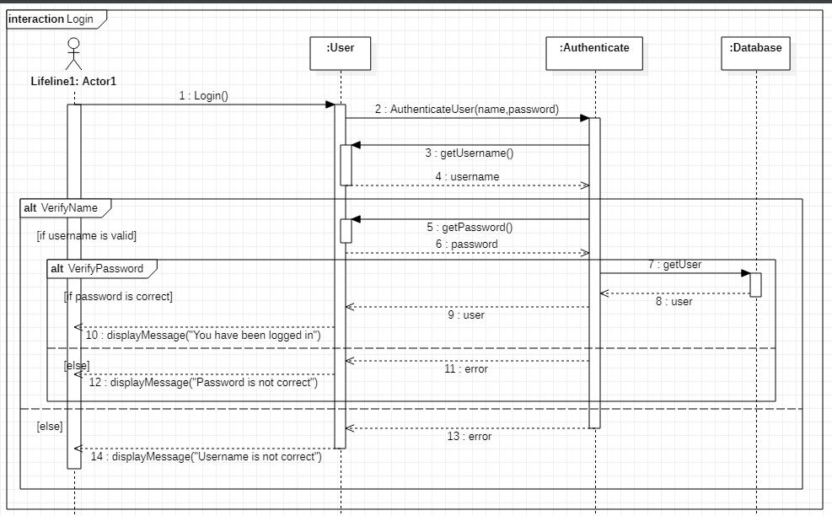

Design Sequence Diagram of UC8: logout
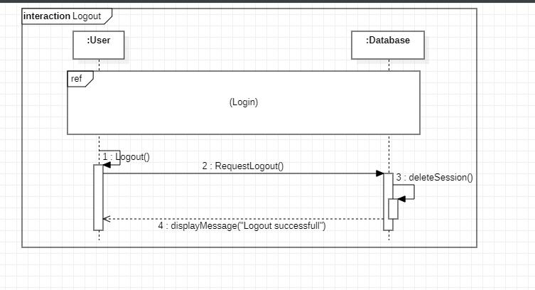

Design Sequence Diagram of UC10: add course
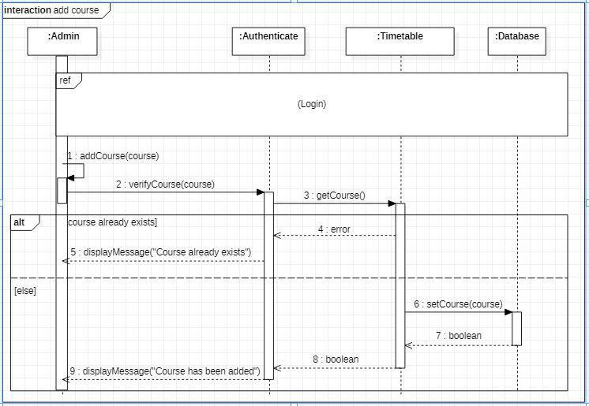

Design Sequence Diagram of UC11: delete course
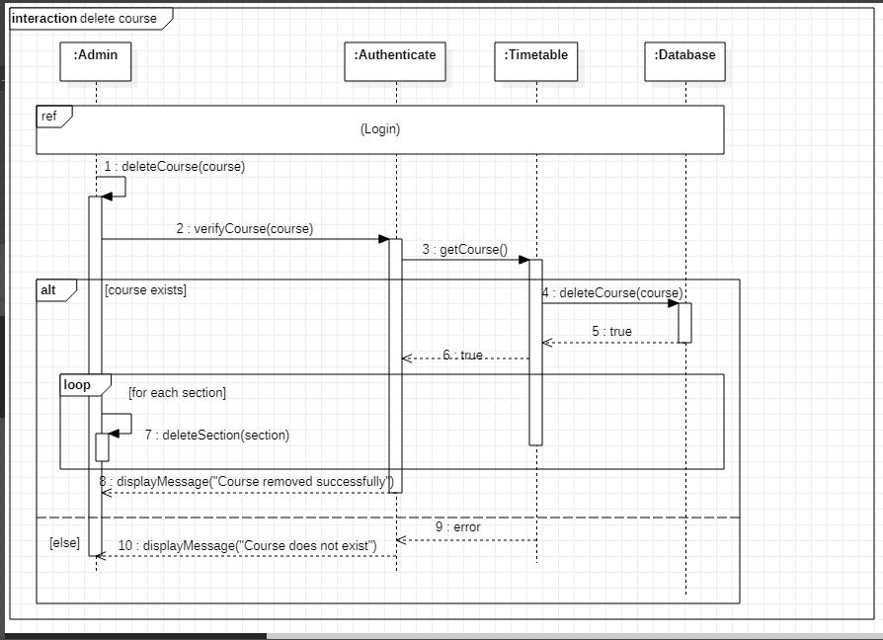

Design Sequence Diagram of UC12: add venue
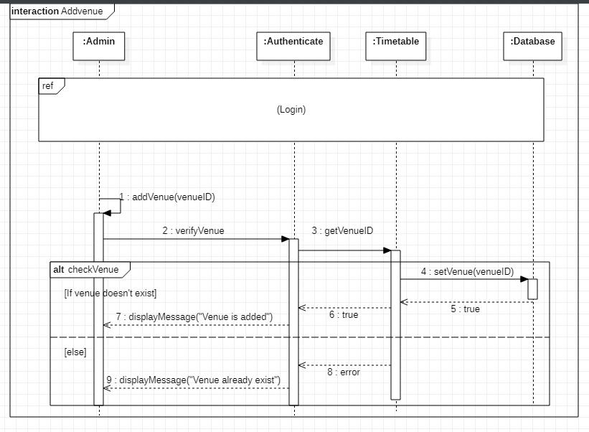

Design Sequence Diagram of UC13: delete venue
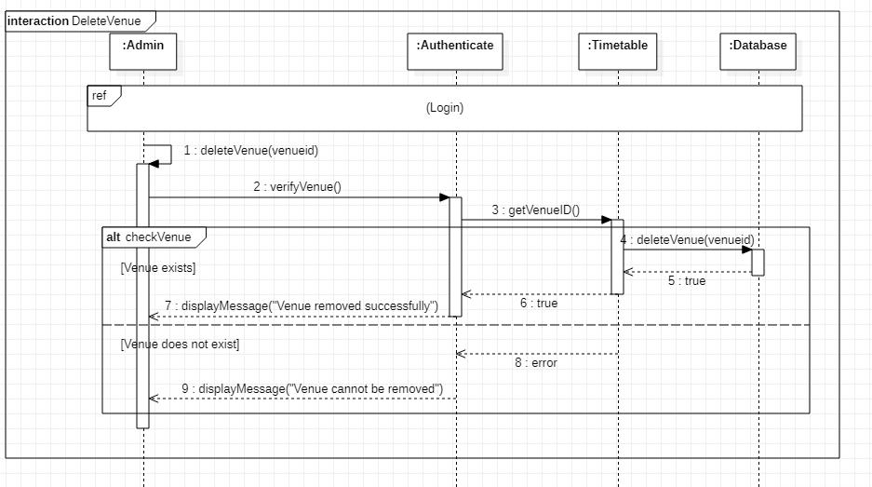

Design Sequence Diagram of UC14: delete instructor
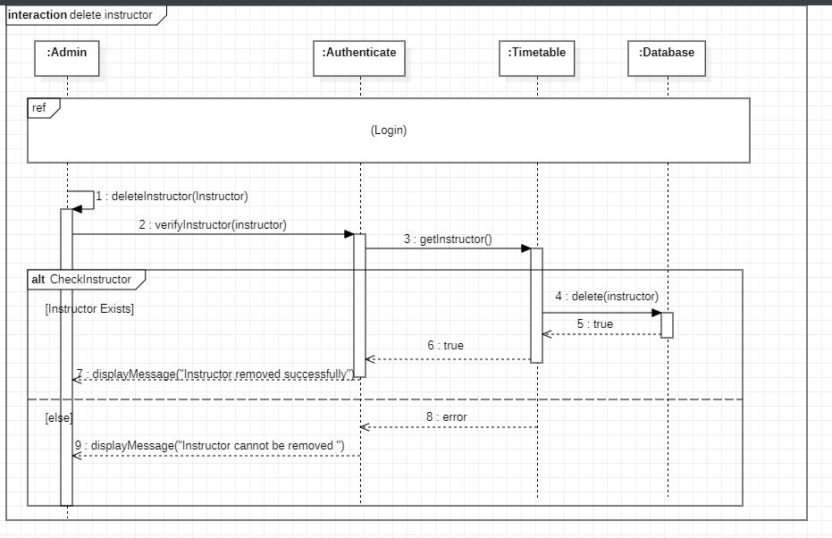

Design Sequence Diagram of UC15: add instructor
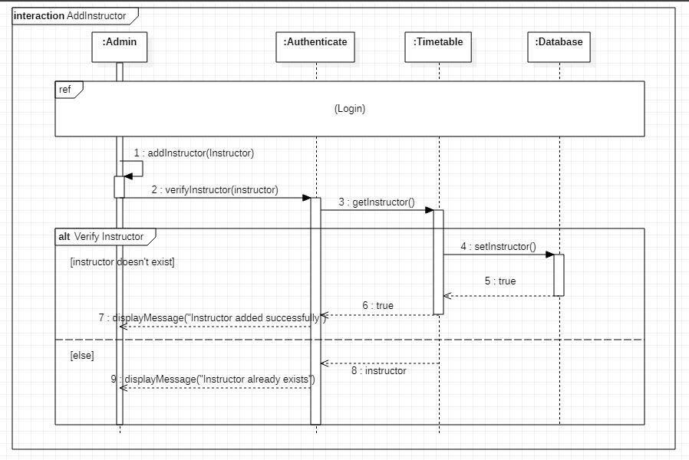
Design Sequence Diagram of UC16: view timetable of department batch wise
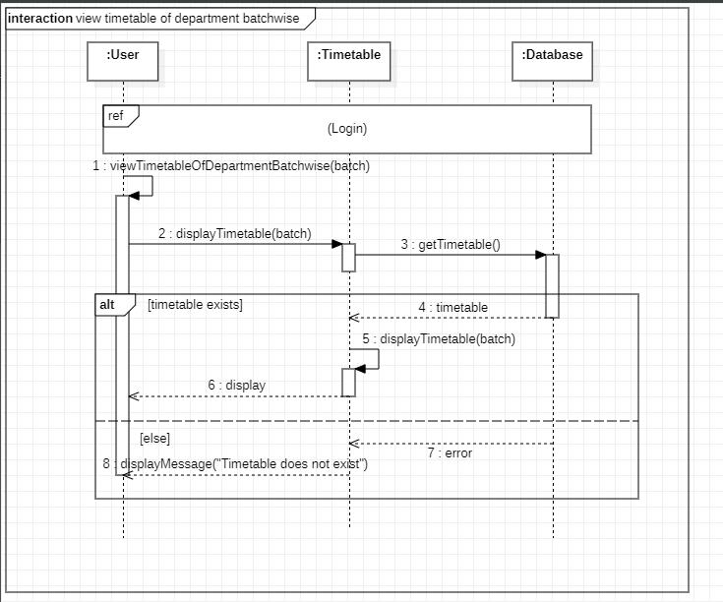
Design Sequence Diagram of UC17: view timetable course wise
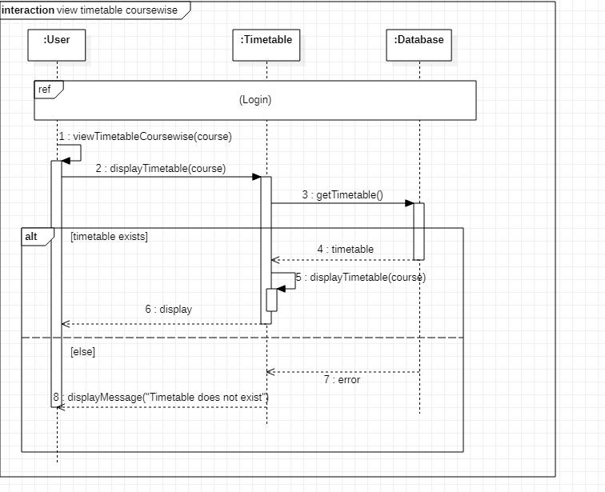
Design Sequence Diagram of UC18: view timetable instructor wise
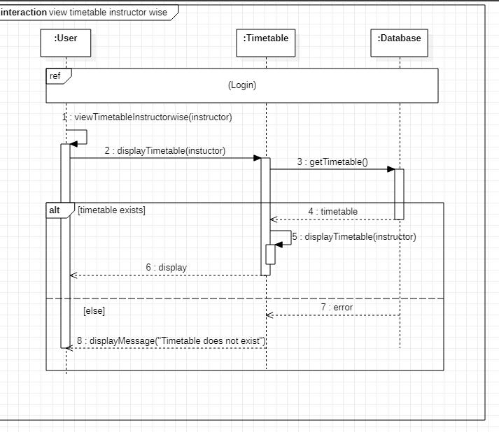
Design Sequence Diagram of UC19: view timetable student wise
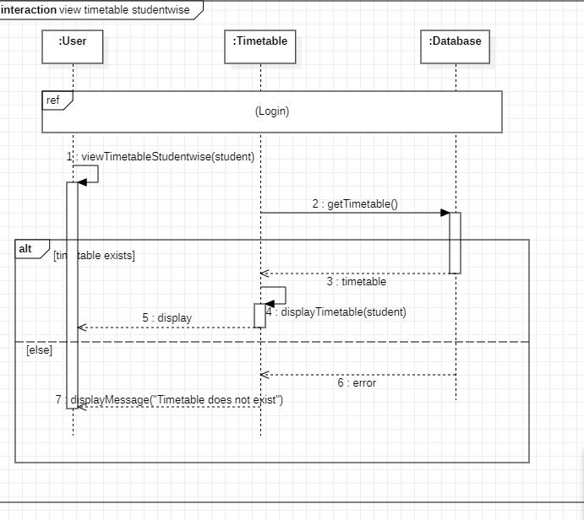
Design Sequence Diagram of UC20: delete slot
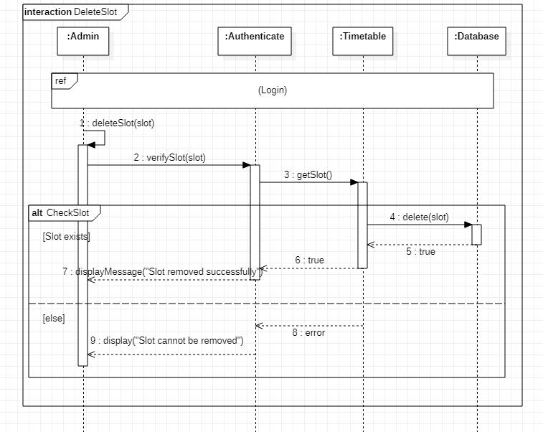
Design Sequence Diagram of UC21: signup
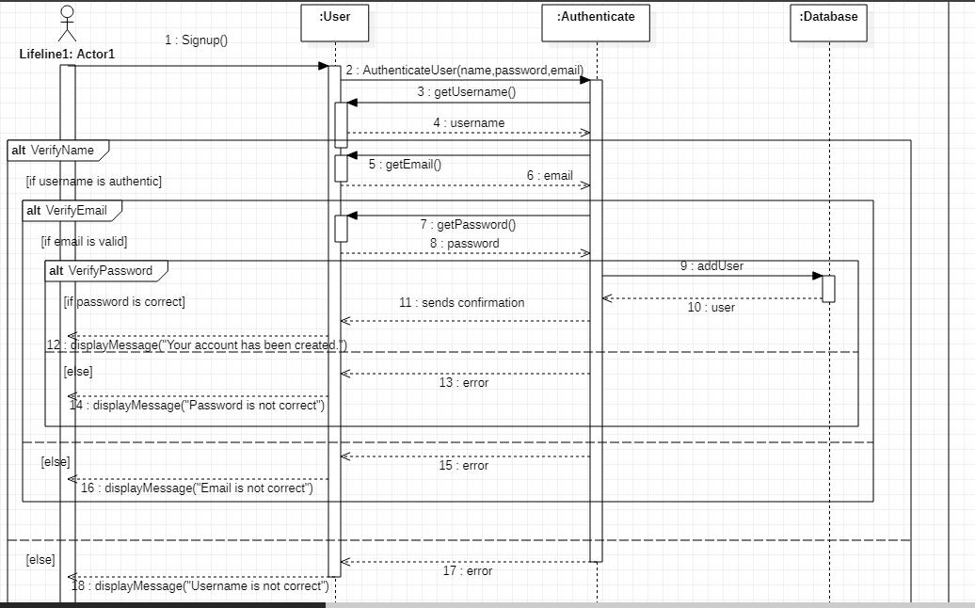
Prototype:

Home Page:
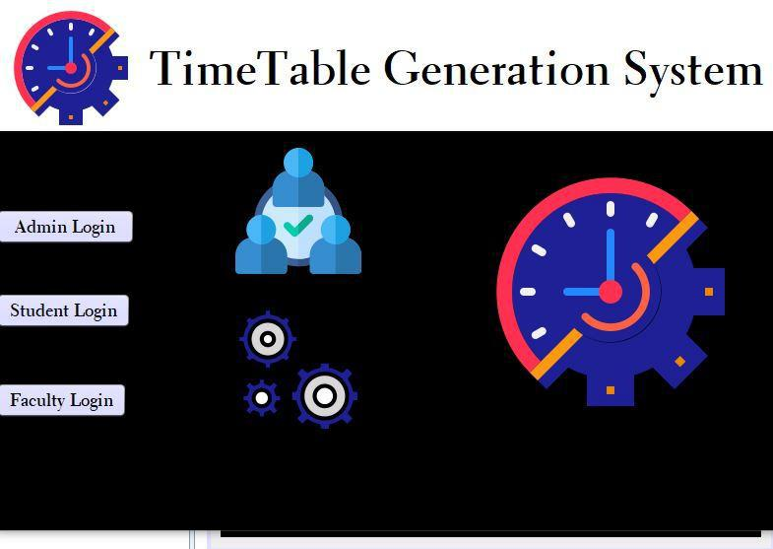

Screen of UC21: signup
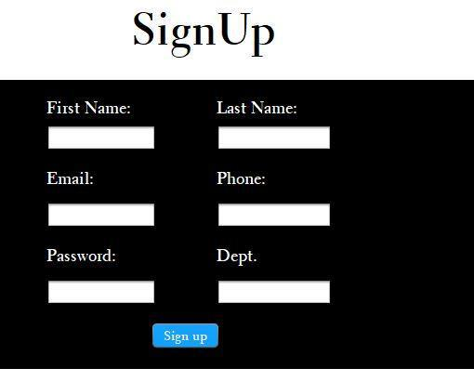

Screen of UC7: Login
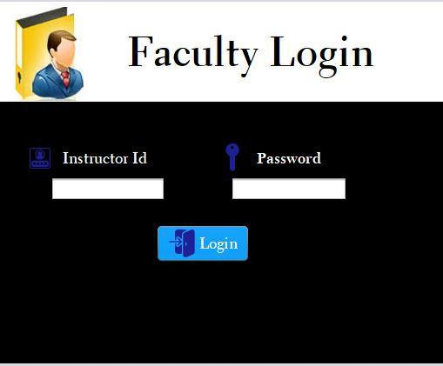
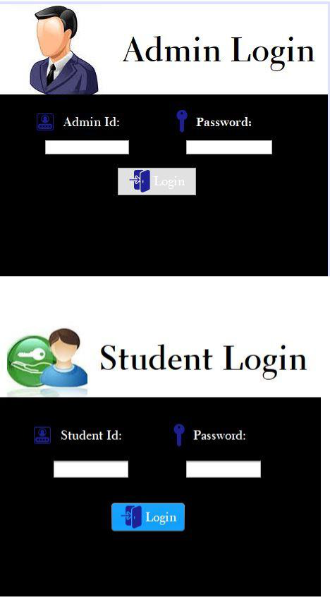
Admin Portal:
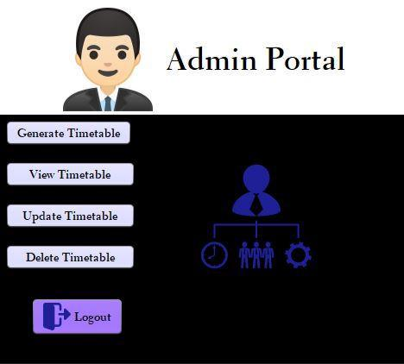
Student Page:
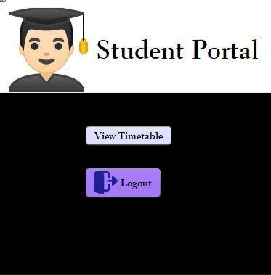

Instructor Page:
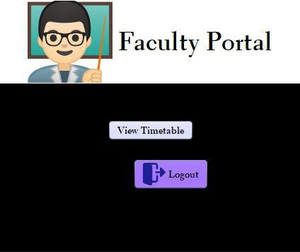

Screen of UC2: generate timetable
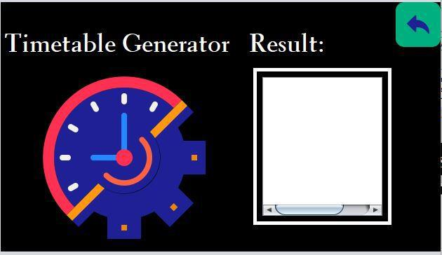

Screen of UC3: delete timetable
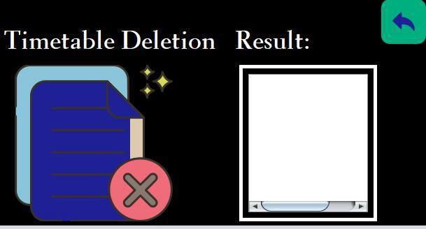

Screen of UC1: view timetable
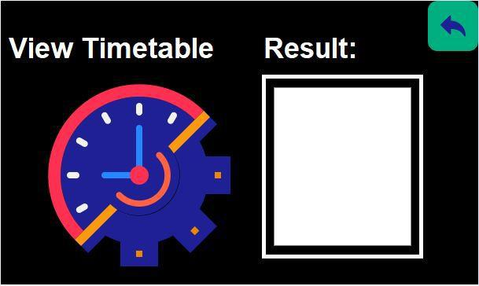

Screen of UC16: view timetable of department batch wise
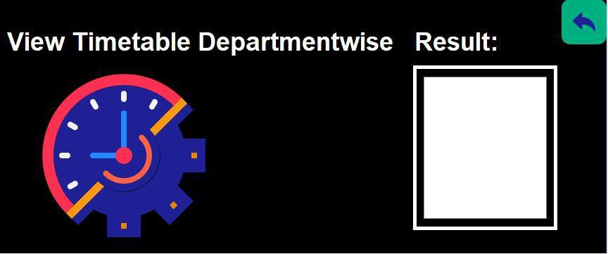

Screen of UC17: view timetable course wise
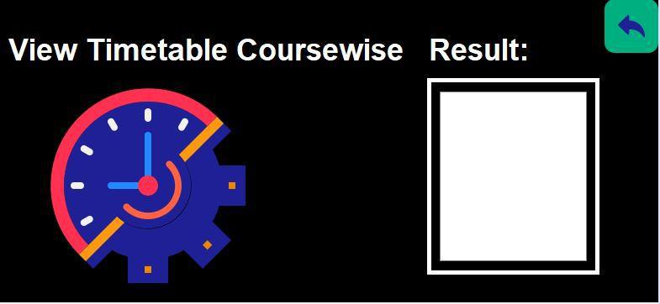

Screen of UC18: view timetable instructor wise
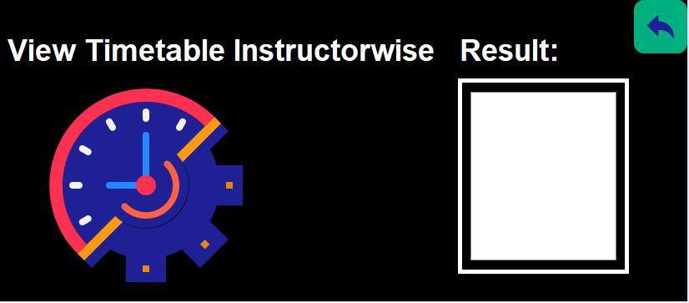

Screen of UC19: view timetable student wise
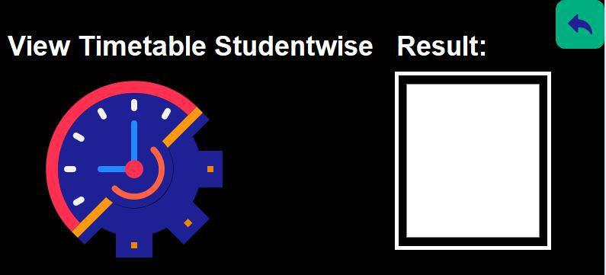

Update Timetable Page:
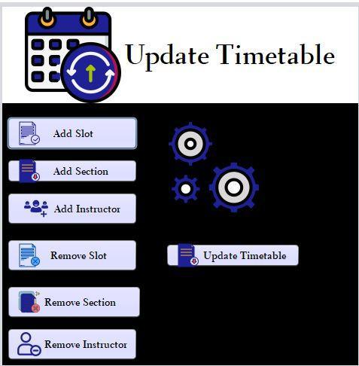

Screen of UC4: add slot
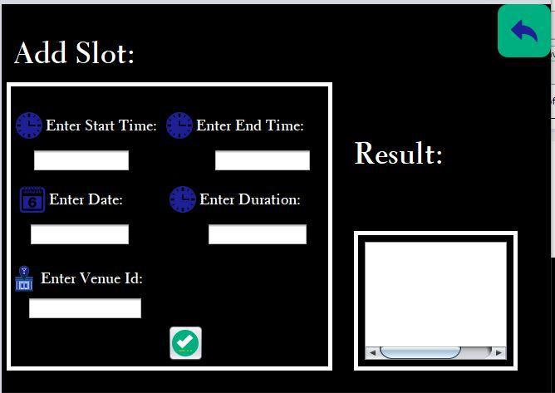

Screen of UC20: delete slot
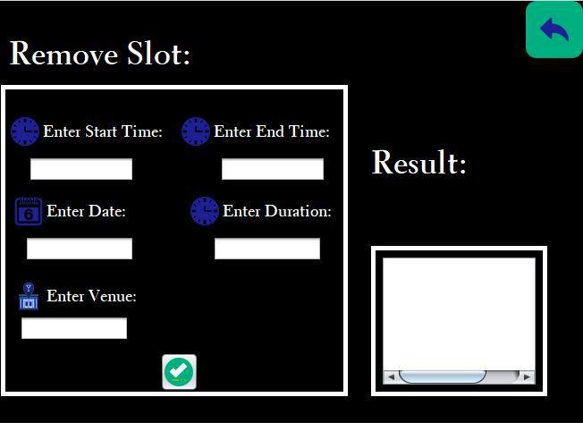

Screen of UC5: add section
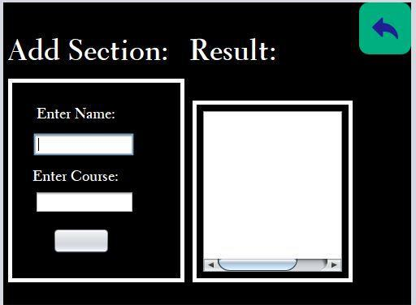

Screen of UC6: delete section
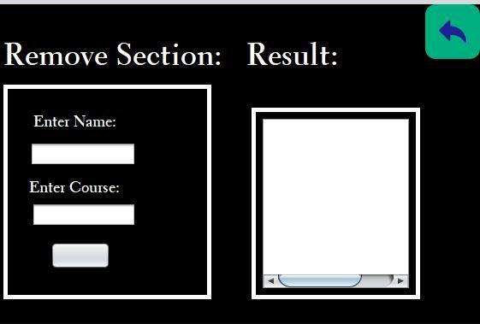

Screen of UC15: add instructor
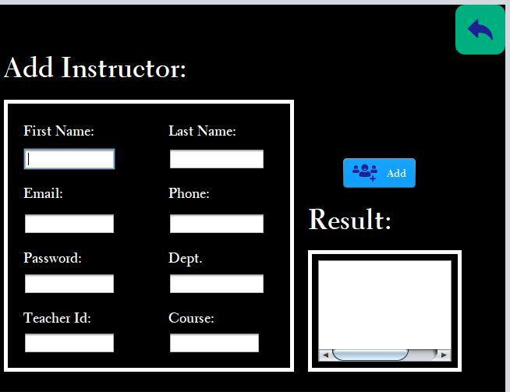

Screen of UC14: delete instructor
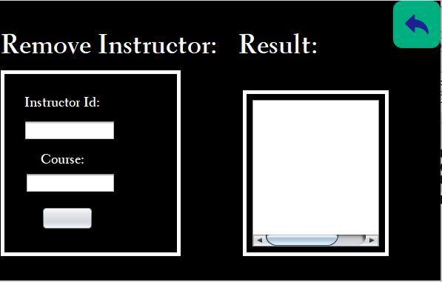

Updated Timetable Screen:
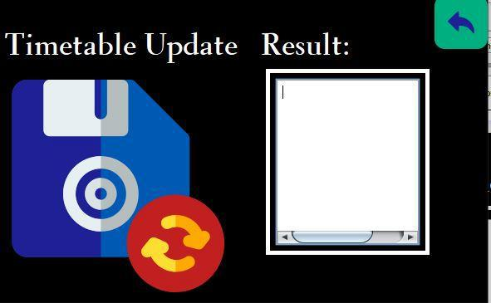

Screen of UC10: add course
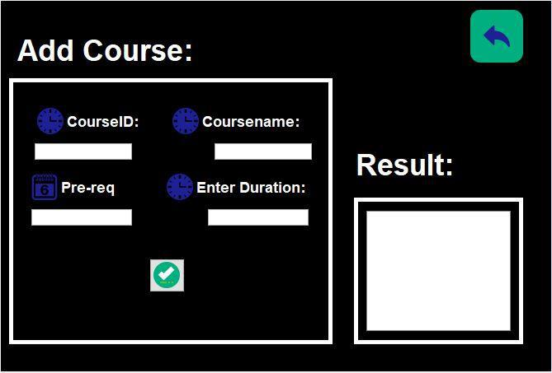

Screen of UC11: delete course
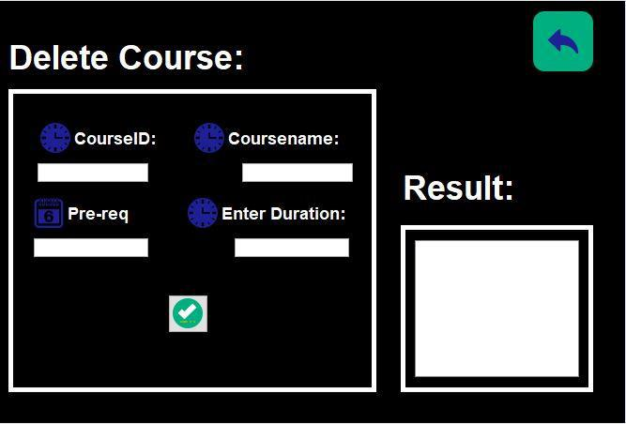

Screen of UC12: add venue
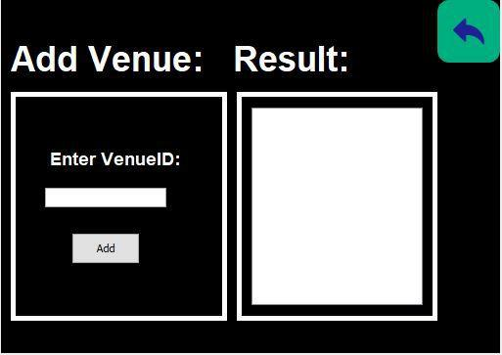

Screen of UC13: delete venue
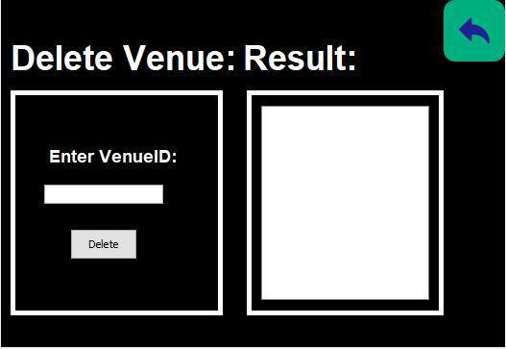

Screen of UC8: logout
