LinkedIn post, November: draft 2 with FIRMS data
Draft for review, not posted. Numbers from the forest-fire-indonesia-2026 notebook, NASA FIRMS near real time data from 1 August to 31 October 2026, prepared 2 November 2026.
Before posting: check the sentences highlighted in yellow and sort out the GADM licence for the Brazil map. Details in the table at the end.

Post text
Ready to paste once checked. 2,965 of 3,000 characters. Yellow: not verified, see the table.
In October, smoke over Manaus got so thick that the city closed its schools, with fine particle pollution (PM2.5) above 135 µg/m³. Weeks earlier, smoke from Borneo and Sumatra had drifted to Malaysia and Singapore.
We mapped every NASA FIRMS fire alert from August to October 2026 in Kalimantan and mainland Sumatra, and in the nine states of Brazil's Legal Amazon: 1.18 million alerts in Indonesia and 1.22 million in the Legal Amazon.
Indonesia peaked first. Its busiest week ended on 20 September, the Legal Amazon's on 11 October, three weeks later. In the last week of October, Indonesia was down to fewer than 3,000 alerts a day, while the Amazon still had 10,000 to 20,000. That fits the El Niño pattern scientists described in 2017, in which Indonesia dries out before the central Amazon.
The fires were concentrated. Central Kalimantan alone had 536,000 alerts, 45% of the Indonesian total, and one in six land cells of about 1 km in Kalimantan had at least one alert. Kota Palangkaraya had about 1,700 alerts per 100 km², the highest of any district in either region. In Brazil, Pará led with 473,000.
More than half of the alerts fell in areas mapped as forest in 2020: 54% in Indonesia and 65% in the Legal Amazon. In Indonesia that share rose every month, from 45% in August to 61% in October.
What do these numbers measure? A FIRMS alert is a hot pixel seen by a satellite as it passes over: 375 m for VIIRS, 1 km for MODIS. It is not a count of fires and not a burned area. One fire can produce many alerts, and a fire under thick smoke or cloud may produce none.
So daily counts jump. On 9 October, alerts in Kalimantan and Sumatra almost halved in one day. On 22 October they reached the highest day of the season, 38,000. A drop like that can mean fires are going out, or that the sensors cannot see through the smoke.
Night matters too. 54% of the Indonesian alerts were detected at night, against 34% in the Amazon, which fits fires smouldering in peat. Peat burning below the surface can be missed altogether.
Radar satellites like Sentinel-1 fill part of the gap. Smoke and clouds do not block them, and they show where the canopy has changed, although they do not see heat. Space4Good uses this kind of radar data in its FORESTER system and sends alerts to forest teams, who check them on the ground. The system was tested in Indonesia and Brazil, the same two places shown on the map.
The takeaway: a fire map shows where satellites saw heat, not everything that burned. Counts swing with smoke and cloud, not only with the fires, and in Indonesia the fires moved further into forest as the season went on. Heat data says when and where to look. Radar and people on the ground show what was lost.
The fires will slow down when the rain comes: in Indonesia this month, in the Amazon around December or January. The gap in the data will still be there next season.
#EarthObservation #RemoteSensing #Wildfires #Amazon #Indonesia #GIS

Figures
Use figure 1 as the post image, and figure 2 as a second image or in the comments.
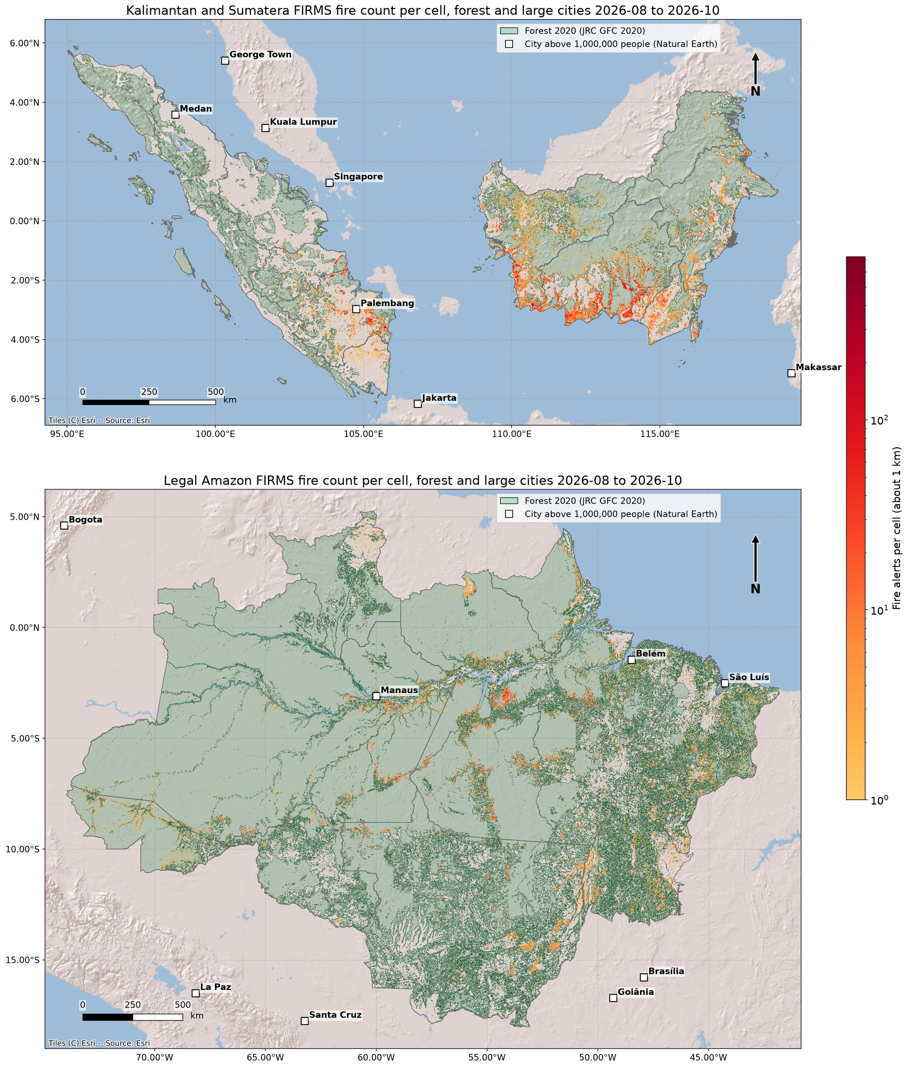
Figure 1. FIRMS fire alerts per cell of about 1 km (0.009°), August to October 2026, Kalimantan and mainland Sumatra (top) and the Legal Amazon (bottom), one shared colour scale. Green: forest in 2020 (JRC Global Forest Cover 2020, European Commission, CC BY 4.0). Sea, water (ESA WorldCover) and areas outside the provinces masked. Cities above 1 million people from Natural Earth.
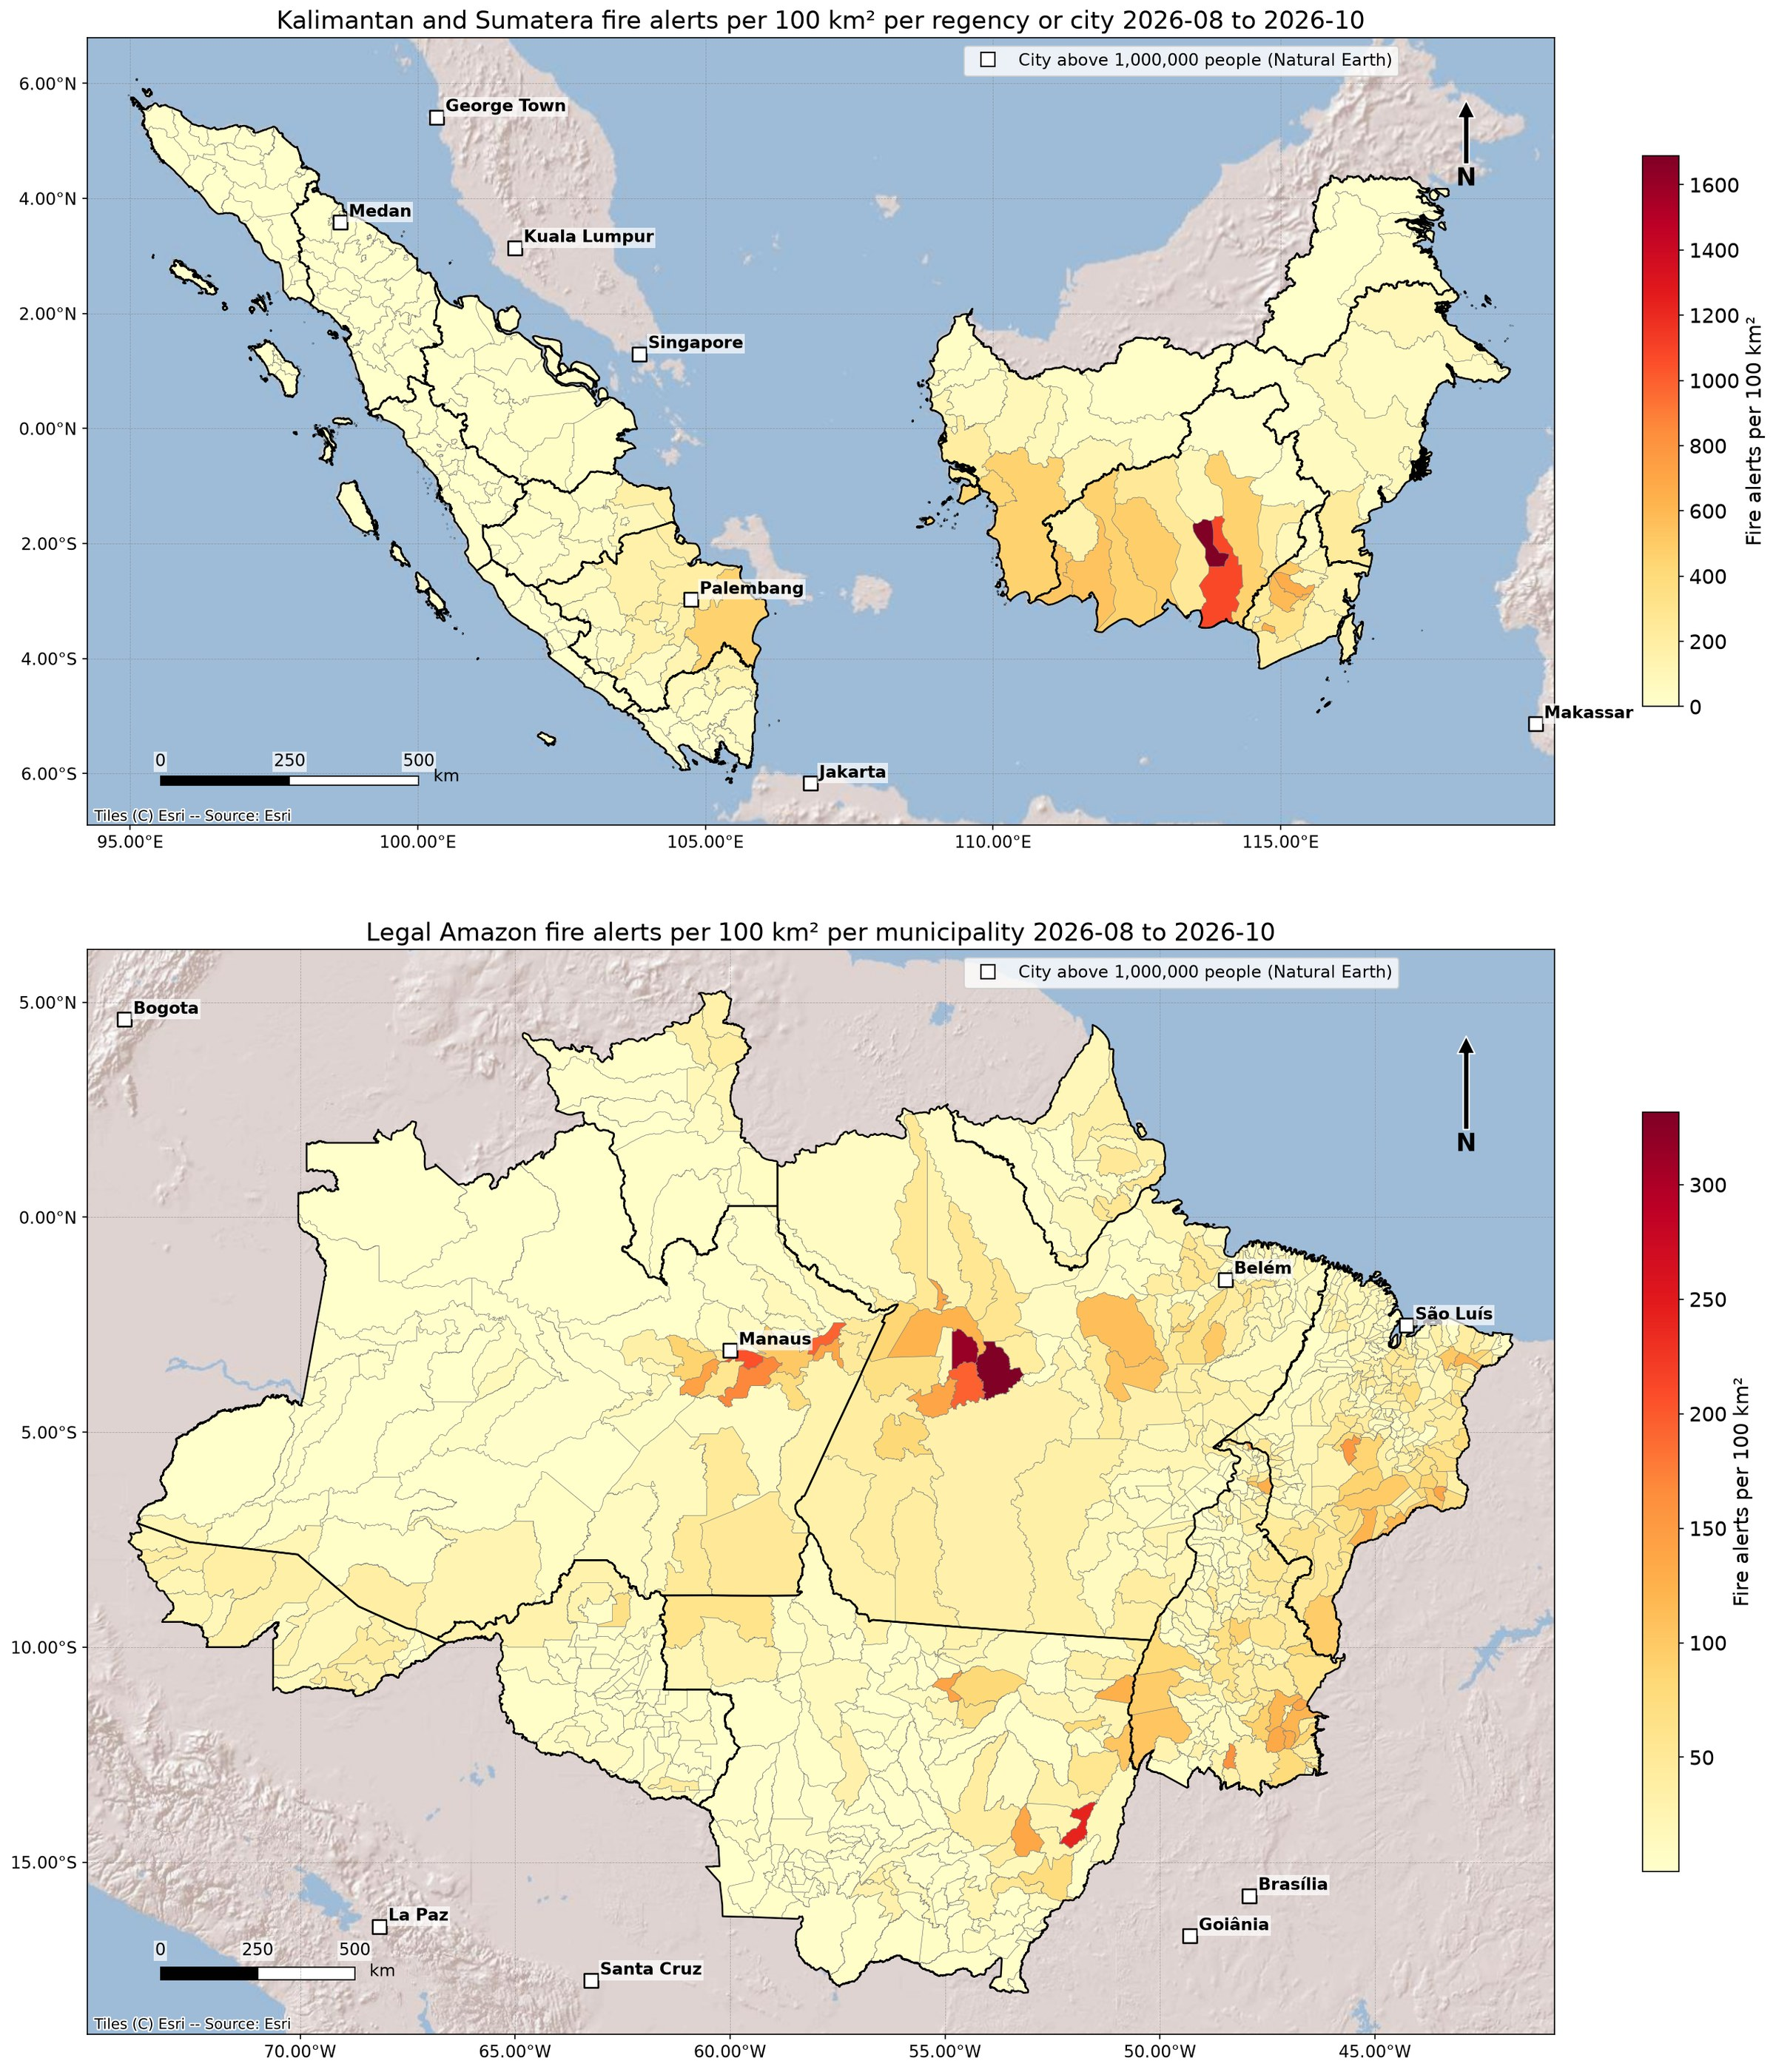
Figure 2. FIRMS fire alerts per 100 km² per regency or city (Indonesia) and municipality (Brazil, GADM 4.1), August to October 2026. Each region has its own colour scale, so compare the patterns, not the colours.

What changed from draft 1
- Added our own numbers: alerts per region, the timing of each season's peak, the most affected province and district, and the share of alerts in 2020 forest.
- Satellite section rewritten: what a FIRMS alert is (a hot pixel at the time of a satellite pass, not a fire or a burned area), why daily counts jump, night detections and peat, and what radar adds and what it does not.
- Replaced the 9 October figures with ours (draft 1 did not match our data) and removed the unsourced Santarém study.
- New conclusion based on the data: heat data shows when and where to look, radar and ground checks show what was lost.

Claims to check before posting
Claim | Status | Action
Manaus closed its schools, PM2.5 above 135 µg/m³ | Not verified, not in our data | Find the official or press source and link it, or remove.
Smoke from Borneo and Sumatra reached Malaysia and Singapore | Not verified, not in our data | Find a source (for example national air quality agencies) or remove.
El Niño pattern described in 2017 | Not verified | Find and cite the paper. Our data only shows the peaks three weeks apart, it does not show the cause.
FORESTER tested in Indonesia and Brazil | Company claim, not checked here | Confirm with the FORESTER team and use the exact wording they approve.
Rain timing: Indonesia this month, Amazon December or January | Not verified | Check a seasonal outlook (BMKG, INMET) or soften the wording.
Draft 1: 67% drop on 9 October, above 1,100 ten days later | Does not match our data | Removed. Our data: 19,469 to 10,021 alerts (49% drop) on 9 October, 6,735 on 19 October. If the original came from another source (for example BMKG hotspots), cite it instead.
Draft 1: about 40% more fires near Santarém | Not verified | Removed. Add back only with the study linked.
Brazil boundaries are GADM | Licence: non-commercial use only | Get GADM permission or swap to official IBGE boundaries before using the map on a company page.
Basemap is Esri World Shaded Relief | Attribution needed | Keep the 'Esri' credit visible in the image and check Esri's terms for social media use.

Data and method notes
- Alerts: NASA FIRMS near real time, VIIRS (S-NPP, NOAA-20, NOAA-21) and MODIS, downloaded per province by bounding box and clipped to the province. MODIS near real time has no data before 1 September, so August is VIIRS only.
- Completeness: every download is checked to be a FIRMS CSV and retried, and every province was checked for days and satellite windows without alerts. The days left without alerts are in provinces with very few alerts (Aceh, Sumatera Barat, Sumatera Utara), not failed downloads.
- Regions: Kalimantan and mainland Sumatra (8 provinces, Kepulauan Riau and Bangka Belitung left out); Legal Amazon (9 states, Maranhão taken whole although only part of it is in the Legal Amazon).
- Alert counts are detections, not fires. One fire seen on several passes and days is counted each time.
- Forest share: each alert checked against JRC Global Forest Cover 2020 at 100 m. Forest in 2020 does not mean forest in 2026, and an alert pixel (375 m or 1 km) can cover forest and non-forest.
- Grid (figure 1): the count per cell includes alerts within half a cell of the cell centre, so it counts about 20% fewer alerts than the totals above. Totals in the text come from the alert points, not the grid.
- Night share: share of alerts with the FIRMS day/night flag set to night. The link to peat is an interpretation, not measured here.
- Season timing compares the busiest calendar week (Monday to Sunday) in each region. Half of all alerts were detected by 18 September in Indonesia and 22 September in the Legal Amazon. From 25 to 31 October Indonesia had 994 to 2,827 alerts a day, the Legal Amazon 10,712 to 20,050.

