Gerardo Ramirez

11/9/2020

GitHub Project

<https://github.com/ramirezmuyal/udagram-gera-project-api>

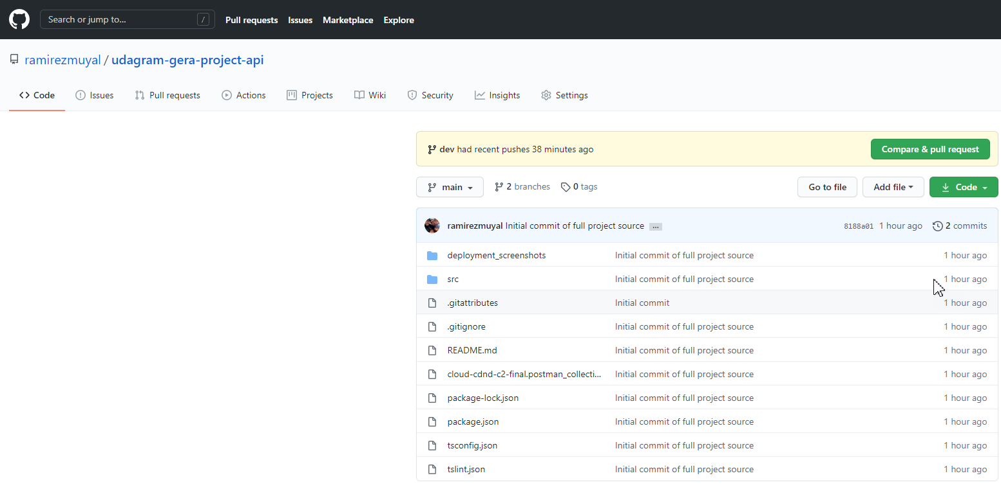

Elastic Beanstalk Environment

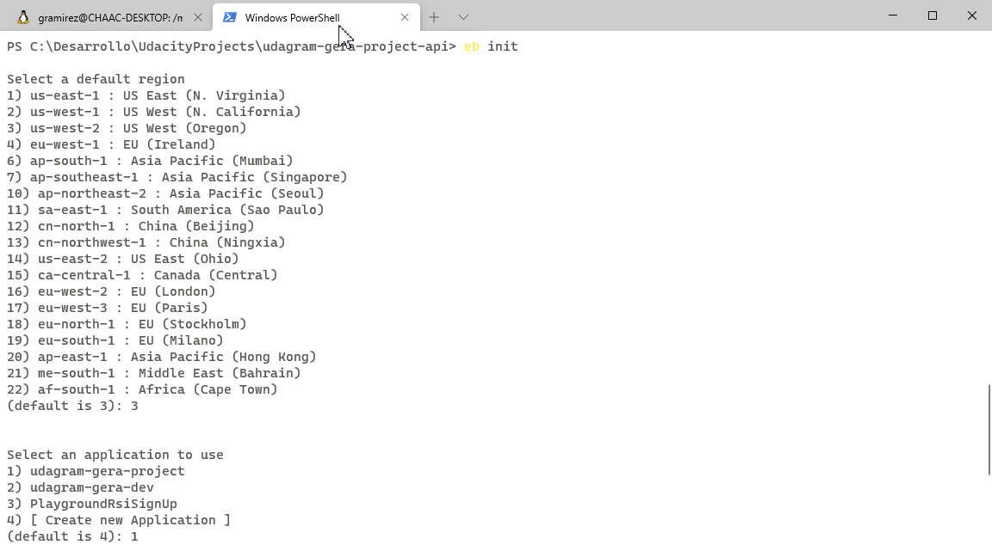

PS C:\Desarrollo\UdacityProjects\udagram-gera-project-api> **eb deploy**

warning: LF will be replaced by CRLF in src/server.ts.

The file will have its original line endings in your working directory

Uploading **udagram-gera-project/app-cd4b-201109_103716.zip to S3**. This may take a while.

Upload Complete.

2020-11-09 18:37:19 INFO Environment update is starting.

2020-11-09 18:37:23 INFO Deploying new version to instance(s).

2020-11-09 18:37:27 INFO Instance deployment: You didn't specify a Node.js version in the 'package.json' file in your source bundle. The deployment didn't install a specific Node.js version.

2020-11-09 18:37:38 INFO Instance deployment completed successfully.

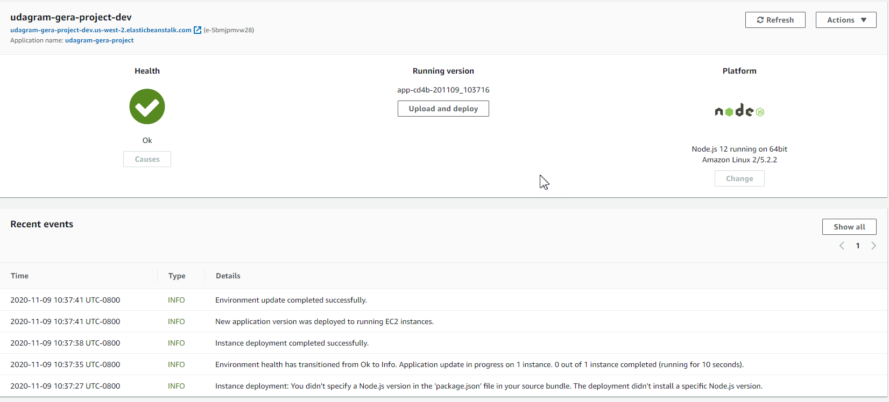

Optional - Custom Domain

<http://api.udagram.muyalcraft.com/>

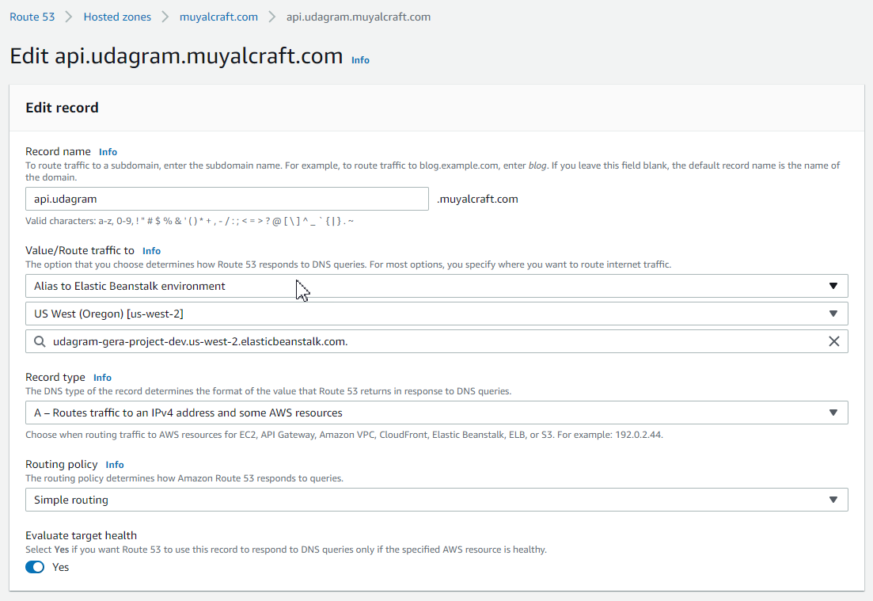

JSON Test using Postman

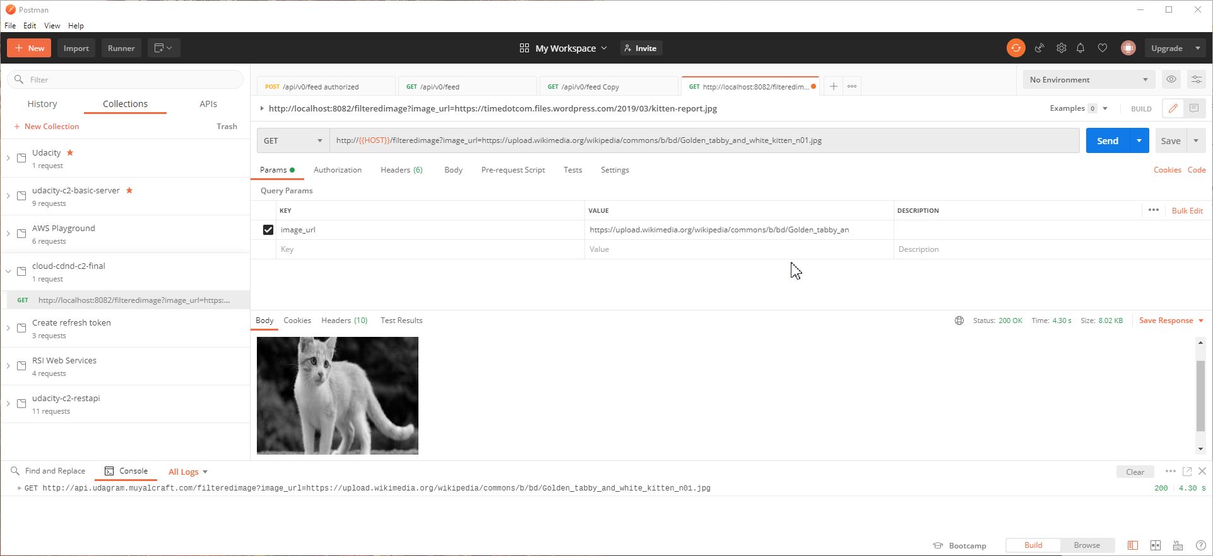

Testing Successful Attempt – Status code 200

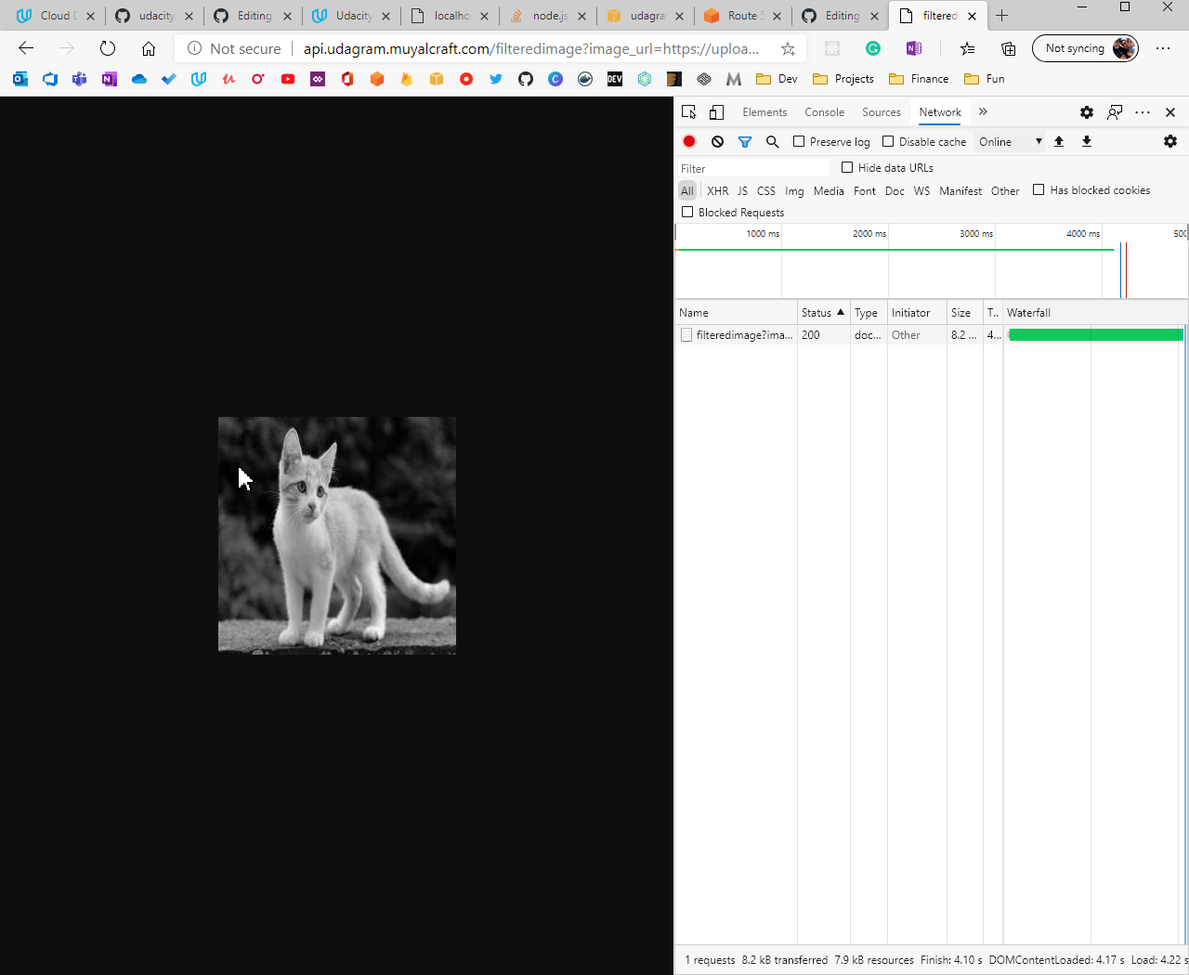

Testing Failed Attempt – Status code 400

