AEM Cloud Manager
Study Guide for Beginners
Visual companion to the Cloud Manager and AEMaaCS recap
A complete walkthrough of the platform, roles, pipelines, code quality, testing, deployments, and monitoring.

Table of contents

1. Introduction
This guide is a full recap of Cloud Manager and the AEM as a Cloud Service (AEMaaCS) platform. It covers the most important concepts grouped in nine categories, designed to help you connect the pieces and see the big picture.
We go through each category, highlighting the key points you need to remember.
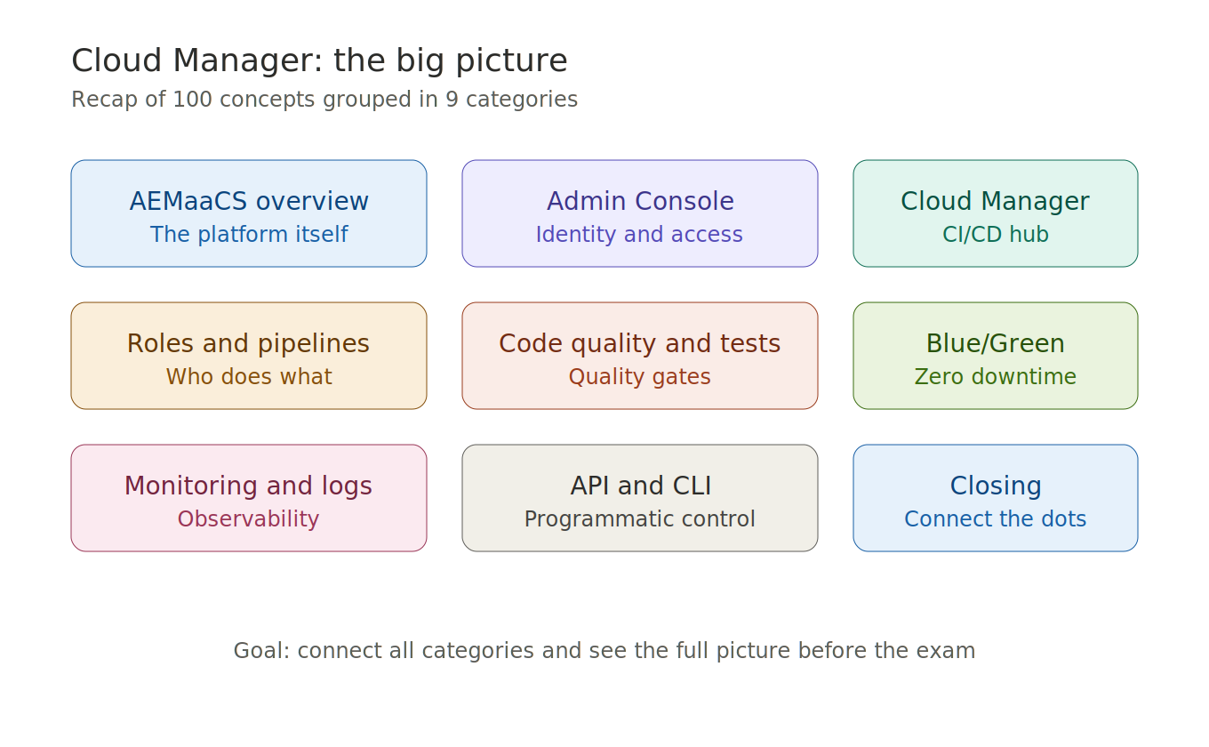
Figure 1. The nine categories covered in this guide.

2. AEMaaCS overview
AEM as a Cloud Service is Adobe's fully managed, cloud-native CMS.

Key traits
- Always on the latest version — no manual upgrades, Adobe handles it continuously.
- Auto-scaling — resources grow and shrink automatically based on traffic.
- Built-in CDN — content is served from edge nodes close to the user.
- Containers — AEMaaCS runs as Docker containers, not as a fixed Java process.

Two architecture layers
Immutable layer: /apps and /libs are read-only at runtime. Changes only come in through a Cloud Manager pipeline deployment.
Mutable layer: /content and /conf survive deployments. They are stored in a persistent repository backed by Azure Blob Storage.

Other important concepts
- Sling Content Distribution (SCD) replaces traditional replication agents.
- Asset Microservices handle rendition processing at scale via Adobe I/O Runtime.
- RDE (Rapid Development Environment) allows instant code deploys without running a full pipeline.
- Cloud Acceleration Manager (CAM) helps teams plan and track migrations from AEM 6.x.
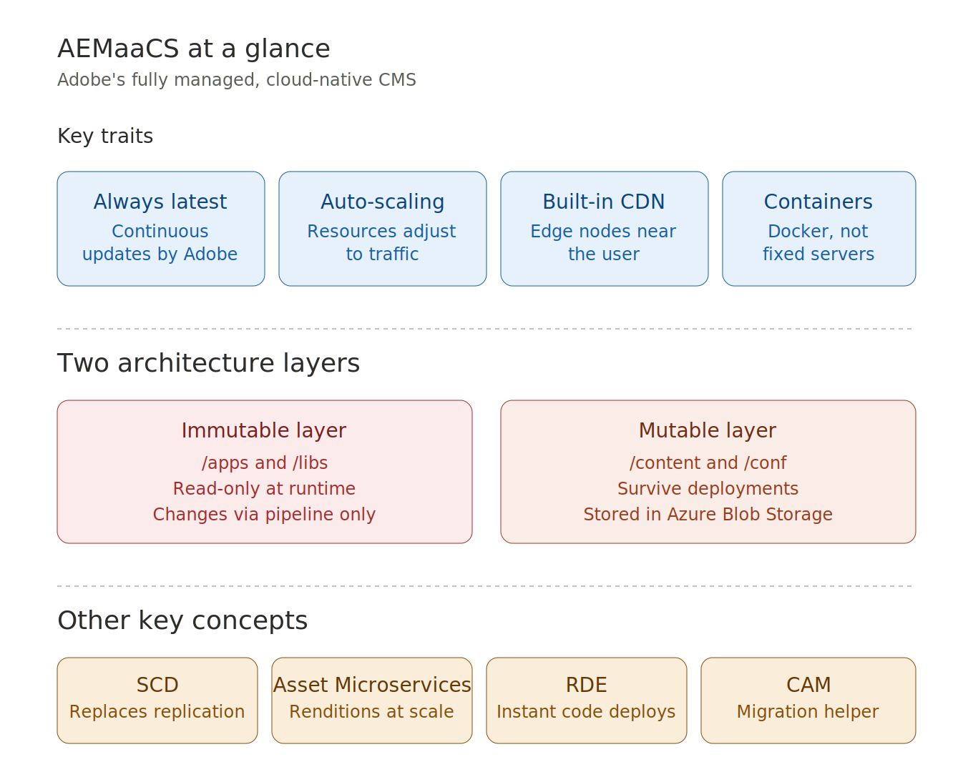
Figure 2. AEMaaCS at a glance: traits, layers, and key concepts.

3. Adobe Admin Console
The Adobe Admin Console is the central identity and access management portal for all Adobe products.

Key concepts
- IMS Organization — the top-level entity representing a company's entitlement to Adobe products.
- All AEMaaCS programs belong to an IMS Org.
- The IMS Org Admin has the highest level of access.

Two types of product profiles for AEMaaCS
Cloud Manager profiles control what users can do inside Cloud Manager. They include Business Owner, Program Manager, Deployment Manager, and Developer.
AEM environment profiles control access to the AEM Author and Publish services. They include AEM Administrators and AEM Users — one set per environment tier.
Cloud Manager roles do NOT automatically grant AEM Author access — those are separate.
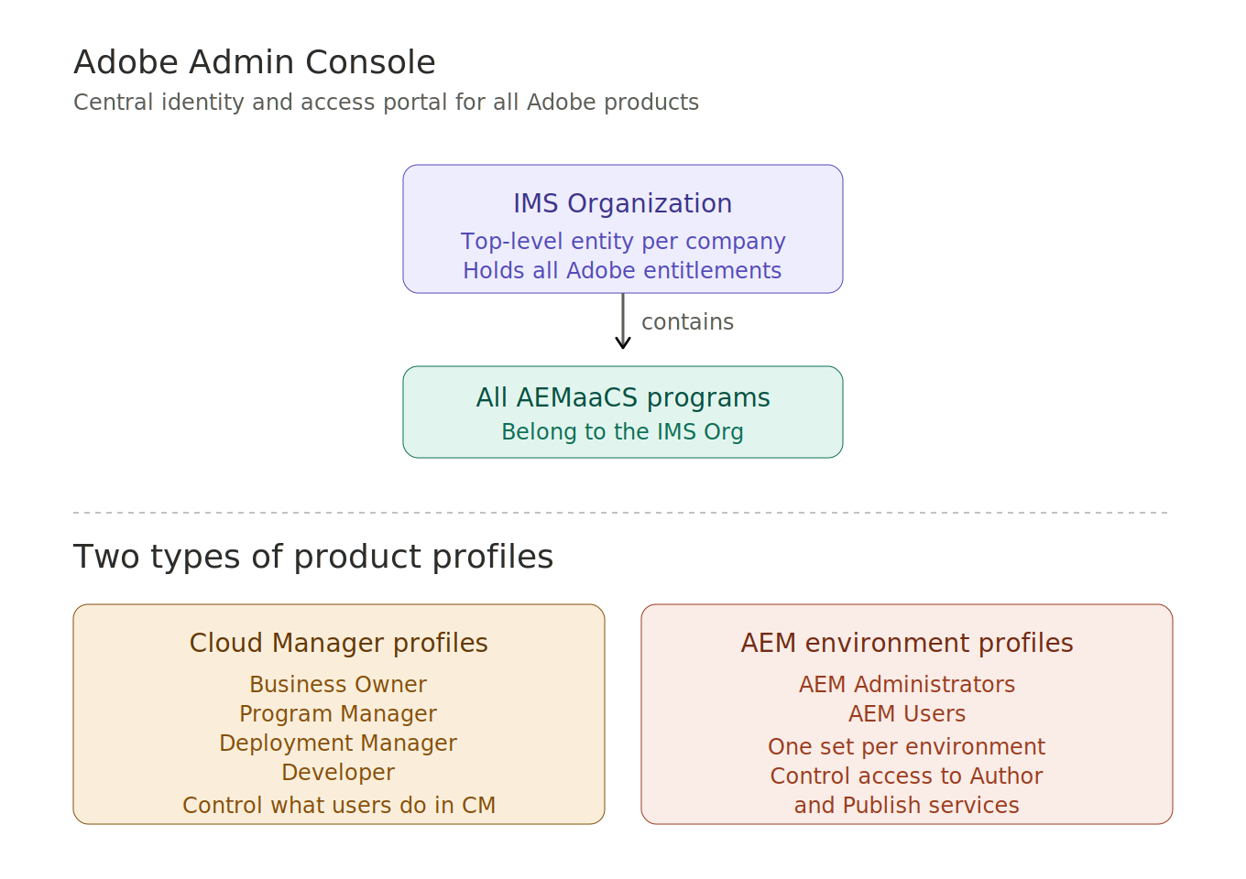
Figure 3. IMS Org and the two types of product profiles.

4. Cloud Manager overview
Cloud Manager is Adobe's CI/CD and operational platform for AEMaaCS. It is the single hub for deploying code via pipelines, provisioning and managing environments, monitoring and alerting, and accessing logs and developer tools.

Programs
A Program is the top-level container in Cloud Manager. It groups environments, pipelines, a Git repository, and user access.
- Sandbox — for learning, demos, and PoCs. No production environment, no SLA, environments auto-hibernate after ~8 hours of inactivity.
- Production — full capacity, Adobe SLA-backed, used for real business workloads.

Git repositories
Cloud Manager provides a built-in Adobe-hosted Git repo per program. External repositories (GitHub, GitLab, Bitbucket) can also be connected, enabling teams to keep using their existing VCS workflow.
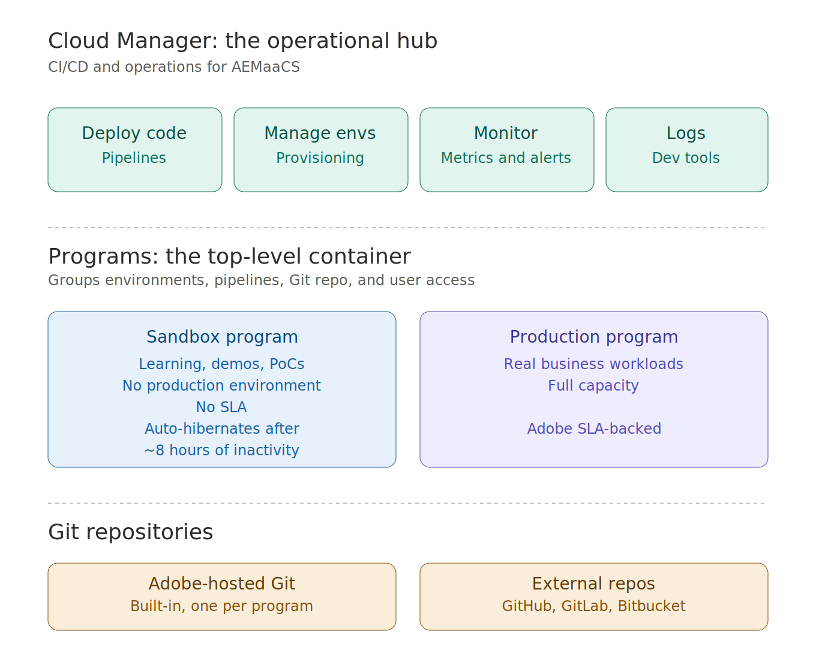
Figure 4. Cloud Manager hub, programs, and Git repositories.

5. Roles and permissions
There are four Cloud Manager roles, each with a clear scope. All roles are assigned via product profiles in the Adobe Admin Console.

Business Owner
Highest governance role. Creates programs, sets production KPI targets, and approves Go Live. Must be assigned in the Admin Console.

Program Manager
Coordination and planning role. Manages timelines and cross-team visibility. No pipeline configuration or deployment rights.

Deployment Manager
Configures and triggers pipelines, including production. Manages environment variables. Can override Important quality gate failures.

Developer
Access to logs, AEM Developer Console, and environment details. Can trigger non-production pipelines. Cannot trigger production pipelines or manage program settings.
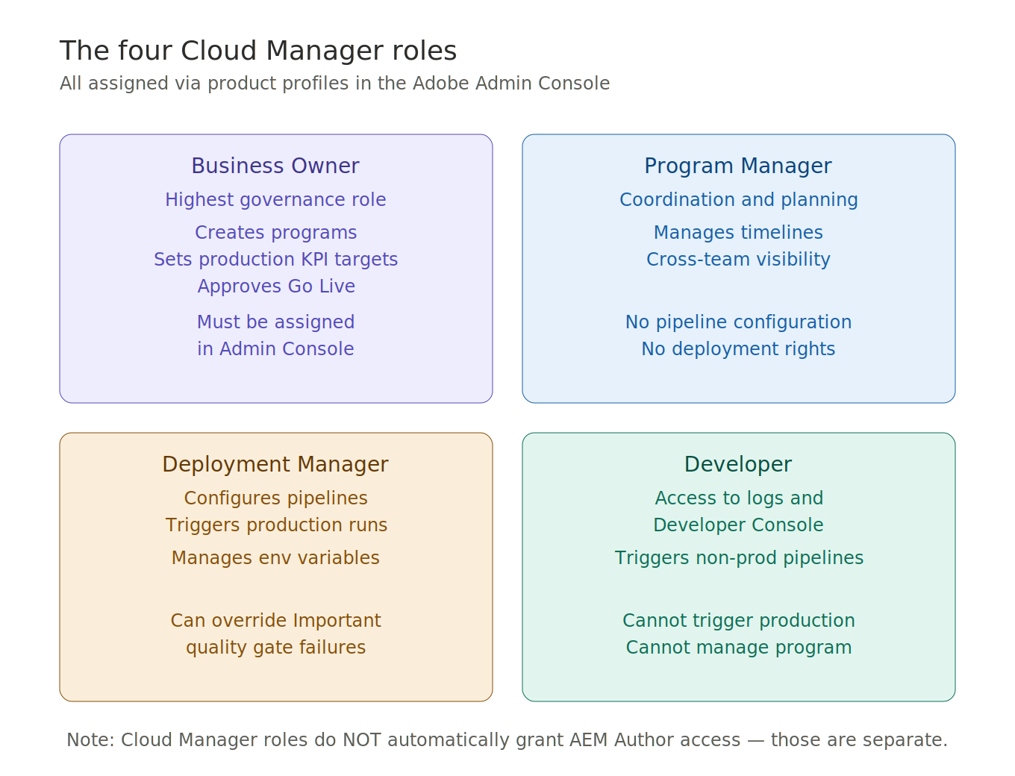
Figure 5. The four Cloud Manager roles and their scopes.

6. Pipeline types
Cloud Manager supports several pipeline types. Choosing the right one matters for both speed and scope.

Full Stack Pipeline
Builds and deploys everything: OSGi bundles, content packages, Dispatcher config, and front-end assets. The standard pipeline for all-layer deployments.

Front End Pipeline
Deploys only compiled CSS and JavaScript assets. Runs an npm/webpack build and skips the Maven backend build. Allows front-end teams to deploy independently and faster.

Config Pipeline
Deploys only configuration files: OSGi run-mode configs, CDN rules, and log forwarding settings. Skips compilation entirely — much faster than Full Stack.

Web Tier Config Pipeline
Specifically for Dispatcher and Apache HTTP configuration changes.

Code Quality Pipeline (standalone)
Runs SonarQube analysis without deploying to any environment. Useful for validating feature branches or pull requests early.
Important constraint: each Cloud Manager program supports exactly one Production Pipeline. Multiple Non-Production, Config, Front End, and Code Quality pipelines are allowed.
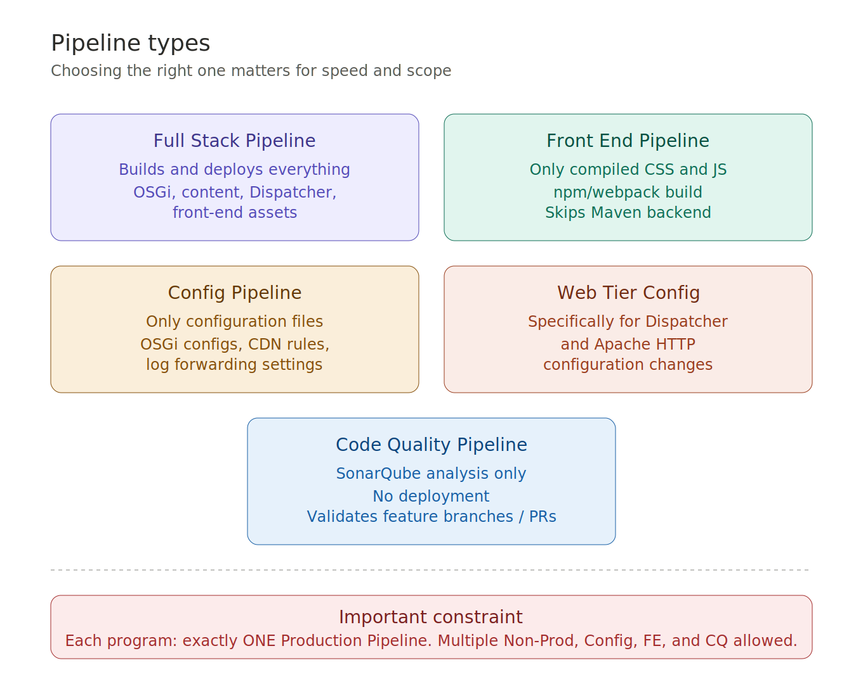
Figure 6. Pipeline types and the one-Production-Pipeline rule.

7. Production Pipeline — step by step
The Production Pipeline is the primary deployment mechanism. Know this flow.

Step 1 — Build
Cloud Manager checks out the Git branch, runs mvn clean package, compiles Java, runs unit tests, measures coverage, and produces the deployable artifact.

Step 2 — Code Quality
Runs SonarQube static analysis on the build artifact. Evaluates Reliability, Security, and Maintainability ratings. Failures can be Critical (hard stop) or Important (overridable).

Step 3 — Deploy to Stage
Installs the artifact on the Stage environment (Author and Publish). Stage is used for integration testing and UAT.

Step 4 — Testing
Product Functional Tests, Custom Functional Tests, Custom UI Tests, and Performance Tests run against Stage.

Step 5 — Go Live Approval
Manual gate that pauses the pipeline. A Business Owner or Deployment Manager must approve before Production deployment. Can also be scheduled for a future maintenance window.

Step 6 — Deploy to Production
Blue/Green deployment with zero downtime. The Dispatcher cache is automatically flushed after deployment.
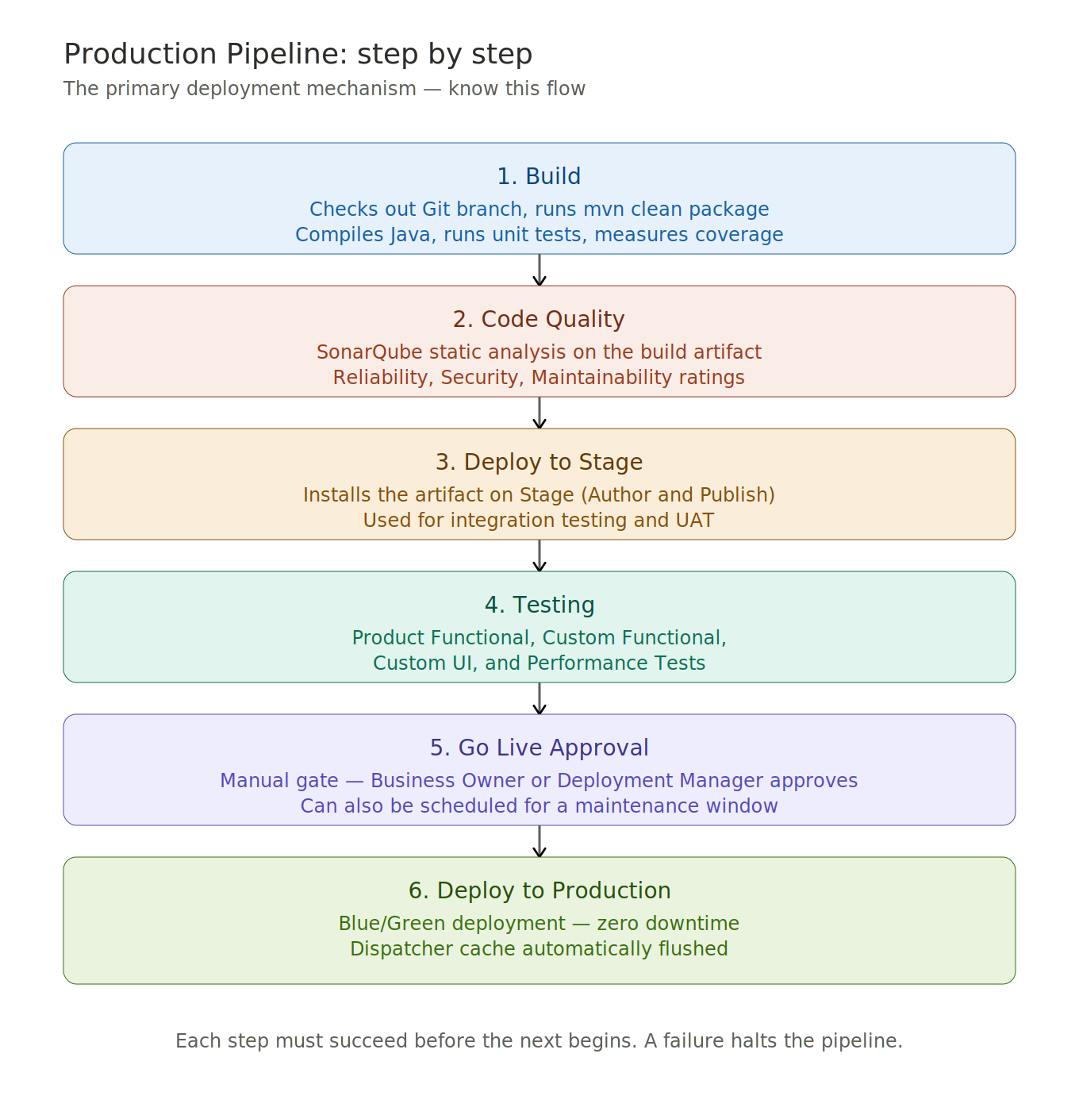
Figure 7. The six-step Production Pipeline.

8. Pipeline triggers and variables

Three ways to start a pipeline
- Manual — someone clicks Run in the Cloud Manager UI or via the API.
- On Git Push — automatic CI trigger when code is pushed to the configured branch.
- Scheduled — runs at a defined time, for example nightly.

Environment variables
Cloud Manager supports two types of variables:
- Plain text — for non-sensitive configuration values. Referenced as $[env:VARIABLE_NAME].
- Secrets — stored encrypted, never exposed in logs. Referenced as $[secret:SECRET_NAME].
Variables can be scoped per environment (Dev, Stage, Production).

Pull Request validation
When using Connected Repositories, Cloud Manager can automatically trigger a Code Quality scan when a PR is opened. Results are posted back directly to GitHub, GitLab, or Bitbucket.
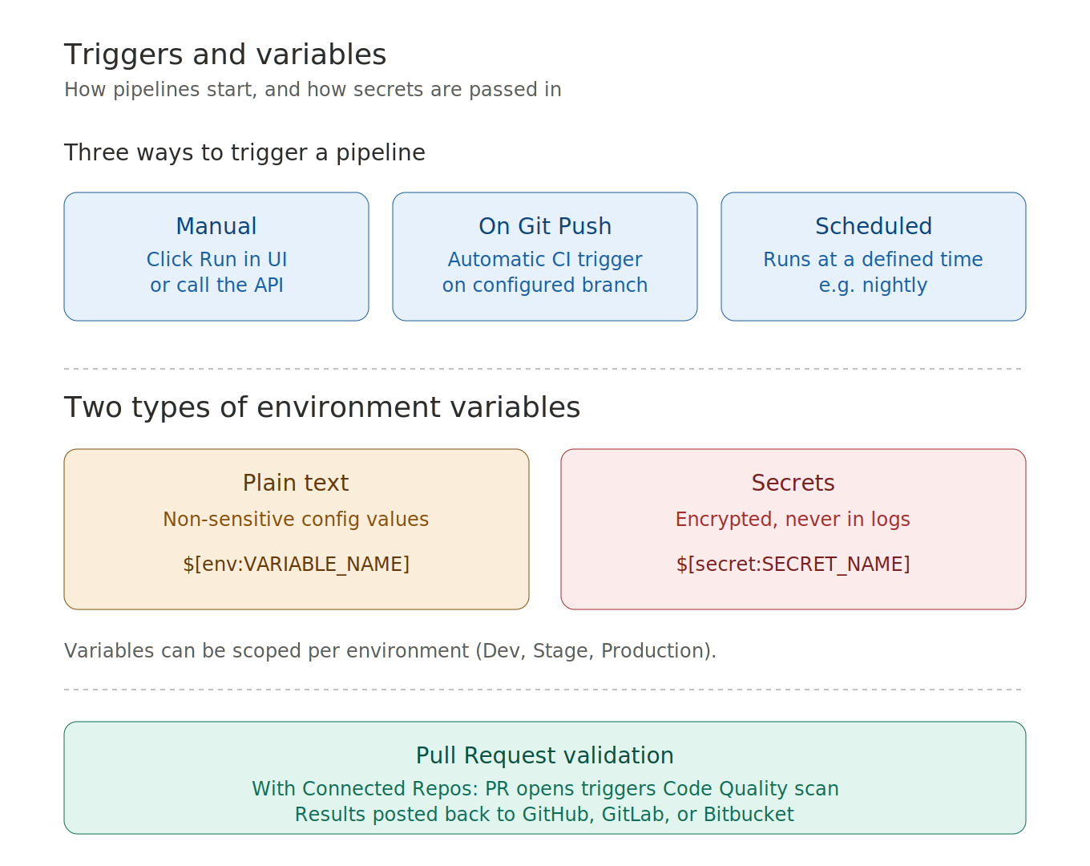
Figure 8. Triggers, variable types, and PR validation.

9. Code Quality gates
Code quality is enforced at the Code Quality step using SonarQube.

Three rating dimensions (each rated A through E)
- Reliability Rating — based on detected bugs. A means no bugs, E means at least one blocker bug.
- Security Rating — based on vulnerabilities and security hotspots. Patterns like SQL injection, XSS, and hardcoded credentials.
- Maintainability Rating — based on code smells and technical debt ratio, also includes code duplication percentage.

Additional checks
- Code coverage — default Important threshold is 50% line coverage (measured by JaCoCo).
- AEM-specific rules — on top of standard SonarQube: ResourceResolver/Session not closed, use of admin sessions, deprecated AEM APIs, null-unsafe Sling Model injections.
- AEM Analyzer Maven Plugin — detects AEMaaCS compatibility issues during the Build step.

Two failure levels
- Critical — pipeline stops immediately, must be fixed, cannot be overridden.
- Important — pipeline pauses, a Deployment Manager or Business Owner can override and continue.
SonarQube behavior can be customized with a sonar-project.properties file at the repository root.
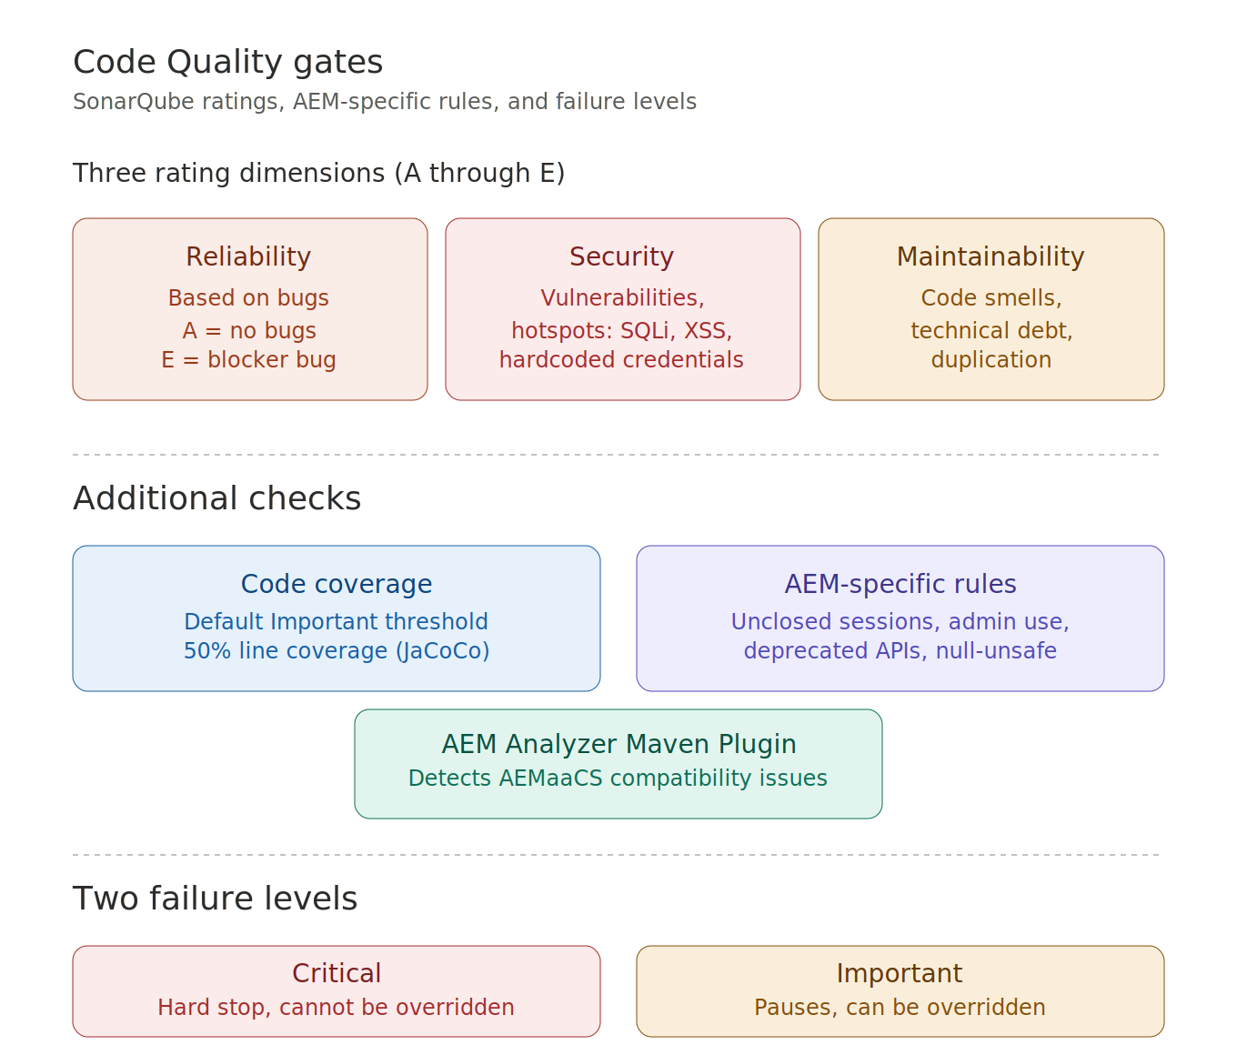
Figure 9. SonarQube ratings, additional checks, and failure levels.

10. Testing in pipelines
After Stage deployment, four types of tests can run.

Product Functional Tests
Developed and maintained by Adobe. Verify that core AEM features work correctly after your code is deployed. Always run automatically.

Custom Functional Tests
Written by your team and packaged as Docker images. HTTP/REST tests against the deployed AEM environment. Validate application-specific behavior.

Custom UI Tests
Browser automation tests, packaged as Docker images. Supports Selenium, Cypress, Playwright, and WebdriverIO. Cloud Manager provides the Selenium Grid.

Performance Tests
Simulate real user traffic against Stage. Measure response time (avg and 95th percentile), error rate, CPU usage, and page views per minute. Results are compared against KPI thresholds set by the Business Owner.
If any step fails, the pipeline stops at that step. The previously deployed version stays active. The team must fix the issue and trigger a new run.
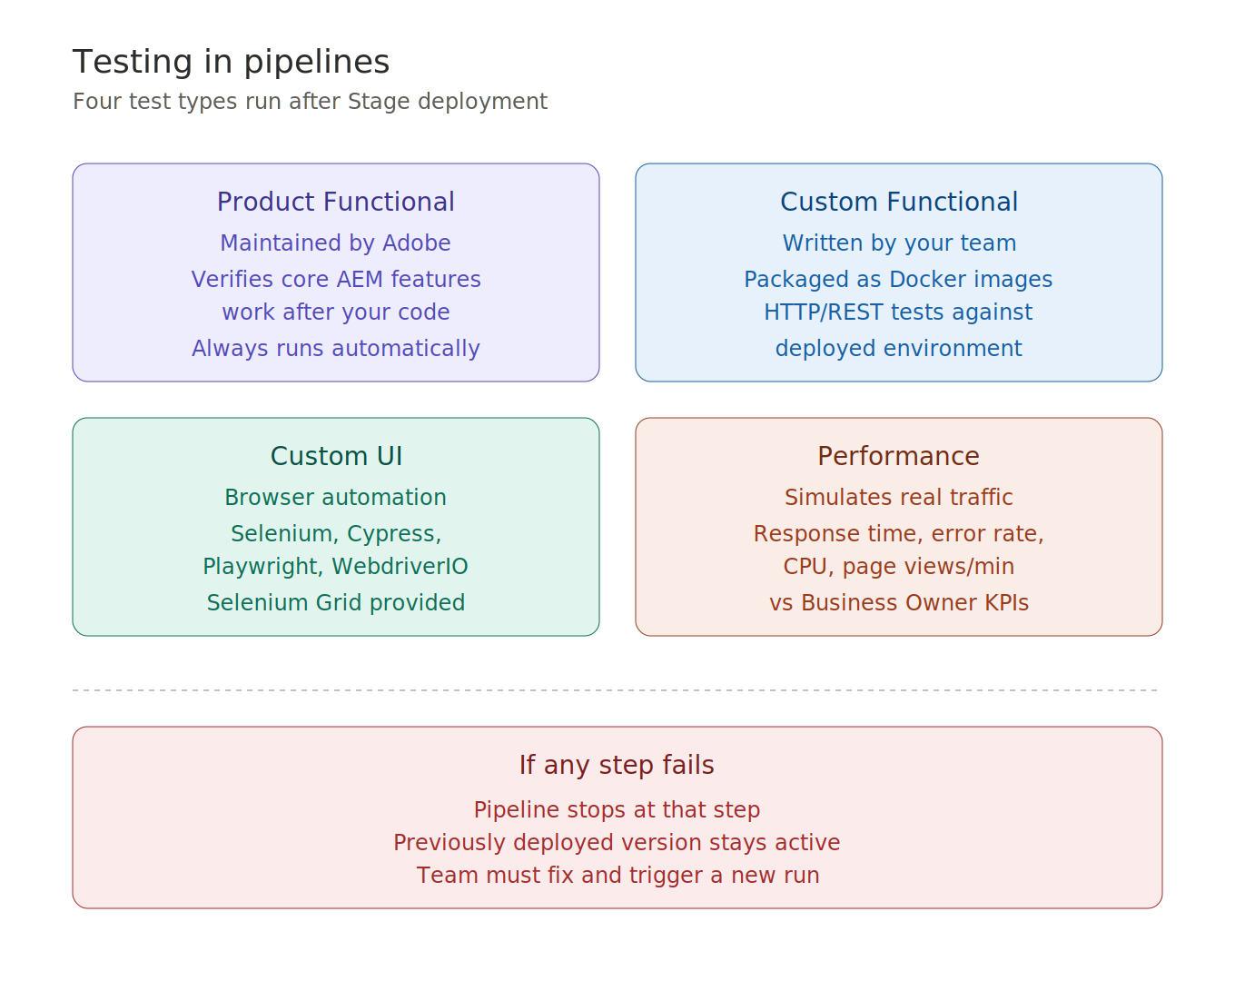
Figure 10. The four test types and what happens on failure.

11. Blue/Green deployment
Blue/Green is how AEMaaCS achieves zero-downtime deployments.

How it works
- The current live environment is Blue.
- The new deployment goes to the idle Green environment.
- Once health checks pass, traffic switches from Blue to Green automatically.
- Blue remains briefly available for rollback if needed.
After every deployment, the Dispatcher cache is automatically flushed. This ensures users get the new content and code changes immediately, not cached stale responses.
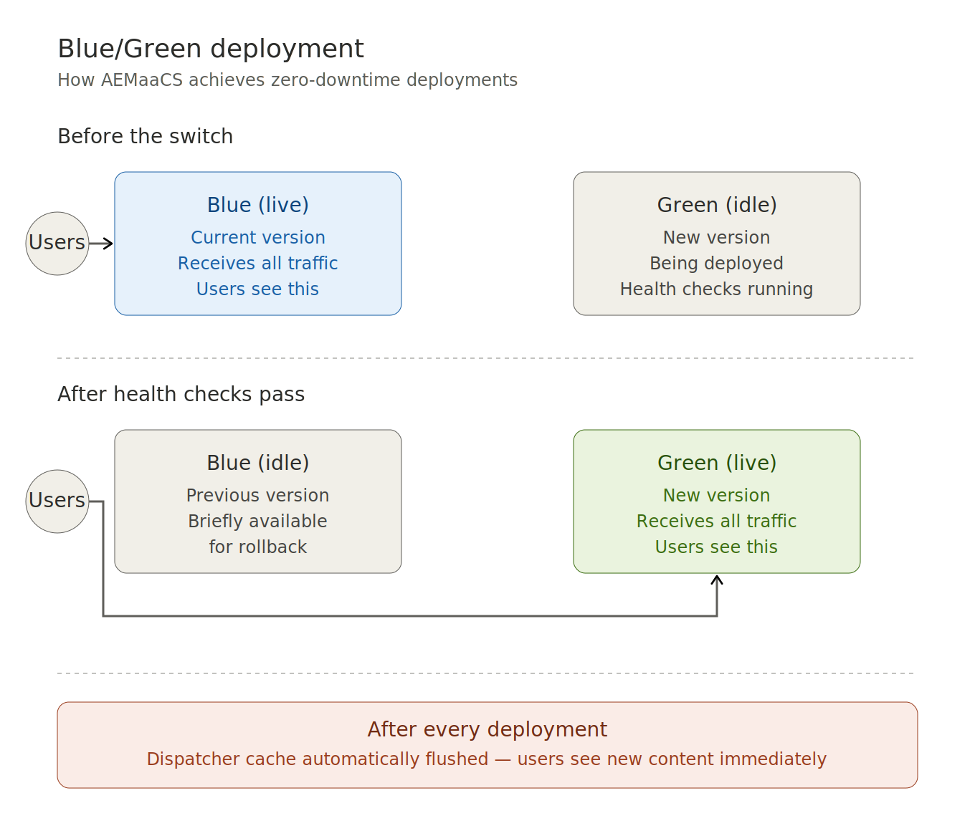
Figure 11. Blue/Green deployment before and after the traffic switch.

12. Monitoring and logs
Cloud Manager provides several monitoring and observability tools.

Built-in dashboards
- System metrics: CPU, memory, disk utilization.
- HTTP metrics: request rate, error rate, response time.
- Environment health status.

AEM Developer Console
Accessible from Cloud Manager per environment. Provides runtime inspection: OSGi bundle state, Sling servlet bindings, request logs, query debugging. Available to users with the Developer role.

Log access options
- Cloud Manager UI — download logs per environment, service, and date.
- Cloud Manager CLI or API — programmatic access.
- AEM Developer Console — view recent request logs interactively.
- Log Forwarding — continuous streaming to Splunk, Datadog, Azure Blob Storage, or Amazon S3.

Custom Alerts
Notify users when KPI thresholds are breached. For example, error rate above a percentage, or response time above a target.

Content Audit / Experience Audit
Runs Google Lighthouse against configured URLs on Stage. Evaluates Performance, SEO, Accessibility, and Best Practices. Shows score trends across pipeline runs to detect regressions.

New Relic Integration
Adobe provisions New Relic One automatically for AEMaaCS customers. Provides deep APM monitoring: JVM heap, GC, Sling request traces, and error tracking. No separate New Relic subscription is needed — it is accessible through Cloud Manager.
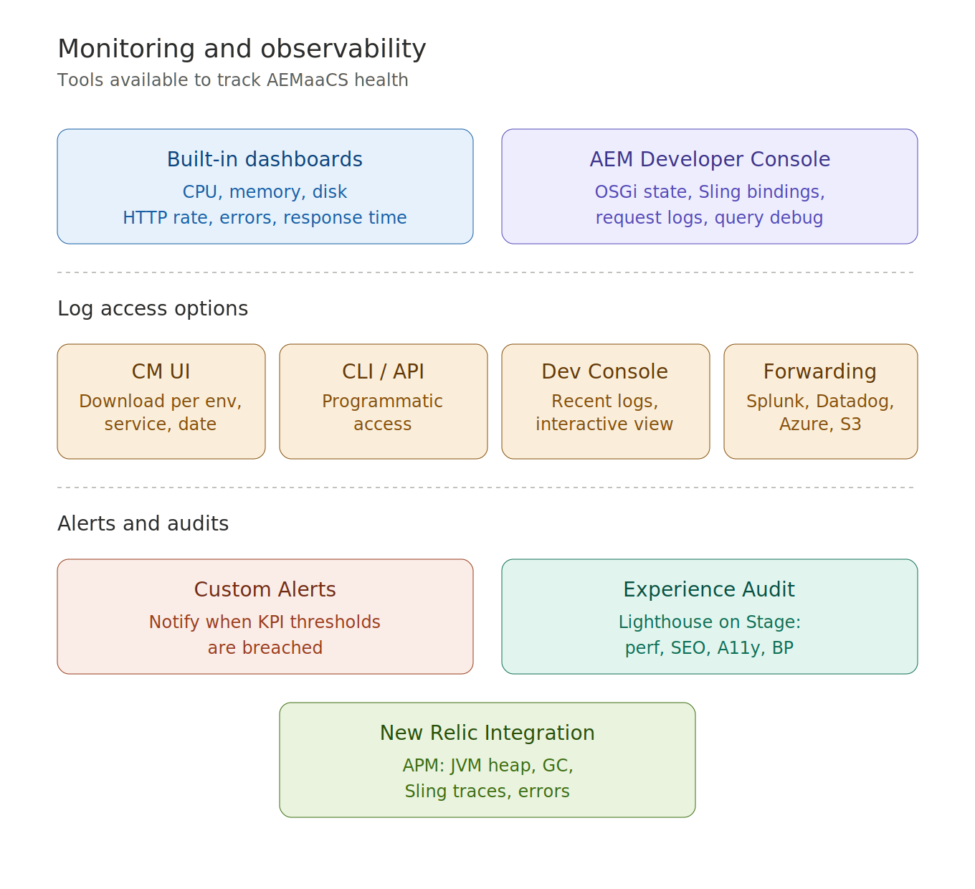
Figure 12. Monitoring tools, log access options, and integrations.

13. Cloud Manager API and CLI
Cloud Manager is fully operable via API and command line.

Cloud Manager REST API
Available at cloudmanager.adobe.io. Authenticated via Adobe IMS using a Service Account (Technical Account) from Adobe Developer Console.
Capabilities: trigger pipeline runs, poll execution status, download logs, manage variables, create or delete environments.

Key API use cases
- Triggering deployments from external CI/CD systems (Jenkins, GitHub Actions).
- Automating environment variable and secret rotation.
- Programmatically approving the Go Live gate via the Advance endpoint.

Adobe I/O CLI (aio)
Install with: npm install -g @adobe/aio-cli
Add the Cloud Manager plugin: aio plugins:install @adobe/aio-cli-plugin-cloudmanager
Common commands: list programs, list environments, trigger pipelines, tail logs in real time.
Authentication uses OAuth Server-to-Server credentials. JWT credentials were fully removed in January 2025.
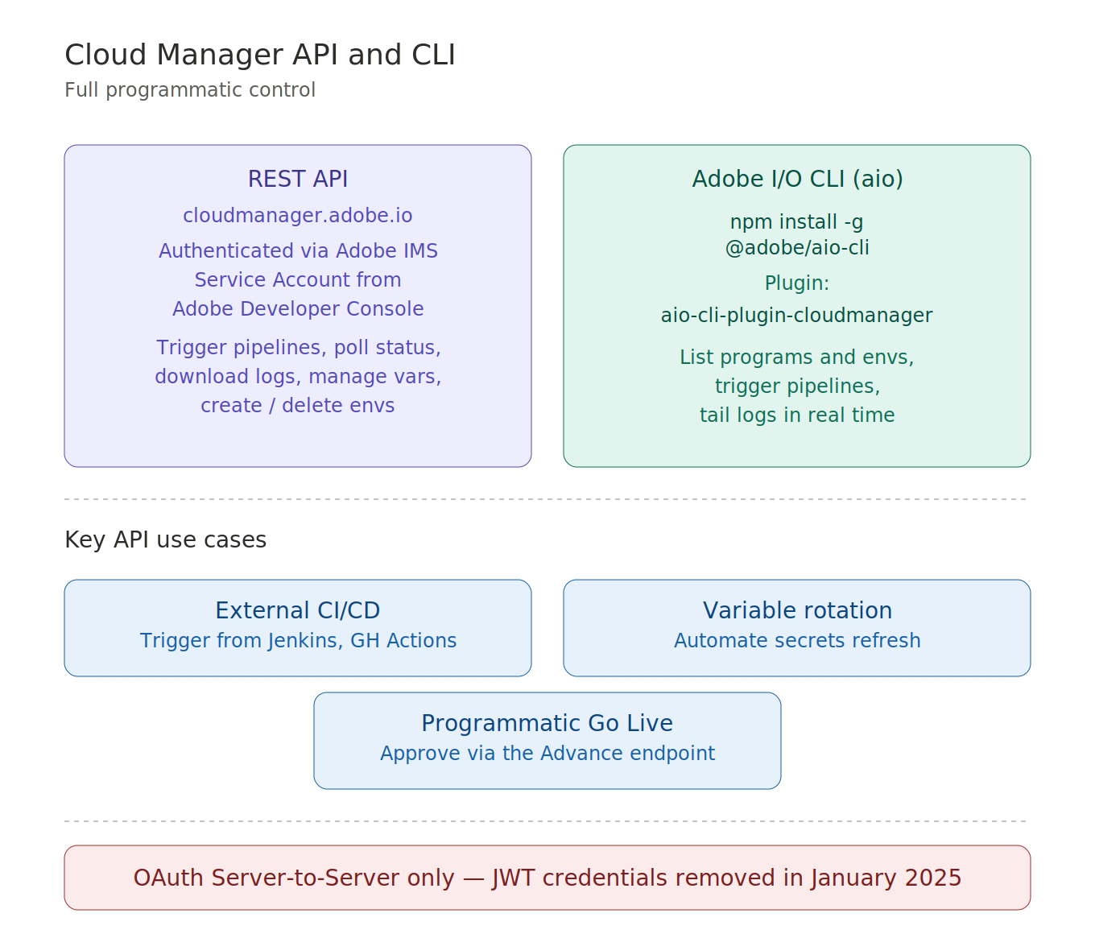
Figure 13. REST API, Adobe I/O CLI, and key use cases.

14. Closing
Cloud Manager is the operational backbone of AEM as a Cloud Service. The key connections to keep in mind are:
- AEMaaCS architecture — immutable code layer, mutable content layer.
- Admin Console — where all roles and profiles are assigned.
- Programs — the organizational container, Sandbox vs Production.
- Pipelines — Full Stack for everything, Front End for CSS/JS only, Config for settings only.
- Production Pipeline flow — Build → Code Quality → Stage → Testing → Go Live Approval → Production.
- Code Quality — SonarQube ratings, AEM-specific rules, Critical vs Important failures.
- Blue/Green — zero-downtime, automatic Dispatcher flush.
- Monitoring — Developer Console, Log Forwarding, New Relic, Experience Audit.
- API and CLI — full programmatic control via REST API and aio CLI.
If you can connect these nine categories, you are well prepared for the Cloud Manager questions on the exam.

