AEM Environment Setup
Study Guide for Beginners
Building, running, and testing AEM code on your own machine before sending anything to the cloud.

Volume 4 of the AEM study material series.

Table of contents

1. Introduction
Now that we understand what AEM is, how Cloud Manager works, and the code quality standards, it's time to set up a local development environment.
The goal here is to be able to develop, build, and test AEM code on your own machine before sending anything to the cloud.
This is one of the most practical lessons in the certification.

What this guide covers
- The three components of a local AEM environment.
- Development tools you must install (Java, Node, Maven, Git).
- The Adobe I/O CLI and OAuth Server-to-Server authentication.
- File system organization and the QuickStart Jar.
- How to simulate content distribution between Author and Publish locally.
- Setting up the local Dispatcher with Docker.
- The Maven project structure and module conventions.
- Repo Init and the AEM Project Archetype.
- A practical troubleshooting checklist.
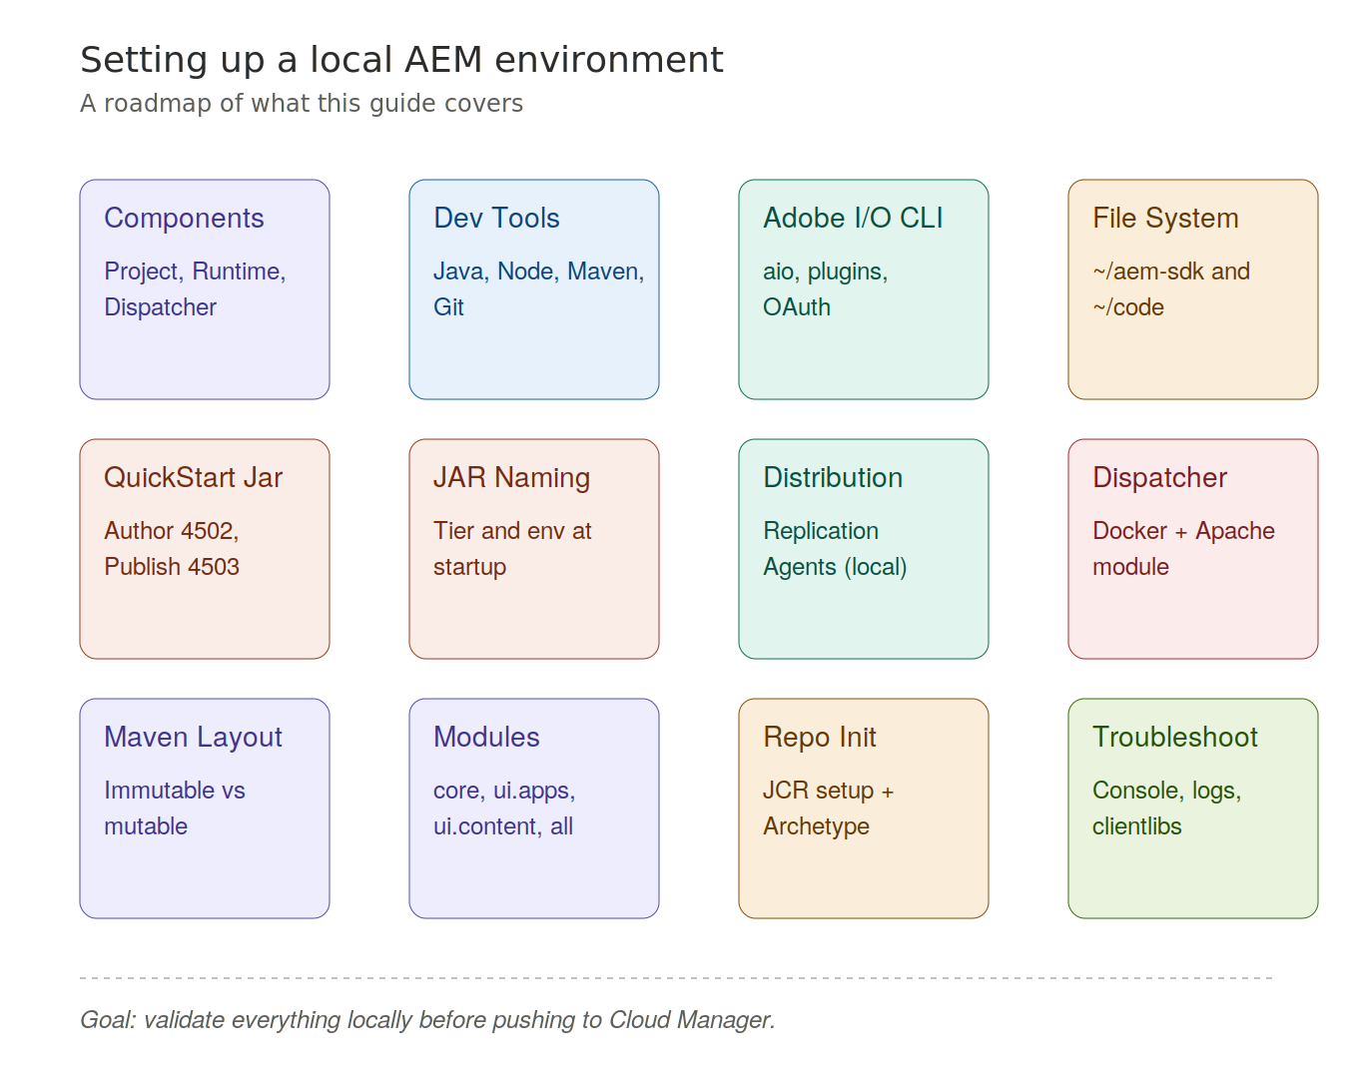
Figure 1. A roadmap of every topic in this guide.

2. The three components
A local AEM environment has three logical parts.

The components
- The AEM Project — your custom code, configuration, and content.
- The Local AEM Runtime — a local version of the Author and Publish services.
- The Local Dispatcher Runtime — a local version of Apache HTTP Server with the Dispatcher module.
Think of it as a miniature version of what runs in the cloud, all on your laptop.
The goal is to validate everything locally before it goes through Cloud Manager.
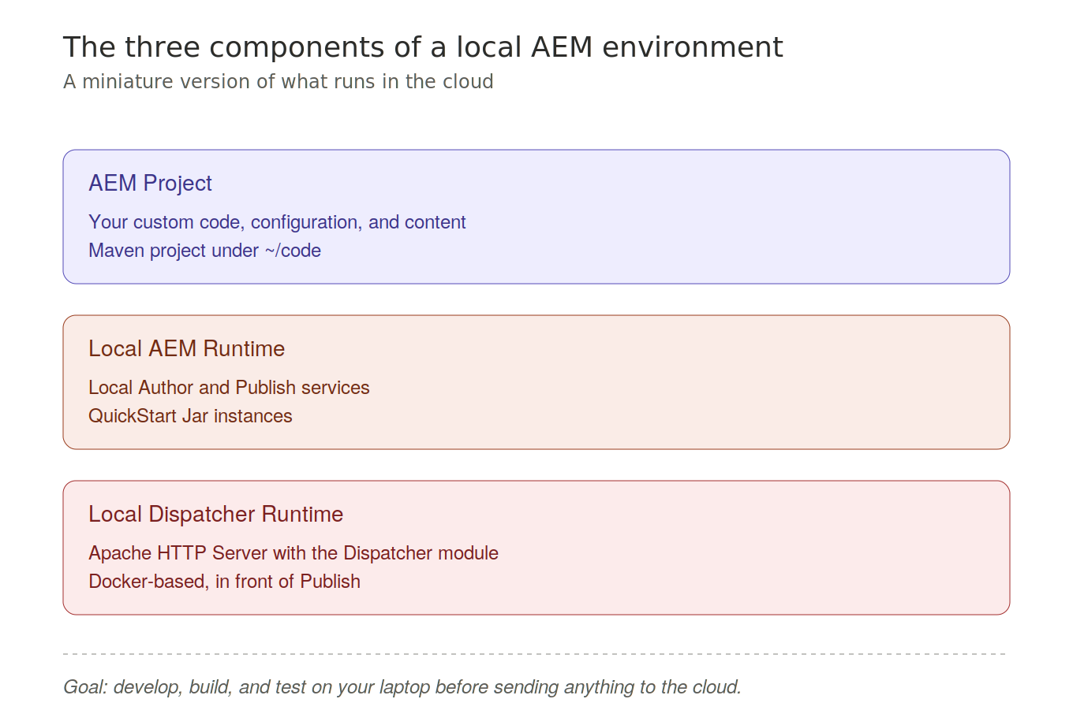
Figure 2. The three logical parts of a local AEM environment.

3. Development tools
To work with AEM locally, you need four core tools.

The four tools
- Java JDK 21 — AEM is a Java application, and Java 21 is the recommended version.
- Node.js — required for front-end tooling and the Adobe I/O CLI.
- Apache Maven — the build tool for all AEM projects.
- Git — source control.

Verify each install
After installing each one, always verify with a version command:
java -version
mvn -v
node --version
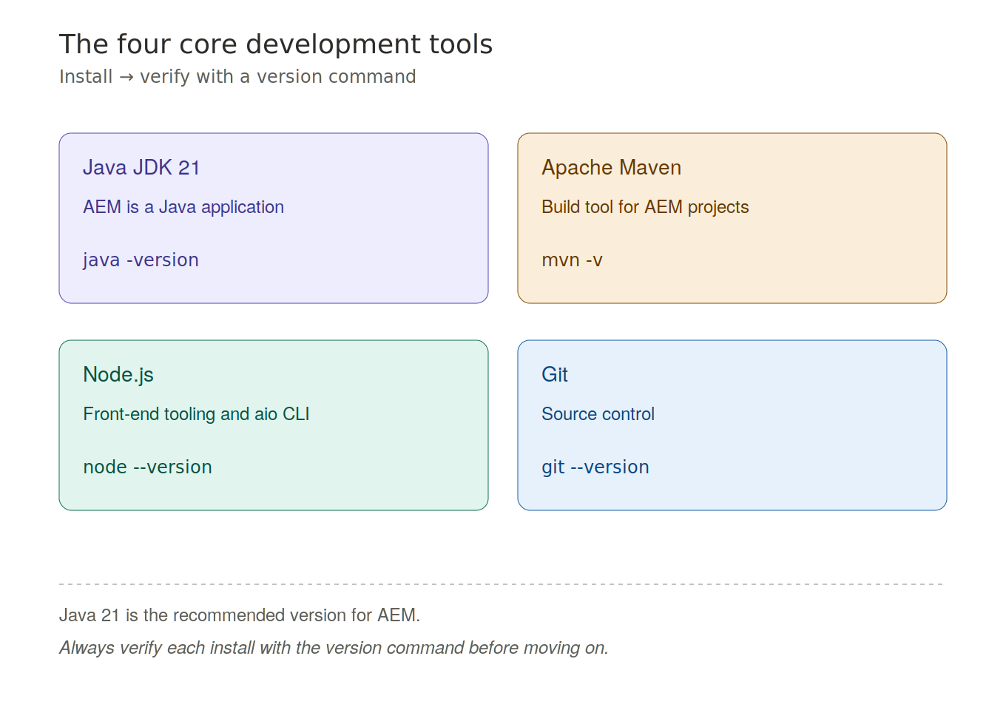
Figure 3. The four core development tools and their verify commands.

4. Adobe I/O CLI
The Adobe I/O CLI, known as aio, is a command-line tool that lets you interact with Adobe services.

Installation
You install it as a global npm package:
npm install -g @adobe/aio-cli

Plugins
Once installed, you add plugins for the services you need:
- Cloud Manager plugin — manage pipelines, environments, and deployments.
- AEM Rapid Development Environment (RDE) plugin — push code to a sandbox for fast iteration.
- Asset Compute plugin — develop and test custom asset workers.

Authentication
Important: the old JWT authentication was removed in January 2025.
The only supported method now is OAuth Server-to-Server, configured through the Adobe Developer Console.
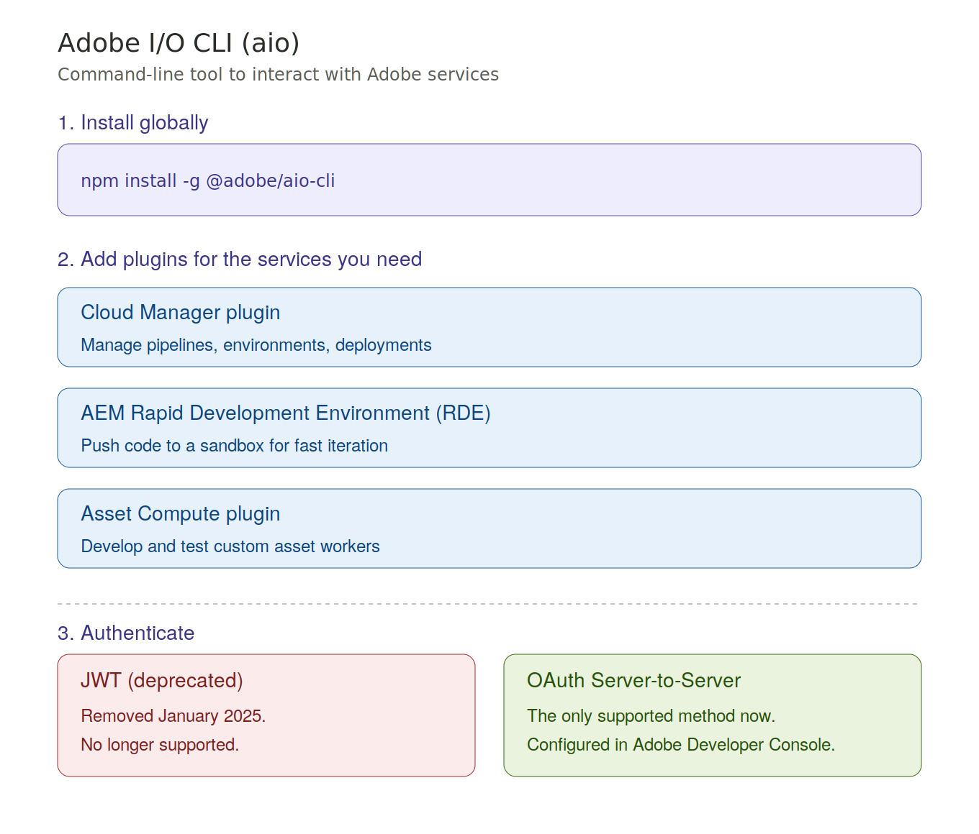
Figure 4. Install, plug in, and authenticate the Adobe I/O CLI.

5. File system organization
Adobe recommends a specific folder structure for local development.

Recommended structure
~/aem-sdk/
author/ → local Author service
publish/ → local Publish service
dispatcher/ → local Dispatcher Tools
~/code/<project-name>/ → your AEM Maven project
This keeps everything organized and makes it easy to manage multiple SDK versions.
On Windows, the tilde (~) maps to %HOMEPATH%.
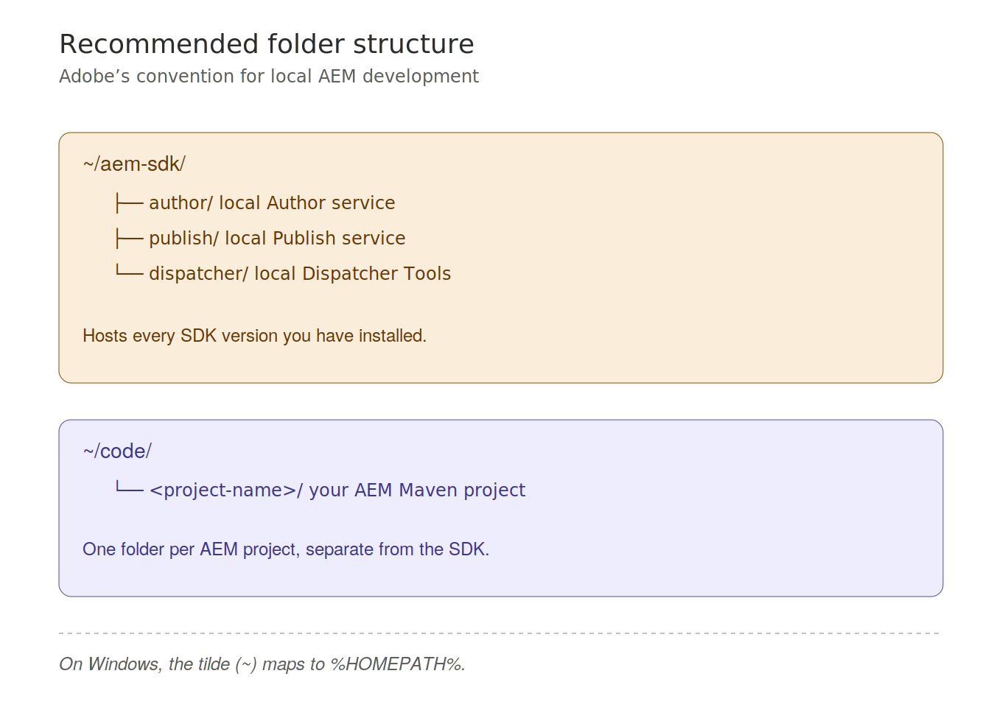
Figure 5. The recommended folder layout for local AEM development.

6. The QuickStart Jar
The AEMaaCS SDK includes a QuickStart Jar, which is a self-contained JAR file that runs a full AEM instance locally.
You download it from Adobe Software Distribution, and you can use it to run either Author or Publish.

Two important rules
- Never double-click the JAR file — it must be started from the command line so the filename conventions for tier, environment, and port apply correctly.
- Always start it from the command line:
java -jar aem-author-p4502.jar

Default ports
- Author runs on port 4502.
- Publish runs on port 4503.
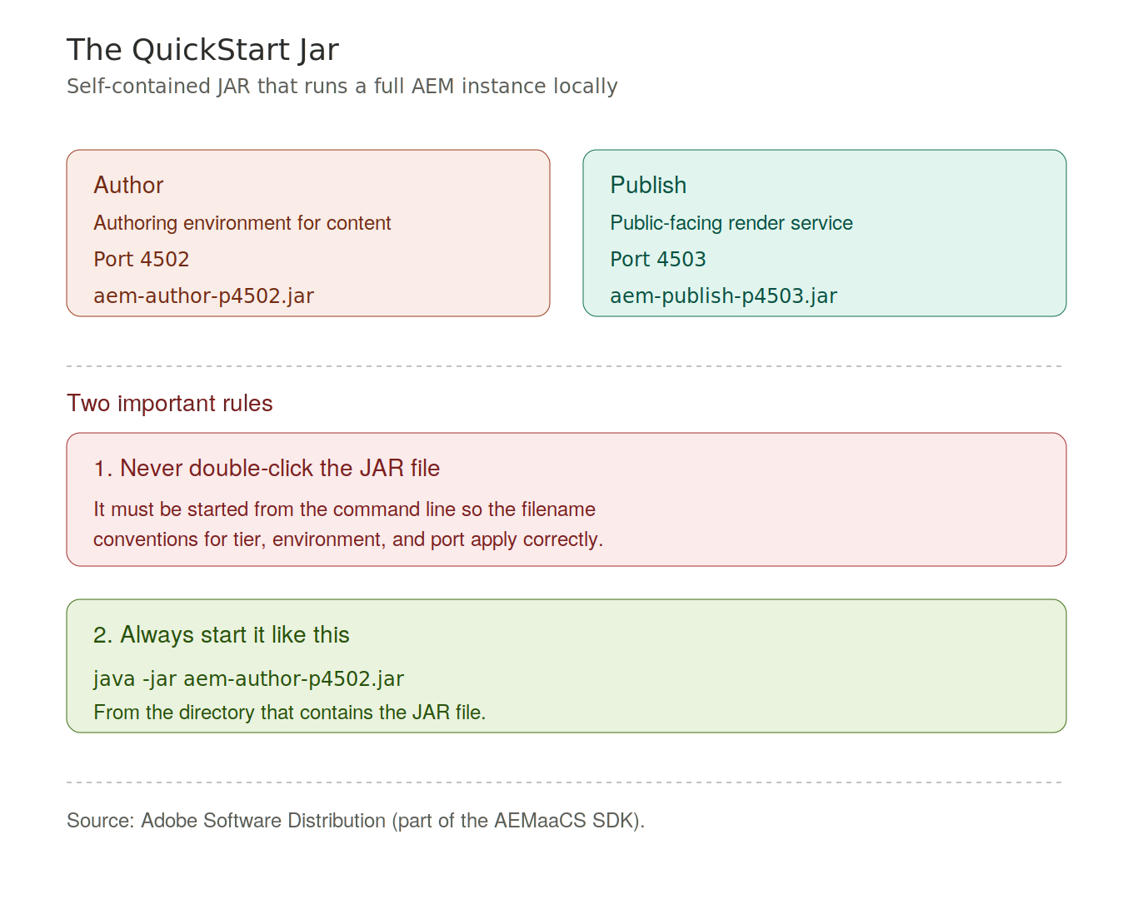
Figure 6. The QuickStart Jar: ports, naming, and the two startup rules.

7. QuickStart Jar naming convention
The filename of the JAR controls how AEM starts up.

Format
aem-<tier>_<environment>-p<port>.jar

Examples
- aem-author-p4502.jar — Author in Dev mode on port 4502.
- aem-publish-p4503.jar — Publish in Dev mode on port 4503.
- aem-author_prod-p4502.jar — Author in Production mode.

Tier is locked on first startup
The tier — author or publish — is locked on first startup. If you need to change it, you must delete the crx-quickstart folder and start fresh.
The environment mode is useful for testing environment-specific OSGi configurations.
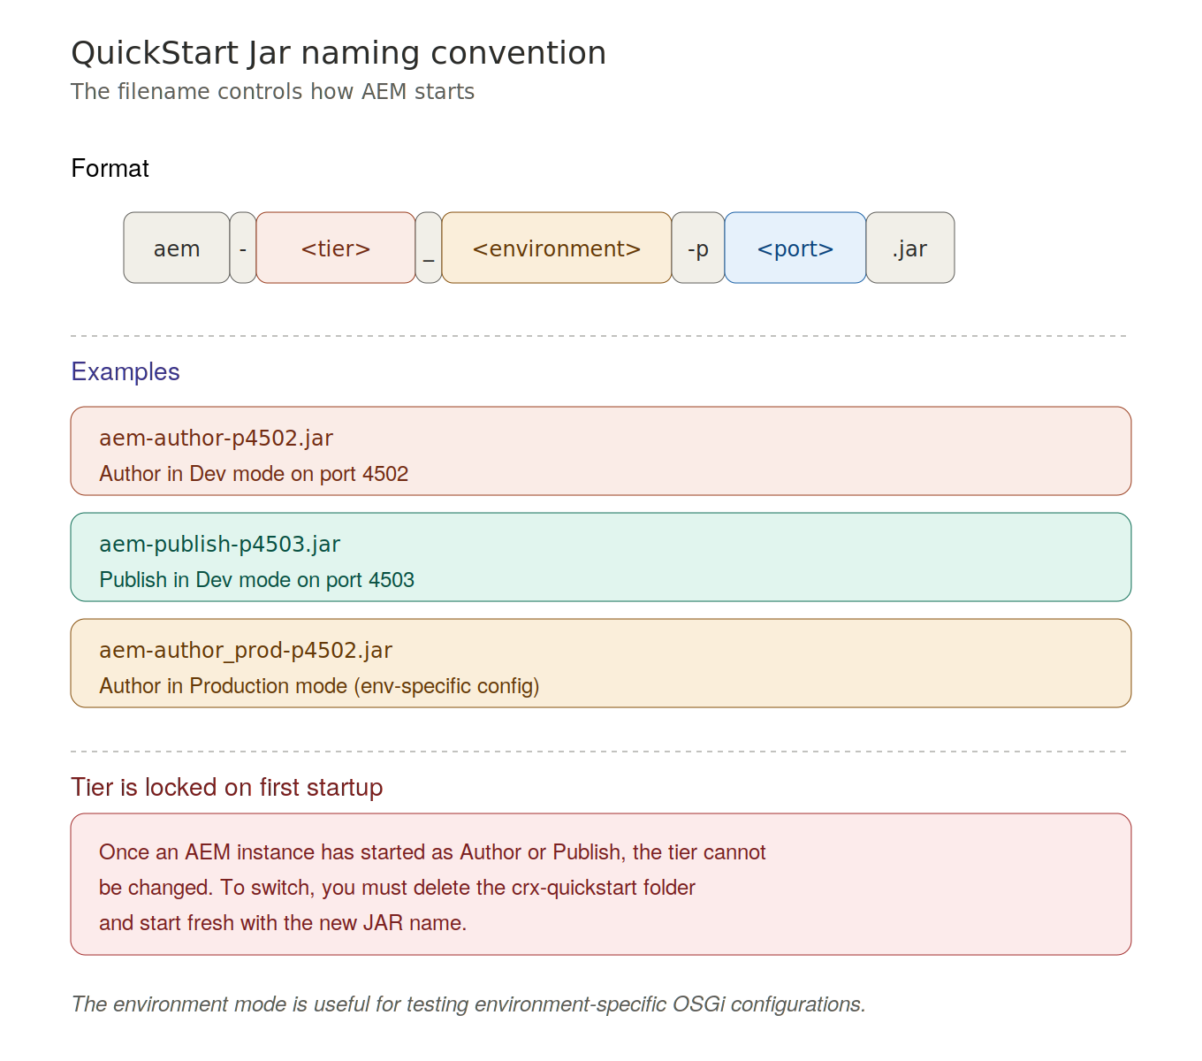
Figure 7. Anatomy of the QuickStart Jar filename.

8. Simulating content distribution
In production, content moves from Author to Publish through the Adobe Pipeline, which is a cloud-only microservice.
Locally, you simulate this using legacy Replication Agents.

Steps to enable
From the Author service:
- Open /etc/replication/agents.author.html
- Open the Default Agent
- Enable it and point the transport URI to localhost:4503
After this, anything you publish on Author will replicate to your local Publish instance.
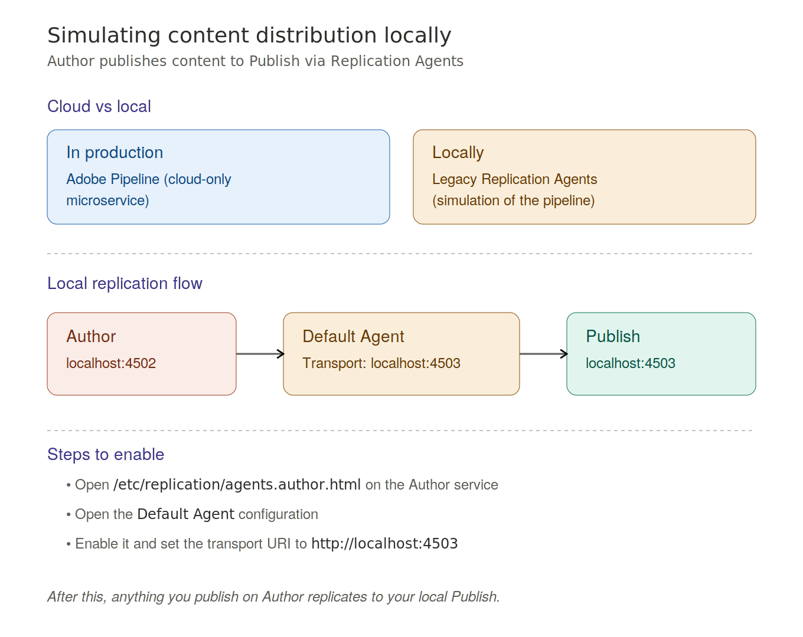
Figure 8. Local replication flow: Author → Default Agent → Publish.

9. Local Dispatcher
The Dispatcher Tools are Docker-based. They run an Apache HTTP Server with the Dispatcher module inside a container.

Starting the Dispatcher
You start it with a single script:
./bin/docker_run_hot_reload.sh ./src localhost:4503 8080
This connects the Dispatcher to your local Publish service and exposes it on port 8080.
The hot-reload variant is preferred because it reloads configuration automatically when files change.

Validator
There is also a validator tool to check your Apache and Dispatcher configuration for errors before you deploy:
./bin/validate ./src
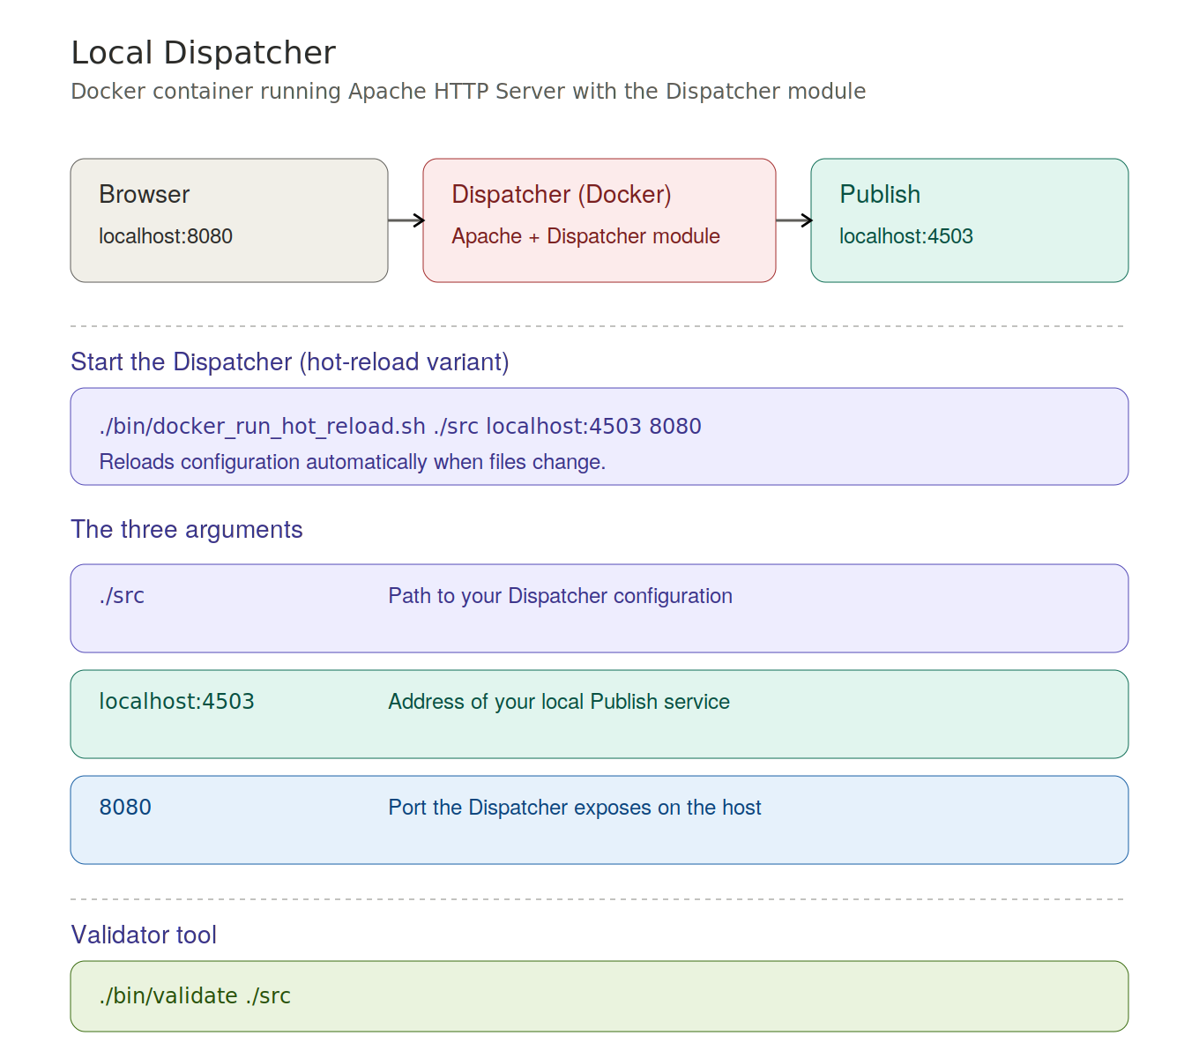
Figure 9. Browser → Dispatcher (Docker) → Publish, with the run script and arguments.

10. Maven project structure
This is where things get important for the exam.
AEM enforces a clear separation between code and content. The repository has two types of areas.

Immutable — cannot be changed at runtime
- /apps — your custom components, scripts, clientlibs.
- /libs — AEM platform code, never touch this.

Mutable — can be changed at runtime
- /content — pages, assets, authored data.
- /conf — configuration (CAConfig).
- /var — runtime data, queues, indexes.
- /etc — legacy configuration tree.
Each type of content belongs in a specific Maven module — covered next.
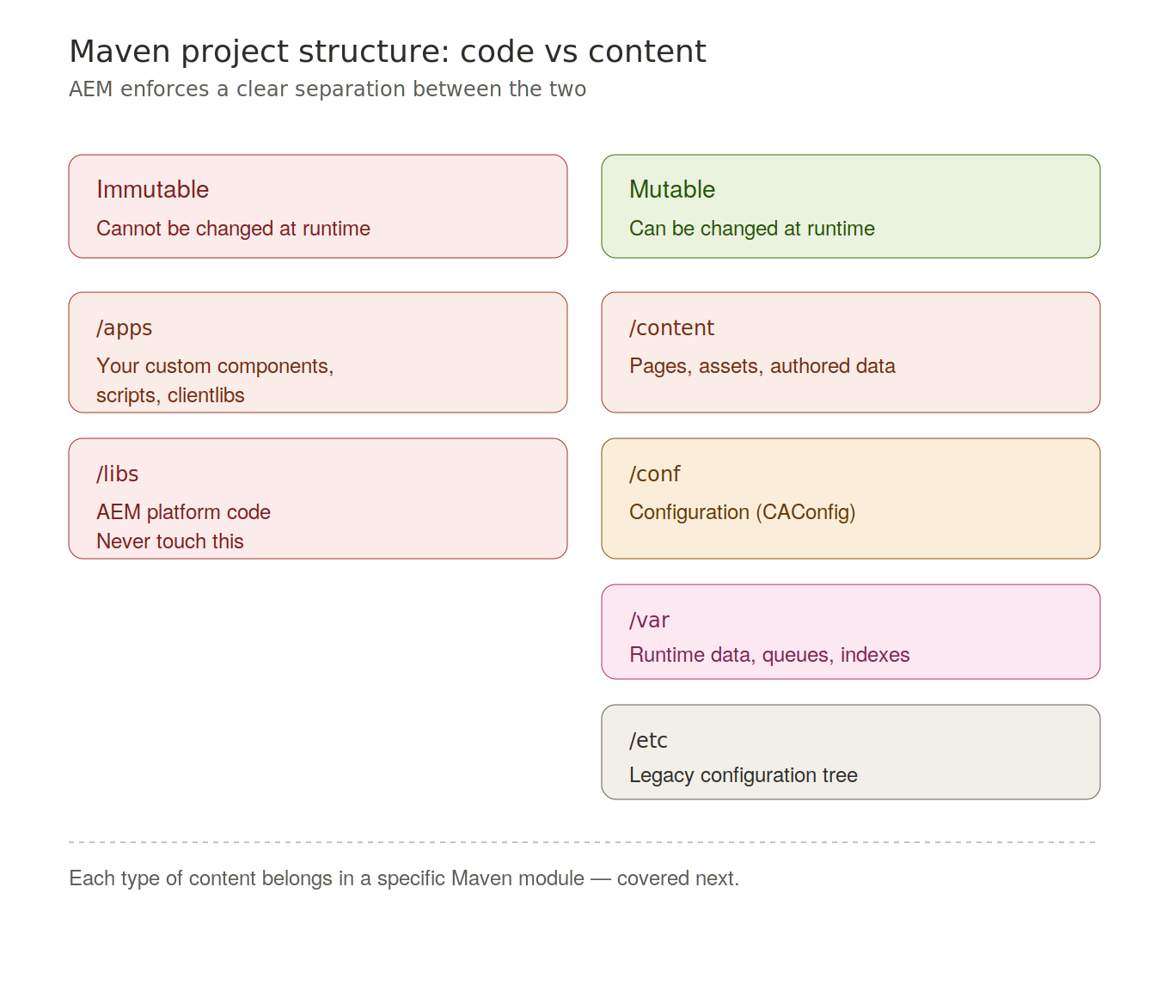
Figure 10. Immutable vs mutable repository areas.

11. Maven modules and package types
A standard AEM project has these key modules.

The modules
- core — Java OSGi bundle (services, models, servlets).
- ui.apps — code package, deploys to /apps.
- ui.content — content package, deploys to /content and /conf.
- ui.config — OSGi configurations and Repo Init scripts.
- all — the container package, the only artifact deployed by Cloud Manager.

Package types
- application — for code packages like ui.apps.
- content — for content packages like ui.content.
- container — for the all package.

The all package
The all package embeds all other modules and is the single deployment artifact.
All other packages must set cloudManagerTarget to none so Cloud Manager ignores them.
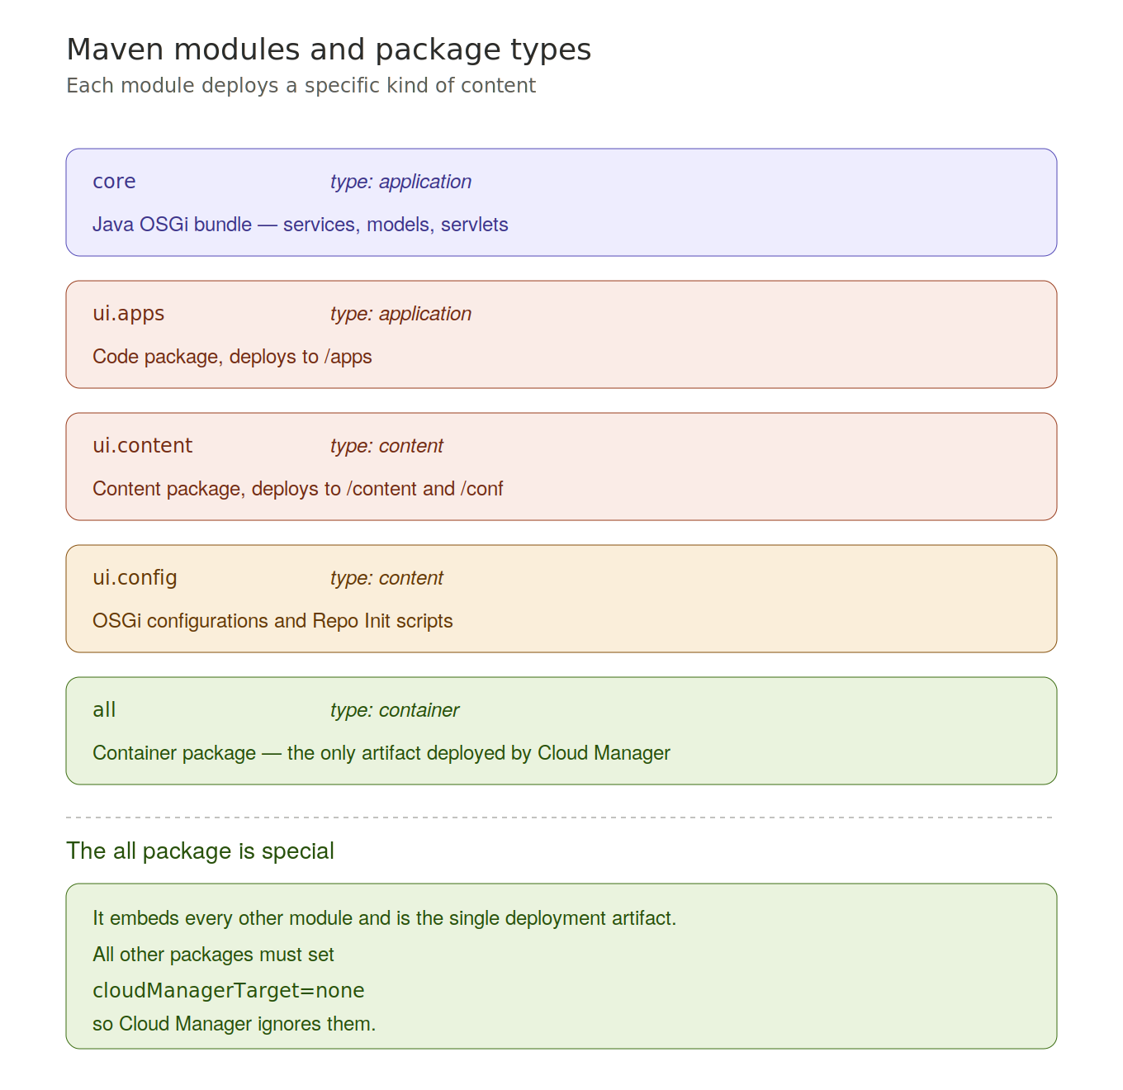
Figure 11. The Maven modules of a standard AEM project and their package types.

12. Repo Init and the AEM Archetype

Repo Init
Repo Init is a mechanism that defines JCR structures as part of the application.
You use it to create:
- Folder structures.
- Service users.
- Groups.
- ACL permissions.
These scripts run early in the deployment lifecycle, before any application code. They live in ui.config and are scoped by run mode.

AEM Project Archetype
To start a new project, you use the AEM Project Archetype. The current version is 56.
It generates the full project structure with best practices already in place:
- all, core, ui.apps, ui.content, ui.config.
- ui.frontend, tests, and dispatcher configuration.
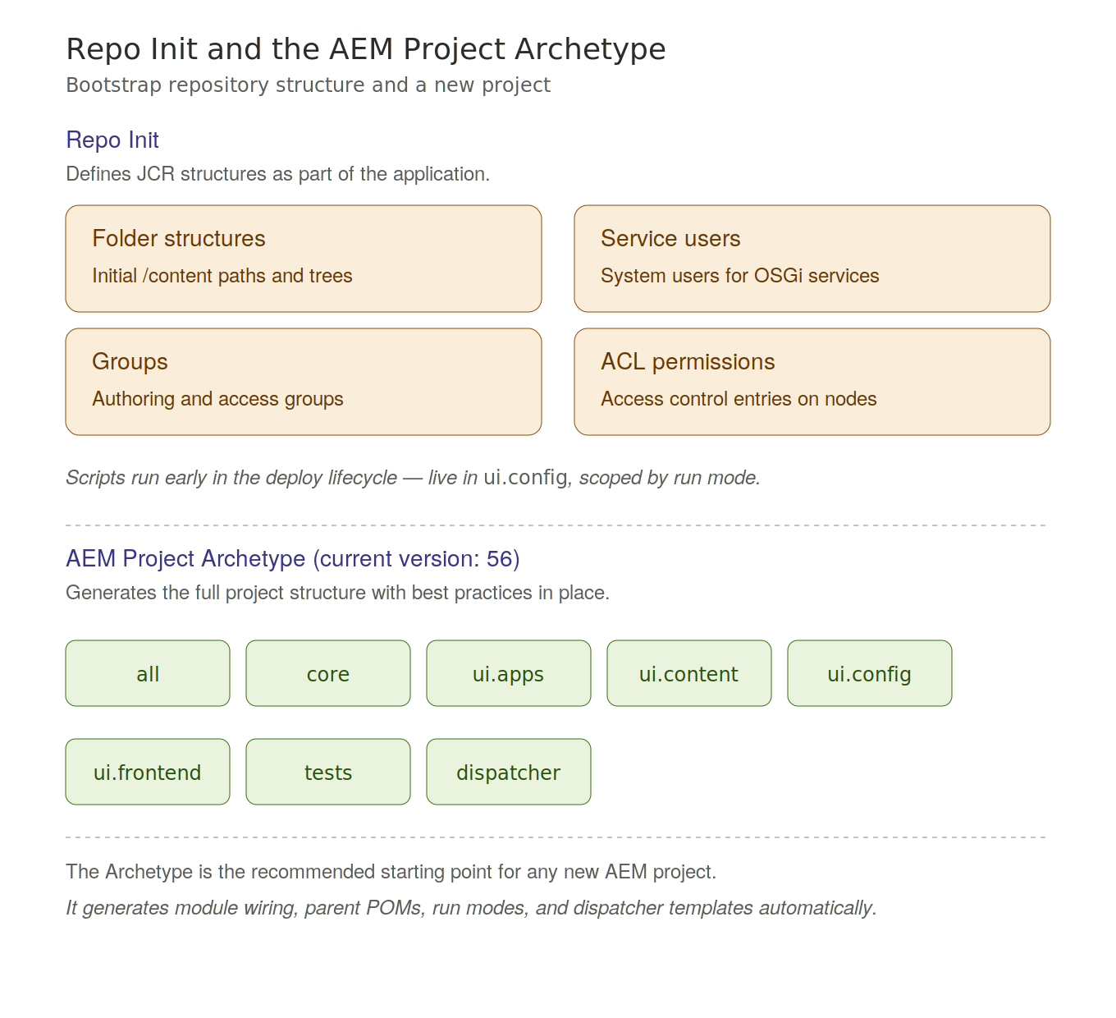
Figure 12. Repo Init capabilities and the modules generated by the AEM Archetype.

13. Troubleshooting
When something is not working, follow this sequence.

The five-step diagnostic flow
- 1. Check Package Manager — was the package actually installed? http://localhost:4502/crx/packmgr
- 2. Check CRXDE Lite — is the file there and is the content correct? http://localhost:4502/crx/de
- 3. Check the Bundle Console — is the OSGi bundle Active? http://localhost:4502/system/console/bundles
- 4. Read the error.log — AEM logs everything there. Location: crx-quickstart/logs/error.log
- 5. For front-end issues — use the clientlib debug tools at /libs/granite/ui/content/dumplibs.html

Most common errors
- Wrong Java version.
- Trying to double-click the QuickStart Jar.
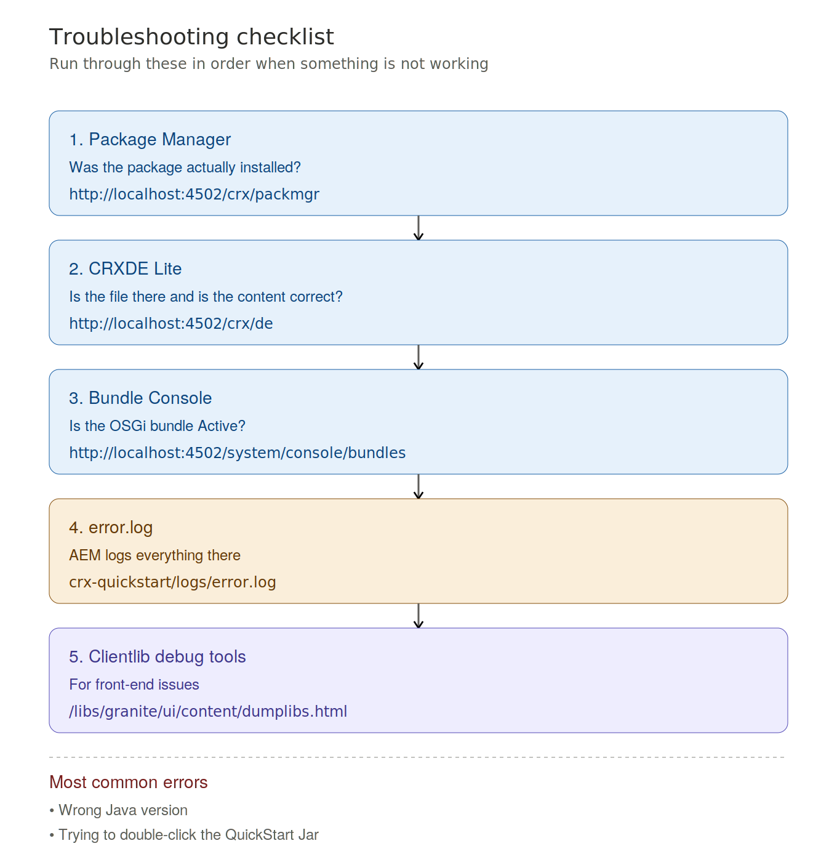
Figure 13. The five-step troubleshooting checklist with URLs and log paths.

14. Closing
Setting up a local AEM environment is not just a setup task — it is the foundation for everything that follows.

What you now have
- The tools to build AEM projects.
- A local runtime to test your code.
- An understanding of how Maven packages are structured.
- A troubleshooting process when things go wrong.

Key concepts to remember for the exam
- QuickStart Jar naming convention and startup rules.
- Mutable vs immutable repository areas.
- The role of each Maven module (core, ui.apps, ui.content, ui.config).
- The all package as the single Cloud Manager deployment artifact.
- OAuth Server-to-Server is the only supported aio CLI authentication method (JWT removed January 2025).
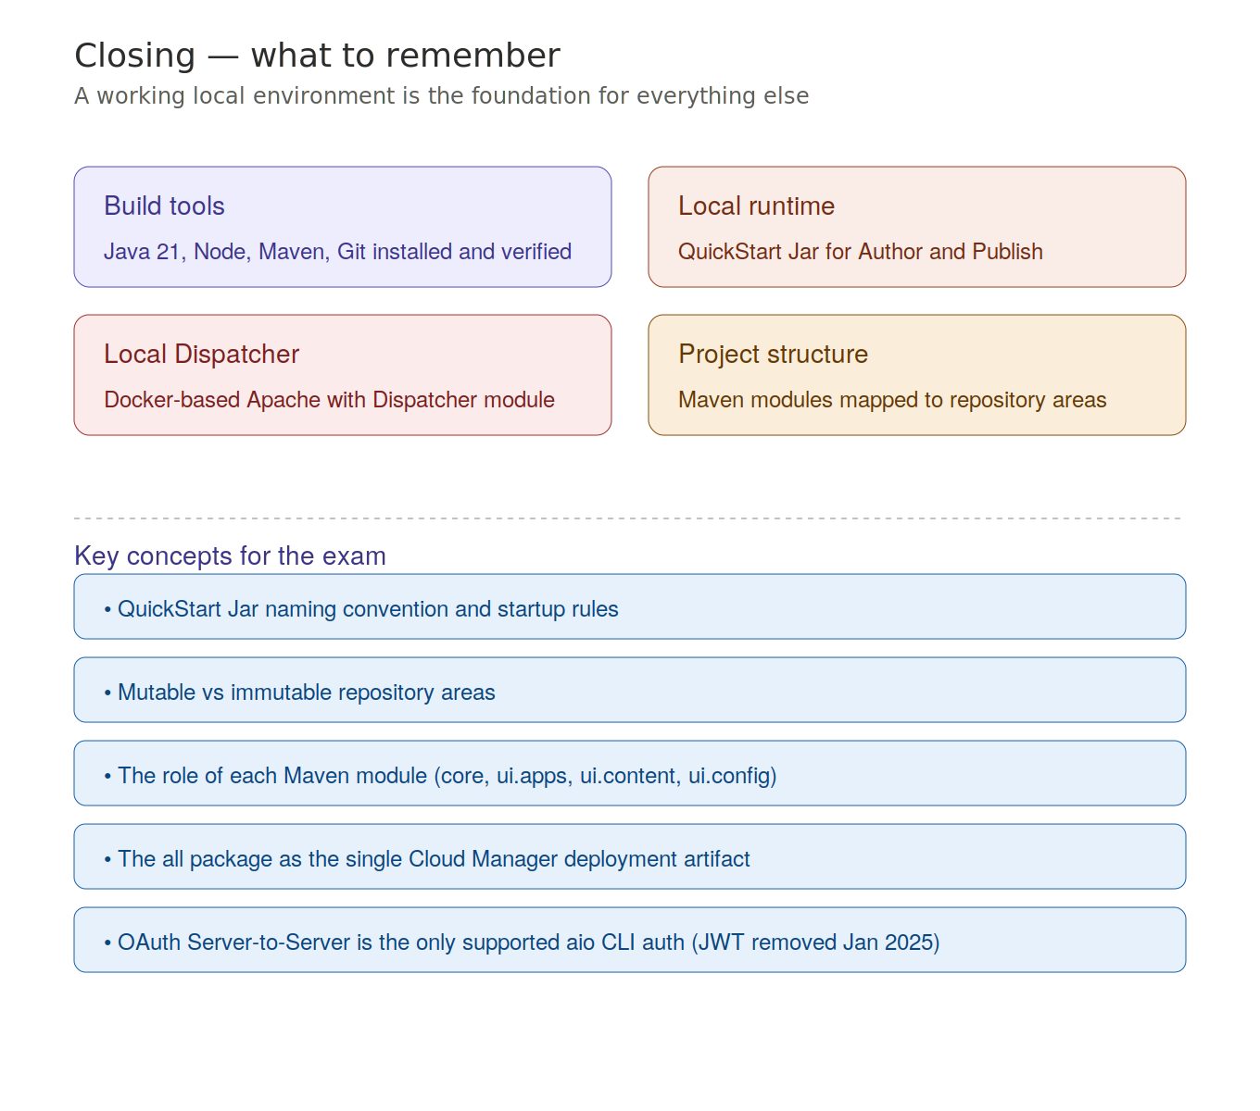
Figure 14. Recap of the four pillars and the key concepts for the exam.

