<https://www.codeproject.com/Articles/838097/CRUD-Operations-Using-the-Generic-Repository-Pat>

Clone => Branches => master => (right click) => New Local Branch From .. =>

Type user Name/branch name => Checkout branch ticked => Create Branch

Commit (commit change is for local check in)

Sync => Fetch (get changes from server/remote branch)

Push (changes go to the server/publish)

Pull is (fetch/get latest & merger to the local) : > git pull origin master

**Pull = Fetch + Merge**

If there is code conflict than pull fails and we need to **Fetch first and before merge compare**

After Fetch (for merging) go to Branches => merge => origin/master (from dropdown) => into current branch => Merge

Pull Request: Merging from a branch to the master is called Pull request (actually pushing to the master).

VS -> Team Explorer -> **Branches** -> double click master branch -> Merge -> select you_BranchName from Branch menu => Merge

To Delete:

Team Explorer -> **Branches** -> select development Branch -> right click -> Delete -> select development_ Branch under remotes/origin -> Delete Branch From Remote.

Click home => Pull request => Create New => master < branch1 => comments => Create pull request

Confirm the request: go to browser => Pull request tab => select the pull request => ask for review => confirm the request

For local master: In VS Team Explorer => Branches => master => Sync => Pull

In case of conflicts

Got path till directory

* Open .git
* Git branch –h
* Git status
* Git branch –m users/Naveed/NewBranch1

Git Ignore file is a list of files like bin, debug folder, result of builds, or nugget packages etc. which we don’t want to commit.

Get latest: Pull = Fetch + Merge. In case conflict fetch and then merge from origin master to the local branch.

Git is a distributed version control system because every user has a local copy of the code along with history/commits (local full working copy).

When you create a pull request the team that is the current context is added as a reviewer.  You can see the current team context in the top left corner of the web page.  If your context is ITSP, use the drop down to select **ITSP/Azure Team** or browse.

cid:image002.png@01D42329.D849BF10

From the browse screen select the expand icon to the left of the project name and choose the Azure Team, you can also add it to your favourites so it appears on your TFS Collection home page.

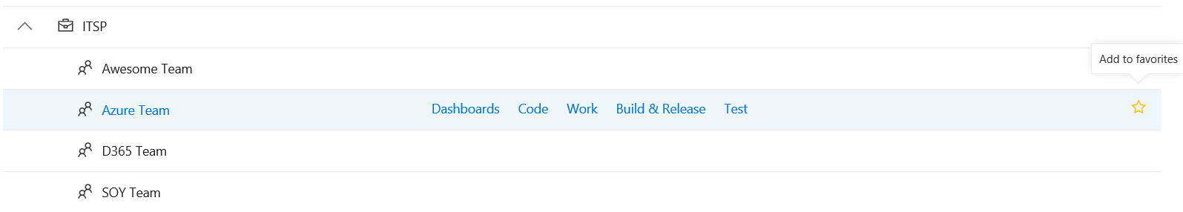

Now when creating a pull request the reviewer added is [ITSP]\Azure Team.  We have a reviewer set using the branch policy, so you can delete the default reviewer and let the branch policy manage it.

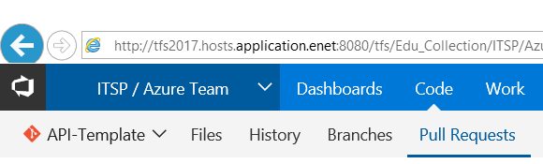

Default reviewer based on the current context

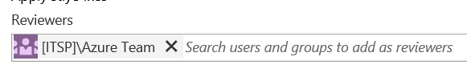

The team context is also used when looking at the backlogs (Work).