MorvelHRM Management

# The expanding HRM management platform



PROJECT REPORT

A Project by:

Asfand Shakeel, Ramis Mustafa and Umer Farooq

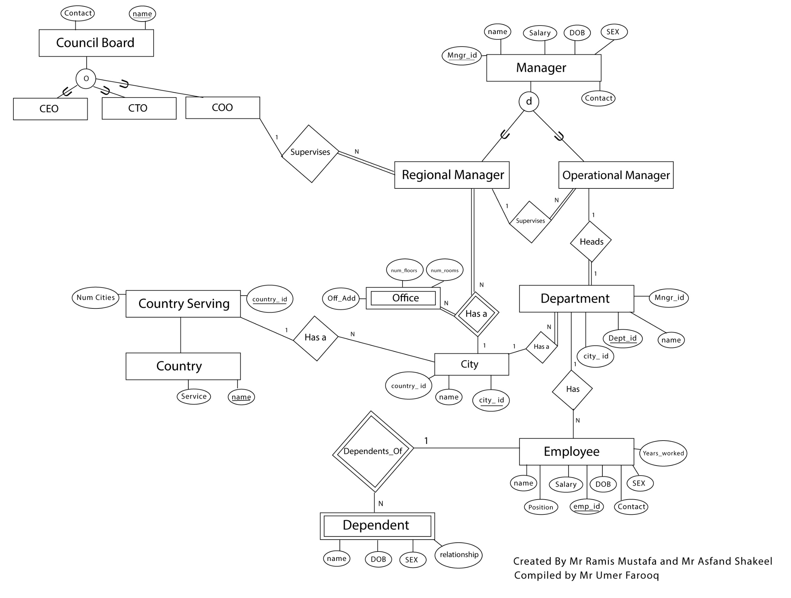

# HRM

# 

# Original Relational Schema

COO (OBKey, Name)

COUNTRY_SERVING (country_ID, name, num_cities)

CITY (city_ID, city_name, country_ID)

DEPARTMENT (department_ID, city_ID, department_name, manager_ID)

OFFICE (city_ID, manager_ID, address, num_rooms)

OPERATIONAL_MANAGER (manager_ID, manager_name, dob, sex, salary, contact_num)

REGIONAL_MANAGER (manager_ID, manager_name, dob, sex, salary, city_ID, contact_num, office_address, COOkey)

SUPERVISION (supervisor, supervisee)

EMPLOYEE (employee_ID, employee_name, sex, years_worked, position, salary, contact_num, department_ID)

DEPENDENT (employee_ID, dependant_name, relationship)

# Functional Dependencies in the original schema

## COO:

OBKey 🡪 Name

## COUNTRY_SERVING:

country_ID 🡪 name, num_cities

## CITY:

city_ID 🡪 city_name, country_ID

# DEPARTMENT:

department_ID 🡪 city_ID, department_name, manager_ID

## OFFICE:

city_ID, manager_ID 🡪 address, num_rooms

## OPERATIONAL_MANAGER:

manager_ID 🡪 manager_name, dob, sex, salary, contact_num

## OPERATIONAL_MANAGER:

manager_ID 🡪 manager_name, dob, sex, salary, city_ID, contact_num, office_address, COOKey)

## SUPERVISION:

supervisor 🡪 supervisee

## EMPLOYEE:

employee_ID 🡪 employee_name, sex, years_worked, position, salary, contact_num, department_ID

position 🡪 salary (partial dependency to be cleared)

## DEPENDENT:

employee_ID, dependent_name 🡪 relationship

# Applying normalization to schema produces one relation to resolve the dependency in the employee relation.

EMPLOYEE (employee_ID, employee_name, sex, years_worked, position,  
salary, contact_num, department_ID)

EMPLOYEE_PAY (position, salary)

# The schema has achieved 3NF and is sufficiently normalized.

# CODE:

## Schema.sql:

drop schema if exists MorvelHRM;

create schema MorvelHRM;

create table MorvelHRM.COUNTRY_SERVING(

country_ID integer(3),

name varchar(30),

num_cities integer(2),

primary key (country_ID)

);

create table MorvelHRM.CITY(

city_ID integer(3),

city_name char(15),

country_ID integer(3)

);

create table MorvelHRM.COO(

OBKey integer(3),

name varchar(25),

primary key(OBKey)

);

Create table MorvelHRM.DEPARTMENT(

department_ID integer(3),

city_ID integer(3),

department_name varchar(25),

manager_ID integer(3),

primary key (department_ID)

);

create table MorvelHRM.OPERATIONAL_MANAGER(

manager_ID integer(3),

manager_name varchar(25),

dob varchar(12),

sex char(1),

salary integer(7),

contact_num integer(7),

department_ID integer(3),

primary key(manager_ID)

);

create table MorvelHRM.OFFICE(

city_ID integer(3) unique,

manager_ID integer(3) unique,

address varchar(50) unique,

num_rooms integer(2)

);

create table MorvelHRM.REGIONAL_MANAGER(

manager_ID integer(3),

manager_name varchar(25),

dob varchar(12),

sex char(1),

salary integer(7),

contact_num integer(7),

city_ID integer(3),

office_address varchar(50),

COOKey integer(3),

primary key(manager_ID)

);

create table MorvelHRM.EMPLOYEE(

employee_ID integer(3),

employee_name varchar(25),

sex char(1),

years_worked integer(2),

position varchar(20),

contact_num integer(7),

department_ID integer(3)

);

create table MorvelHRM.EMPLOYEE_PAY(

position varchar(20),

salary integer(7),

primary key (position)

);

create table MorvelHRM.DEPENDENT(

employee_ID integer(3) unique,

dependent_name varchar(25) unique,

relationship varchar(15)

);

create table MorvelHRM.SUPERVISION(

supervisor_ID integer(3),

supervisee_ID integer(3)

);

alter table MorvelHRM.EMPLOYEE

add constraint epk primary key(employee_ID),

add constraint efk foreign key (department_ID) references DEPARTMENT(department_ID);

alter table MorvelHRM.DEPENDENT

add constraint dfk foreign key dfk (employee_ID) references EMPLOYEE(employee_ID) on update restrict,

add constraint dpk primary key (employee_ID, dependent_name);

alter table MorvelHRM.CITY

add constraint csfk foreign key (country_ID) references COUNTRY_SERVING(country_ID),

add constraint cspk primary key (city_ID);

alter table MorvelHRM.OFFICE

add constraint cityidfk foreign key(city_id) references City(city_id) on delete restrict on update cascade,

add constraint manageridfk foreign key(manager_ID) references REGIONAL_MANAGER(manager_ID) on update cascade,

add constraint officepk primary key(city_ID,manager_ID);

alter table MorvelHRM.DEPARTMENT

add constraint managerfk foreign key(manager_ID) references OPERATIONAL_MANAGER(manager_ID),

add constraint cityfk foreign key(city_ID) references CITY(city_ID);

alter table MorvelHRM.SUPERVISION

add constraint regfk foreign key(supervisor_ID) references regional_manager(manager_ID),

add constraint operfk foreign key(supervisee_ID) references operational_manager(manager_ID),

add constraint pkfk primary key(supervisor_ID, supervisee_ID);

alter table MorvelHRM.REGIONAL_MANAGER

add constraint cityid_fk foreign key(city_id) references City(city_id) on delete cascade on update cascade,

add constraint office_fk foreign key(office_address) references OFFICE(address) on update cascade,

add constraint COkey foreign key(COOKey) references COO(OBKey);

## Insert Data.sql:

set foreign_key_checks = 0;

load data INFILE 'C:/Users/omen/Desktop/DBS Project ER/CSV/Regional_Manager.csv'

into table MorvelHRM.REGIONAL_MANAGER

fields terminated by ','

optionally enclosed by '"'

lines terminated by '\n';

load data INFILE 'C:/Users/omen/Desktop/DBS Project ER/CSV/Operational_Manager.csv'

into table MorvelHRM.OPERATIONAL_MANAGER

fields terminated by ','

optionally enclosed by '"'

lines terminated by '\n';

load data INFILE 'C:/Users/omen/Desktop/DBS Project ER/CSV/Supervision.csv'

into table MorvelHRM.SUPERVISION

fields terminated by ','

optionally enclosed by '"'

lines terminated by '\n';

load data INFILE 'C:/Users/omen/Desktop/DBS Project ER/CSV/Employee.csv'

into table MorvelHRM.EMPLOYEE

fields terminated by ','

optionally enclosed by '"'

lines terminated by '\n';

load data INFILE 'C:/Users/omen/Desktop/DBS Project ER/CSV/City.csv'

into table MorvelHRM.CITY

fields terminated by ','

optionally enclosed by '"'

lines terminated by '\n';

load data INFILE 'C:/Users/omen/Desktop/DBS Project ER/CSV/Country_Serving.csv'

into table MorvelHRM.COUNTRY_SERVING

fields terminated by ','

optionally enclosed by '"'

lines terminated by '\n';

load data INFILE 'C:/Users/omen/Desktop/DBS Project ER/CSV/Department.csv'

into table MorvelHRM.DEPARTMENT

fields terminated by ','

optionally enclosed by '"'

lines terminated by '\n';

load data INFILE 'C:/Users/omen/Desktop/DBS Project ER/CSV/Dependent.csv'

into table MorvelHRM.DEPENDENT

fields terminated by ','

optionally enclosed by '"'

lines terminated by '\n';

load data INFILE 'C:/Users/omen/Desktop/DBS Project ER/CSV/Employee_Pay.csv'

into table MorvelHRM.EMPLOYEE_PAY

fields terminated by ','

optionally enclosed by '"'

lines terminated by '\n';

load data INFILE 'C:/Users/omen/Desktop/DBS Project ER/CSV/COO.csv'

into table MorvelHRM.COO

fields terminated by ','

optionally enclosed by '"'

lines terminated by '\n';

load data INFILE 'C:/Users/omen/Desktop/DBS Project ER/CSV/Office.csv'

into table MorvelHRM.OFFICE

fields terminated by ','

optionally enclosed by '"'

lines terminated by '\n';

load data INFILE 'C:/Users/omen/Desktop/DBS Project ER/CSV/Country.csv'

into table MorvelHRM.COUNTRY

fields terminated by ','

optionally enclosed by '"'

lines terminated by '\n';

set foreign_key_checks = 1;

# Example Queries:

#Displays all operational managers assigned to departments

select manager_name as Manager, department_name as DName

from MorvelHRM.OPERATIONAL_MANAGER INNER JOIN MorvelHRM.DEPARTMENT

using (department_ID);

#Display operational managers indirectly operating under COOs

select COO.name as COO, operational_manager.manager_name as OpMgr

from (((MorvelHRM.regional_manager inner join MorvelHRM.supervision

on regional_manager.manager_ID = Supervision.supervisor_ID)

inner join MorvelHRM.operational_manager

on operational_manager.manager_ID = supervision.supervisee_ID)

inner join MorvelHRM.COO

on COO.OBKey = Regional_Manager.COOKey)

#Regional managers from the same country

select manager_name as Regional_Mgr, country_serving.name as Country

from (((MorvelHRM.Regional_manager inner join MorvelHRM.city

using (city_ID)) inner join MorvelHRM.country_serving using (country_ID)));