# INFO 2604 Info Systems Security Question 1 ReadMe File

## Requirements

* Python 3.7.5
* packages used:
  + pycryptodome 3.9.7 (Check requirements.txt file)

## Assumptions made:

* Programs A1,A2,A3 are located in the same folder
* Programs B1,B2,B3 are located in the same folder
* All programs are executed on the localHost.

## Order of execution

Press <y> when prompted by B1, to use the local OTP file. (This is due to the specification mentioned in Question 1)

Otherwise, Keep B1 running, and on another console(s), run B2 then A2, and come back to B1 and press Enter. The program can follow the rest of the order after.

B1 -> A1 -> B2 -> A2 -> A3 -> B3

Or

B1 -> A1 -> pause at B1

B2 -> A2 ->

continue B1-> A3 -> B3

## Screenshots:

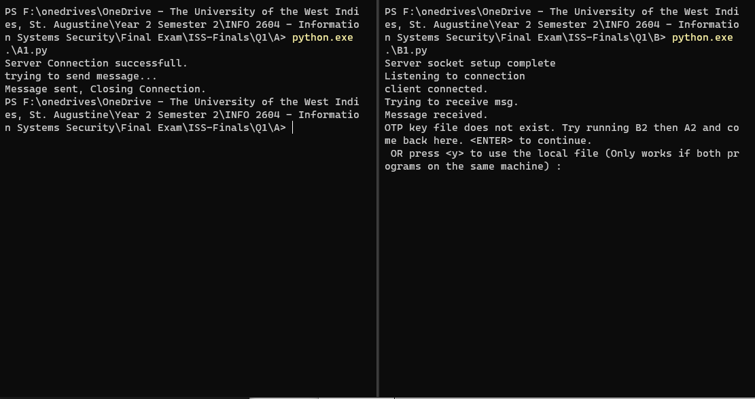

A1(left) and B1(right)

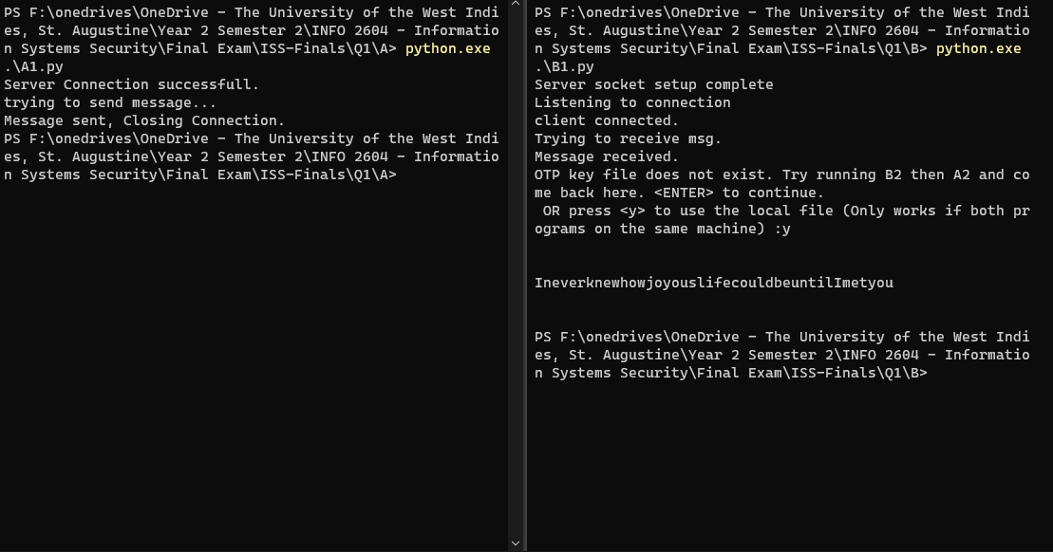

A1(Left) and B1(right) upon completion

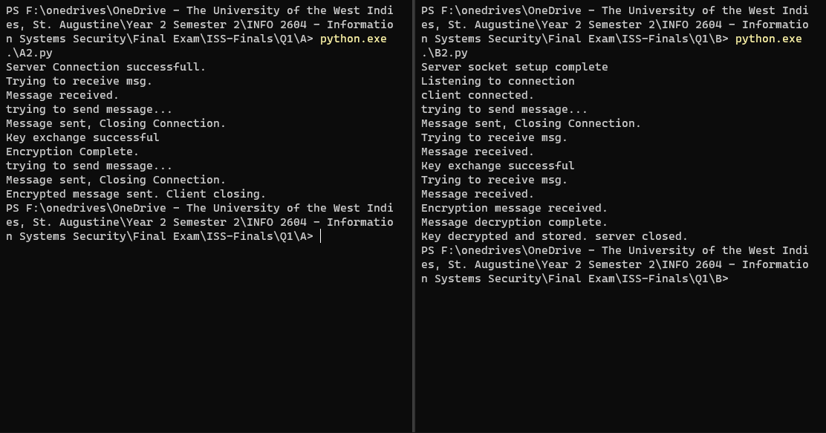

A2(left) and B2(right)

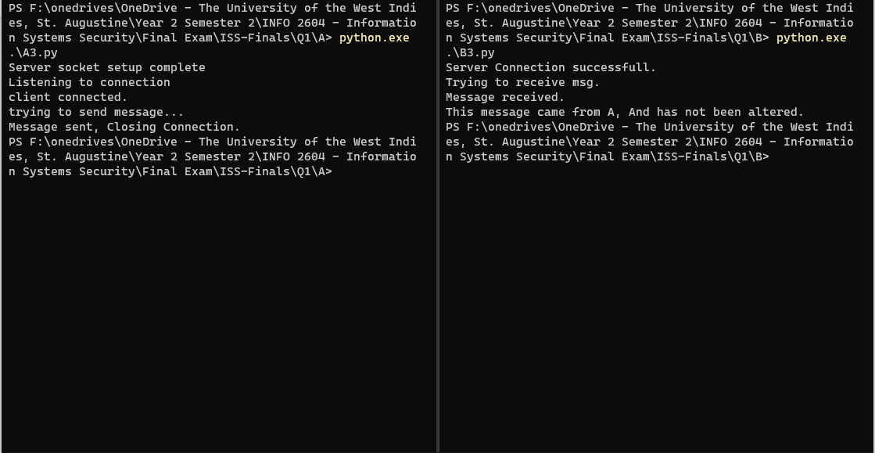

A3(left) and B3(right)