The background check confirmation system.

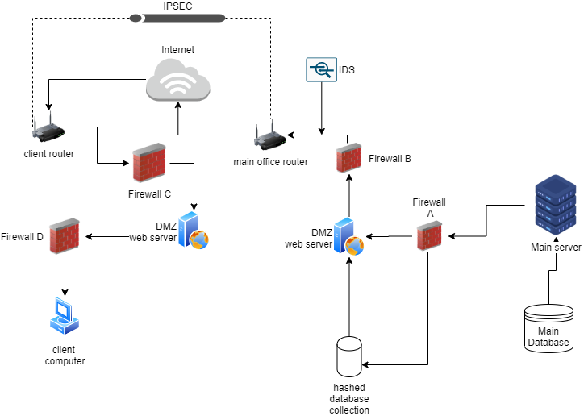

The system design explanation below is based on the diagram above, starting from the server end (right side):

The main database that contain raw information (DOB/Name in plain text) of the sex offenders can only be accessed through the main server. The main server can restrict SQL commands sent to the database by only allowing INSERT and SELECT. This, along with regular backups/ disk level encryption and physical safety measures (fireproof casing, flood proofing), will provide Data integrity and limit access to the database (Appending data only).

Every time the main server appends the main database, it can hash, by using SHA256, a concatenated String of offender’s DOB and name +salt; and store that hash, along with an auto generated id and the random salt, on the hashed database collection outside the internal network.

A firewall (firewall A) rule can be implemented to only allow communication between the main server and the hashed database collection that will update the Hashed data. The DMZ webserver will intersect all communication to and from the internal network, as well as manage interactions with the hashed database collection (queries only). This will hide the internal network from the internet while providing an extra layer of security to the local network.

To avoid insider attacks, the main server and main database can exist on the same physical location, which can have limited access only to authorized users. Since the data sent from the main server to the hashed database collection is just hashed data (apart from the id and salt), That data will not be useful if an attack occurs.

The DMZ server will be responsible for communicating with the clients. It will authenticate the user, using IPSEC, and generate A symmetric key by using the Diffie Hellman key exchange (provided by IPsec protocol). After this interaction, the client can then send a number, indicating the amount of records contained in the client database. This can be used to determine if it is necessary to update the client side.

If there are new records to send, the web server can then generate a HMAC to each hashed entry by using the symmetric key sent to that specific client + hashed BOD/name + salt. Then the hash values, along with their respective HMAC and salt, can be sent to the client. The HMAC will ensure the authenticity and integrity of the data, while the separate symmetric keys per each client/server connection will add an extra layer of complexity for data integrity. The salt added will greatly reduce the chances of a successful dictionary attack. Dictionary attacks can also be reduced by monitoring the network with an IDS. This can send alerts any administrators if a high number of requests comes into the network.

The network traffic can also be scheduled, since the client’s commutations are to update their databases, the requests can be timed, maybe early in the morning, for each client. That can aid in monitoring unusual network activity. Firewall B will restrict traffic to the web server via a specific port (The only port visible to the external network).

A VPN, more specifically IPSEC tunneling with ESP, can be used to communicate with clients. This will provide a layer of security that provides confidentiality, data integrity and anti-replay features. Tunneling can provide an extra layer of protection to packets, and if there was an attempt at breaking data, the tunnel can be destroyed and built on a different path. The choice of IPSEC over SSL is due to the authentication options IPSEC provides which must be achieved using third party systems for SSL. Along with user authentication. IPSEC protocol also provides a Diffie Hellman key group to be used in the encryption process.

Even if an eavesdropping was successful, data within is hash codes with HMAC appended, and contain no recognizable information.

The client side will provide the same layer of protection from the DMZ server, where the internal network is hidden, and all requests are passed through the DMZ webserver. Firewall D can have a rule where any specific connections regarding the host responsible for analyzing our data, must pass through a certain IP, that is used by one client in the network responsible for analyzing data.

Firewall C will have similar implementations as firewall B.

A database on the client’s computer can be used to store the hash codes after checking the integrity of the data and if it was sent by the right authority (checked using the HMAC). This can improve performance even if there was not a network connection available. When a user types in information of a person, the software can generate a SHA256 hash based on the DOB/name +salt and compare; if the codes matches, a positive identification can be shown indicating that the person is a sex offender.