9a) Write a program to traverse a graph using BFS method.

#include <stdio.h>
#define MAX 20

int queue[MAX], front = -1, rear = -1;
int visited[MAX];

void enqueue(int v) {
if (rear == MAX - 1) {
printf("Queue Overflow\n");
return;
}
if (front == -1)
front = 0;
queue[++rear] = v;
}

int dequeue() {
if (front == -1 || front > rear)
return -1;
return queue[front++];
}

void BFS(int adj[MAX][MAX], int n, int start) {
int i, j;

for (i = 0; i < n; i++)
visited[i] = 0;

enqueue(start);
visited[start] = 1;

printf("BFS Traversal: ");

while (front != -1 && front <= rear) {
int node = dequeue();
printf("%d ", node);

for (j = 0; j < n; j++) {
if (adj[node][j] == 1 && !visited[j]) {
enqueue(j);
visited[j] = 1;
}
}
}
}

int main() {
int n, start;
int adj[MAX][MAX];

printf("Enter number of vertices: ");
scanf("%d", &n);

printf("Enter adjacency matrix:\n");
for (int i = 0; i < n; i++) {
for (int j = 0; j < n; j++) {
scanf("%d", &adj[i][j]);
}
}

printf("Enter starting vertex: ");
scanf("%d", &start);

BFS(adj, n, start);
return 0;
}

Output:
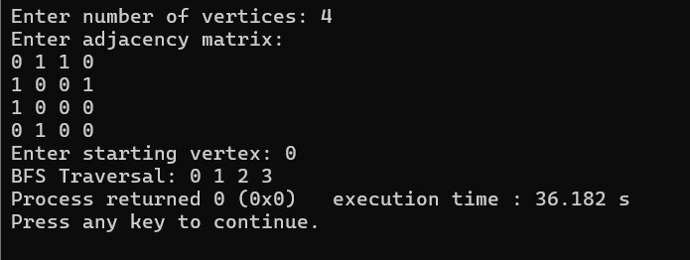

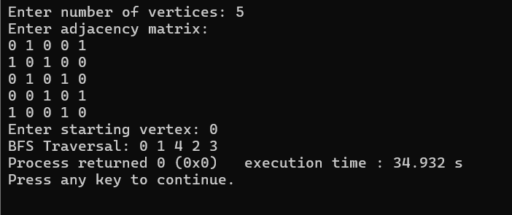

9(b) Write a program to check whether a given graph is connected or not using the DFS method.

#include <stdio.h>
#define MAX 20

int visited[MAX];

void DFS(int adj[MAX][MAX], int n, int start) {
visited[start] = 1;
for (int j = 0; j < n; j++) {
if (adj[start][j] == 1 && !visited[j]) {
DFS(adj, n, j);
}
}
}

int main() {
int n;
int adj[MAX][MAX];

printf("Enter number of vertices: ");
scanf("%d", &n);

printf("Enter adjacency matrix:\n");
for (int i = 0; i < n; i++) {
for (int j = 0; j < n; j++) {
scanf("%d", &adj[i][j]);
}
}

for (int i = 0; i < n; i++)
visited[i] = 0;

DFS(adj, n, 0);

int connected = 1;
for (int i = 0; i < n; i++) {
if (!visited[i]) {
connected = 0;
break;
}
}

if (connected)
printf("The graph is connected.\n");
else
printf("The graph is NOT connected.\n");

return 0;
}

Output:
