6a) WAP to Implement Single Link List with following operations: Sort the linked list, Reverse the linked list, Concatenation of two linked lists.

#include<stdio.h>
#include<stdlib.h>
struct node
{
int val;
struct node *next;
};
struct node *createsll()
{
struct node *start = NULL , *p ,*last ;
int item;
printf("\nEnter element -999 to exit:");
scanf("%d",&item);
while(item!=-999)
{
p=(struct node *)malloc(sizeof(struct node));
p->val=item;
if(start==NULL)
{
p->next=NULL;
start=p;
last=p;
}
else{
last->next=p;
p->next=NULL;
last=p;
}
scanf("%d",&item);
}
return start;
};

struct node *reversesll(struct node * start)
{
struct node *prev = NULL;
struct node *curr=start;
struct node *next=NULL;
while(curr!=NULL)
{
next=curr->next;
curr->next=prev;
prev=curr;
curr=next;
}
return prev;
};

struct node *sortsll(struct node *start)
{
struct node *min , *i , *j ;
int temp;
for(i=start ; i!=NULL ; i=i->next)
{
min=i;
for(j=i->next ; j!=NULL ; j=j->next)
{
if(j->val < min->val)
min=j;
}
temp=min->val;
min->val=i->val;
i->val=temp;
}
return start;
};

struct node *concatsll(struct node *start1 , struct node *start2)
{
struct node *temp = start1;
while(temp->next!=NULL)
temp=temp->next;
temp->next=start2;
return start1;

};

void display(struct node *start)
{
struct node *temp=start;
while(temp!=NULL)
{
printf("%d->",temp->val);
temp=temp->next;
}

}
int main()
{
struct node *start1=NULL , *start2=NULL;
printf("\nCreate first linked list :");
start1=createsll();
printf("\nCreate second linked list :");
start2=createsll();
printf("\nAfter sorting First sll :");
start1=sortsll(start1);
display(start1);
printf("\nAfter reversing first sll:");
start1=reversesll(start1);
display(start1);
printf("\nAfter concatenating both linked lists:");
start1=concatsll(start1,start2);
display(start1);

}

Output

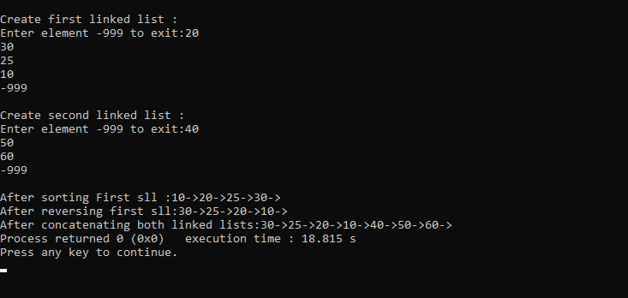

6b) WAP to Implement Single Link List to simulate Stack & Queue Operations

#include<stdio.h>
#include<stdlib.h>
struct node
{
int val;
struct node *next;
};
struct node *createsll()
{
struct node *start = NULL , *p ,*last ;
int item;
printf("\nEnter element -999 to exit:");
scanf("%d",&item);
while(item!=-999)
{
p=(struct node *)malloc(sizeof(struct node));
p->val=item;
if(start==NULL)
{
p->next=NULL;
start=p;
last=p;
}
else{
last->next=p;
p->next=NULL;
last=p;
}
scanf("%d",&item);
}
return start;
};
struct node *stackpush(struct node *start)
{
struct node *p;
int item;
printf("\nEnter item to push:");
scanf("%d",&item);
p=(struct node *)malloc(sizeof(struct node));
p->val=item;
if(start==NULL)
{
p->next=NULL;
start=p;
}
else
{
p->next=start;
start=p;
}
return start;

};

struct node *pop(struct node *start)
{
struct node *p;
if(start ==NULL)
{
printf("Stack/Queue is empty");
}
else{
p=start;
start=start->next;
printf("Deleted ele is %d",p->val);
free(p);
}
return start;
};

struct node *queueinsert(struct node *start)

{
struct node *p , *temp;
int ele;
printf("\nEnter element to insert into queue:");
scanf("%d",&ele);
p=(struct node *)malloc(sizeof(struct node ));
p->val=ele;
if(start==NULL)
{
p->next=NULL;
start=p;

}
else{
temp=start;
while(temp->next!=NULL)
temp=temp->next;
temp->next=p;
p->next=NULL;
}
return start;
};

void display(struct node *start)
{
struct node *temp=start;
while(temp!=NULL)
{
printf("%d\t",temp->val);
temp=temp->next;
}

}

int main() {
struct node *stack = NULL;
struct node *queue = NULL;
int choice;

while (1) {
printf("\n--- MENU ---\n");
printf("1. Push into Stack\n");
printf("2. Pop from Stack\n");
printf("3. Display Stack\n");
printf("4. Insert into Queue\n");
printf("5. Delete from Queue\n");
printf("6. Display Queue\n");
printf("7. Exit\n");
printf("Enter your choice: ");
scanf("%d", &choice);

switch (choice) {
case 1:
stack = stackpush(stack);
break;
case 2:
stack = pop(stack);
break;
case 3:
display(stack);
break;
case 4:
queue = queueinsert(queue);
break;
case 5:
queue = pop(queue);
break;
case 6:
display(queue);
break;
case 7:
printf("\nExiting program...\n");
exit(0);
default:
printf("\nInvalid choice! Try again.\n");
}
}
return 0;
}

OUTPUT:
