

Ramith H

1WN24CS222

PROGRAM 1 - STACK OPERATIONS

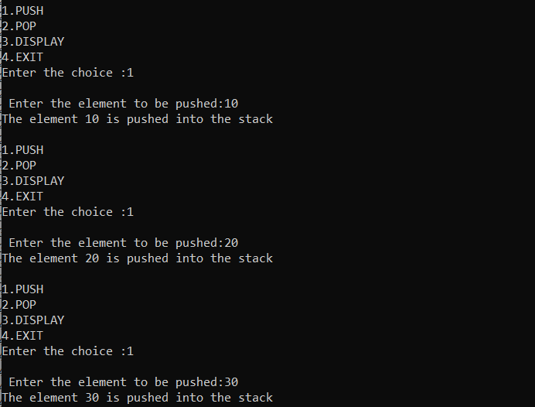

OUTPUT:

