Customer Segmentation & Churn Pattern Analytics in European Banking
Research Paper: Exploratory Data Analysis, Insights and Recommendations
Date: October 2026 | Project
Author: Ramit Singh

Abstract
Customer churn is one of the largest hidden costs in retail banking. This paper analyses a dataset of 10,000 customers of a European retail bank in France, Spain and Germany to find out who leaves, where, and how much balance the bank loses. Customers were divided into segments by country, age, credit score, tenure and balance, and churn rates were compared across them.
The overall churn rate is 20.37% (2,037 customers). Churn is highly concentrated: Germany (32.4%) churns twice as fast as France (16.2%) and Spain (16.7%); customers aged 46-60 churn at 51.1%; women churn more than men (25.1% vs 16.5%); inactive members churn at 26.9% vs 14.3% for active members; and customers with 3 or 4 products almost all leave. Credit score, tenure and salary have little influence. Churned customers hold EUR 185.6 million, or 24.3% of all balances held in the dataset. Recommendations focus on Germany, the 46-60 age group, inactive members and multi-product customers.

1. Introduction and Problem Statement
Losing an existing customer reduces lifetime value, raises acquisition costs and makes revenue unstable. Banks usually track a single churn rate, but a single number does not show which customers are leaving or why. Without that detail, retention actions stay generic, reactive and inefficient.
This project answers three questions:
- Which customer groups are most likely to churn?
- How does churn differ across countries, age groups and financial profiles?
- Is churn concentrated among high-value or low-value customers, and how much money is at risk?

Objectives
- Measure the overall churn rate.
- Identify the churn distribution across customer segments.
- Compare churn across European regions.
- Understand churn among high-value customers, and evaluate engagement and tenure patterns.

2. Dataset Description
The dataset contains 10,000 customer records and 14 columns. Each row is one customer. The target variable is Exited (1 = customer left the bank, 0 = customer stayed).
Column | Description
CreditScore | Customer creditworthiness (350-850)
Geography | France, Spain or Germany
Gender | Male / Female
Age | Customer age (18-92)
Tenure | Years with the bank (0-10)
Balance | Account balance in EUR
NumOfProducts | Number of bank products held (1-4)
HasCrCard / IsActiveMember | Credit card ownership / activity indicator (0 or 1)
EstimatedSalary | Estimated annual salary in EUR
Exited | Churn indicator (target)
Year, CustomerId, Surname | Year is 2025 for all rows; CustomerId and Surname are identifiers. All three were removed.

3. Methodology

3.1 Data validation
Before any analysis the data was checked for quality. The results were:
- No missing values and no duplicate rows in any column.
- CustomerId is unique, so every customer appears once.
- HasCrCard, IsActiveMember and Exited contain only 0 and 1.
- Geography contains only France, Spain and Germany; Gender only Male and Female.
- NumOfProducts ranges from 1 to 4 (5,084 / 4,590 / 266 / 60 customers).
- Exited: 7,963 customers stayed and 2,037 left, which gives the churn label we use throughout.

3.2 Cleaning and segmentation
Surname, CustomerId and Year were removed because they carry no analytical meaning. Five segmentation dimensions were then created, using the cut-offs below.
Dimension | Groups (cut-offs) | Justification
Geography | France, Spain, Germany | Given in the data
Age Group | <30, 30-45, 46-60, 60+ | As specified in the project brief
Credit Band | Low (<=579), Medium (580-669), High (>=670) | Common credit score ranges used in lending
Tenure Group | New (0-2), Mid-term (3-6), Long-term (7-10 years) | Roughly equal thirds of the 0-10 year range
Balance Segment | Zero-balance; Low (below EUR 119,840); High (EUR 119,840 and above) | Zero is its own group; the others are split at the median of non-zero balances

3.3 Metrics used
Because Exited is 0/1, the average of Exited for a group equals that group's churn rate. For each segment we report (a) the churn rate, (b) the churn contribution, meaning its share of all churners, and (c) a risk index, meaning segment churn divided by overall churn (above 1.0 is worse than average). All work was done in Python (pandas, numpy, plotly, matplotlib, seaborn) and the dashboard in Streamlit.

4. Exploratory Data Analysis and Findings

4.1 Overall churn
Of 10,000 customers, 2,037 left, an overall churn rate of 20.37%. About one in five customers is lost. This is the benchmark against which all segments are compared.

4.2 Geography
Country | Customers | Churned | Churn rate | Risk index
France | 5,014 | 810 | 16.15% | 0.79
Germany | 2,509 | 814 | 32.44% | 1.59
Spain | 2,477 | 413 | 16.67% | 0.82
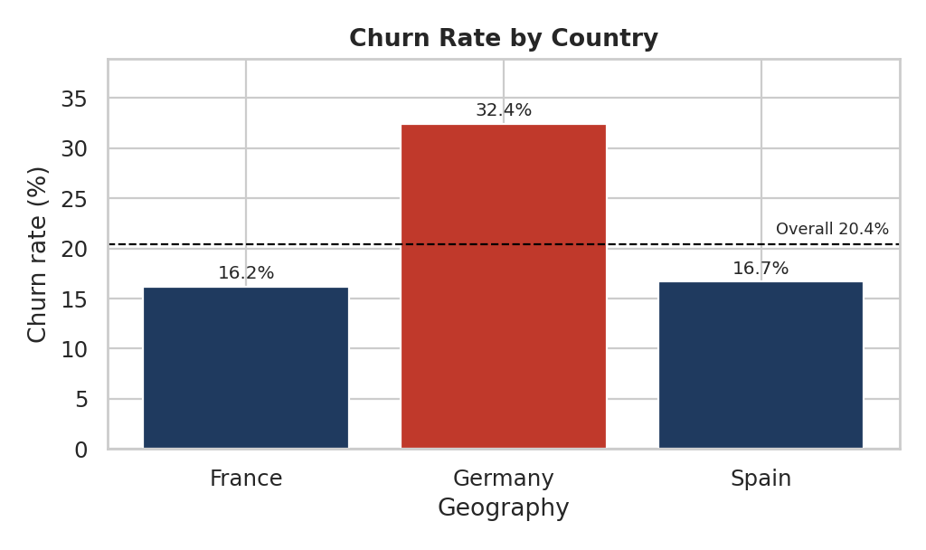
Figure 1: Churn rate by country
Germany has only 25% of the customers but 40% of all churners, and its churn rate is almost double that of France and Spain. Germany is the single biggest regional risk. France and Spain have similar, below-average churn. A further observation: no German customer has a zero balance, while about 48% of French and Spanish customers do, so Germany's customer base is made up entirely of balance-holding customers.

4.3 Age
Age group | Customers | Churned | Churn rate | Share of churners
<30 | 1,641 | 124 | 7.56% | 6.1%
30-45 | 6,248 | 956 | 15.30% | 46.9%
46-60 | 1,647 | 842 | 51.12% | 41.3%
60+ | 464 | 115 | 24.78% | 5.7%
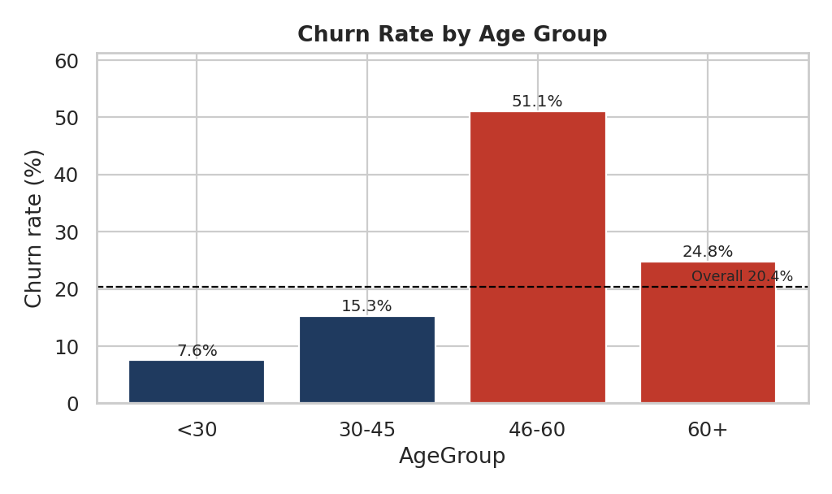
Figure 2: Churn rate by age group
Age is the strongest single driver of churn. More than half of customers aged 46-60 leave, and this group is only 16.5% of customers yet 41.3% of churners. The average churned customer is 44.8 years old, against 37.4 for retained customers. Young customers (<30) are the most loyal.

4.4 Gender
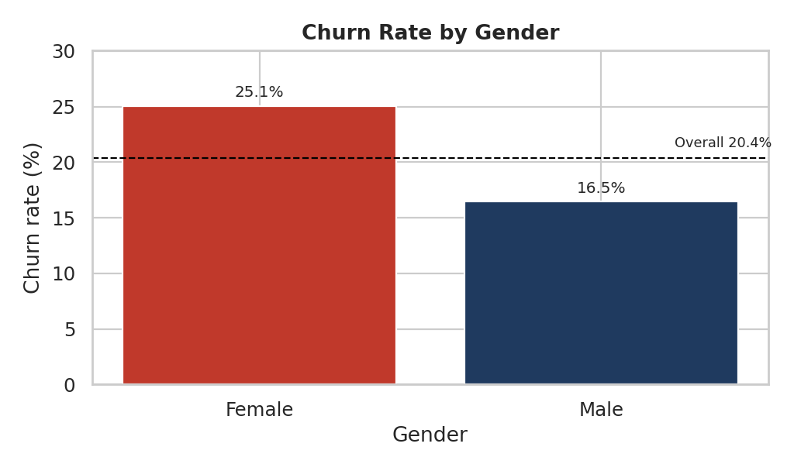
Figure 3: Churn rate by gender
Women churn at 25.07% against 16.46% for men (risk indexes 1.23 and 0.81). Women make up 45% of customers but 56% of churners. The gap appears in every country: France 20.3% vs 12.7%, Germany 37.6% vs 27.8%, Spain 21.2% vs 13.1%.

4.5 Geography and age together
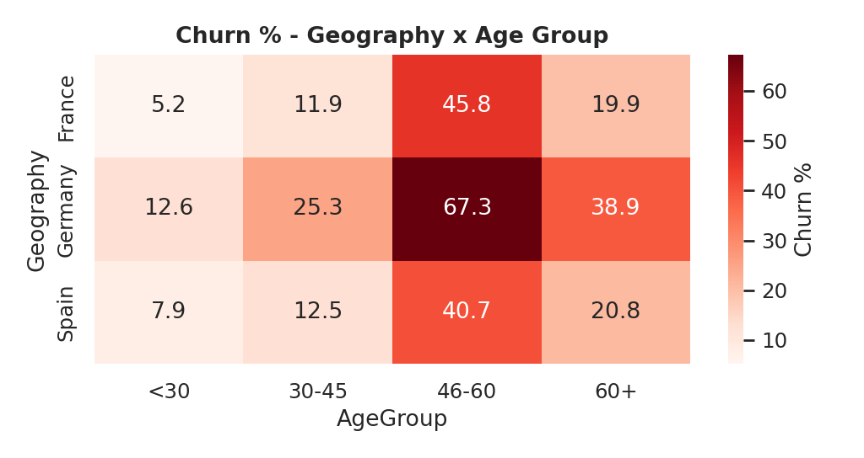
Figure 4: Churn % by geography and age group
Combining the two factors shows where the risk is extreme: 67.3% of German customers aged 46-60 leave. Even the 60+ group in Germany churns at 38.9%. In France and Spain the 46-60 group churns at 45.8% and 40.7%. Age risk is present everywhere but is amplified in Germany.

4.6 Financial profile: credit score, tenure, balance and salary
Segment | Low / New / Zero | Medium / Mid | High / Long | Spread
Credit band | 22.0% | 20.6% | 19.3% | 2.7 pts
Tenure group | 21.2% | 20.6% | 19.5% | 1.6 pts
Salary quartile (Q1 to Q4) | 20.0% | 19.8% / 20.1% | 21.6% | 1.8 pts

Credit score, tenure and salary show only small differences in churn (a few percentage points). Low-credit and new customers are slightly more likely to leave, but these are weak signals compared with age, country and engagement. In other words, a customer's financial stability and loyalty period do not explain who leaves.
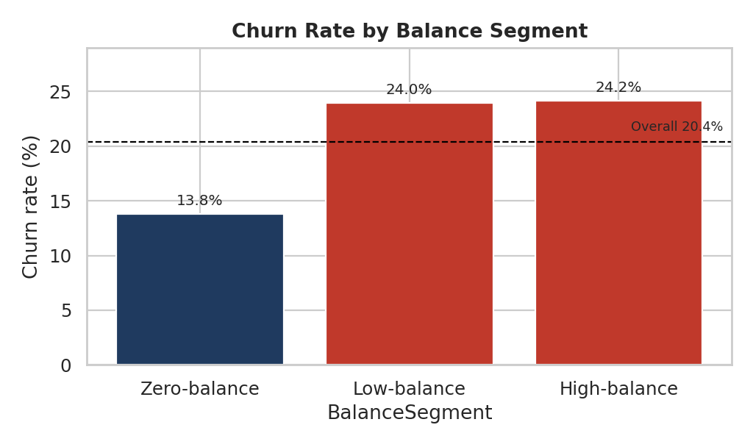
Figure 5: Churn rate by balance segment
Balance is different. Zero-balance customers churn at 13.8%, while customers who hold a balance churn at about 24% (low-balance 24.0%, high-balance 24.2%). The bank is losing customers who actually keep money with it.

4.7 Engagement and number of products
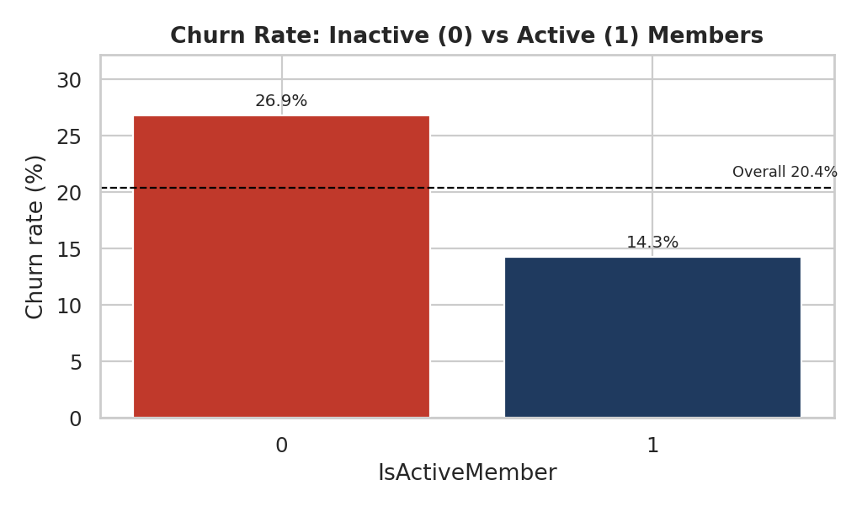
Figure 6: Churn rate, inactive vs active members
Inactive members churn at 26.85% and active members at 14.27%, a ratio of 1.88x (the Engagement Drop Indicator). Inactive members are 48.5% of customers but 63.9% of churners. The pattern holds in every country (for example Germany: 41.1% inactive vs 23.7% active). Inactivity is a clear early warning sign.
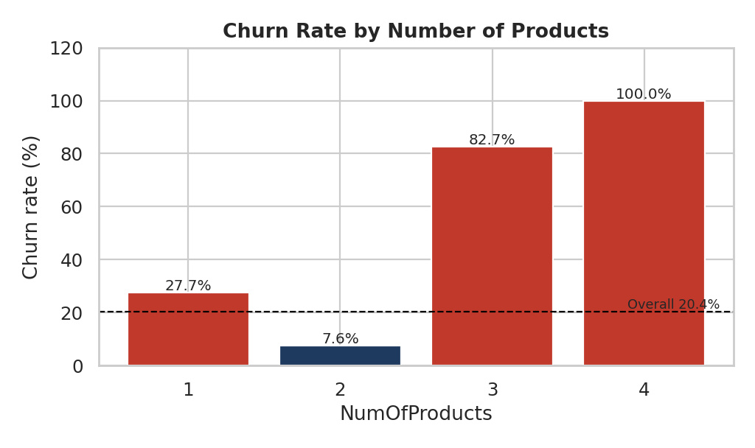
Figure 7: Churn rate by number of products
Products | Customers | Churned | Churn rate | Share of churners
1 | 5,084 | 1,409 | 27.71% | 69.2%
2 | 4,590 | 348 | 7.58% | 17.1%
3 | 266 | 220 | 82.71% | 10.8%
4 | 60 | 60 | 100% | 3.0%

Customers with two products are the most loyal (7.6% churn). Single-product customers are 51% of the base and account for 69% of churners. Customers with 3 or 4 products are few (326) but almost all of them leave. This suggests a problem with how the bank sells or services larger product bundles, and should be investigated.

4.8 Churned vs retained customers
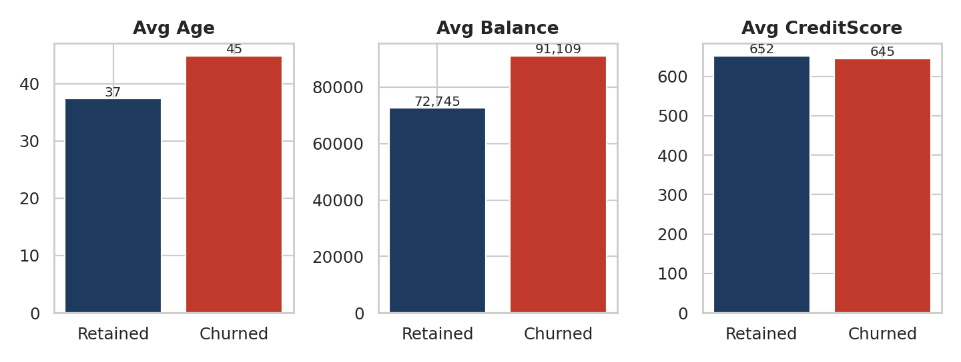
Figure 8: Average age, balance and credit score of retained vs churned customers
Average | Retained | Churned | Difference
Age (years) | 37.4 | 44.8 | +7.4
Balance (EUR) | 72,745 | 91,109 | +25%
Credit score | 651.9 | 645.4 | -6.5 (small)
Tenure (years) | 5.03 | 4.93 | -0.1 (none)
Active member (share) | 55% | 36% | -19 pts

The typical churner is older, holds a higher balance and is less active. Credit score and tenure are almost identical between the two groups. Correlation with Exited confirms the ranking: age (+0.29), inactivity (-0.16 for active status), balance (+0.12); all others are close to zero.
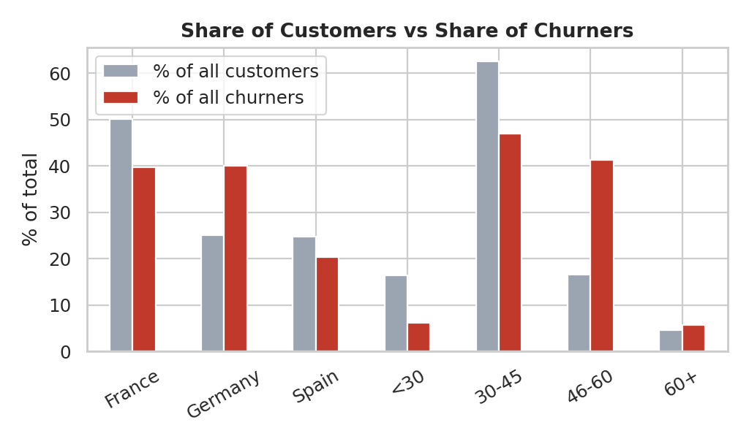
Figure 9: Share of customers vs share of churners

5. High-Value Customer Analysis
High-value customers were defined as the top 25% by account balance (balance above EUR 127,644; 2,500 customers). Revenue risk is measured as the balance held by customers who left, used as a proxy for lost deposits because the dataset has no revenue field.
Measure | High-value (top 25%) | Other customers
Customers | 2,500 | 7,500
Churn rate | 23.68% | 19.27%
France / Germany / Spain churn | 20.3% / 29.0% / 20.8% | -

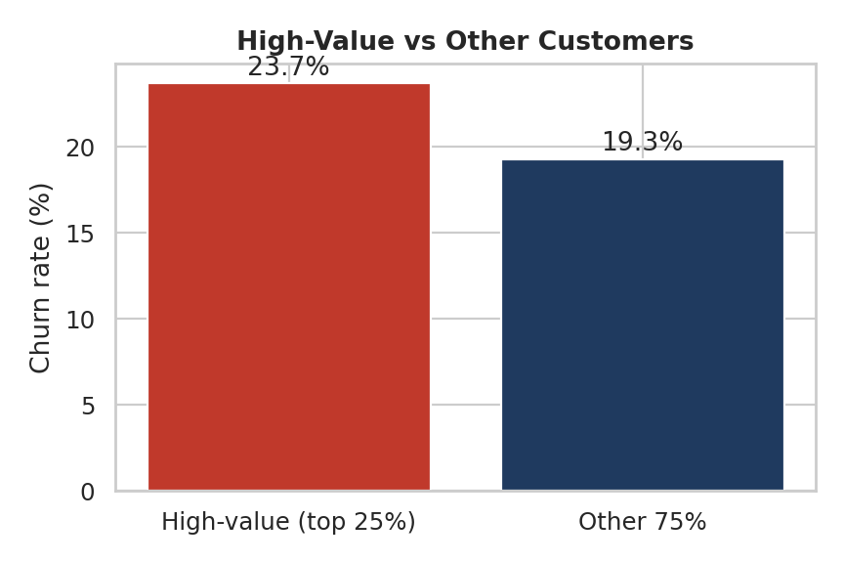
Figure 10: Churn rate, high-value vs other customers
High-value customers churn more often than the rest (23.7% vs 19.3%), and because their balances are large the money at stake is much bigger. Customers who left took EUR 185.6 million, which is 24.3% of all balances (EUR 764.9 million in total). Churning high-value customers alone account for EUR 88.7 million, or 47.8% of the lost balance, although they are only 29% of all churners. By country, Germany carries the largest loss (EUR 98.0 million), then France (EUR 57.7 million) and Spain (EUR 29.9 million).
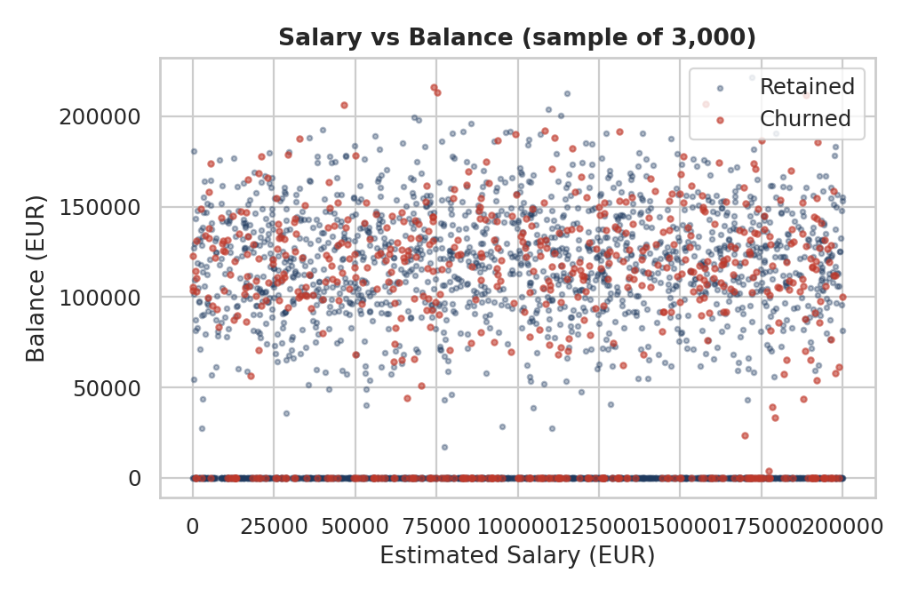
Figure 11: Salary vs balance, coloured by churn
The salary-versus-balance scatter plot shows that churners (red) are spread across the whole salary range. Salary quartiles churn at almost the same rate (20.0%, 19.8%, 20.1%, 21.6%). Balance, not salary, is what makes a lost customer expensive, so retention effort should follow the balance a customer holds, not the income they earn.

6. Key Performance Indicators
KPI | How it is calculated | Result
Overall Churn Rate | Churned / all customers | 20.37%
Segment Churn Rate | Churn % within each segment | See Section 4 (e.g. Germany 32.4%, age 46-60 51.1%)
High-Value Churn Ratio | Churn among top 25% by balance | 23.68%
Geographic Risk Index | Country churn / overall churn | Germany 1.59, Spain 0.82, France 0.79
Engagement Drop Indicator | Inactive churn / active churn | 1.88x (26.85% vs 14.27%)

7. Recommendations
- Run a priority retention programme in Germany. It has 40% of churners and EUR 98 million of lost balance. Investigate causes locally (pricing, service, competition) through customer interviews or exit surveys.
- Target customers aged 46-60. Offer relationship-manager contact, savings and retirement-planning products, and proactive outreach. Start with German customers in this age band, where churn is 67%.
- Build an inactivity early-warning system. Flag members who become inactive and contact them with re-engagement offers before they leave. Inactive members churn 1.9 times more often.
- Review the 3-4 product offering. Check whether bundles are mis-sold, expensive or poorly serviced. Meanwhile, encourage single-product customers to adopt a second product, since two-product customers churn the least (7.6%).
- Protect high-balance customers first. Give customers above EUR 127,644 a dedicated service and retention offers; a saved high-value customer is worth far more than an average one.
- Look into the gender gap. Women churn 8 to 10 points more than men in every country; review whether products, communication or service are meeting their needs.
- De-prioritise credit score, tenure and salary targeting. They do not separate churners from stayers, so marketing money is better spent on the segments above.

8. Limitations
- The data is a single snapshot with no dates of exit, so we cannot study how churn develops over time or the reason each customer left.
- The findings show association, not proof of cause. For example, we know older customers leave more, but not why.
- Balance is used as a proxy for revenue; real profit per customer (fees, interest margin, product income) is not available.
- Segment cut-offs (age, credit, tenure, balance) are reasonable choices but other cut-offs could change the exact percentages slightly.
- Groups with few customers (3-4 products: 326 customers; 60+ age group: 464) give less stable percentages.
- No predictive model was built; the work is descriptive and segment based.

9. Conclusion
Churn at this bank is not random. One in five customers leaves, but the loss is concentrated in identifiable groups: German customers, customers aged 46-60, women, inactive members, single-product customers and the unusual group holding 3-4 products. Together with high-balance customers, who carry EUR 88.7 million of the EUR 185.6 million lost, these groups give the bank a clear order of priority for retention spending. Credit score, tenure and salary do not explain churn, so broad campaigns based on them would be inefficient. The accompanying Streamlit dashboard lets decision-makers explore any segment and see the churn rate and balance at risk update live.

