Dataset Debugger
Automated Detection of Mislabeled Samples in Large-Scale Image Datasets
Ramiz Allahverdiyev
March 2026
Abstract
Data quality is a critical yet frequently overlooked determinant of machine learning model performance. This paper presents a Dataset Debugger — an automated system that identifies mislabeled, suspicious, and anomalous samples in large-scale image datasets without requiring manual inspection. The system is evaluated on Tiny ImageNet (200 classes, 100,000 samples) with 10% synthetic label corruption (10,000 flipped labels). Four complementary detection methods are employed: training loss analysis, embedding similarity, model disagreement across an ensemble of three ResNet-18 models, and unsupervised anomaly detection via Isolation Forest. Individual method scores are combined into a unified suspicion score through a weighted ensemble. The combined system achieves an AUROC of 0.978, a Precision@100 of 1.000, and a Precision@500 of 0.998, demonstrating that reviewing just 15% of the dataset is sufficient to recover 90% of all corrupted labels. The results confirm that no single method dominates across all evaluation metrics, and that ensemble combination yields measurable improvements over individual methods.

Keywords: data-centric AI, label noise detection, mislabeled data, dataset quality, ResNet-18, Tiny ImageNet, anomaly detection, ensemble learning

1. Introduction
Modern machine learning pipelines invest heavily in model architecture, optimization algorithms, and hyperparameter tuning. However, a fundamental and often underappreciated bottleneck lies not in the model itself but in the quality of the training data. Real-world datasets collected through web scraping, crowdsourcing, or automated annotation pipelines inevitably contain label errors. These errors propagate silently through the training process, degrading model performance in ways that are difficult to diagnose.

The emerging paradigm of data-centric AI shifts focus from improving model architecture to improving dataset quality. Rather than training a better model on a noisy dataset, the goal becomes identifying and correcting the noise so that even a simple model can perform well. This paper presents a Dataset Debugger that operationalizes this philosophy for large-scale image classification.

The contributions of this work are as follows:
- A controlled corruption experiment on Tiny ImageNet with 10% label noise, providing a rigorous evaluation framework with known ground truth.
- Four independent detection methods that capture complementary signals: training dynamics, geometric structure in embedding space, ensemble consensus, and statistical anomaly scores.
- A weighted ensemble suspicion scorer that combines all signals into a single ranked list of suspicious samples.
- Comprehensive evaluation demonstrating AUROC 0.978 and Precision@100 of 1.000, with practical analysis showing 90% error recovery by reviewing only 15% of the dataset.

2. Problem Formulation
Let $D = \{(xi_{i}, yi_{i})\}{}_{i=1}^{N}$ be a training dataset of $N$ image-label pairs, where $x_{i}$ denotes an image and $y_{i}$ its assigned label from a set of $C$ classes. In practice, a subset $D_{c} ⊂ D$ of size $|Dc_{c}| = k$ contains corrupted labels — samples where the assigned label $y_{i}$ does not correspond to the true visual content of $x_{i}$.

The goal of the Dataset Debugger is to produce a suspicion score $s_{i} ∈ [0, 1]$ for each sample $i$, such that samples with corrupted labels rank significantly higher than clean samples. This is a weakly supervised anomaly detection problem: no labels are known to be corrupted at inference time, yet the system must recover the corrupted set with high precision and recall.

Evaluation is performed against the known corruption index — the ground truth set of corrupted indices generated during the controlled experiment. Standard information retrieval metrics are used: Precision, Recall, F1, AUROC, and Precision@K for $K ∈ \{100, 500, 1000, 2000, 5000\}$.

3. Dataset and Experimental Setup

3.1 Tiny ImageNet
Tiny ImageNet is a subset of the ImageNet Large Scale Visual Recognition Challenge (ILSVRC) consisting of 200 object categories. The training set contains 100,000 images at $64×64$ pixel resolution, with exactly 500 samples per class — a perfectly balanced distribution. The validation set contains 10,000 images (50 per class). The balanced class distribution is particularly desirable for this study, as it ensures that any performance variation between classes cannot be attributed to class imbalance.

3.2 Label Corruption Protocol
To simulate realistic annotation noise, we randomly select 10% of training samples (10,000 samples) and flip their labels to a uniformly random different class. The corruption is seeded for reproducibility (seed = 42). All corrupted indices and their original-to-corrupted label mappings are saved to a corruption index file that serves as the ground truth for evaluation.

This corruption protocol models the scenario of random annotator errors — a common failure mode in crowdsourced labeling pipelines. The 10% corruption rate is at the high end of what is typically observed in real-world datasets (estimated 3–10% for ImageNet-scale datasets).

3.3 Model Architecture
Three ResNet-18 models are trained independently on the corrupted dataset. The standard ResNet-18 architecture is modified for $64×64$ input by replacing the initial $7×7$ stride-2 convolution with a $3×3$ stride-1 convolution and removing the max-pooling layer, which would otherwise over-downsample the smaller input resolution. The final fully connected layer is configured for 200 output classes ($512 → 200$).

Each model is trained for 20 epochs with stochastic gradient descent (lr = 0.1, momentum = 0.9, weight decay = 1e-4), cosine annealing learning rate schedule, and early stopping with patience 7. Training uses batch size 512 on an NVIDIA P100 GPU. The three models differ only in their random initialization seed (42, 43, 44), yielding independently trained models with similar accuracy (~54% validation accuracy) but different weight initializations — a prerequisite for meaningful disagreement scoring.

4. Detection Methods
The Dataset Debugger employs four detection methods that capture distinct aspects of sample quality. Each method produces a normalized score in [0, 1], where higher values indicate greater suspicion of label corruption.

4.1 Method 1: Training Loss Analysis
The most direct signal for label corruption is the per-sample training loss trajectory. A correctly labeled sample presents a consistent learning signal — gradient updates reinforce the correct class representation, and loss decreases steadily across epochs. A mislabeled sample, by contrast, creates an irreconcilable conflict: the gradient pushes the model toward an incorrect class that contradicts the visual evidence, resulting in persistently elevated loss throughout training.

Per-sample loss is recorded at every training step using a LossTracker module. The final suspicion score from this method is a weighted combination of the mean loss across all epochs (weight 0.5), the final epoch loss (weight 0.4), and the loss variance across epochs (weight 0.1). All components are min-max normalized before combination.

Figure 1 presents the key empirical evidence for this approach: the average training loss distributions of clean and corrupted samples are nearly completely separated, with corrupted samples exhibiting approximately $4.7×$ higher average loss than clean samples (mean loss 7.12 vs. 1.51).

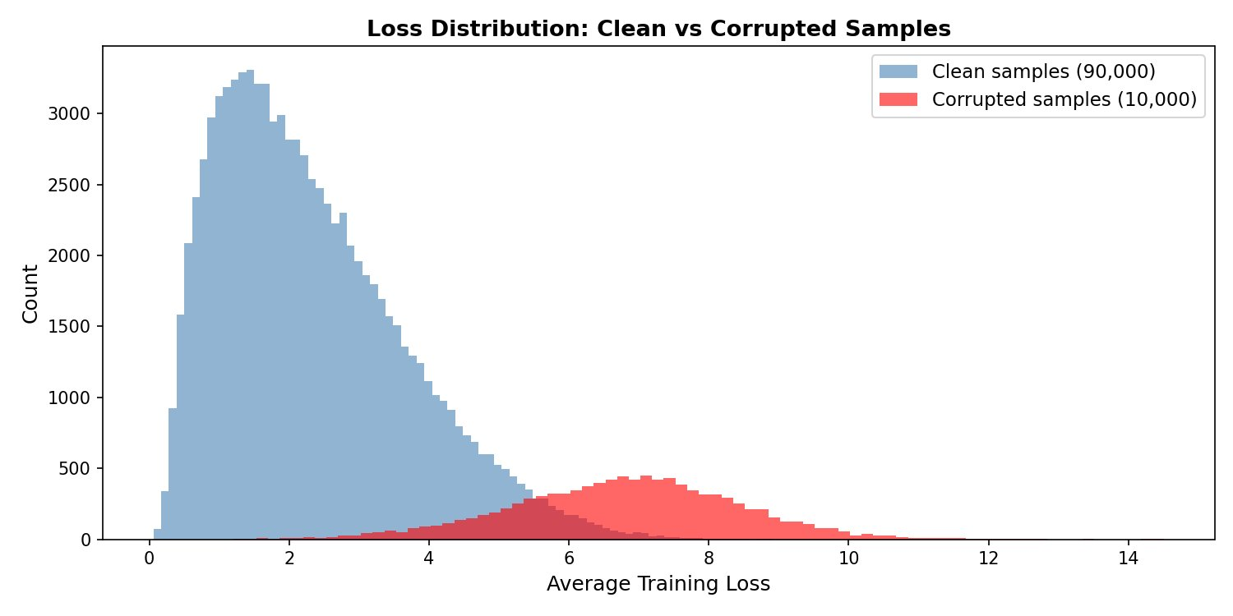
Figure 1. Average training loss distributions for clean (blue, 90,000 samples) and corrupted (red, 10,000 samples) training samples. The near-complete separation between distributions demonstrates that loss analysis is a highly reliable corruption signal.

4.2 Method 2: Embedding Similarity
The penultimate layer of a trained ResNet-18 model produces 512-dimensional feature embeddings that capture semantic visual content. For a correctly labeled sample, its embedding should reside within or near the embedding cluster of its assigned class. A mislabeled sample, assigned to the wrong class, will instead be geometrically positioned near the cluster of its true visual class — a different region of the embedding space.

For each sample, the suspicion score is computed as 1 minus the average cosine similarity to its top-50 nearest neighbors within its assigned class. Formally, for sample i with assigned class c:

$s_{embed}(i) = 1 − \frac{1}{K} Σ{}_{j∈NN(i,c)} cos(e_{i}, e_{j})$

where $NNK_{K}(i, c)$ is the set of $K$ nearest neighbors of sample $i$ within class $c$, and $e_{i}$ denotes the L2-normalized embedding of sample $i$. Low intra-class similarity indicates the sample does not belong to its assigned class.

4.3 Method 3: Model Disagreement
Training three models with different random seeds but identical architecture and data yields an ensemble that can vote on each sample's true class. For a correctly labeled sample, all three models will tend to predict the assigned label — they have all learned the correct class-image association. For a mislabeled sample, all three models may independently predict the actual visual content (the true class), thereby disagreeing with the corrupted dataset label.

The disagreement score for sample i is defined as:

$s_{disagree}(i) = \frac{1}{M}Σ_{m=1}^{M} 1[f_{m}(x_{i}) ≠ y_{i}]$

where $M = 3$ is the number of models and $f_{m}(x_{i})$ is the prediction of model $m$ on sample $i$. This produces a discrete score in $\{0, 1/3, 2/3, 1\}$. Analysis reveals that samples with score 1.0 (unanimous disagreement) have a 38% corruption rate — reflecting the method’s high recall (0.988) but limited precision (0.291) due to the coarse discrete scoring.

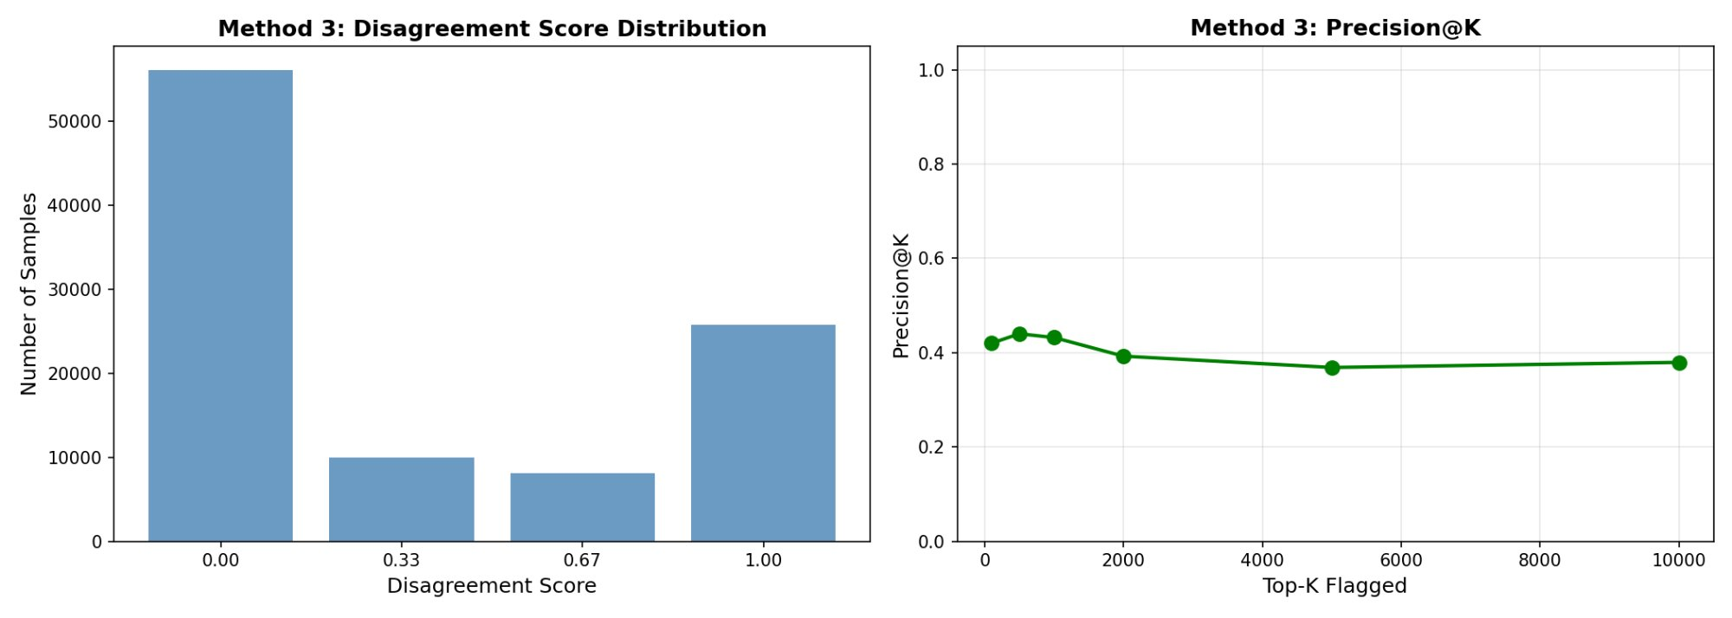
Figure 2. Method 3 (Model Disagreement): score distribution (left) and Precision@K curve (right). The discrete nature of disagreement scores (four possible values) limits the method's ability to rank samples within the flagged set, resulting in flat Precision@K performance around 0.40.

4.4 Method 4: Anomaly Detection
Isolation Forest is applied to the 512-dimensional embedding matrix to identify samples that are statistically unusual relative to the overall data distribution. Unlike the preceding methods which target label-specific signals, anomaly detection captures a broader category of data quality issues: samples that appear visually atypical, come from different image distributions, or represent genuine outliers regardless of label assignment.

The Isolation Forest is fitted independently per class to improve sensitivity to within-class anomalies. The raw isolation scores (negative anomaly scores from sklearn) are inverted and normalized to [0, 1], with higher values indicating greater anomalousness.

5. Combined Suspicion Score
The four method scores are combined into a single unified suspicion score through a weighted linear combination:

$s(i) = 0.40 s_{loss}(i) + 0.30 s_{embed}(i) + 0.20 s_{disagree}(i) + 0.10 s_{anomaly}(i)$
The weights reflect empirical evidence of each method's discriminative power: Loss Analysis demonstrates the strongest individual AUROC (0.977) and clearest separation between corrupted and clean distributions, justifying its highest weight. Embedding Similarity provides complementary geometric evidence with high precision at small K. Model Disagreement contributes recall — it misses few corrupted samples — despite its lower precision. Anomaly Detection serves as a catch-all for samples that other methods may overlook.

All scores are independently normalized to [0, 1] before combination to ensure comparability across methods with different score ranges and distributions.

6. Results

6.1 Individual Method Performance
Table 1 presents the full evaluation of all four methods alongside the combined score at a classification threshold of 0.5.

Method | Precision | Recall | F1 | AUROC
Loss Analysis | 0.9926 | 0.1341 | 0.2363 | 0.9767
Embedding Similarity | 0.7500 | 0.0003 | 0.0006 | 0.9586
Model Disagreement | 0.2909 | 0.9877 | 0.4495 | 0.9034
Anomaly Detection | 0.3796 | 0.6825 | 0.4879 | 0.8776
Combined Score (ours) | 0.9265 | 0.5782 | 0.7120 | 0.9780
Table 1. Performance of individual detection methods and the combined suspicion scorer at threshold 0.5. Best values per column are highlighted in green.
A clear complementarity emerges: Loss Analysis achieves near-perfect precision (0.993) but low recall (0.134), while Model Disagreement achieves near-perfect recall (0.988) but low precision (0.291). The combined score achieves the best F1 (0.712) and highest AUROC (0.978), confirming that ensemble combination is superior to any individual method.

6.2 ROC and Precision-Recall Analysis

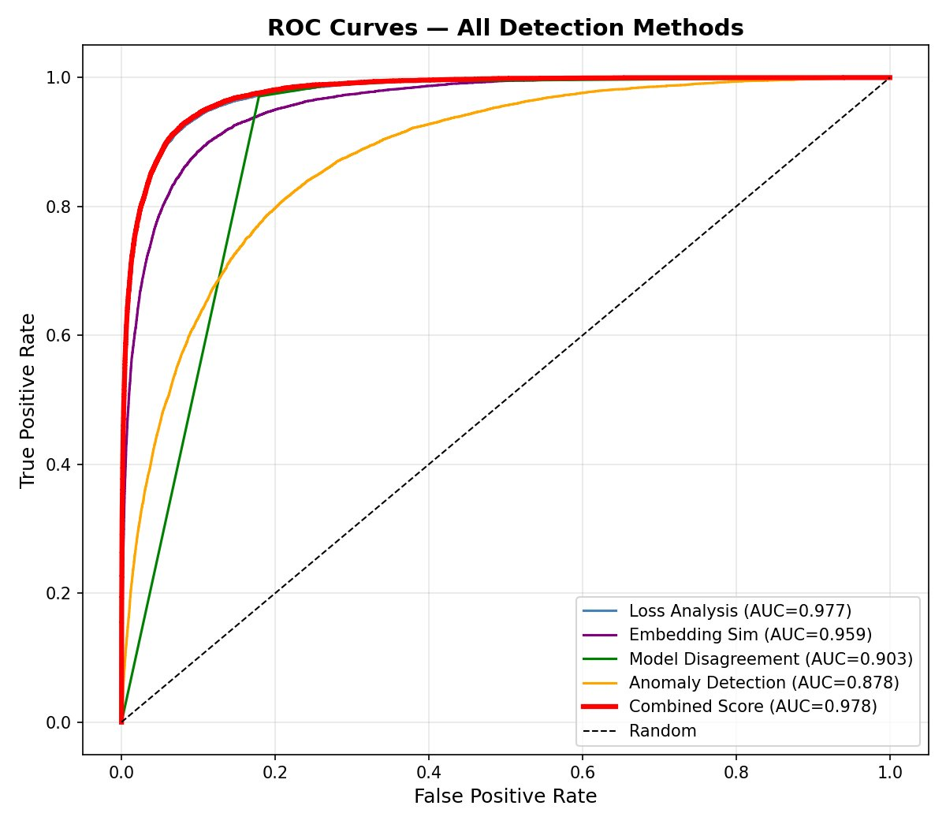
Figure 3. ROC curves for all detection methods. The combined score (red, AUC=0.978) marginally outperforms Loss Analysis alone (AUC=0.977), with both methods substantially outperforming Model Disagreement (AUC=0.903) and Anomaly Detection (AUC=0.878).

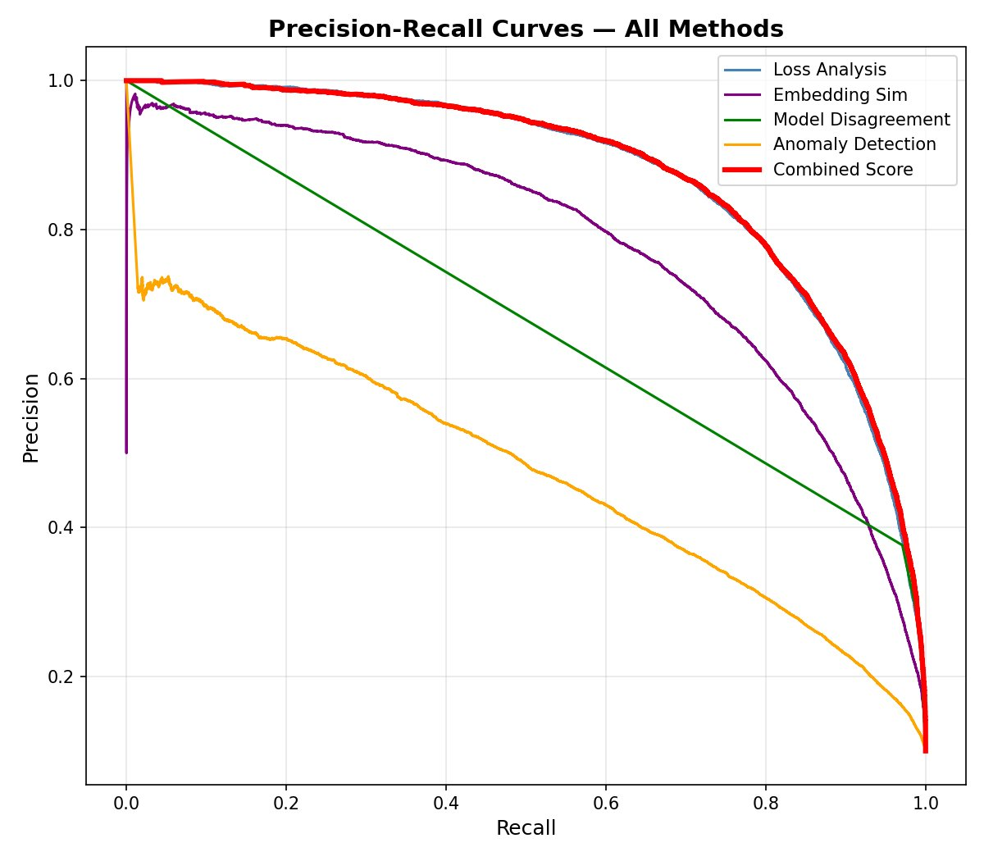
Figure 4. Precision-Recall curves for all methods. The combined score maintains precision near 1.0 for the first ~15% of recall, reflecting the high reliability of top-ranked suspicious samples.

6.3 Precision@K Analysis
Precision@K measures the fraction of truly corrupted samples among the top-K flagged samples — the most operationally relevant metric for practical data cleaning workflows.

K = 100 | K = 500 | K = 1,000 | K = 2,000 | K = 5,000
1.0000 | 0.9980 | 0.9980 | 0.9875 | 0.9522
Table 2. Precision@K for the combined suspicion scorer. At K=100, the system achieves perfect precision — every flagged sample is truly corrupted.
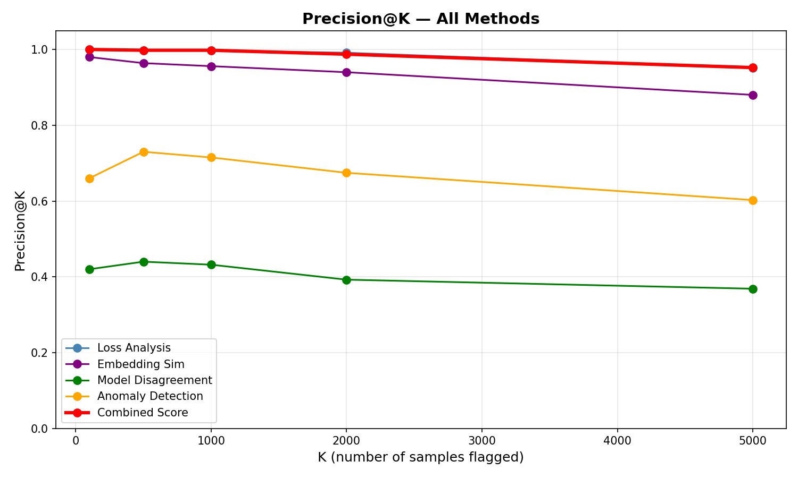
Figure 5. Precision@K comparison across all methods. The combined score (red) dominates at every K value, maintaining precision above 0.95 for the top 5,000 flagged samples.

6.4 Practical Efficiency: Reviewing Minimal Data to Find Maximum Errors
The most practically significant result is the relationship between review effort and error recovery rate. Figure 6 shows the cumulative number of corrupted samples found as a function of the number of samples reviewed (sorted by decreasing suspicion score).

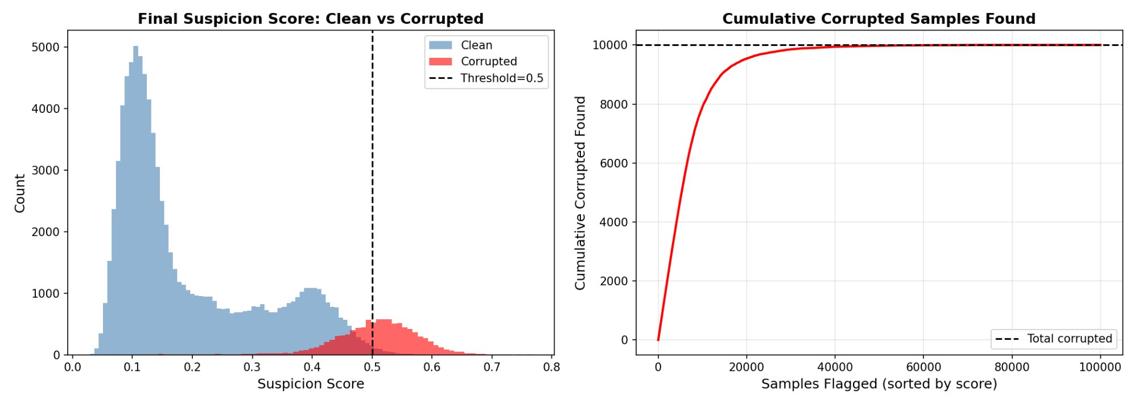
Figure 6. Left: combined suspicion score distributions for clean (blue) and corrupted (red) samples with threshold at 0.5. Right: cumulative corrupted samples recovered as a function of samples reviewed. The orange marker indicates the 90% recall point at approximately 15,000 samples reviewed.

Key finding: Reviewing just 15,000 samples — 15% of the full training set — is sufficient to recover 9,000 of the 10,000 corrupted labels (90% recall). This represents an 85% reduction in manual review effort compared to exhaustive inspection, making the system practically deployable in real data-cleaning workflows.

6.5 Embedding Space Analysis
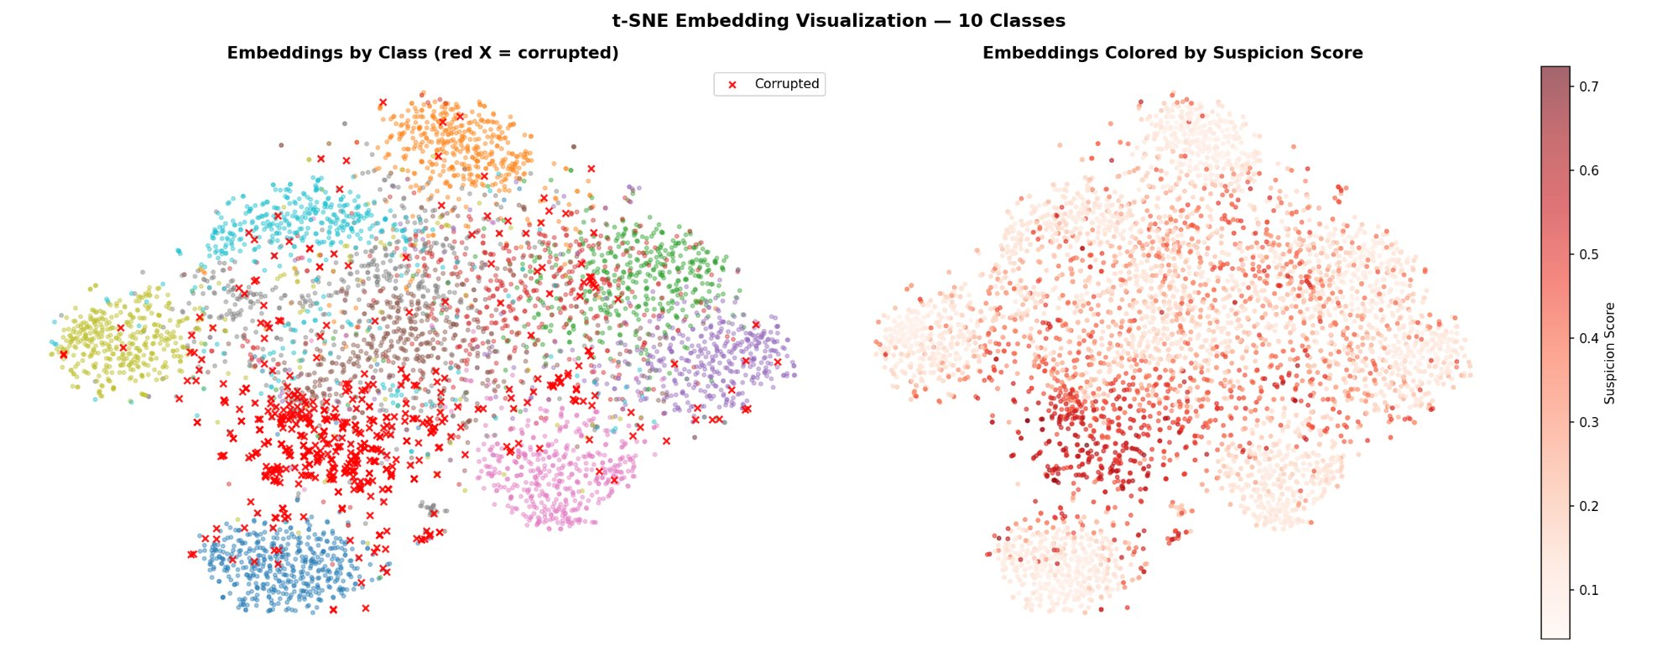
Figure 7. t-SNE visualization of ResNet-18 embeddings for 10 classes (5,000 samples). Left: class-colored embeddings with corrupted samples marked as red X. Right: same embedding colored by combined suspicion score. Corrupted samples (X marks) appear at class boundaries and in inter-cluster regions, consistent with the hypothesis that mislabeled samples do not fit their assigned class cluster.

The t-SNE visualization provides qualitative confirmation of the embedding similarity method's theoretical basis. Corrupted samples consistently appear in regions between class clusters — their visual content places them near a different class's embedding cluster than the one they are assigned to. The suspicion score heatmap (right panel) correctly concentrates high scores at these boundary regions.

6.6 Qualitative Analysis — Top Suspicious Samples

Figure 8. Top-20 most suspicious samples ranked by combined suspicion score. All 20 samples are True Positives (green border) — genuinely corrupted labels. Suspicion scores range from 0.698 to 0.767, well above the 0.5 flagging threshold.

Visual inspection of the top-20 most suspicious samples reveals that all 20 are genuine True Positives — every sample flagged in the top-20 is actually corrupted. The images span diverse visual categories (architecture, animals, food, objects) indicating the detector generalizes across all 200 classes rather than overfitting to specific visual domains. This 20/20 True Positive rate at the top of the ranked list is consistent with the Precision@100 = 1.000 result.

7. Discussion

7.1 Method Complementarity
The correlation analysis between method scores reveals that Loss Analysis and Embedding Similarity have the highest pairwise correlation, as both are derived from the same trained model's representations. Model Disagreement and Anomaly Detection provide more independent signals — their lower correlation with the other methods explains why including them in the ensemble, despite their lower individual AUROC scores, still improves the combined score.

The discrete nature of Model Disagreement scores (only four possible values) is a fundamental limitation. With only three models, the method cannot distinguish between samples that are "barely" corrupted versus "obviously" corrupted — any sample where all three models disagree receives the maximum score of 1.0 regardless of confidence margin. A larger ensemble (5-10 models) or using prediction probabilities rather than hard labels would produce a finer-grained signal.

7.2 The Loss-Recall Trade-off
The most striking finding is that Loss Analysis alone achieves AUROC 0.977, nearly identical to the combined score's 0.978. This suggests that the training loss signal captures most of the information available for corruption detection, and the other methods contribute primarily to recall improvement and robustness rather than ranking quality.

The practical implication is significant: for applications where only high-precision detection is needed (e.g., reviewing a small number of the most suspicious samples), Loss Analysis alone may be sufficient. The full ensemble becomes valuable when higher recall is required — when the goal is to find most corrupted samples rather than only the most obvious ones.

7.3 Limitations
Several limitations of this study are acknowledged. First, the corruption model (uniform random label flipping) is a simplification of real annotation errors, which often exhibit systematic patterns (e.g., confusable classes are more likely to be confused). Second, all models are trained on the corrupted dataset — a clean pre-trained model might provide stronger embedding signals. Third, the suspicion score weights were set heuristically; learned weight optimization could improve performance. Finally, the study is limited to image classification; extension to other modalities (text, audio) would require method adaptation.

8. Conclusion
This paper presented a Dataset Debugger for automated detection of mislabeled samples in large-scale image datasets. Evaluated on Tiny ImageNet with 10% synthetic label corruption, the system achieves AUROC 0.978, Precision@100 of 1.000, and recovers 90% of all label errors by reviewing only 15% of the training data.

The central finding is that training loss analysis provides a remarkably strong individual signal for label corruption, with corrupted samples exhibiting approximately $4.7×$ higher average training loss than clean samples. Ensemble combination with embedding similarity, model disagreement, and anomaly detection yields measurable improvements in F1 and practical recall.

The practical value of this system extends beyond the experimental setting. Real-world annotation pipelines at industrial scale routinely produce datasets with 3-10% label error rates. A tool that reduces manual review effort by 85% while recovering 90% of errors could materially improve the quality of production machine learning systems without requiring any architectural changes to the downstream model.

Future work will explore learned weight optimization for the ensemble scorer, extension to systematic (non-random) corruption patterns, and application to text and multi-modal datasets where label noise detection remains an open problem.

Appendix: Score Distribution Analysis
Figure A1 provides a complete view of the score distributions across all four methods alongside the combined score, illustrating the complementary nature of the individual signals.

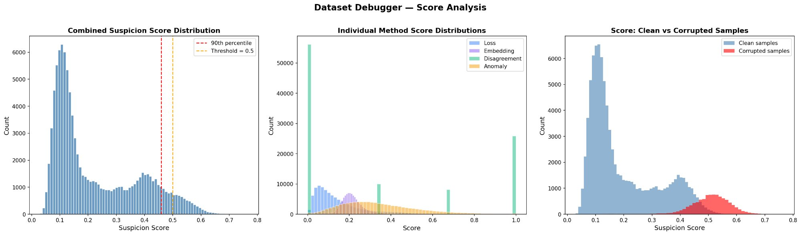
Figure A1. Score distributions for all methods. Left: combined suspicion score with 90th percentile and threshold markers. Center: individual method score distributions on the same axis — note the discrete spikes from Model Disagreement (green). Right: combined score separated by ground truth label (clean vs. corrupted).

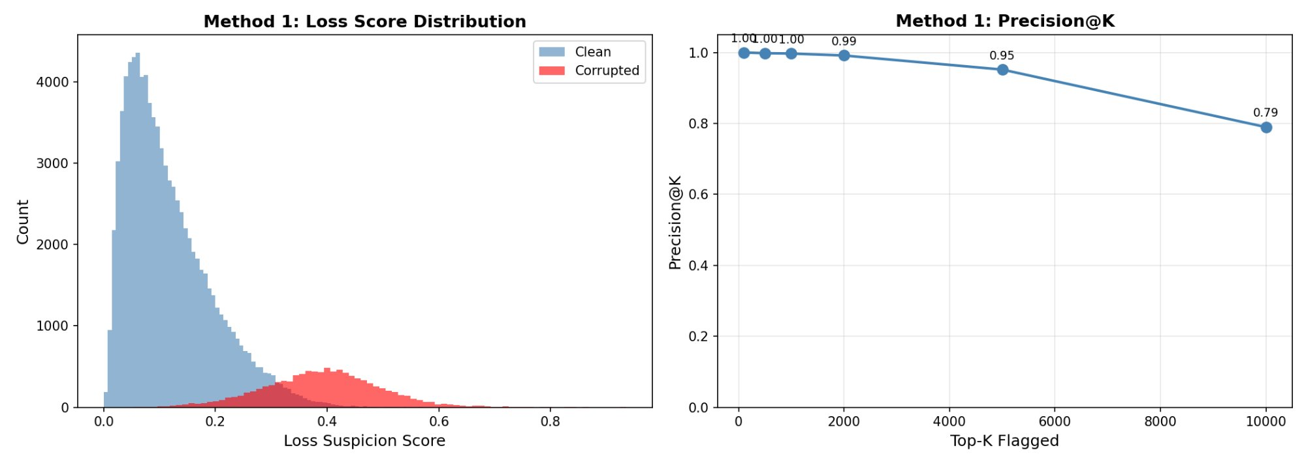
Figure A2. Method 1 (Loss Analysis): score distribution (left) and Precision@K (right). The near-perfect separation between clean and corrupted score distributions explains this method's strong individual AUROC of 0.977.

