**Title**: Team Mavericks QA Assignment

**Objective**: Write an automated functional UI test suite to test reddit.com

**Framework** **Used**: Robot Framework

**Language**: Python

**Design Pattern**: Page Object Model

**Browser:** Chrome. Version 90.0.4430.85 (Official Build) (64-bit)

**Test Automation Framework Architecture Diagram**:-

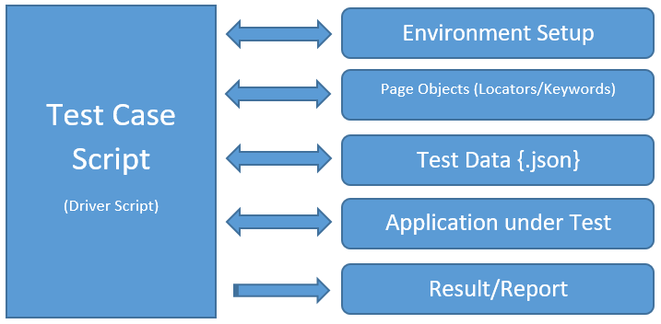

**Steps for Execution**:-

1. Clone repository from git on Local Drive
   * Command: git clone <repository path>
2. Run **pip install -r requirements.txt** to install dependencies on the local machine. It should be run in the same location where repository is cloned.
3. Execute following command from root folder of the project:-
   * [Command] **robot -d Results Tests**
   * **Results** is the directory for report generation
   * **Tests** is the suite name.
4. User will be prompted to make a browser selection

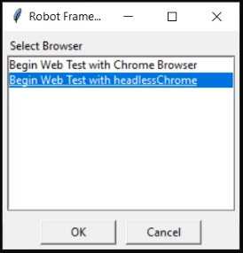

1. Make a selection and click OK to begin execution.
2. After successful execution report is generated in Result folder.

Must Read:

* The script supports only the Chrome Browser.
* It can be executed in both variants of the chrome browser (Normal & Headless)
* During execution you will see the following in the command line:-



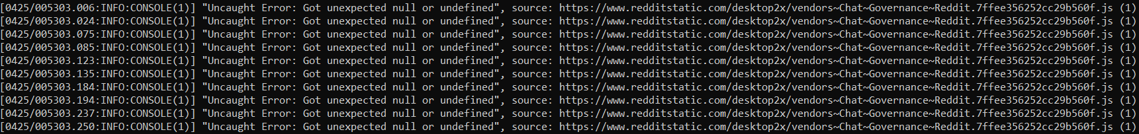

It is not any error, please do not force stop the execution. It does not impact the executing script. Let it complete.

* Once completed, check out Results folder for detailed report.

Note: You can also refer test execution videos.

* DemoVideo-Chrome
* DemoVideo-HeadlessChrome