**CHAPTER 1**

**INTRODUCTION**

Agriculture is the backbone of Indian economy. It is a source of livelihood for more than half of the population of India. Along with its allied sectors, agriculture accounted for 23% of Indian GDP, and employed 59% of the total workforce in India. The industrial sector also depends on agriculture for raw products. Food production must be increased by 70% to feed the world population by 2050. The population of the world is likely to increase by two billion to three billion by 2050 which will double the demand of food, according to several studies. Even today when there is plenty of food, the world population almost one billion people suffer from chronic hunger. The loss in crop yield has to be taken into consideration for improving the return on investment for people depending on agriculture as well as for strengthening the economy of the country. The yield losses are caused by three major factors weed invasion, pests and pathogens, from which weeds are a major issue. Weed control is the process of reducing or completely eliminating the loss in crop yield caused due to weed invasion.

One of the easiest ways to control weeds is through prevention or cultural control. Close planting in the garden can reduce weed growth by eliminating open space. Cover crops are good for this as well. These crops are used to eliminate the space to prevent weed growth. The problem with this method is that it requires high knowledge of spacing of crops and the type of cover crop that can be used. Chemical control is done by using herbicides which kill certain targets while leaving the desired crop relatively unharmed. Some of these acts by interfering with the growth of the weed and are often based on plant hormones. Herbicides can have several side effects on biotic and abiotic environment and bear a risk to harm human health. Therefore, a reduction in the amount of herbicides used in the modern agriculture is a relevant step towards sustainable agriculture. Mechanical weeding means machines equipped with classifiers, classifying the plant as crop or weed. The classification task is related to computer vision which in turn is based on Artificial Intelligence.

The main objective of this article is to classify an image of the plant as crop or weed using deep learning and to evaluate the performance of state-of-the-art models on a benchmark dataset using various performance parameters.

**CHAPTER 2**

**METHODOLOGY**

**Dataset:**

The database is recorded approximately 960 unique plants that belong to 12 species at several growth stages, and the dataset comprises annotated RGB images with a physical resolution of roughly 10 pixels per mm. In the dataset, there are 4750 images as training set (80% as training and 20% as validation) and 794 images as test set. You could download the dataset we use in his project at “https://www.kaggle.com/competitions/plant-seedlings-classification/data". Below figure shows sample input images belong to each species.

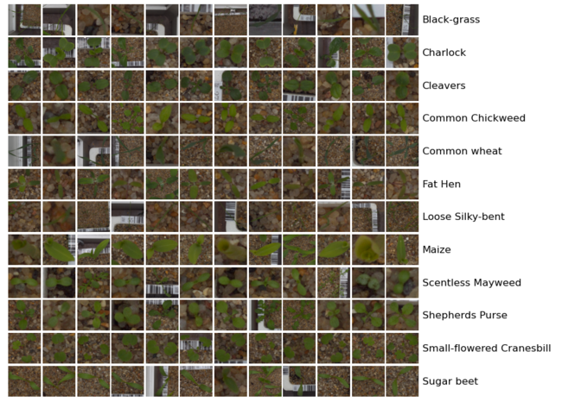

**METHODS:**

**Preprocessing**

The training data were randomly sorted and divided into two parts, 80% for training and 20% for validation. All images were cropped to the same size (299 × 299) and normalized to range [-1,1]. For SVM inputs, images should be converted from RGB to grayscale and then flatten into one dimensional vectors.

* **Data Augmentation:** It was employed to generate a larger training set. This was realized by performing random rotation, translation and flipping on the original inputs. The first image is the original image and the later ones are outputs of data augmentation.
* **Image Segmentation:** Since the images are taken in real environment, it’s natural that there are a lot of noise. Thus, we need to remove the the noise and the background. We first do image blurring to remove noises and get the result shown in the second image. Then, we convert RGB image into HSV, so that it can be easier to separate the color information from the luminance information. The conversion result is shown in the third image. Lastly, we create a mask to remove the background of the image and get the seed part for training and testing.
* **Label Conversion:** The labels are given in string in the dataset, like "Charlock" and "Cleavers", but strings are hard to process when training. Thus, we convert the string labels into the one-hot labels, and 1 indicates the species is detected, while 0 indicates not detected.

**Classification models**

In order to explore the best solution to this classification problem, several different models were employed to compare their performance.

* **Support Vector Machine:** Support Vector Machine (SVM) is a very popular machine learning model for classification. It works well on MNIST image classification task. In this project, SVM was employed first and used as a baseline.
* **Transfer Learning:** Transfer Learning is a machine learning method that uses a network pretrained on one dataset to solve the classification task on another dataset. The final classification layers of the pretrained models should be detached and replaced by a classifier trained to solve the new task.

And two classifiers were compared. They were implemented by using scikit-learn library.

* **Logistic Regression:** This is the most commonly used method for classification. It is very fast and usually performs well.
* **Fully-Connected Neural Network:** Also known as artificial neural network (ANN), Multi-layer Perceptron(MLP). This is a neural network with one hidden layer. Here, the number of units for the hidden layer was set to be 1,000.

**Customized Convolutional Neural Network**

Besides using the pre-trained models, we also define our customized convolutional neural network. This model has 4 dense layers. Following each convolutional layer, there’s a batch normalization layer and a RELU activation layer. There are a maxpooling layer and a dropout after every two convolutional layers. Also, there’s a batch normalization layer, a dropout layer and a RELU activation layer after the first dense layers. The last dense layer is followed by a softmax layer.

Tools Used:

Hardware: Ubuntu 20.04.4 LTS

Platform: Google Collab

Model: Mobilenet

**CHAPTER 3**

**RESULT ANALYSIS**

**Code:**

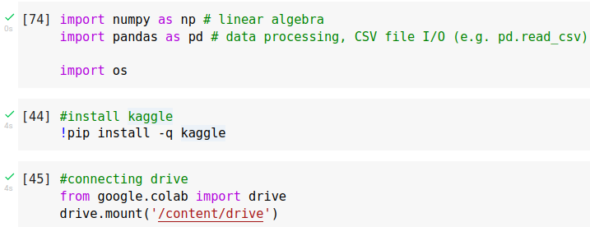

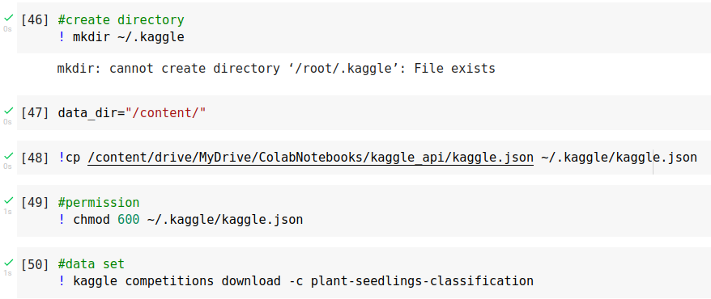

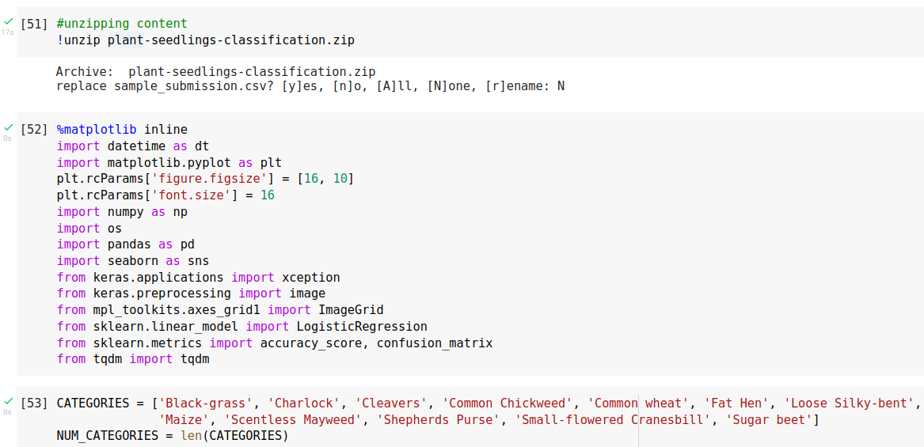

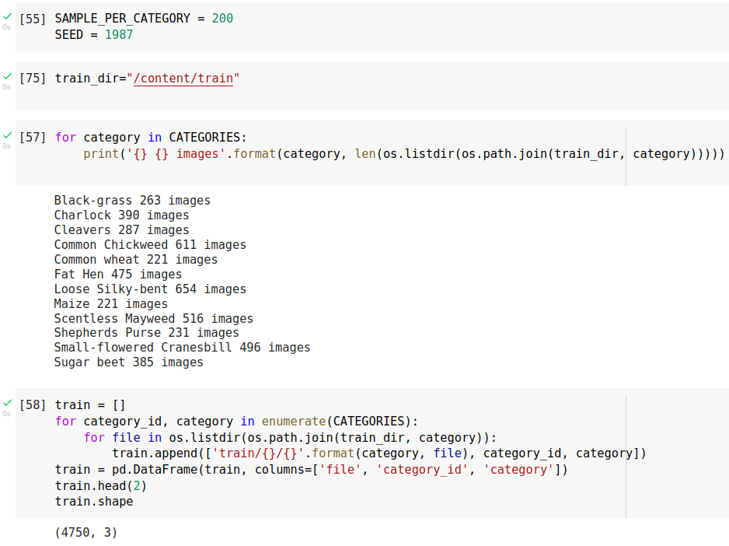

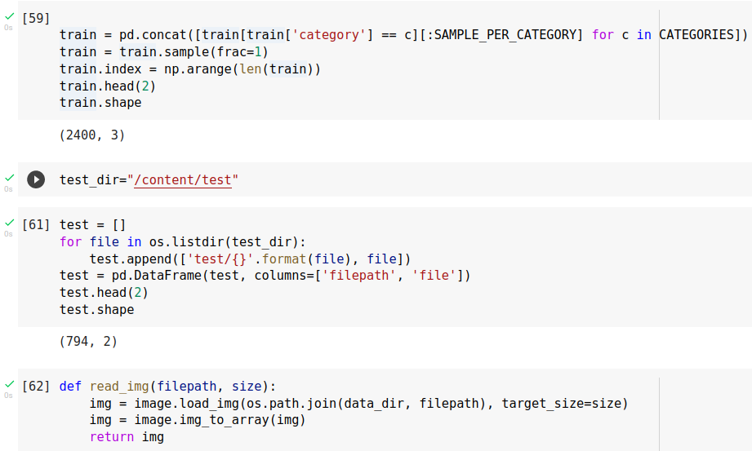

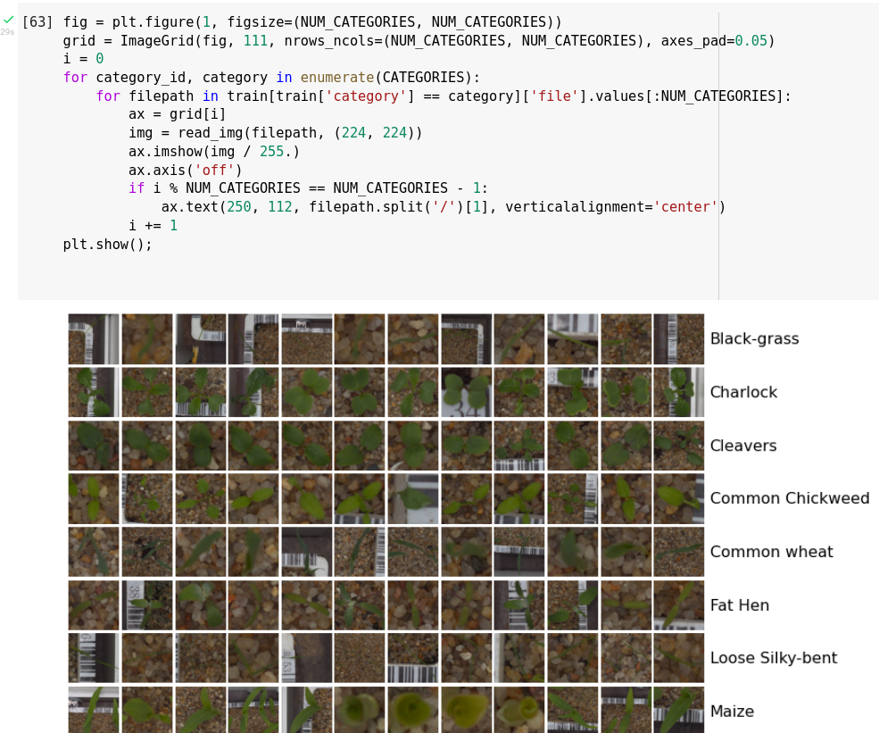

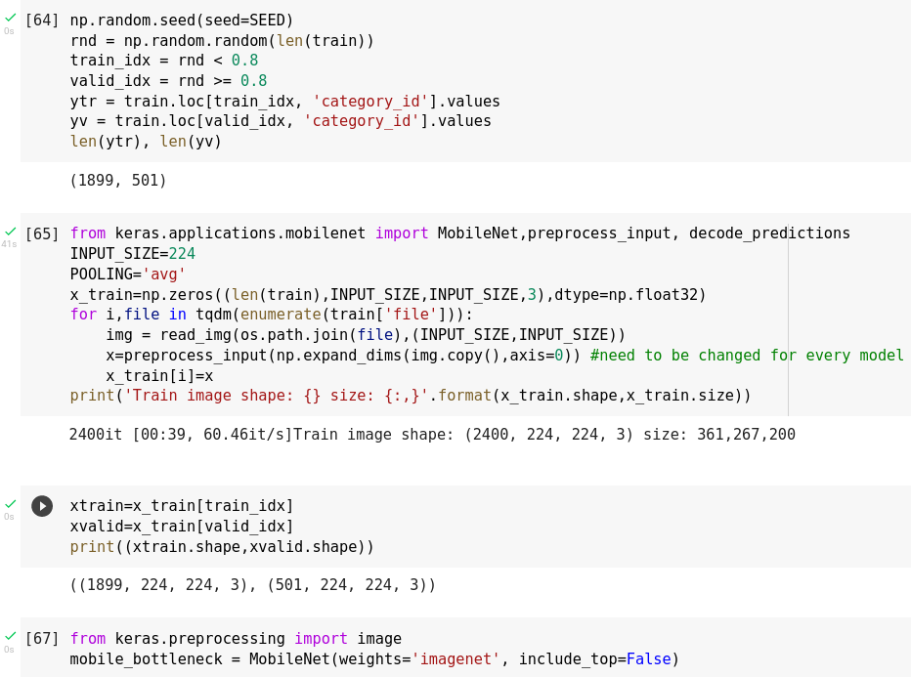

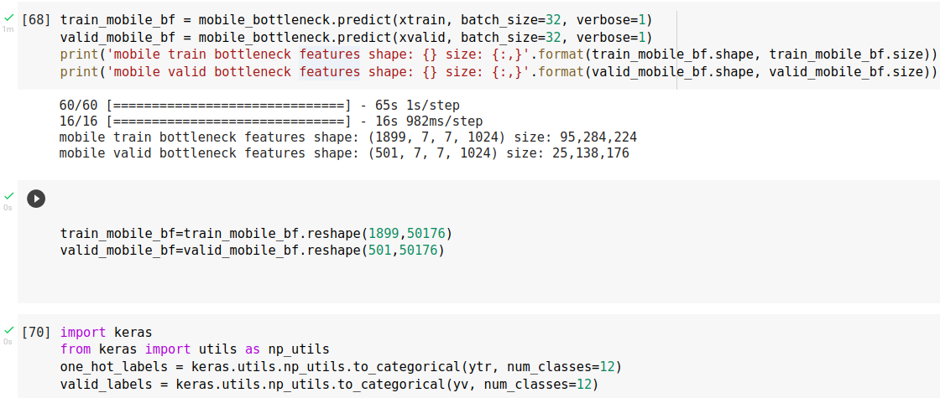

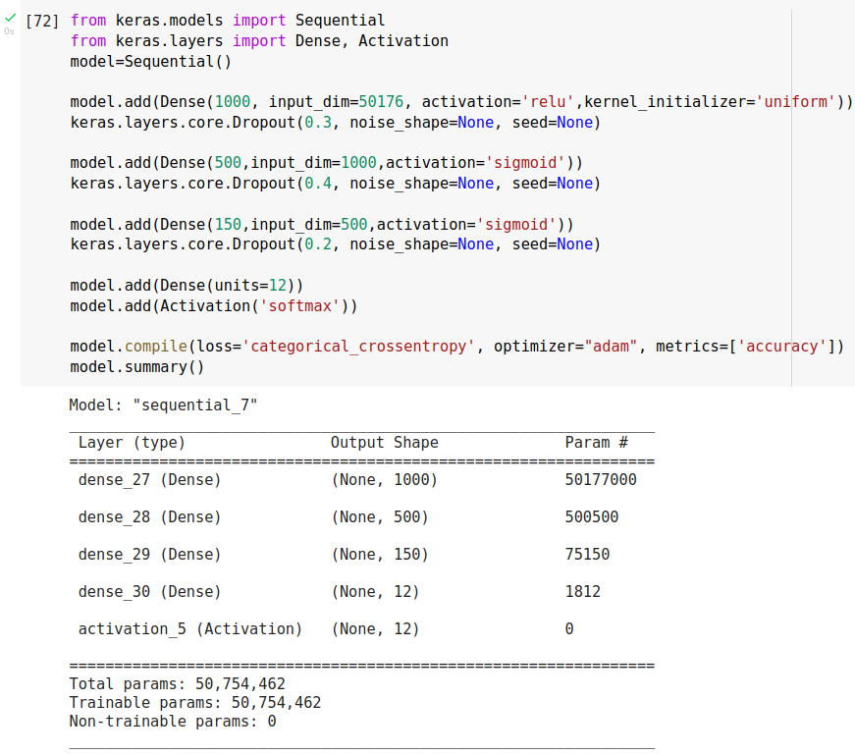

**Result:**

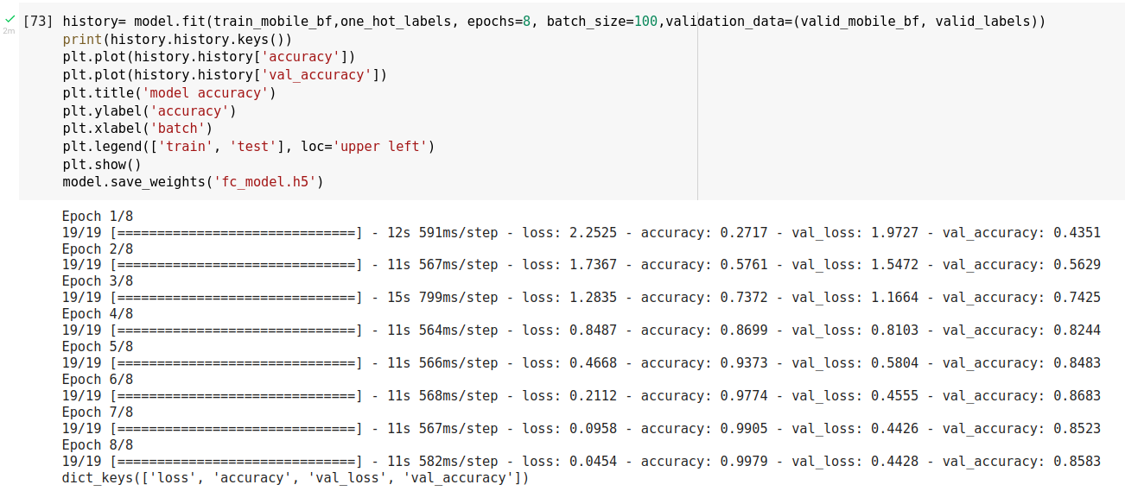

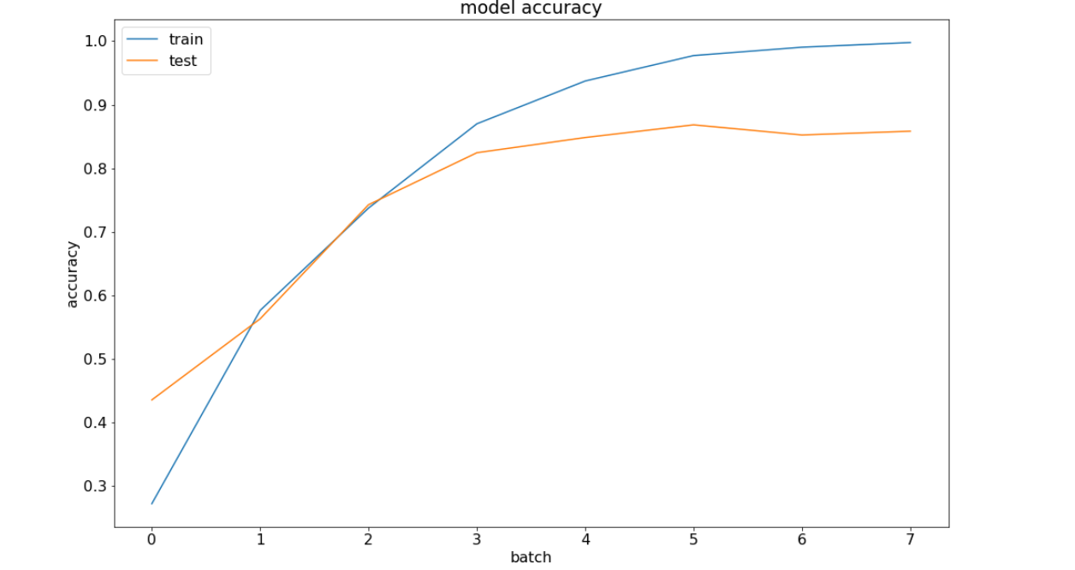

We were able to get an accuracy of 99% according to the classification report. The biggest take away for me was increasing the accuracy. The Dropout layers seemed to really smooth out the training results as well. We can see that most of the species can be well predicted, however, there are some misprediction between Black-grass (BG) and Loose Silkybent (LSB). Some images from the two species classes. We can see that the seedlings of these two species are pretty similar, thus leads to relatively higher misprediction rate than other species.

**CHAPTER 4**

**CONCLUSION**

**Conclusion:**

Our intention was to differentiate weeds seedlings from crops seedlings based on their images. We started from different data preprocessing methods which includes data augmentation, image segmentation, and label conversion for a highly usable training set. Then we explored transfer learning with a range of pre-trained networks which helped to extract features from the input images. Features are then fed into a logistic regression classifier and a neural network classifier for comparison purpose. Our customized model can potentially captures more subtle information and details from the input which the pretrained models may just ignored, thus achieving higher accuracy. Lastly, while SVM model has high accuracy on training set, it performs poorly on testing set. So in this particular experiment, SVM model may be overfitting to the training set due to the curse of dimensionality.

### Future Work:

The Neural Network we build now is not deep enough, but this model has already cost couple hours for training. If we could try to train a much deeper neural network, the test results would be much better. Also, we could try more combinations of the data preprocessing methods.