RAMJI SRIDARAN

Technical Lead
​ +91 9443322527 @ ramjisridaran@gmail.com

SUMMARY

Accomplished Java Technical Lead with expertise in architecting and implementing scalable solutions within AWS and Snowflake environments. Proven experience in developing Java web API applications using Spring Boot, managing message queuing systems, and integrating IoT solutions within a Big Data ecosystem. Adept at technical leadership, mentoring teams, and driving continuous system improvements while ensuring high performance and reliability.

EXPERIENCE

Tech Lead - Java/AWS/Snowflake 06/2021 - 12/2025

Dentsu Global Services
Large scale application development in the advertising domain
- Leading a team of 5 members, managing feature development activities with automated CI/CD strategies using Jenfiins and Kubernetes
- Designed and maintained AWS Simple Work-Flows to process datasets on Snowflafie
- Integrated and synchronized multiple social media platforms (e.g., Facebook, Google Ads, LinkedIn) ensuring compatibility and reducing downtime
- Created new REST APIs and AWS SWF flows using SpringBoot to support ingestion of new datatypes
- Designed and maintained the database tables using Liquibase
- Improved file processing flows to handle diverse usecases using Airflow DAGs G Set up alerts using Datadog monitoring

Java Big-Data Developer 05/2018 - 05/2021

Cognizant Technology Solutions
Migration from Mainframe systems to cloud in Insurance and Retail domain
- MF2C - Leading a team of 2 members to setup data channels using Kaffia with Spring Boot for financial services on Azure
- Set up alerts using Splunfi G Dynatrace based on the logs generated by the applications
- Documented project requirements on Confluence and designed database tables using
Liquibase
- Dental - Migration of data from RDBMS through change data files using Sqoop and loading them into HBase using Sparfi programs using Scala
- Platform - Structuring data from HBase as required by API for faster search through Apache Solr

IoT Developer 02/2014 - 05/2018

Tata Consultancy Services
Internet of Things (IoT) solutions to bring the smart building capability
- Monitoring System implemented for various clients to receive sensor data through MQTT from sensors on industrial devices categorizing them into Kaffia channels and process them through Sparfi engines and store the historical data in Hbase to visualise them using Springboot REST APIs services
- Setting up Device management application to monitor the gateway devices connected to industrial equipments with Leshan and remotely updating agents and store the device information on Postgres

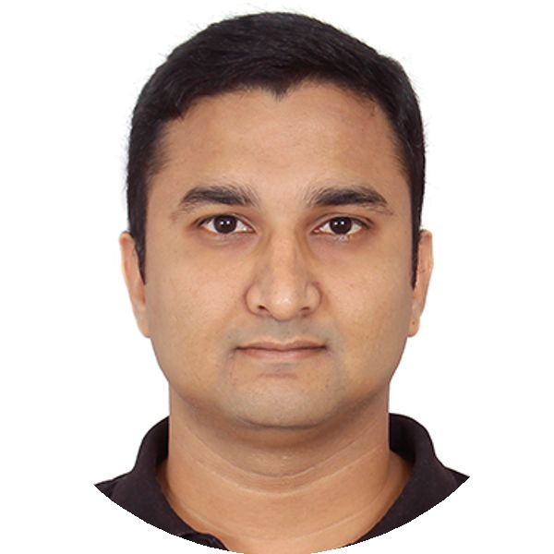
Powered by
EDUCATION

Bachelor in Information Technology
M.Kumarasamy College of Engineering
08/2009 - 05/2013
Karur, Tamil Nadu, India

XII Standard
Jaycees Matriculation Higher Secondary School
05/2009 - 05/2009
Erode, Tamil Nadu, India

X Standard
Jaycees Matriculation Higher Secondary School
05/2007 - 05/2007
Erode, Tamil Nadu, India
SKILLS

Tech Lead
AWS Snowflake Java SpringBoot Python Shell Scripting MySQL Liquibase Datadog WildFly Maven JIRA Agile Jenkins Kubernetes REST Airflow Leadership

Java Big-Data Developer
Sqoop Solr Spark HBase Maven SBT Scala Splunk Dynatrace SonarQube Liquibase Kafka

IoT Developer
Java SpringBoot Kafka Mqtt Spark
HBase Redis Postgres Tomcat Git
TRAININGS & CERTIFICATIONS

SnowPro Associate: Platform Certification

Oracle Certified Professional, Java SE 6 Programmer
​
www.enhancv.com

