Name:pradeepa.s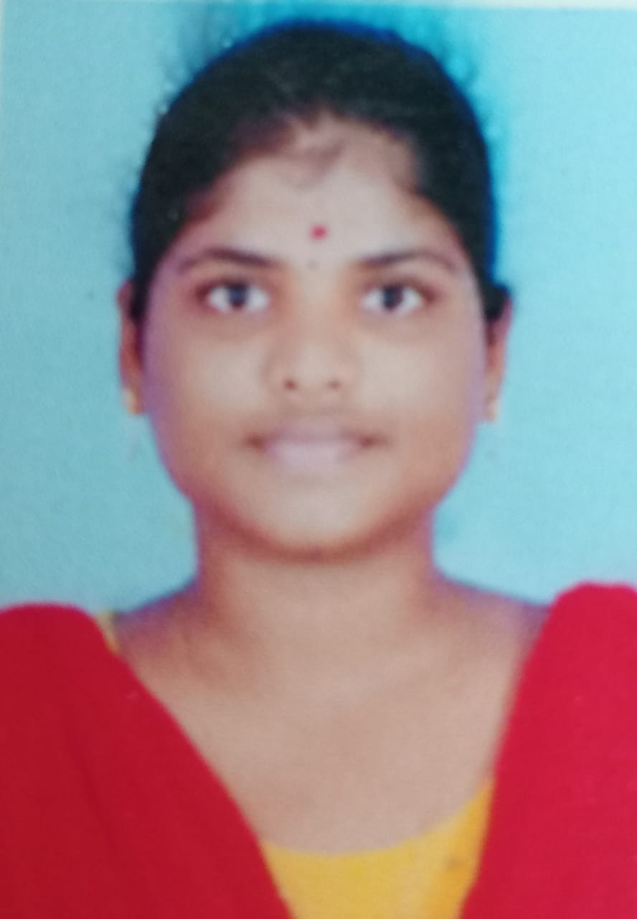

Address:10 vallalar 2nd Street alagappa puram karaikudi

# CARREER OBJECTIVE :

My goal is to become associated with a company where I can utilize my skills and gain further experience while enhancing the company’s productivity and reputation.

# EDUCATIONAL QUALIFICATION :

* Alagappa govt.arts college,Karaikudi.
* 2021
* Pursuing B.sc.Computer Science.
* Chidambaram chettiyar girls Higher Secandory School,Kottaiyur.
* 2020
* HSLC – 90.82%
* Alagappa Matric Higher Secandory School
* 2018
* SSLC – 93.66%

# PROGRAMMING LANGUAGES KNOWN :

* C
* C++
* JAVA
* Python

# STRENGTH/AREA OF EXPERIENCE :

* Positive thinking and active quick learner.
* Planning and scheduling.
* Skilled problem solver.
* Good leadership and supervision quality.
* Presence of mind.
* Ability to built up relationship rapidly and set up trust.

# 

# LANGUAGES KNOWN :

* Tamil
* English

# PERSONAL DETAILS :

|  |  |
| --- | --- |
| NAME | Pradeepa.s |
| DAUGHTER OF/SON OF | Subramanian |
| GENDER (M/F) | FeMALE |
| DATE OF BIRTH | 15/09/2003 |
| NATIONALITY | INDIAN |
| EMAIL ID | pradeepasubramanian15@gmail.com |
| MOBILE NUMBER | 8300110632 |

HOBBIES :

* Reading Books
* Listening Music

# DECLARATION

I hereby declare that the above mentioned statement is correct and true to the best of my knowledge and belief.

DATE : 27.04.2023

Pradeepa.s