Docker

**Docker:** Docker is a configuration management tool that is used to automate the deployment of software in lightweight containers. These containers help applications to work efficiently in different environments.

**Installation Docker on ubuntu:** First we need to take a Machine in ubuntu for install the docker.

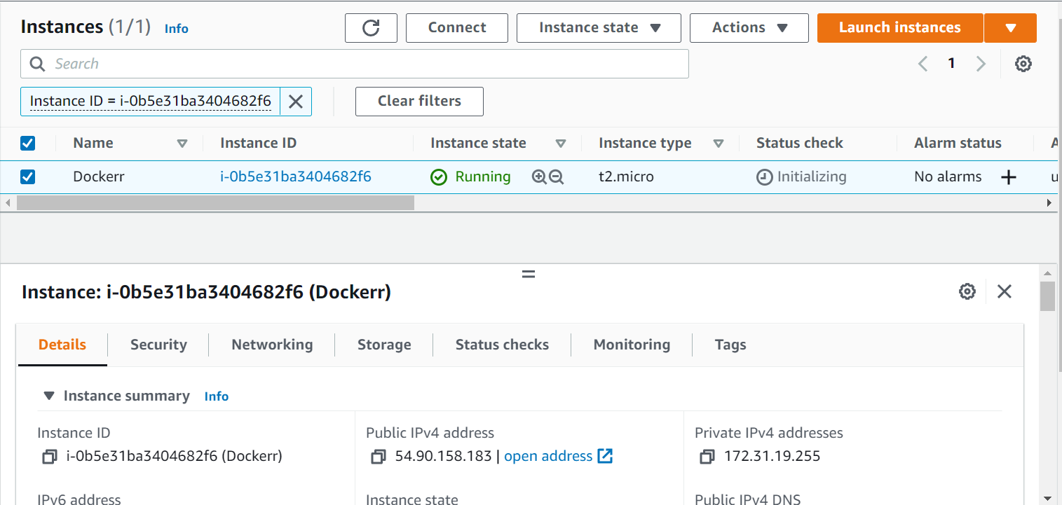

Next we connect to the server through ssh connection.

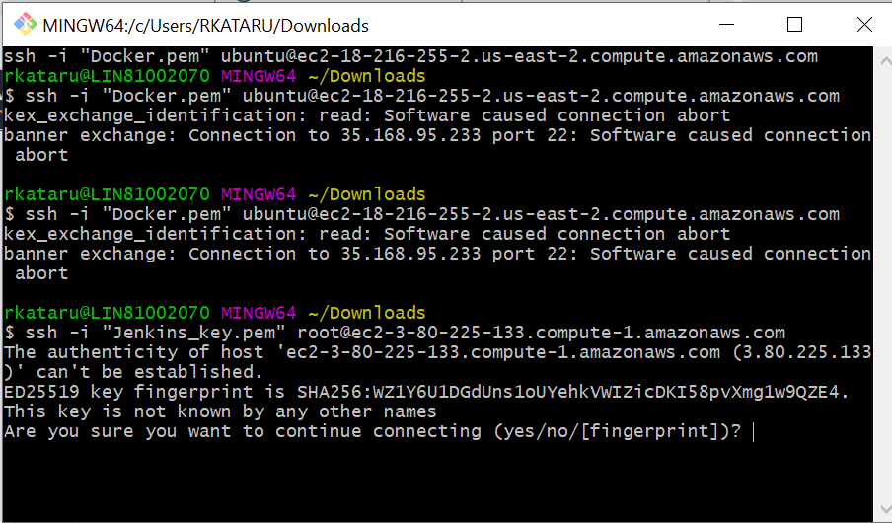

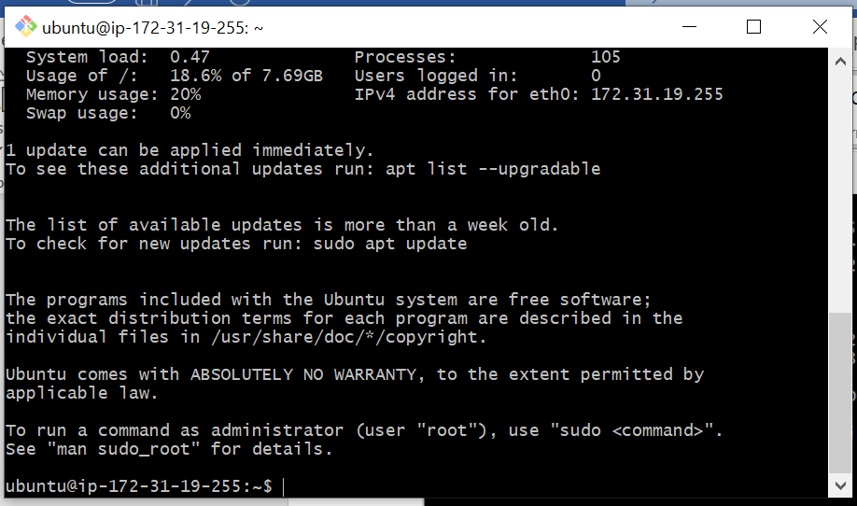

Next we check the weather docker install or not

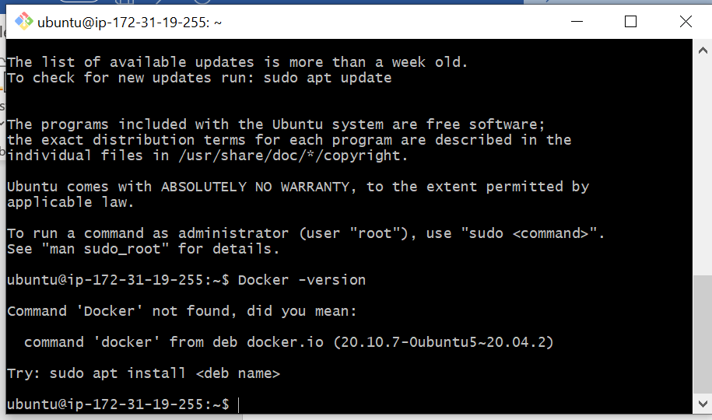

Here Docker was not installed Now we have to install the docker in server

Check if the system is up-to-date using the following command

**sudo apt-get update**

Install Docker using the following command:

**$ sudo apt install docker.io**

You’ll then get a prompt asking you to choose between y/n - choose y

Install all the dependency packages using the following command:

**$ sudo snap install docker**

Before testing Docker, check the version installed using the following command:

**$ docker --version**

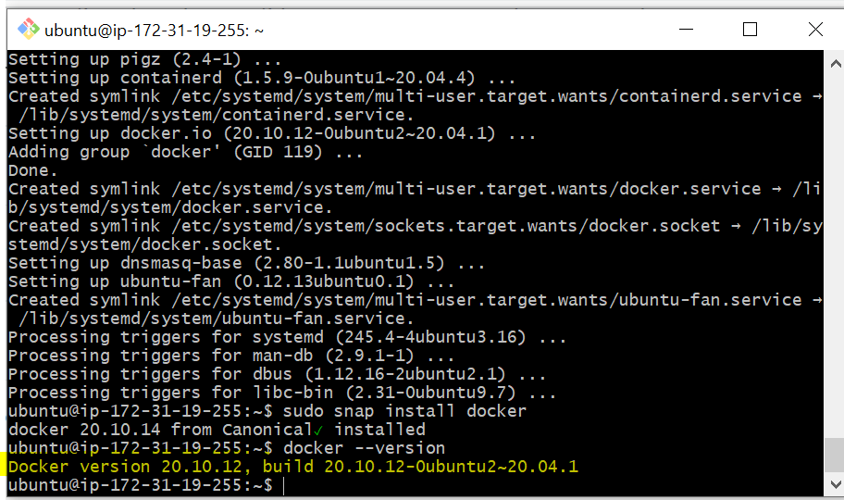

The above image shows the version of Docker