**Be.Cognizant -** [**https://be.cognizant.com**](https://be.cognizant.com)

**What is Be.Cognizant?**

Be.Cognizant is Cognizant’s new intranet. It provides one-stop access, easily connecting our diverse population of 280,000+ associates worldwide to the tools, information and people they need to help them be successful in their work.

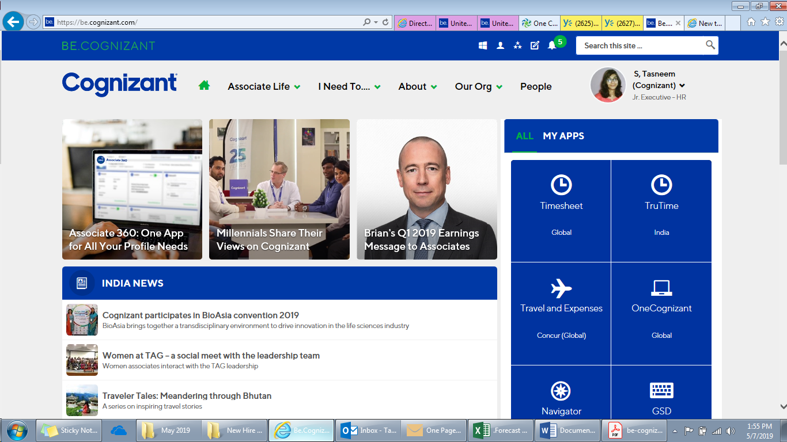

**Different Tabs of Be.Cognizant**

**Associate Life:**

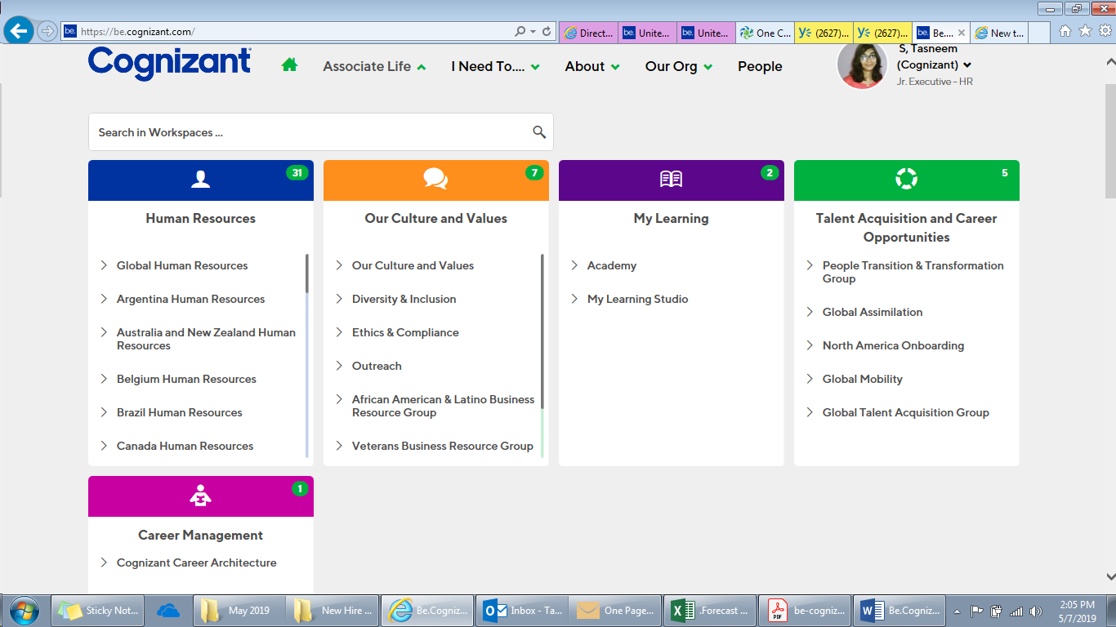

**I Need To…**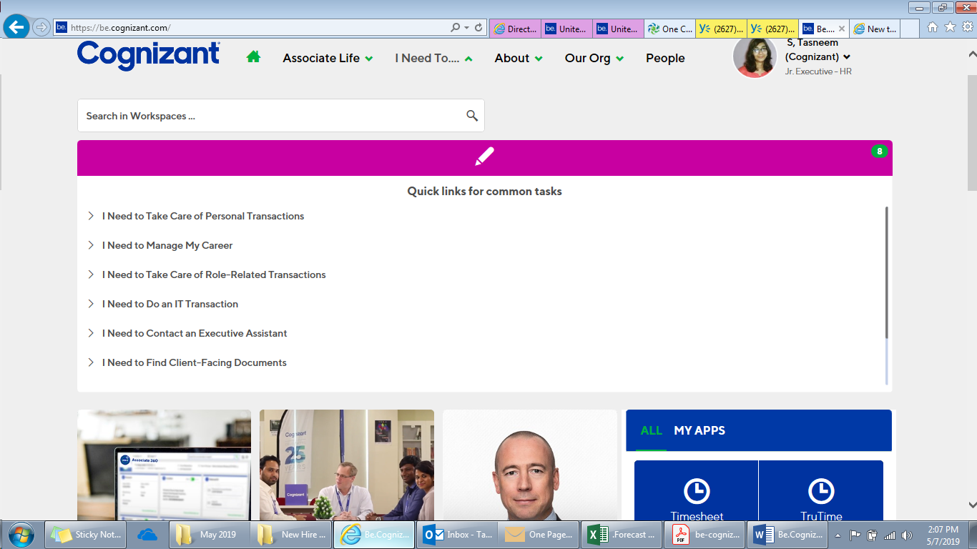

**About:**

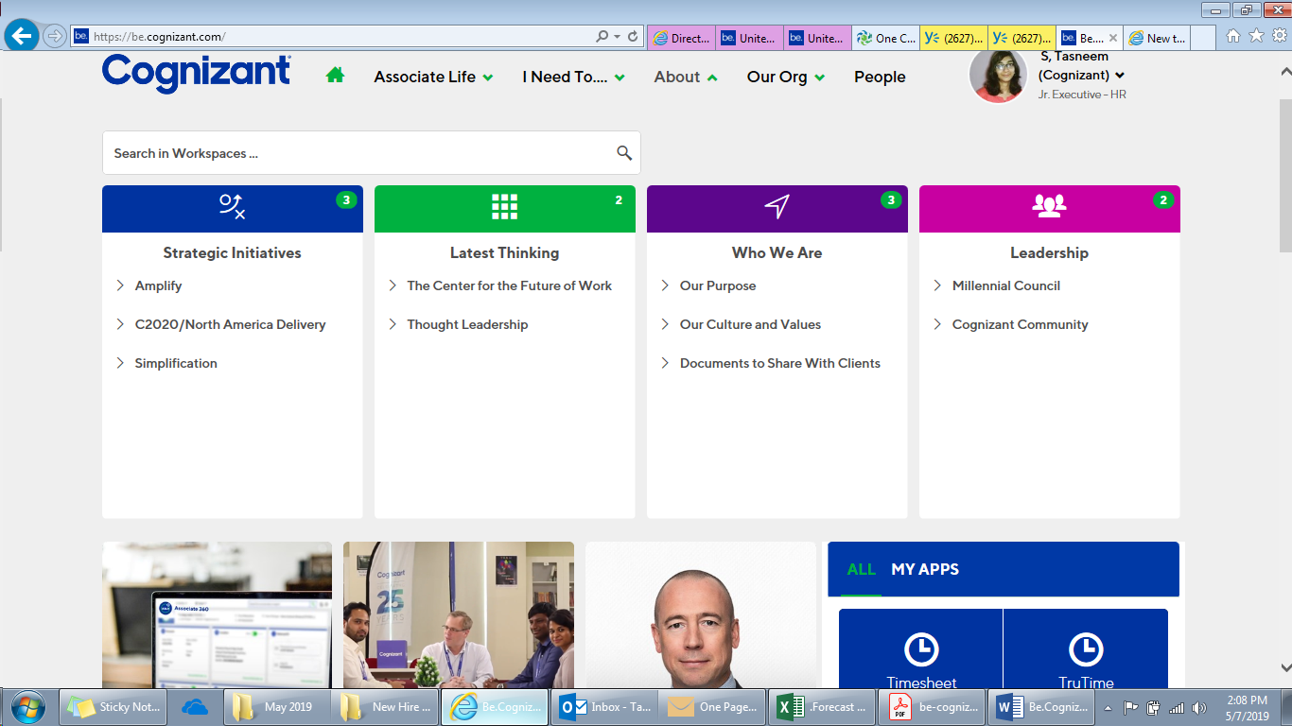

**Our Org:**

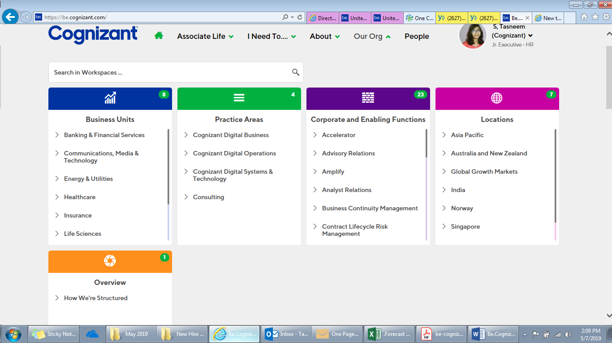

**People:** The People Directory is a robust search tool that allows you to find an associate based on name, associate ID, department or location.

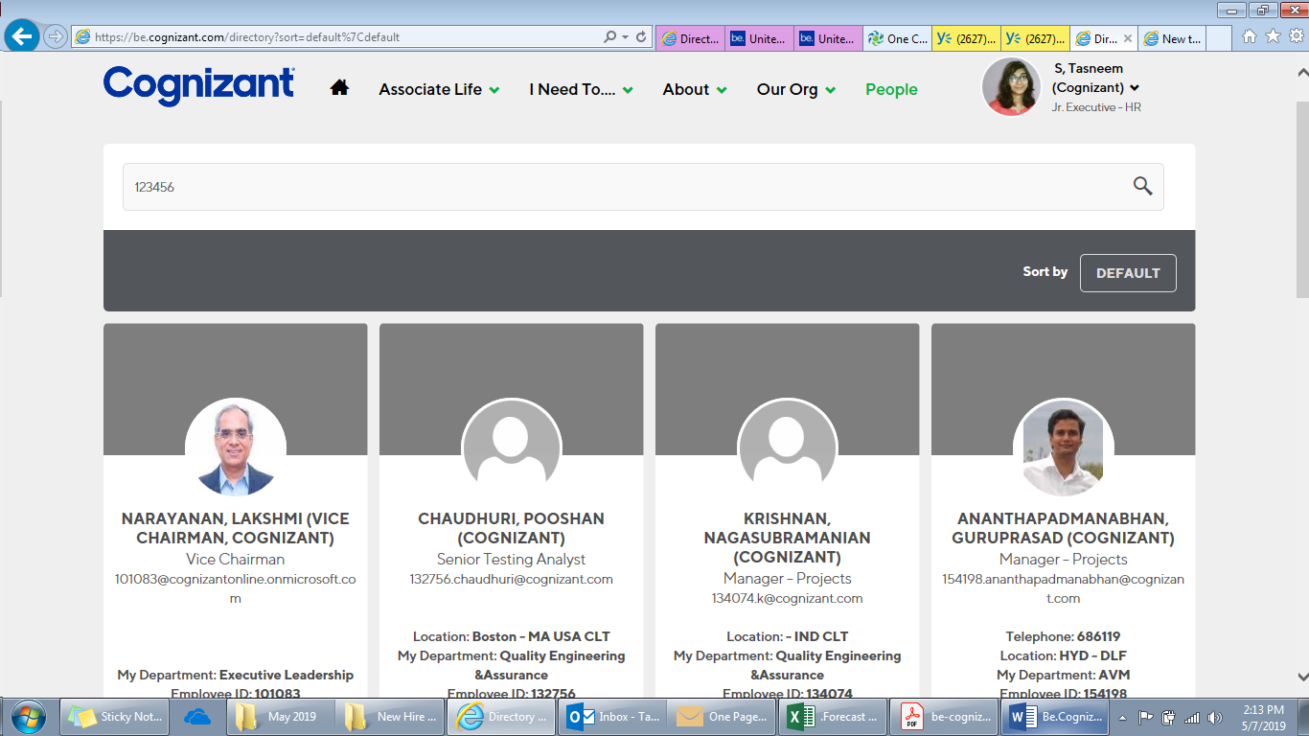

**Using Be.Cognizant**

**How do I add apps to my homepage?**

* Click on APPS AND TOOLS in the top navigation (Windows Icon).
* Click MANAGE.
* Search for and select the apps most relevant to you. Click FINISH.
* Click SAVE CHANGES and refresh your browser.
* You will now see two tabs in the Apps and Tools widget on your homepage. To see the apps you just added, click on the MY APPS tab within the widget.

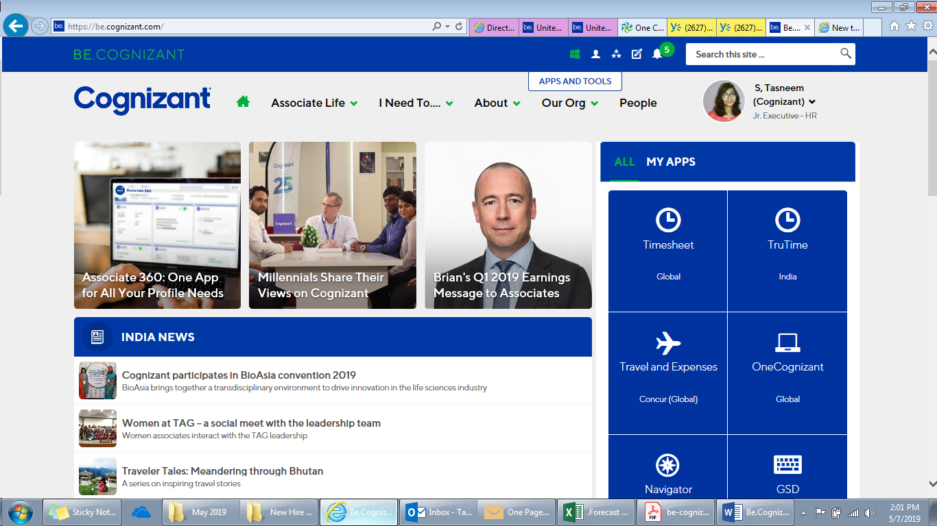

**How do I follow pages or documents that interest me?**

* Navigate to the page, document or other piece of content you want to follow.
* Click the FOLLOW button (star icon) in the top navigation.
* You will receive notifications about the items you’ve selected in the notification bell in the top navigation bar.

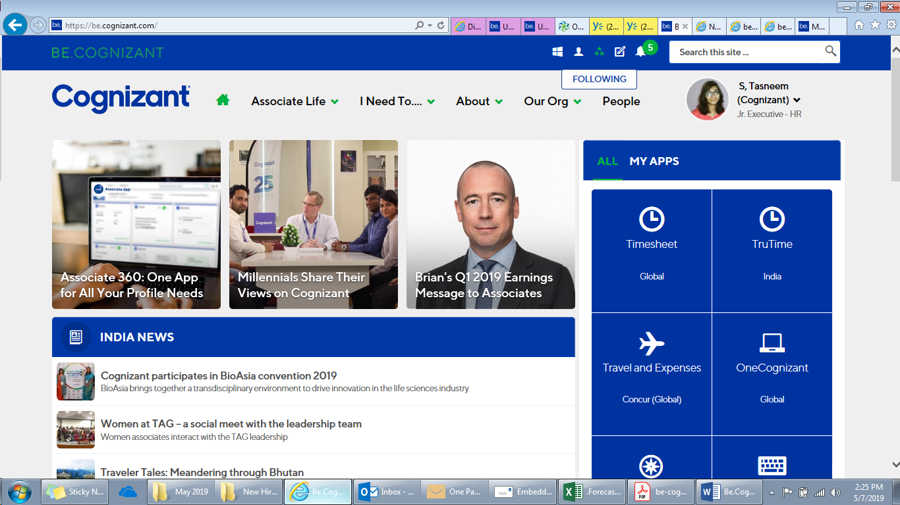

**How do I upload my profile picture?** Read this [Cognizant Hack](https://be.cognizant.com/News/316489/cognizant-hacks-make-an-impression-with-your-profile-picture) for a step-by-step guide to uploading you photo.

**How do I manage notifications for Be.Cognizant?**

* Click on the bell in the top navigation.
* Click SETTINGS.
* Turn off notifications you aren’t interested in receiving and click SUBMIT.

