  

DEPARTMENT OF COMPUTER SCIENCE AND ENGINEERING NAAN MUDHALVAN

# SB8026 – ROBOTIC PROCESS AUTOMATION DEVELOPMENT

**PROJECT TITLE: DOCUMENT TEMPLATING FOR ACADEMIC ADMINISTRATION**

**SUBMITTED BY**

# Raja A-952822104083

**GUIDED BY**

**Mrs.N. Sumi ASP/CSE**



**SCAD College of Engineering and Technology, Cheranmahadevi, Tirunelveli -627414.**

**Anna University -Chennai**

**i**

DEPARTMENT OF COMPUTER SCIENCE AND ENGINEERING

Certified that this is a bonafide record of work done by Selvan / Selvi

Reg.No.of Semester Department of in the Academic year 2024- 2025.

Staff-in-Charge Head of the Department



**Reg. No.**

Submitted for the University Practical Examination held on

**Internal Examiner External Examiner**

**CREATING A UIPATH AUTOMATION CLOUD ACCOUNT**

## Here's a step -by-step guide on how to create an account on the UiPath Automation

**Cloud platform:**

## Visit the UiPath Automation Cloud Sign-Up Page:

Open your web browser and go to the UiPath Automation Cloud sign-up page

## Select the Appropriate Version:

On the download page, you'll see different versions of UiPath Studio available. Choose the version that aligns with your system requirements and needs.

Pay attention to the system requirements, as they specify the minimum hardware and software specifications needed to run UiPath Studio

## Download the Installer:

Once you've selected the desired version, click on the "Download" button. This will initiate the download of the UiPath Studio installer (.msi file).

## Save the Installer:

Choose a suitable location on your computer to save the downloaded .msi file.

This could be your Downloads folder or any other preferred location.

## Run the Installer:

Once the download is complete, double-click on the downloaded .msi file to start the installation process.

Follow the on-screen instructions to complete the installation

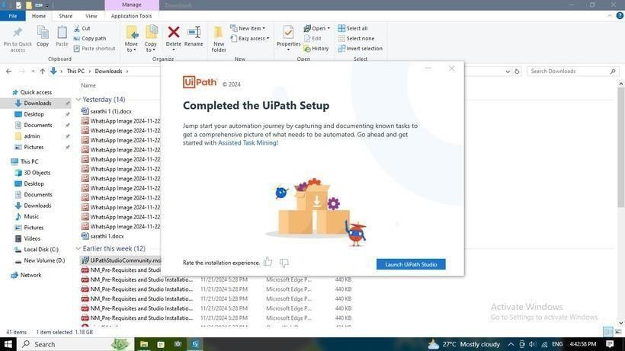

## Launch UiPath Studio:

**Desktop Shortcut:** If you've created a desktop shortcut during installation, double-click on it.

S**tart Menu:** Search for "UiPath Studio" in the Windows Start menu and open it.

## Welcome Screen:

Upon launching, you'll be greeted with the UiPath Studio welcome screen.

## Create a New Project:

Click on the **"Create a New Project"** button. This will open a new project window.

## Project Details:

**Name:** Give your project a meaningful name.

**Description:** Add a brief description of the project's purpose.

**Location:** Choose a suitable location to save your project.

## Create the Project:

Click the **"Create"** button to finalize the project creation process.

## UiPath Studio Interface:

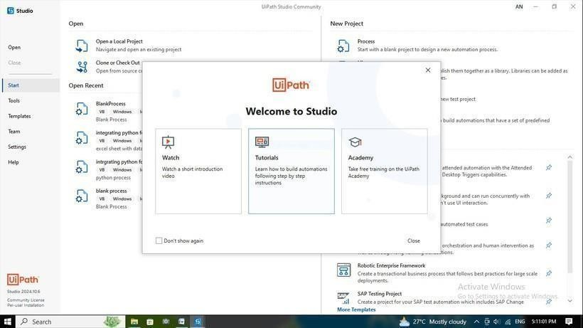

* + - The UiPath Studio interface will open, displaying the following main areas: **Ribbon:** Contains various tools and commands for automation activities. **Designer:** The primary workspace for designing automation workflows. **Properties Panel:** Displays properties and settings of selected elements. **Project Panel:** Shows the project structure, including activities, variables, andarguments

## HERE'S HOW YOU CAN CREATE A MOVE FOLDER SEQUENCE AND A MULTIPLEASSIGN ACTIVITY TO IMPLEMENT THE FILE MOVING LOGIC IN UIPATH STUDIO:

**Create a New Sequence:**

In your UiPath Studio project, right-click on the "Main" sequence and select "Add Sequence."

Give the new sequence a meaningful name like "Move Folder."



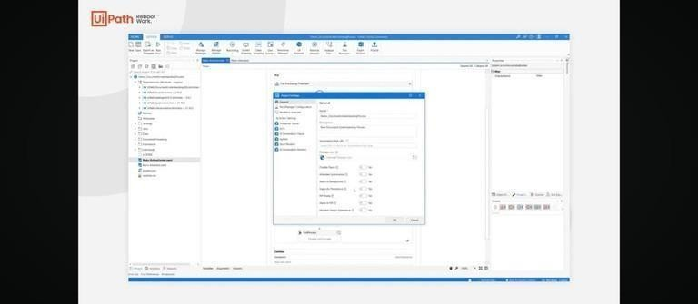

Extract Information from excel through attributes on ui path and replace to

the word

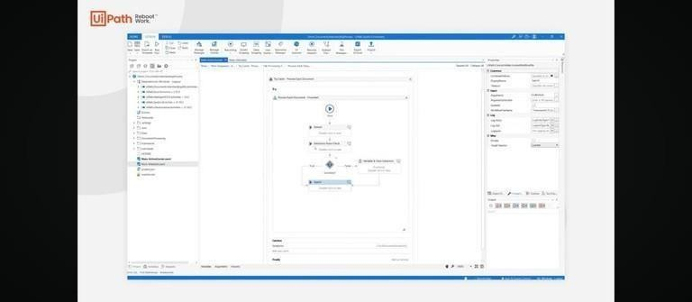

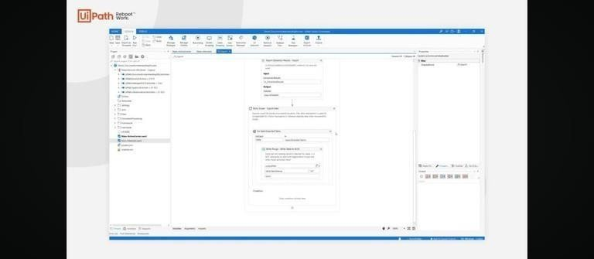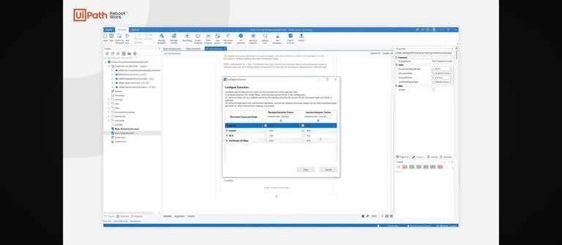

For Word document replacing is done by the insert attribute in the ui path





Finally The Data from excel is replaced in the Word document through all the combined actions on the ui path Studio

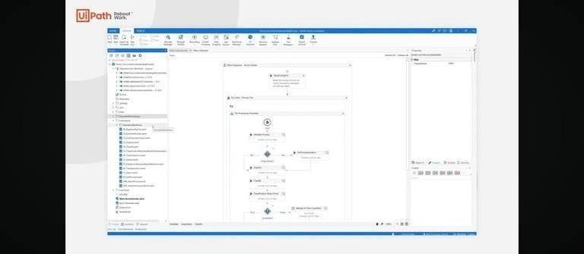



# Create a excel dataset and filter the extracted dataset with the entered minimum and maximum prices and write the extracted data in an excel file.

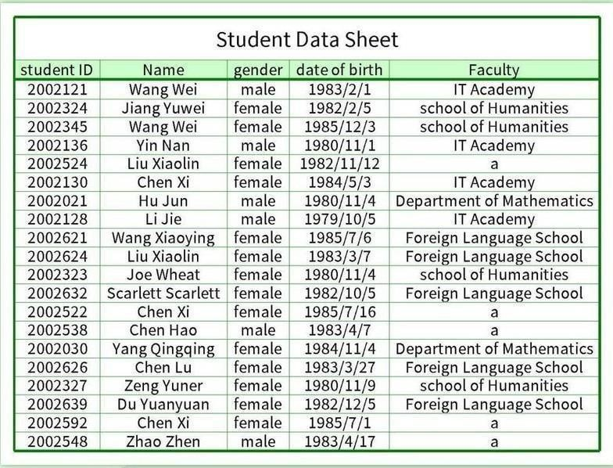



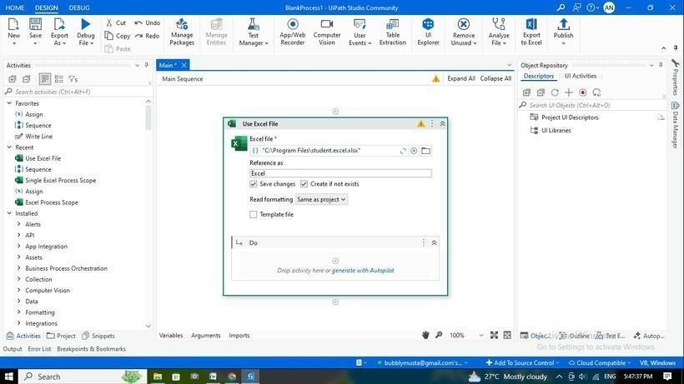

**Diploma Certificate :**



[**Course Link**](https://academy.uipath.com/learning-plans/naan-mudhalvan-robotic-process-automation-foundation-course-for-engineering) (Click for link) **https://drive.google.com/file/d/1N4BrE fcogSzJarpwlTmKXnuMqTtw_6mG/vi ew?usp=drivesdk (**Click for Certificate link)

**CONCLUSION :**

The Document Templating for Academic Administration Project utilizing UiPath provides a streamlined, efficient, and scalable solution to automate the generation and management of academic documents. By integrating UiPath's powerful robotic process automation (RPA) capabilities, the project successfully reduces manual effort, mitigates human error, and enhances consistency in document production.