3.1 Write a Program to find both the maximum and minimum values in the array.Implement using any programming language of your choice. Execute your code and provide the maximum and minimum values found.

AIM
To write a program that finds both the minimum and maximum values from an array of integers.
ALGORITHM
- Input the size of the array N and the array elements.
- Initialize min = a[0] and max = a[0].
- Traverse the array from index 1 to N-1:
- If a[i] < min, update min = a[i].
- If a[i] > max, update max = a[i].
- After traversal, print the min and max.
PROGRAM
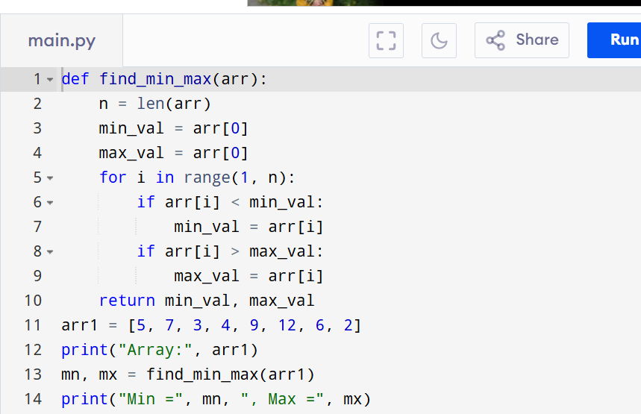

Input:
N=8, a[] = {5,7,3,4,9,12,6,2}
Output:
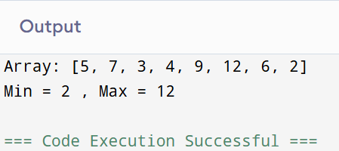

RESULT:
Thus the program to find both the maximum and minimum values in the array is successfully executed and the output is verified.

PERFORMANCE ANALYSIS:
- Time Complexity:O(N).
- Space Complexity:O(1)

