3.10 TOTAL NUMBER OF TUPLES

Aim: To find the total number of tuples (i,j,k,l)(i, j, k, l)(i,j,k,l) such that the sum of elements from four integer lists A[i]+B[j]+C[k]+D[l]=0A[i] + B[j] + C[k] + D[l] = 0A[i]+B[j]+C[k]+D[l]=0.
Algorithm:
- Initialize a dictionary sum_ab to store the frequency of sums of elements from lists A and B.
- Calculate all possible sums of pairs from A and B:
  - For each element a in A:
    - For each element b in B:
      - Compute sum = a + b
      - Increment the count of this sum in sum_ab.
- Initialize a counter count to zero for storing the number of valid tuples.
- Iterate over all pairs from C and D:
  - For each element c in C:
    - For each element d in D:
      - Calculate target = -(c + d)
      - If target exists in sum_ab, add sum_ab[target] to count.
- Return count, which is the total number of tuples satisfying A[i]+B[j]+C[k]+D[l]=0A[i] + B[j] + C[k] + D[l] = 0A[i]+B[j]+C[k]+D[l]=0.
Program:
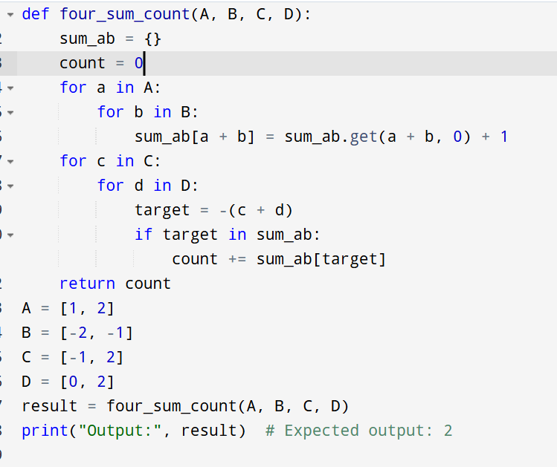

Input:
A = [1, 2]
B = [-2, -1]
C = [-1, 2]
D = [0, 2]
Output:
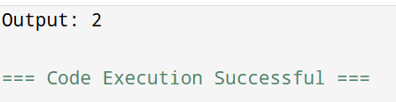
Result: Thus, the program is executed successfully and the output is verified.
Performance analysis:

Approach | Time Complexity | Space Complexity
Naive (4 loops) | O(n4)O(n^4) | O(1)O(1)
Optimized (HashMap) | O(n2)O(n^2) (for sums) | O(n2)O(n^2) for hashmap

