3.11 To Implement the Median of Medians algorithm ensures that you handle the worst-case time complexity efficiently while finding the k-th smallest element in an unsorted array.
arr = [12, 3, 5, 7, 19] k = 2 Expected Output:5
AIM
To implement the Median of Medians algorithm to find the k-th smallest element in an unsorted array efficiently with guaranteed worst-case linear time.
ALGORITHM
- Divide the array into groups of at most 5 elements.
- Sort each group and find the median of each group.
- Recursively apply the Median of Medians algorithm to the medians array to find the pivot.
- Partition the array around the pivot.
- If the pivot’s position matches k, return it.
- If k is smaller, recurse on the left side; otherwise, recurse on the right side.
PROGRAM
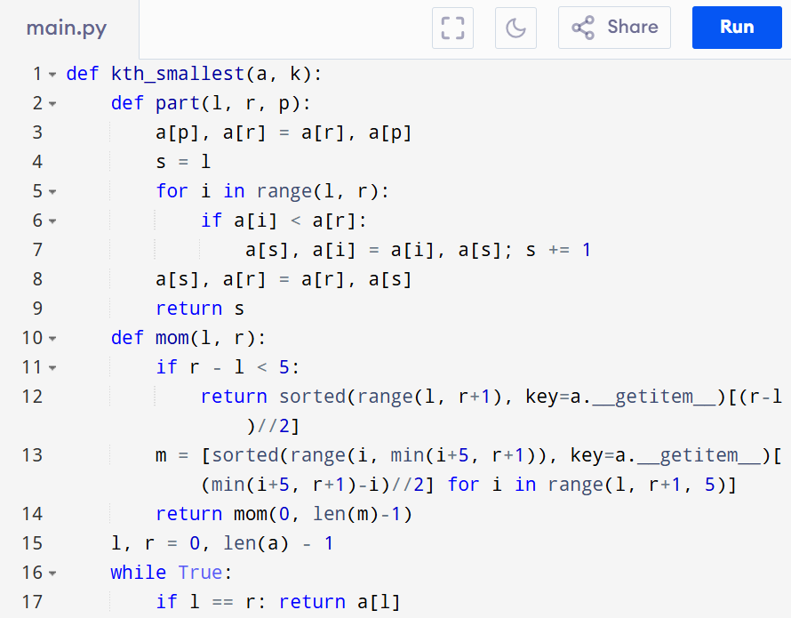
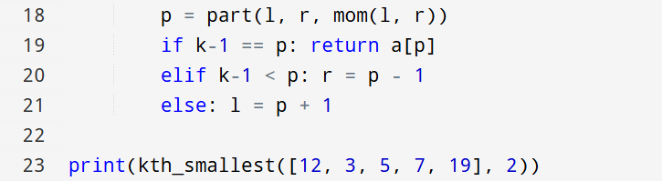

Input:
arr = [12, 3, 5, 7, 19] , k = 2

Output:
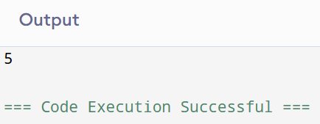

RESULT:
Thus the program to implement the median of medians algorithm is successfully executed and the output is verified.

PERFORMANCE ANALYSIS:
- Time Complexity: O(n).
- Space Complexity:O(log n)

