3.12 Median of Medians Algorithm

Aim: To find the k-th smallest element in an unsorted list in guaranteed linear time (O(n)), overcoming the worst-case inefficiency of simpler selection algorithms like Quickselect.
Algorithm:
- Divide arr into groups of 5 elements.
- Find the median of each group.
- Recursively find the median of medians.
- Use this median as pivot to partition arr.
- Recur on the partition that contains the k-th smallest.
Program:

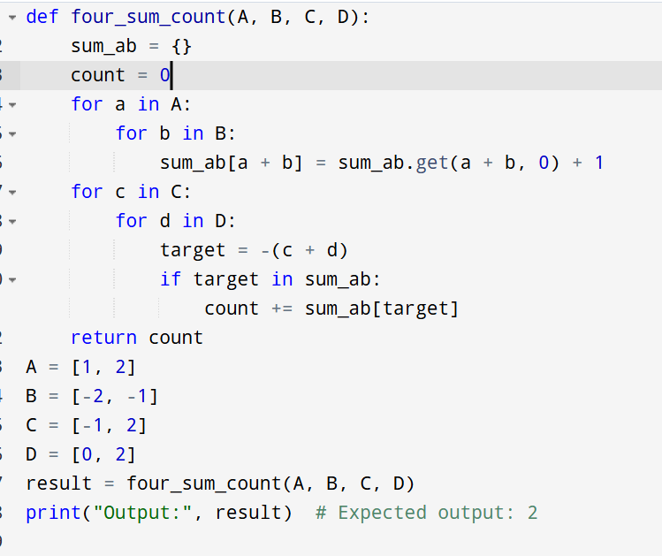

Input:
arr1 = [1, 2, 3, 4, 5, 6, 7, 8, 9, 10]
arr2 = [23, 17, 31, 44, 55, 21, 20, 18, 19, 27]
Output:
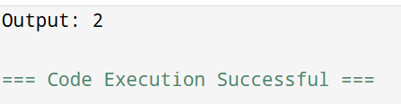
Result: Thus, the program is executed successfully and the output is verified.

Performance analysis:
- Time Complexity: The worst-case time complexity of the Median of Medians algorithm is O(n). This is because:
  - Dividing into groups of 5 takes O(n).
  - Finding medians of groups is O(n).
  - Recursively finding median of medians is T(n/5).
  - Partitioning around the pivot is O(n).
  - The recursion call on a smaller subset (at most 7n/10 elements).
This results in the recurrence:
T(n)≤T(n/5)+T(7n/10)+O(n)T(n) \leq T(n/5) + T(7n/10) + O(n)T(n)≤T(n/5)+T(7n/10)+O(n)
which solves to O(n).
- Space Complexity: O(n) due to recursion stack and list slicing.

