3.13 Write a program to implement Meet in the Middle Technique. Given an array of integers and a target sum, find the subset whose sum is closest to the target. You will use the Meet in the Middle technique to efficiently find this subset.
Set[] = {45, 34, 4, 12, 5, 2} Target Sum : 42
AIM
To implement the Meet in the Middle technique to find a subset whose sum is closest to a given target sum.
ALGORITHM
- Split the array into two halves.
- Generate all subset sums for each half.
- Sort one half’s subset sums.
- For each sum in the first half’s list, use binary search in the second half’s sorted list to find the sum that gets closest to the target.
- Keep track of the best sum and the corresponding subset.
PROGRAM
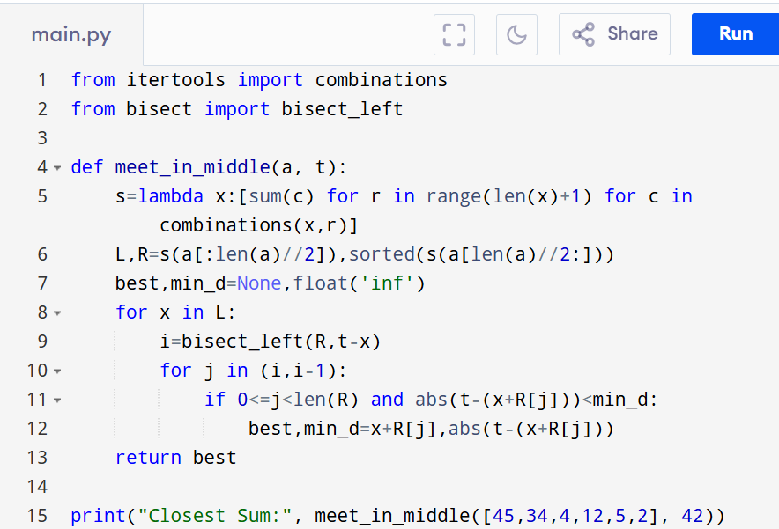

Input:
Set[] = {45, 34, 4, 12, 5, 2}

Output:
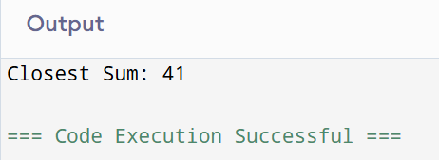
RESULT:
Thus the program to implement the meet in the middle technique is successfully executed and the output is verified.
PERFORMANCE ANALYSIS:
  - Time Complexity: O(2^n/2.n).
  - Space Complexity:O(2n/2).

