3.14 MEET IN MIDDLE TECHNIQUE

Aim: To solve the Subset Sum Problem using the Meet in the Middle (MITM) technique.
Algorithm:
- Split array into two halves: left, right.
- Generate all possible subset sums of both halves.
- Sort the right sums.
- For each sum in the left, check if target - sum exists in right using binary search.
- If found, return True; else, return False.

Program:
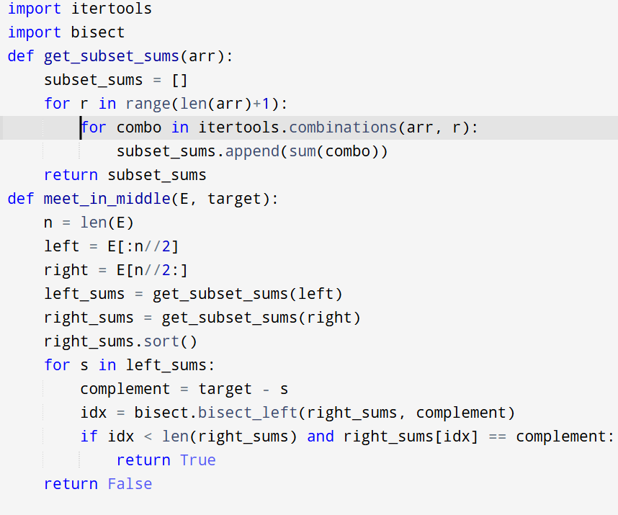

Input:
E = [1, 3, 9, 2, 7, 12]
Output:
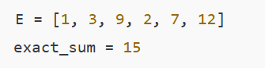

Result: Thus, the program is executed successfully and output is verified.

Performance analysis:
- Time Complexity: O(2^(n/2) * log(2^(n/2))) = O(2^(n/2) * n)
- Space Complexity: O(2^(n/2))

