3.15 Given two 2×2 Matrices A and B
A=(1 7​ , B=( 1 3
3 5) 7 5)
Use Strassen's matrix multiplication algorithm to compute the product matrix C such that C=A×B.

AIM
To multiply two 2×2 matrices using Strassen’s algorithm, which reduces the number of multiplications compared to the standard method.
ALGORITHM
- Let A=[a​b​ B=[e​f
c d] g h]
- Compute the following intermediate products:
M1=(a+d)(e+h)
M2=(c+d)e
M3=a(f−h)
M4=d(g−e)
M5=(a+b)h
M6=(c−a)(e+f)
M7=(b−d)(g+h)
- Compute the result matrix:
C11​=M1+M4−M5+M7
C12​=M3+M5
C21​=M2+M4
C22​=M1−M2+M3+M6

PROGRAM 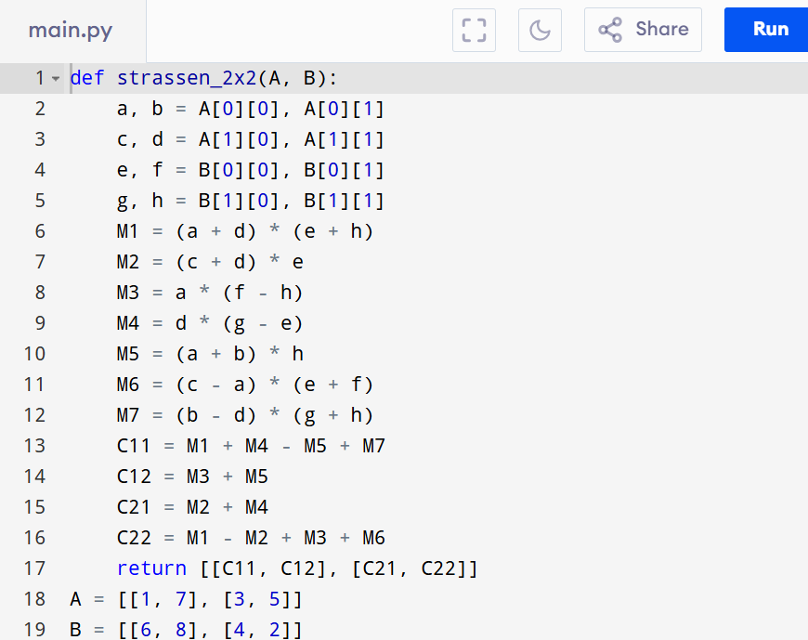
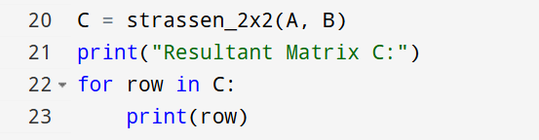

Input:
A=(1 7​ B=( 1 3
3 5) 7 5)

Output:
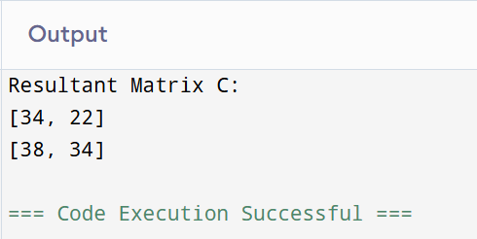

RESULT:
Thus the program to multiply two 2×2 matrices using strassen’s algorithm is successfully executed and the output is verified.

PERFORMANCE ANALYSIS:
- Time Complexity: O(n^3).
- Space Complexity:O(n^2).

