3.16 Karatsuba algorithm

Aim: To compute the product of two integers, X=1234 and Y=5678, using the Karatsuba algorithm and analyse its performance.
Algorithm:
- For two numbers, X and Y, with n digits, they are split into two halves:
- X=acdot10m+b
- Y=ccdot10m+d
- Where m is approximately n/2.
- The product Z=XcdotY is given by the formula:
- Z=(a⋅10m+b)(c⋅10m+d)=ac⋅102m+(ad+bc)⋅10m+bd
- The standard method computes four products: ac, ad, bc, and bd. Karatsuba reduces this to three products by cleverly rearranging the terms:
- P_1=ac
- P_2=bd
- P_3=(a+b)(c+d)
- From these, we can find the middle term:
- (a+b)(c+d)=ac+ad+bc+bd⟹ad+bc=(a+b)(c+d)−ac−bd=P3​−P1​−P2​
- The final product is then:
- Z=P1​⋅102m+(P3​−P1​−P2​)⋅10m+P2​

Program:
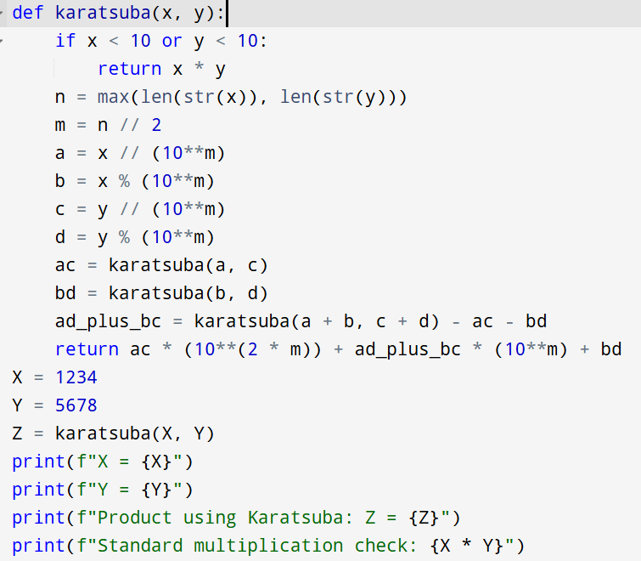

Input:
- X=1234
- Y=5678
Output:
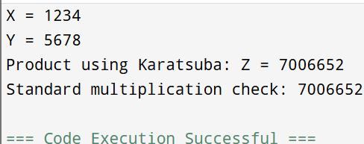

Result: Thus, the program is executed successfully and output is verified.

Performance analysis:
- Time Complexity: O(nlog_23)
- Space Complexity: O(n2).

