3.2 MAXIMUM AND MINIMUM VALUES

Aim: To write a Python program to find the minimum and maximum values in a sorted array.
Algorithm:
- StarT.
- Input: Read integer N and array a[0...N-1]
- Initialize:
- min_val = a[0]
- max_val = a[0]
- Repeat for i = 1 to N - 1:
- If a[i] < min_val, then min_val = a[i]
- If a[i] > max_val, then max_val = a[i]
- Output: min_val and max_val
End
Program:
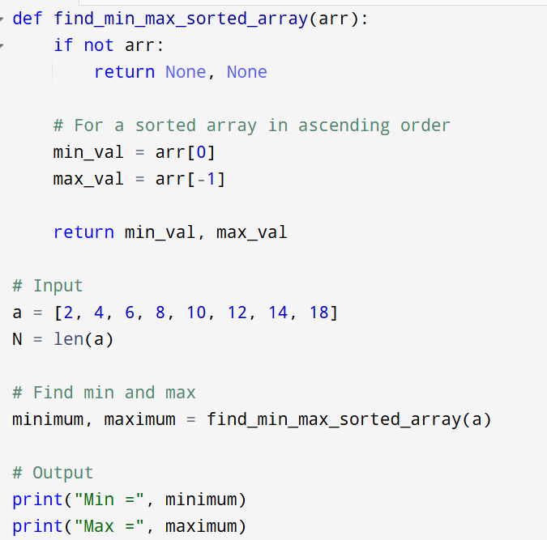
Input:
a = [2, 4, 6, 8, 10, 12, 14, 18]

Output:
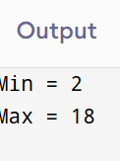

Result: Thus the program is successfully executed and the output is verified.

Performance analysis:
Time Complexity: | O(1) for sorted array (direct access)
Space Complexity: | O(1)

