3.3 You are given an unsorted array 31,23,35,27,11,21,15,28. Write a program for Merge Sort and implement using any programming language of your choice.

AIM
To write a program that sorts an unsorted array using the Merge Sort algorithm.

ALGORITHM
- Input the array of size N.
- If the array has only one element, return (base case).
- Otherwise,Find the middle index.
- Recursively apply Merge Sort on the left subarray.
- Recursively apply Merge Sort on the right subarray.
- Merge the two sorted subarrays into a single sorted array.
- Output the sorted array.
PROGRAM
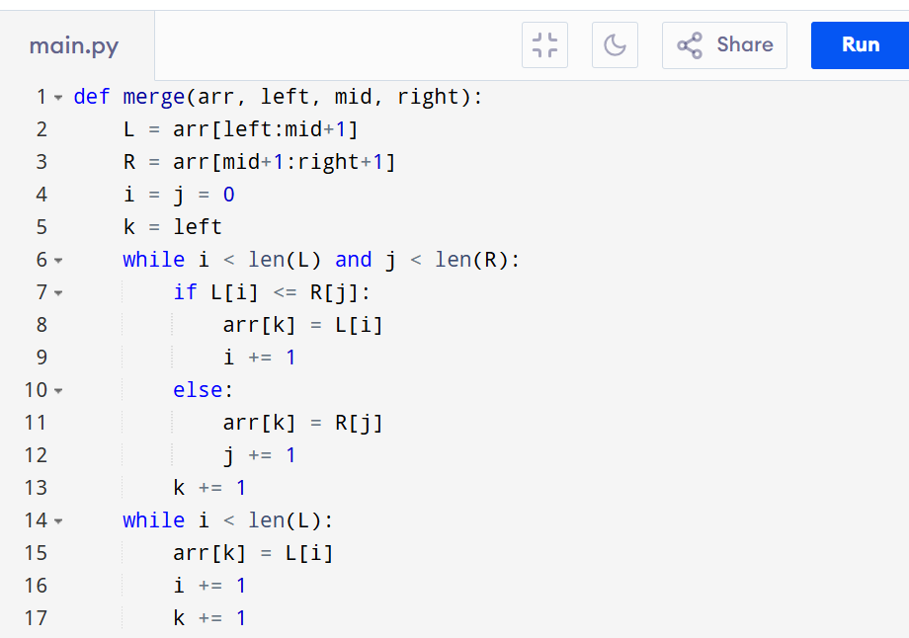
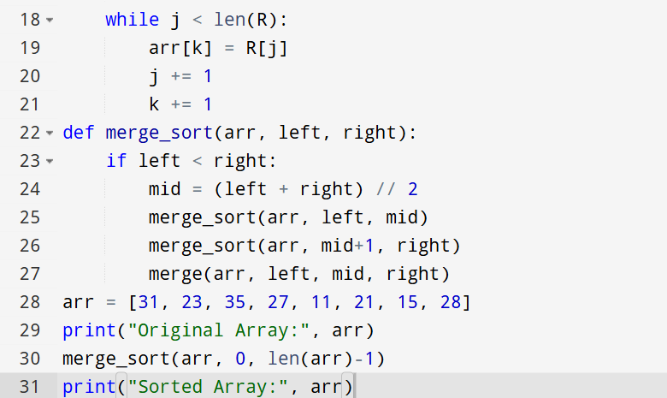

Input:
N=8, a[] = {31,23,35,27,11,21,15,28}
Output:
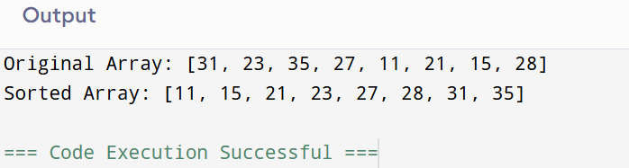
RESULT:
Thus the program that sorts an unsorted array using the Merge Sort algorithm is successfully executed and the output is verified.

PERFORMANCE ANALYSIS:
  - Time Complexity: O(N log N).
  - Space Complexity:O(N)

