3.4 MERGE SORTING

Aim: To write a Python program to execute merge sort.
Algorithm:
- Start
- Input: Read integer N and array a[0...N-1]
- If size of array <= 1, return (base case)
- Divide the array into two halves:
- Left = first half
- Right = second half
- Recursively apply merge sort to both halves
- Merge the two sorted halves into a single sorted array:
- While merging, count each comparison between elements
- Return the merged sorted array
- Output: Sorted array and number of comparisons
- End
Program:
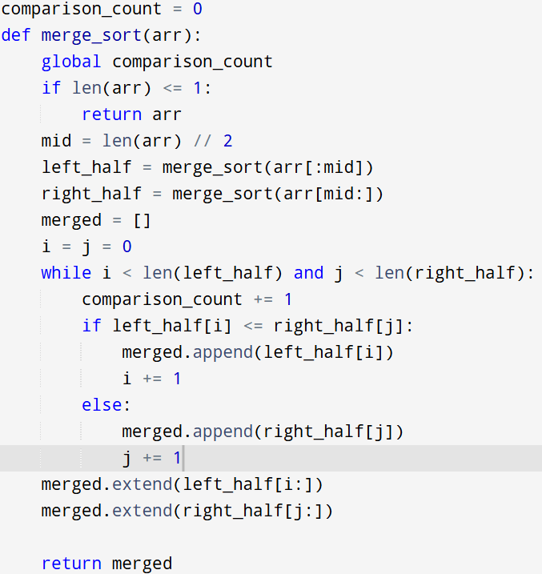
Input:
a = [12, 4, 78, 23, 45, 67, 89, 1]
Output:
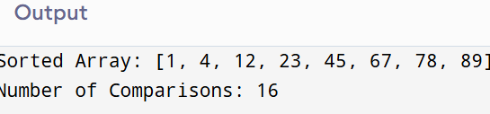

Result: Thus the program is successfully executed and the output is verified.

Performance analysis:
Time Complexity | :O(n log n)

Space Complexity | :O(n) (due to new arrays)

