3.6 QUICK SORTING

Aim: To write a Python program to execute quick sort.
Algorithm:
- Start
- Input: Array a[] and its size N
- If array has 0 or 1 elements, return (already sorted)
- Select Pivot: Choose the middle element as pivot
- Partition:
- Place all elements less than pivot on the left
- Place all elements greater than or equal to pivot on the right
- Recursively apply Quick Sort on left and right sub-arrays
- Output:
- Show array after each partitioning/recursion
- End
Program:
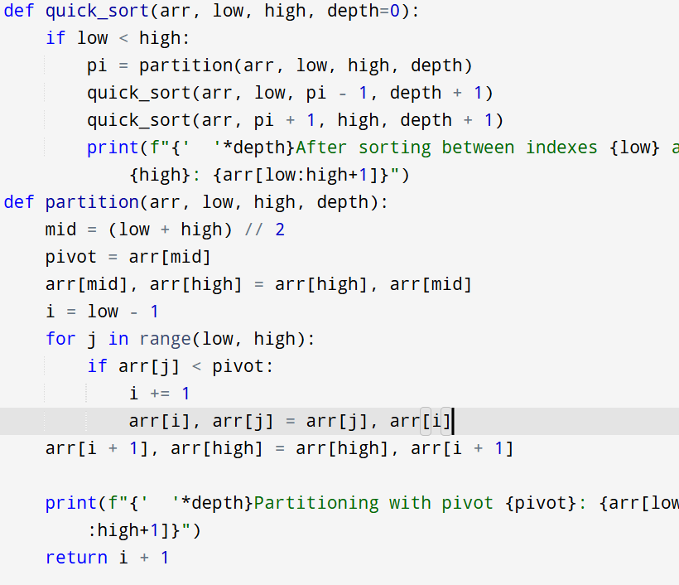
Input:
a = [19, 72, 35, 46, 58, 91, 22, 31]
Output:

Result: Thus the program is successfully executed and the output is verified.

Performance analysis:
Best/Average Time | :O(n log n)

Worst Time (unbalanced pivot) | :O(n²)

Space Complexity | :O(log n) recursion stack

