3.8 BINARY SEARCH ALGORITHM

Aim: To write a Python program to execute binary search algorithm
Algorithm:
- Start
- Input: sorted array a[0...N-1], search key x
- Initialize:
- low = 0
- high = N - 1
- While low <= high:
- Compute mid = (low + high) // 2
- If a[mid] == x, return mid + 1 (for 1-based index)
- If x < a[mid], search left (high = mid - 1)
- If x > a[mid], search right (low = mid + 1)
- If not found, return -1
- End
Program:
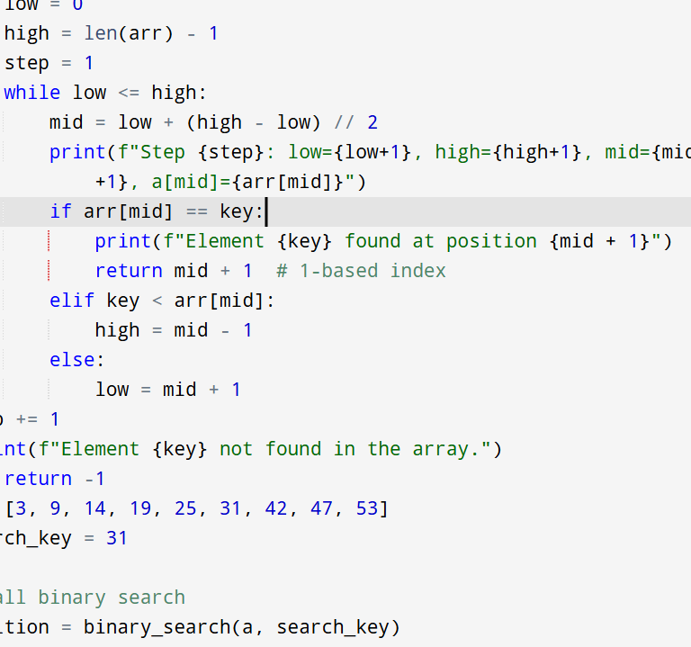
Input:
a = [3, 9, 14, 19, 25, 31, 42, 47, 53]
search_key = 31
Output:
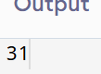
Result: Thus the program is successfully executed and the output is verified.

Performance analysis:
Time Complexity | O(log n)

Space Complexity | O(1)

