3.9 Given an array of points where points[i] = [xi, yi] represents a point on the X-Y plane and an integer k, return the k closest points to the origin (0, 0).

AIM
To find the k closest points to the origin (0,0) from a given list of points using the Euclidean distance formula.

ALGORITHM
- Read the list of points and the integer k.
- For each point (x, y), compute its squared Euclidean distance from (0,0).
- Sort all points in ascending order of distance.
- Return the first k points from the sorted list.
·
PROGRAM
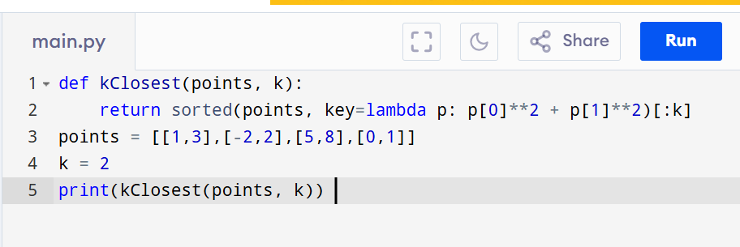

Input:
points = [[1,3],[-2,2],[5,8],[0,1]] , k=2

Output:
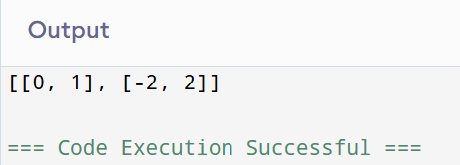

RESULT:
Thus the program for k closest points to origin is successfully executed and the output is verified.

PERFORMANCE ANALYSIS:
  - Time Complexity:O(n log n).
  - Space Complexity: O(n).

