4.1 You are given the number of sides on a die (num_sides), the number of dice to throw (num_dice), and a target sum (target). Develop a program that utilizes dynamic programming to solve the Dice Throw Problem.

AIM
To implement Insertion Sort to sort an array containing duplicate elements
ALGORITHM
1.Start from the second element.
2.Compare the current element with elements before it.
3. Shift larger elements one position ahead to make space.
4. Insert the current element at its correct position.

PROGRAM
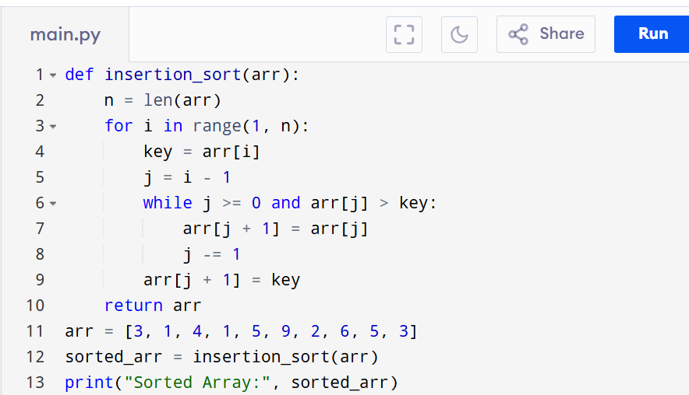

Input:
arr = [3, 1, 4, 1, 5, 9, 2, 6, 5, 3]
sorted_arr = insertion_sort(arr)
print("Sorted Array:", sorted_arr)

Output:
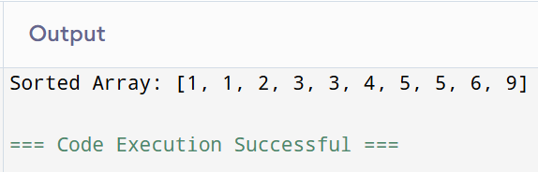

RESULT:
Thus the programo implement Insertion Sort to sort an array containing duplicate elements is successfully executed and the output is verified.

PERFORMANCE ANALYSIS:
Time Complexity:O(n)
Space Complexity: O(1)

