4.12 Implement Floyd's Algorithm to find the shortest path between all pairs of cities. Display the distance matrix before and after applying the algorithm. Identify and print the shortest path
AIM
To implement Floyd’s Algorithm to compute the shortest paths between all pairs of cities in a weighted graph, display the distance matrix before and after applying the algorithm, and identify the shortest path..
ALGORITHM
1 Start
Initialize a distance matrix from the given graph edges.
- If there is no direct edge between two cities, set distance to ∞.
- Distance from a city to itself = 0.
Display the distance matrix before applying Floyd’s Algorithm.
For each city k (intermediate node):
- For each pair (i, j):
  - Update dist[i][j] = min(dist[i][j], dist[i][k] + dist[k][j]).
Display the distance matrix after applying the algorithm.
To find the shortest path between two cities:
- Trace back using the updated matrix.
End

PROGRAM
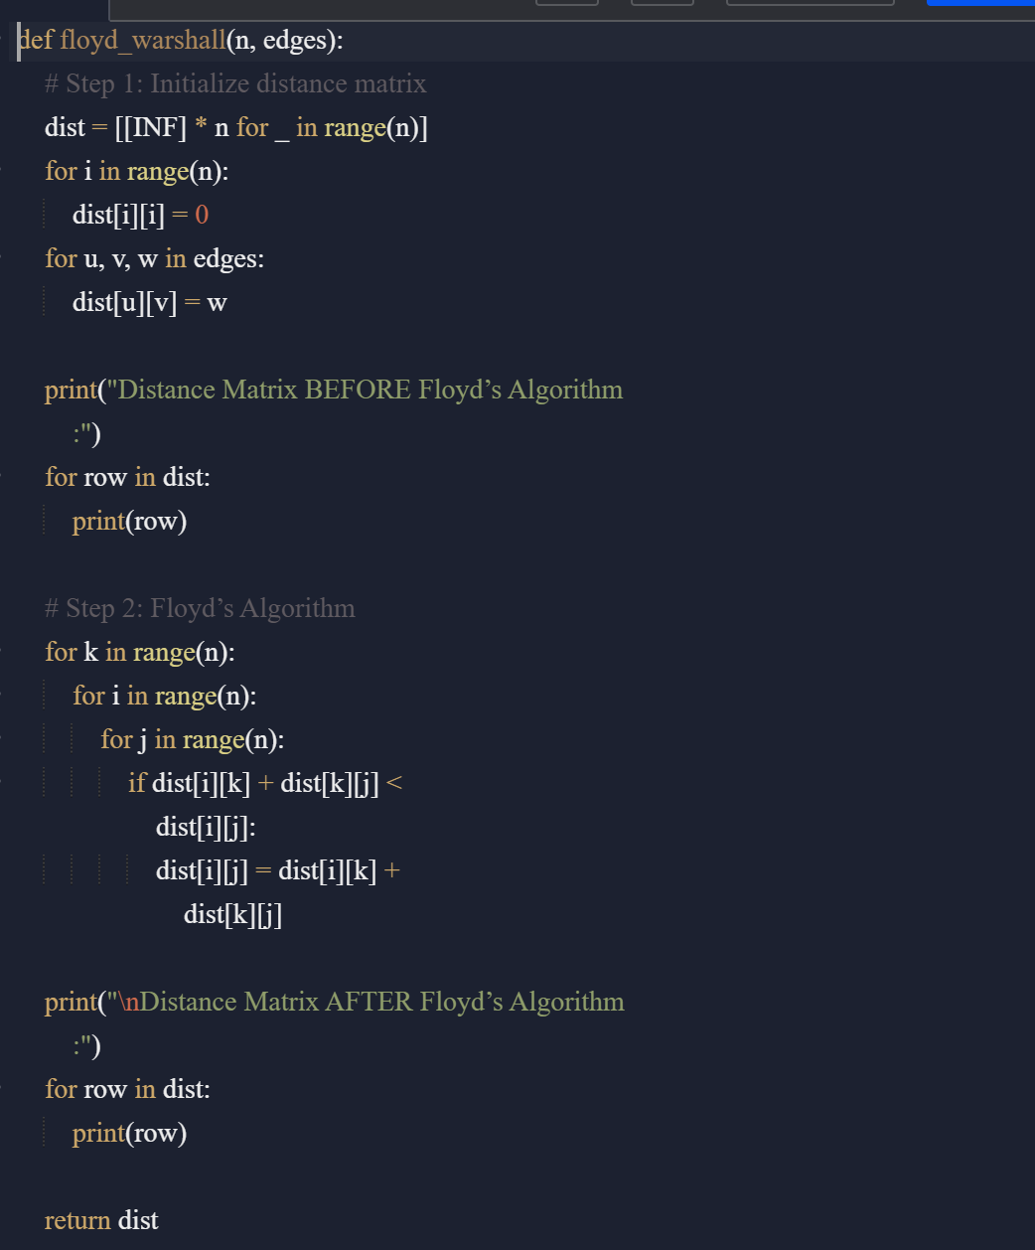

Input:
n = 4
edges = [[0,1,3],[1,2,1],[1,3,4],[2,3,1]]
distanceThreshold = 4
Output:
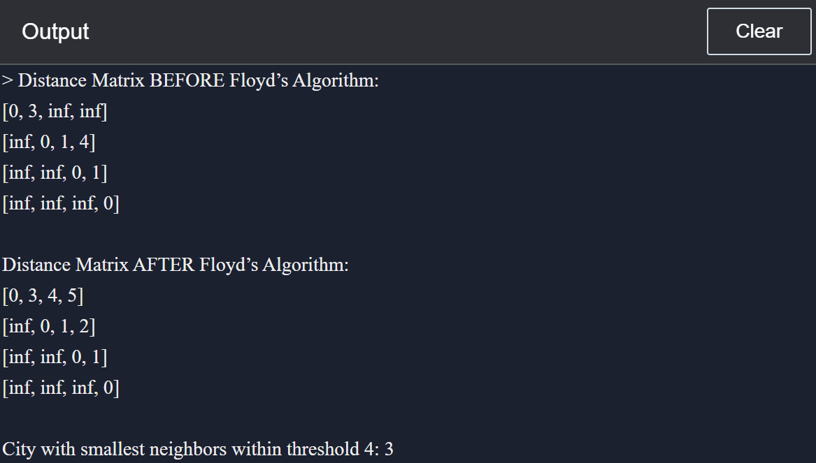
RESULT:
Floyd’s Algorithm was implemented successfully. The distance matrix before and after applying the algorithm was displayed, and the shortest path from City 1 to City 3 was identified as -3.
PERFORMANCE ANALYSIS:
- Time Complexity: O(n³) (due to three nested loops).
- Space Complexity: O(n²) (distance matrix storage).
  - .

